# IMAGE TO eXCEL cONVERSION

**Step 1:** Double clickon **ImageToExcel.zappy**, to start an execution**.**

**Step 2:** Run Zappy Task window will open on screen. Now Click on **OK**.

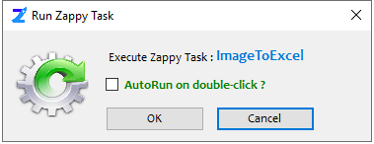

**Step 3:** After clicking on **OK, Select the image.**

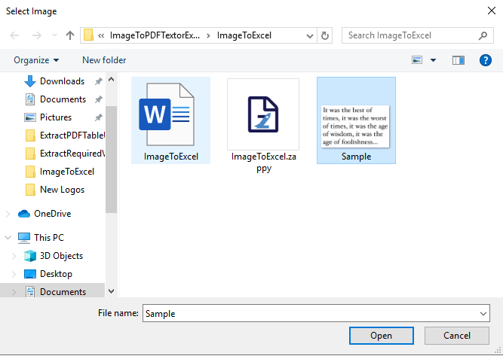

**Output: Zap** will automatically convert the image into an excel.

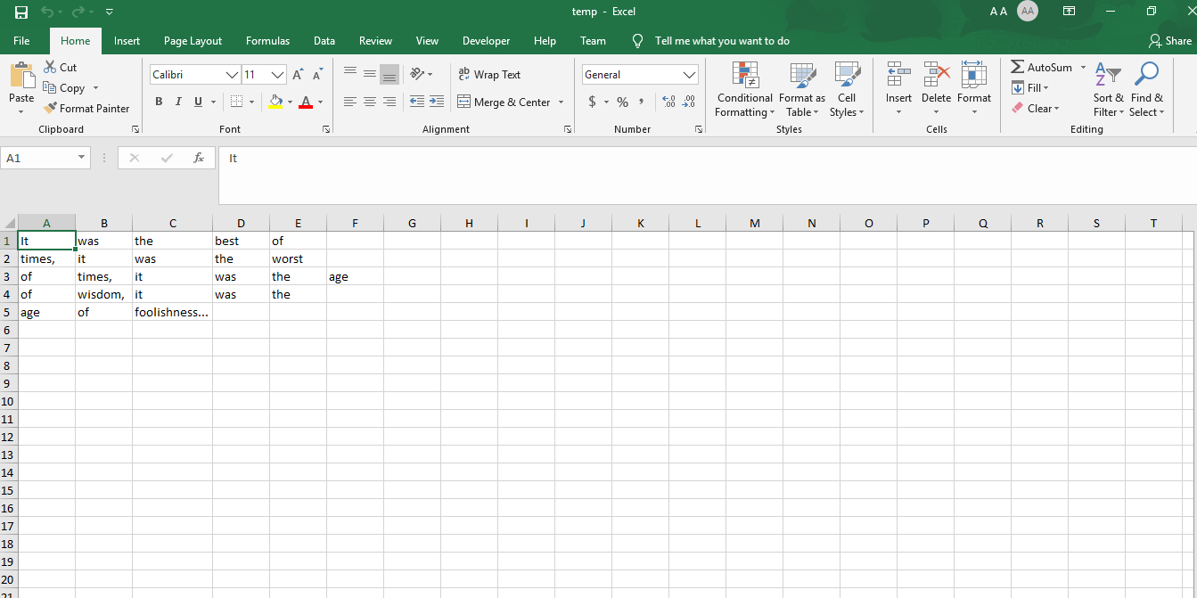

**In this way we can use this automation to convert any image to excel file.**