**Conversion of Multiple Image to single PDF**

This document will explain you how to run automation for converting multiple images into pdf files and merge converted pdf files into single pdf file.

**Step 1:** Double click on **ImageToPdfMerged.zappy** file.

**Step 2:** Run Zap Task window will pop-up, click on **OK**.



**Step 3:** Select images folder.

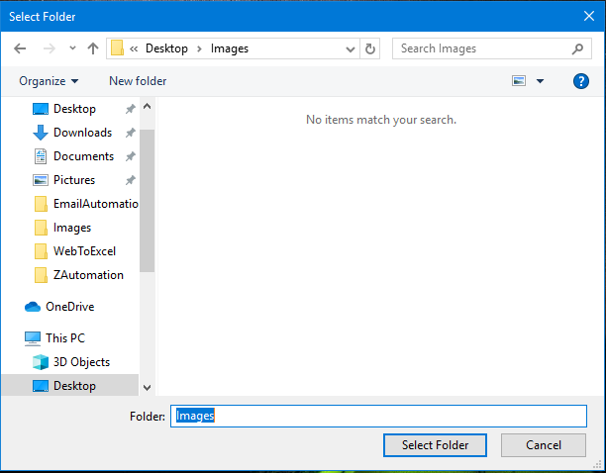

**Step 4:** You will see “**Successfully Executed Task**” message from Zap on successful execution.

**Output:**

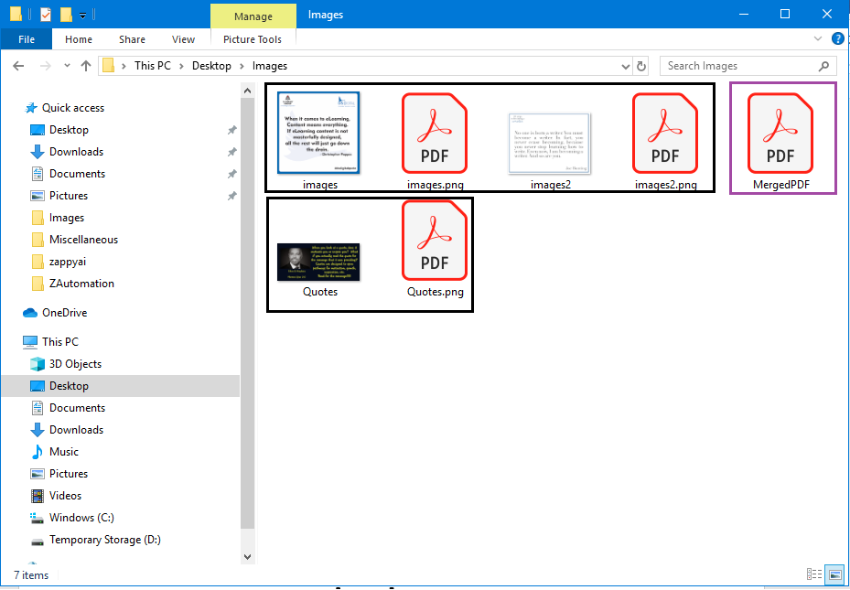

Merged all PDFs into single

Image with their PDF file

**In this way we can use this automation to convert mutiple images to single PDF.**