**Image To PDF Conversion**

This document will explain you, how to create the PDF file from the image.

**Step 1:** Double click **on ImageToPDF.zappy**, to start an execution**.**

**Step 2:** Run Zappy Task window will open on screen. Now Click on **OK**.

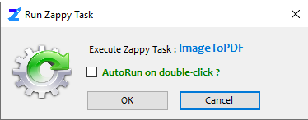

**Step 3:** After click on **OK, Select the image.**

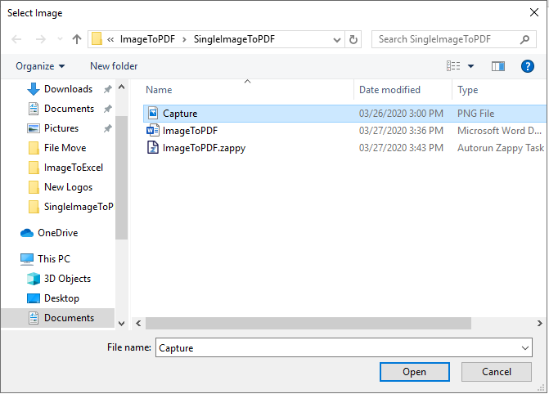

**Output: Zap** will convert the image into PDF in same folder as the image.

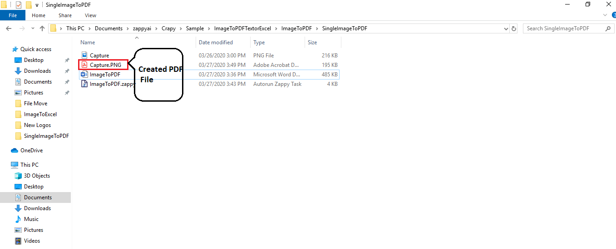

**In this way we can use this automation to convert any image to** **PDF**