**Convert Multiple Images to Text File**

This document will explain you, how to convert image into a text file.

**Step 1:** Double click **on MultipleImagesConvertIntoTextFile.zappy**, to start an execution**.**

**Step 2:** Run Zappy Task window will open on screen. Now Click on **OK**.

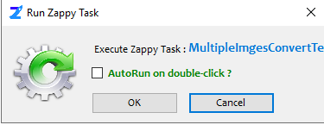

**Step 3:** After click on **OK, Select the images folder.**

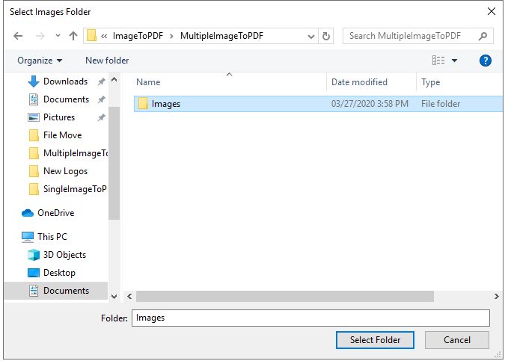

**Output: Zap** will convert the image into an Text file in same folder as the image.

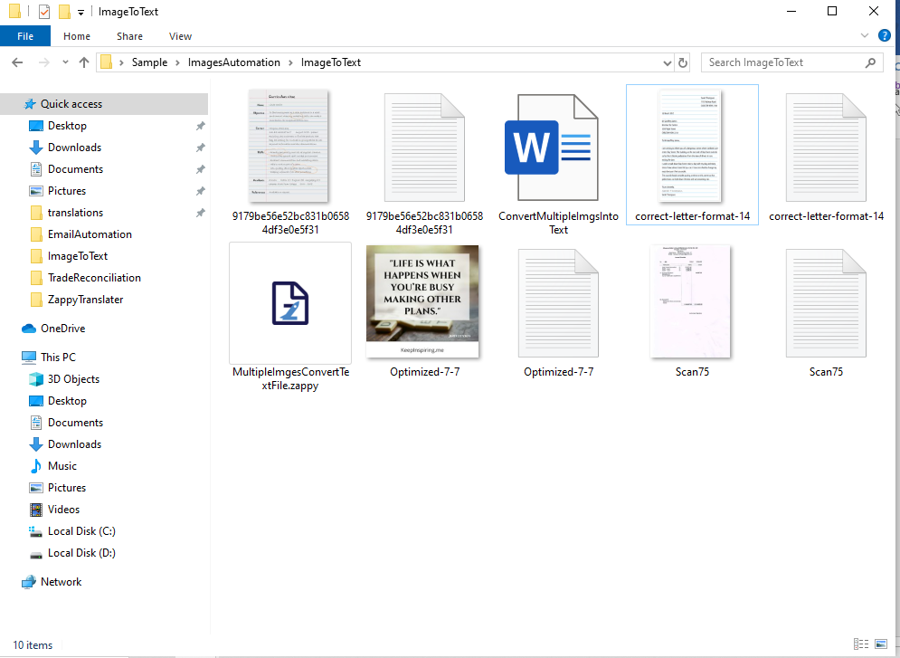

**Converted .txt files**

**.jpg files**

Converted Image to text file.



**In this way we can use this automation to convert Multiple images to Text file.**