# Launch Any application or Any file

**Step 1:** Double click **on LaunchNotepad.zappy**, to start the execution**.**

**Step 2:** Run Zappy Task window will open on screen. Now Click on **OK**.

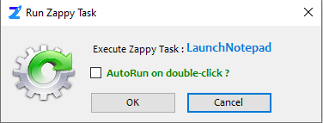

**Step 3:** After click on **OK, Zap** **Automation** will automatically start the **Notepad** application.

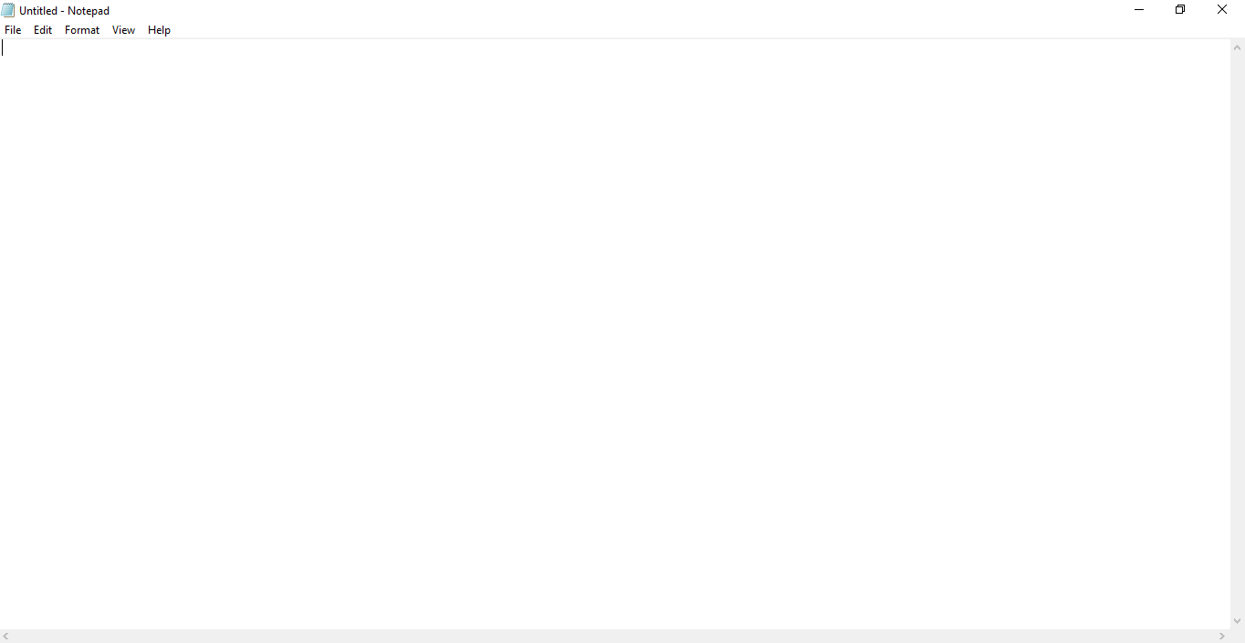

**In this way we can use this automation to start any application or Any file.**

## How to Modify Automation

**You can edit this automation in Task Editor and specify the application name or file name you want to start in front of AppPath field.**

