**Outlook New Email Trigger**

**Note:** Outlook should be open. Make sure Zappy_[Outlook Addin is enabled.](https://docs.zappy.ai/docs/outlook-addin)

**Step 1:** Right click on Zap icon and select Task Editor (or Double click on zap icon)

**Step 2:** Open the **OutlookNewEmailTrigger.zappy**

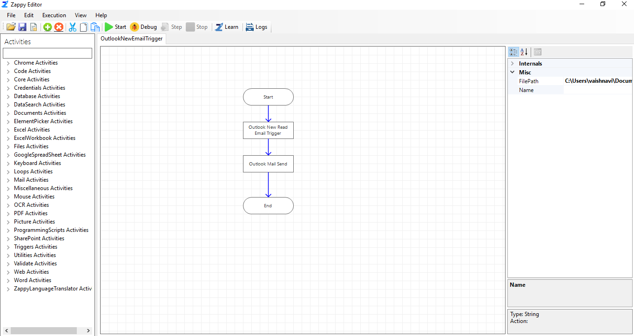

**Step 3:** We can set Outlook Trigger for **From, Subject, Body.**

When we enter the **SaveDirectory** path then, mail will be saved in local directory.

We set the trigger for **From** Mail ID

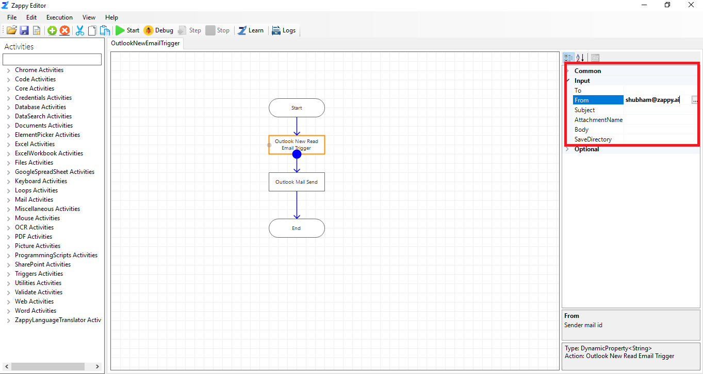

Likewise, we can set trigger for Subject, Body, AttachementName

**Step 4:** Click on **Outlook Mail Send** action and set the properties.

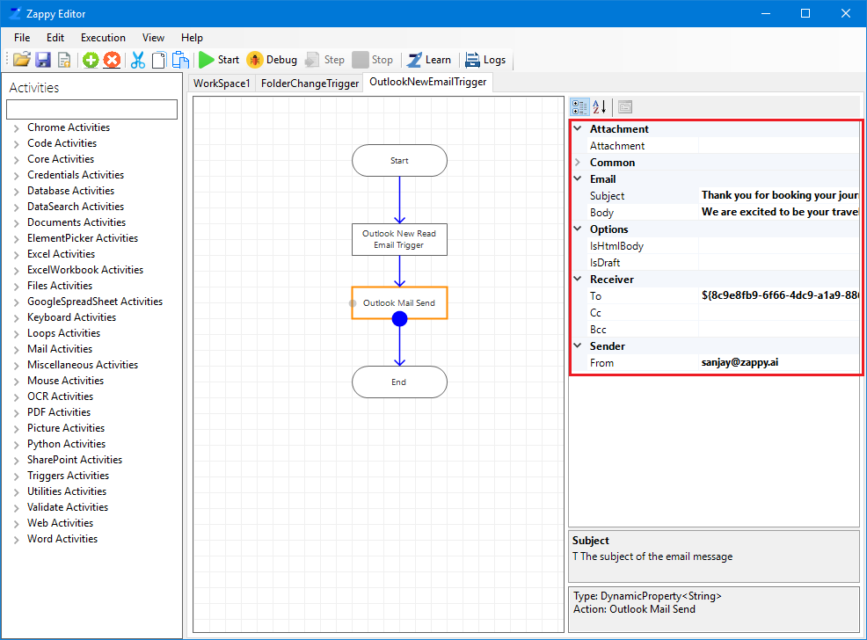

**Whenever any Mail comes from selected Mail ID, OutlookNewEmail Trigger will fire and Mail is also send.**

In this way we can use **Outlook New Email Trigger**.