**Schedule Time Trigger**

**Summary:**

This document will explain to create a Zap task to set the Schedule for daily Reminder.

**Step 1:** Right click on Zap icon at bottom right corner of your window and select Task Editor or double click on **Zap** icon.

**Step 2:** Drag and drop **Schedule Time Trigger** from Activity Panel and set the properties for this.

* **RepeatDays –** User can select weekdays or weekends.
* **TriggerFireTime –** Set the time in 24Hr format.

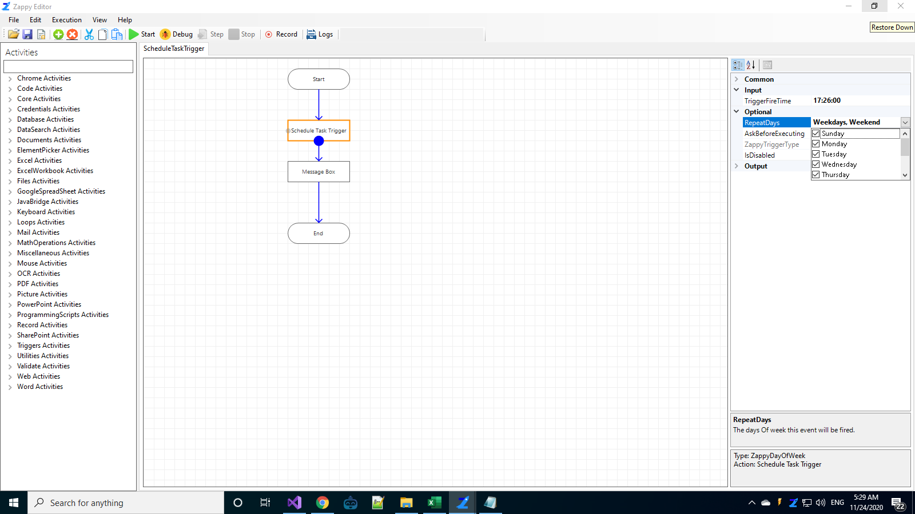

Select weekdays or weekends.

In this example message box will display at Trigger Fire Time. We can also add another action / automation flow according to our requirement.

**Step 3:** Click on **Start** button to register the trigger.

We will see the message after successful register trigger.

v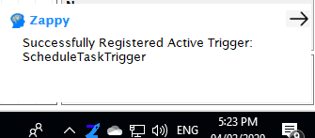

**Output:**

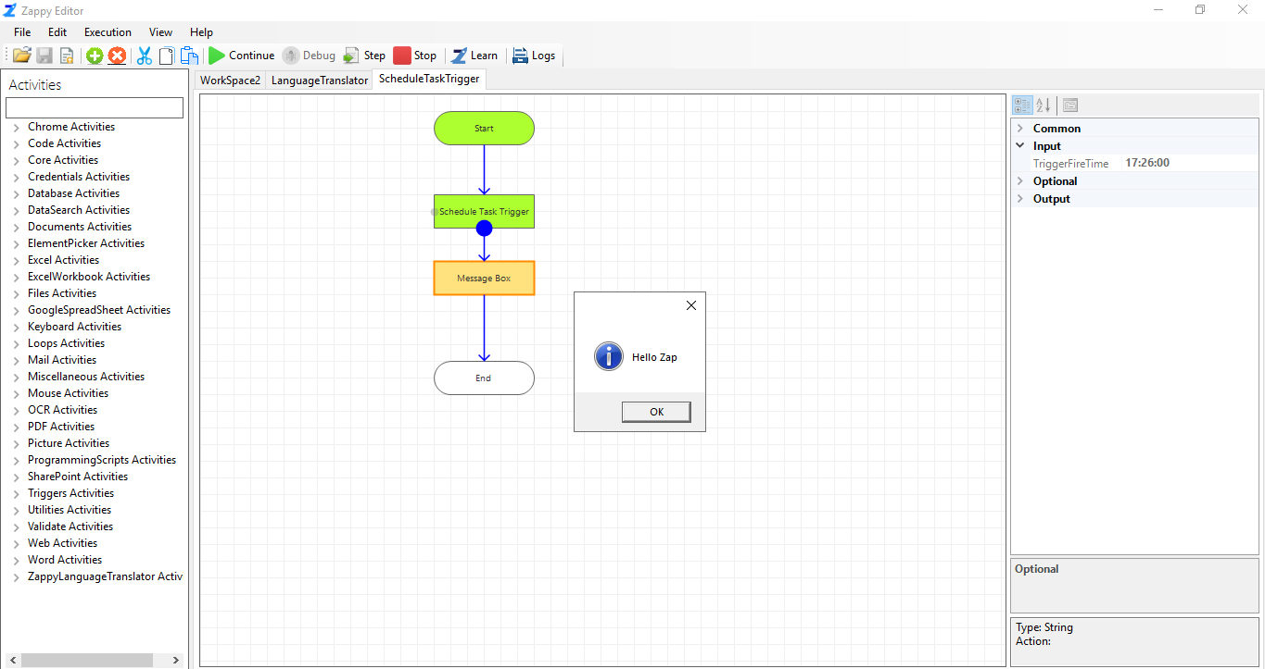

Trigger will fire when set time and system time match

**In this way we can use the Schedule Timer Trigger for daily reminder.**