**Email Automation with Attachment**

This document will explain you how to create automation for sending emails with attachment to the specified users using Excel.

**Step 1:** Open outlook and check [**Addin**](https://docs.zappy.ai/docs/outlook-addin).

**Step 2:** Create an Excel sheet with Sender Email Address, Sender Name and CC Mail Id.

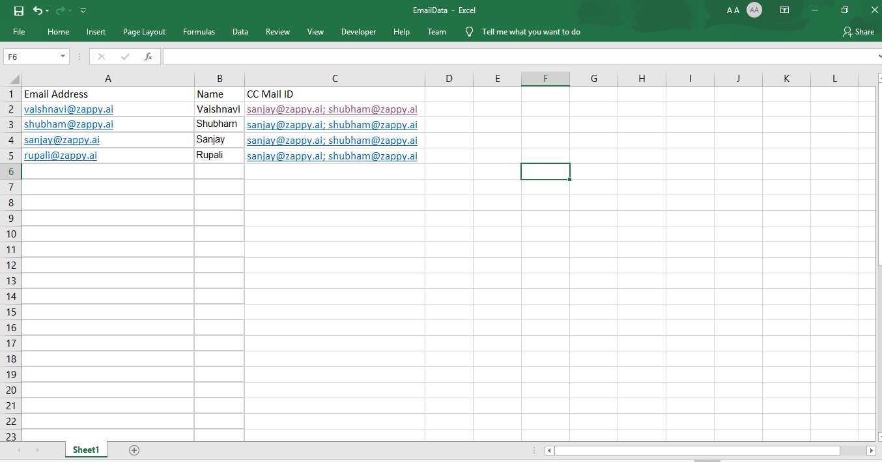

**Step 3:** Right click on Zap icon at bottom right corner of your widow and select Task Editor or double click on **Zap** icon.

**Step 4:** Open **EmailAutomation.zappy** task.

**Automation:**

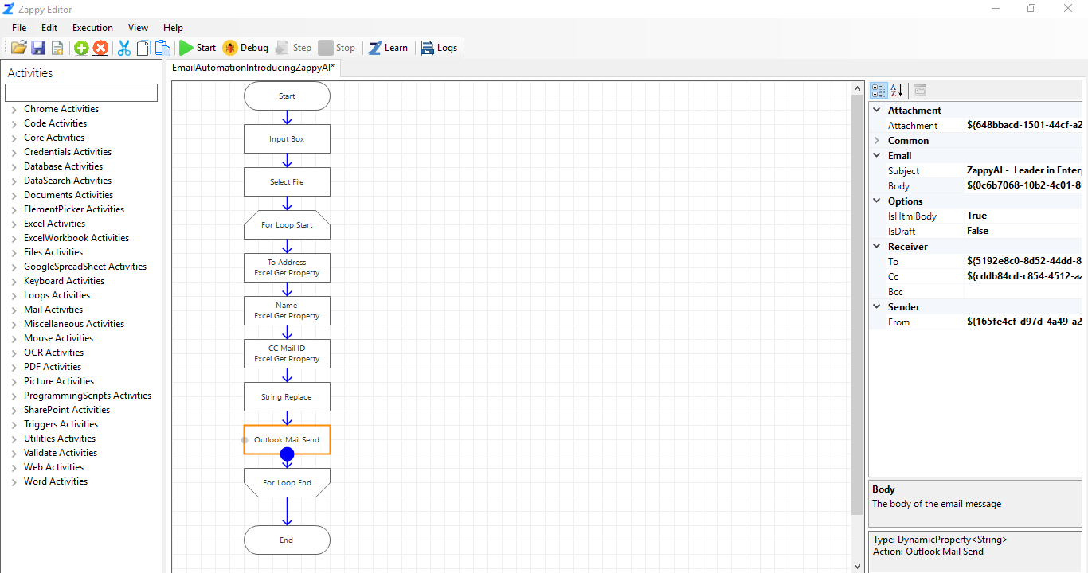

**Step 5:** Click on **For loop Start** action and enter **Intial** and **Final Value** based on your requirement. These are the starting and ending row index values of your excel sheet.

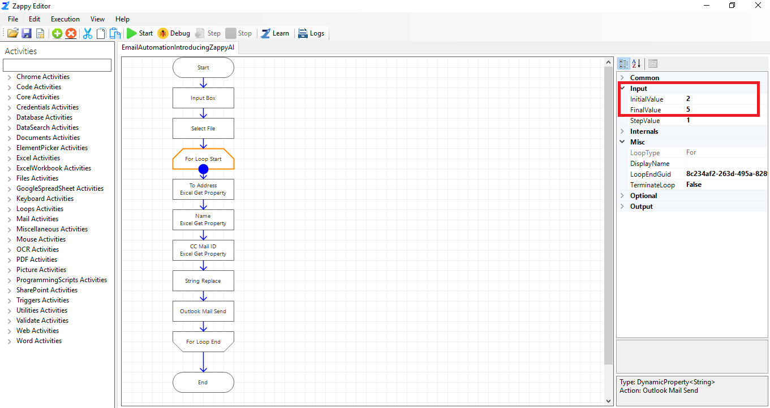

**Step 6:** If user wants to send mail with formatting like bold, with bullets then make sure **IsHtmlBody** field is true and write the **html script** in **Body** field.

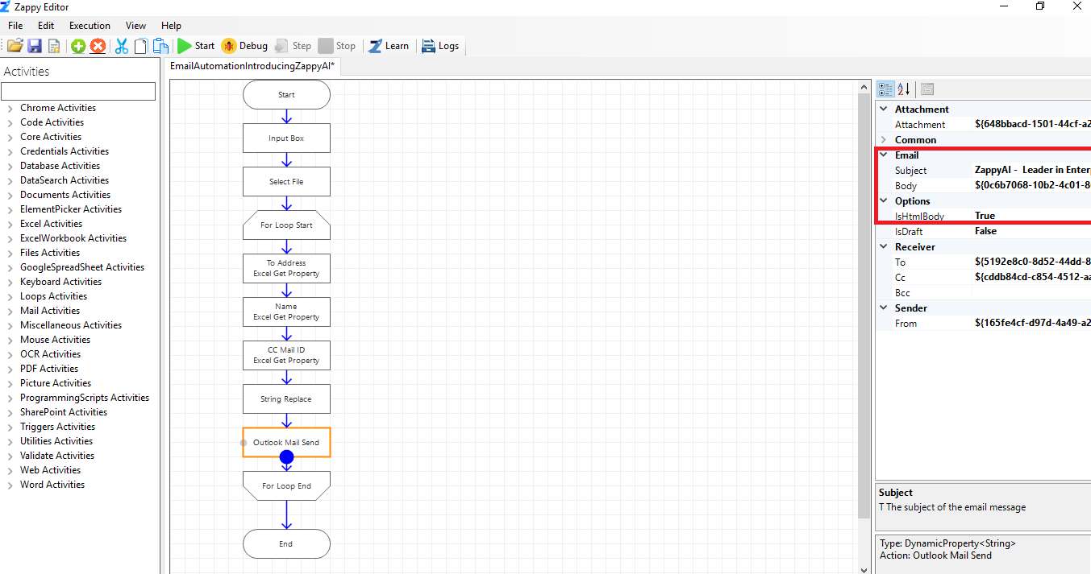

In front of Body field, click on 3 dots to open the Value Picker. Then write the html script in Static Value field as shown below.

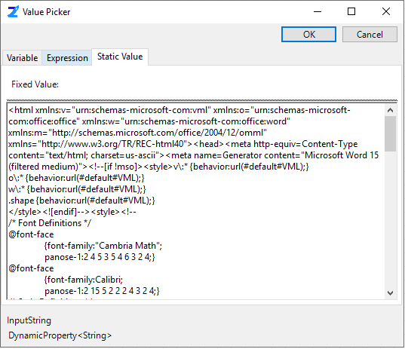

**Step 7:** Enter your Email Id in Input Box and click on **OK**.

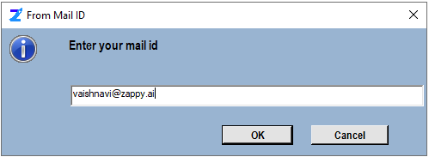

**Step 8:** Select your attachement file.

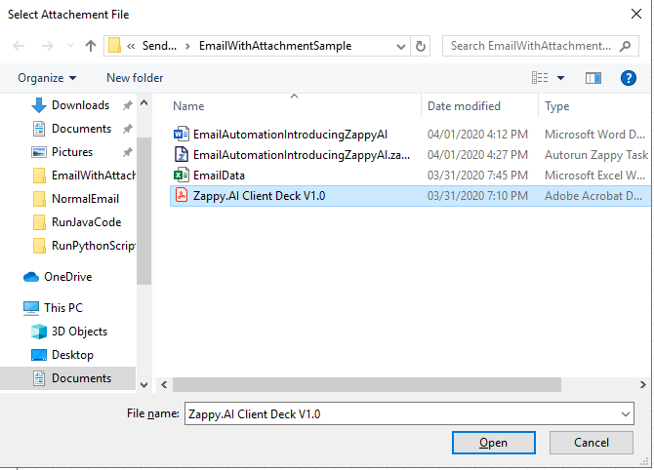

Check your Outlook **Sent Items** to verify that all emails are sent with attachement.