**Click on Image and Write Text**

This document is created for the purpose **“to click on any image and write text”.**

**Step 1:** Right click on **Zap** icon and select Task Editor (or Double click on zap icon to open the Task Editor).

**Step 2:** Drag and Drop **Image Click and Type** action from the Activity panel.

**Step 3:** Click on  in front of **ImageSelector** and click on **Clip** to clip the image.

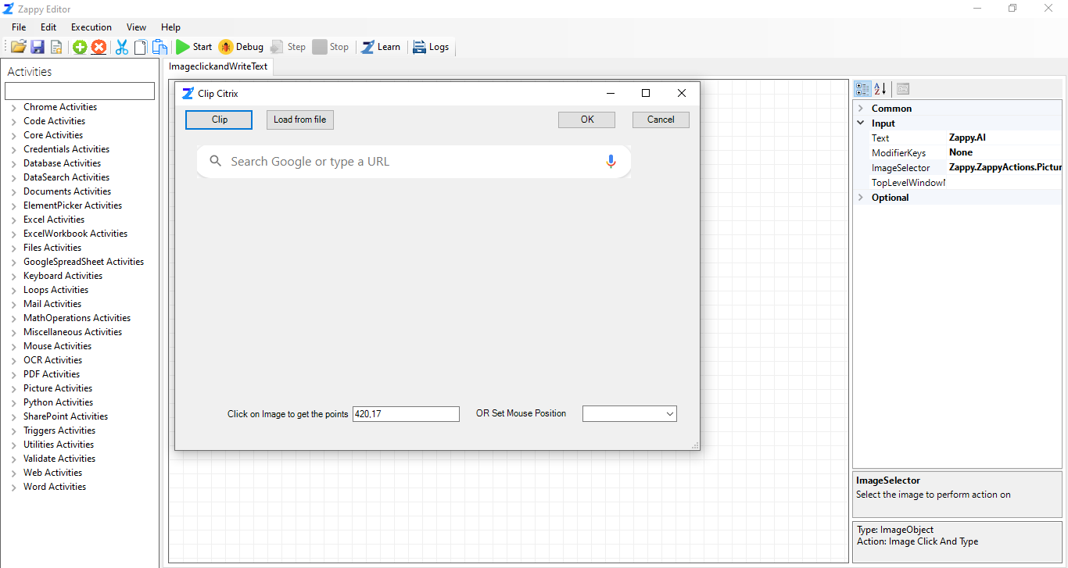

By default, the mouse position is set on **Centre** as shown in above picture**.** Click on image to get image points or set mouse position from drop down menu like Centre, TopLeft, TopRight and so on. Then click on OK button.

**For example:** We clip search tab from chrome.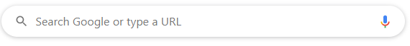

**Step 4 :** Enter text in front on **Text** Field. User can also use Modifier Keys like ctrl, shift etc. Modifier key can be selected from the drop down menu in front of **ModifireKeys field**.

**Step 5:** Then **Save** theautomation.

**Step 6**: Click on **Start** button to run the automation.

**Output:** Zap Automation will click on search tab in chrome and write text.

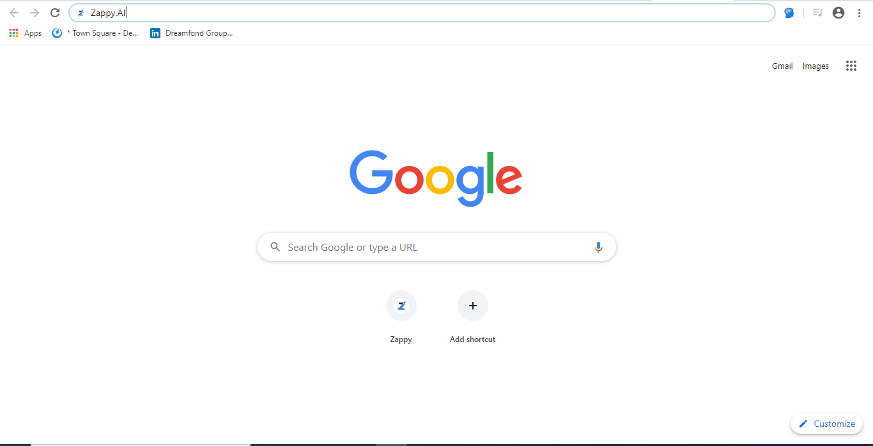

**Note:** Set your system **Scale and Layout** as 100%

Right click on Desktop and go to **Display settings**

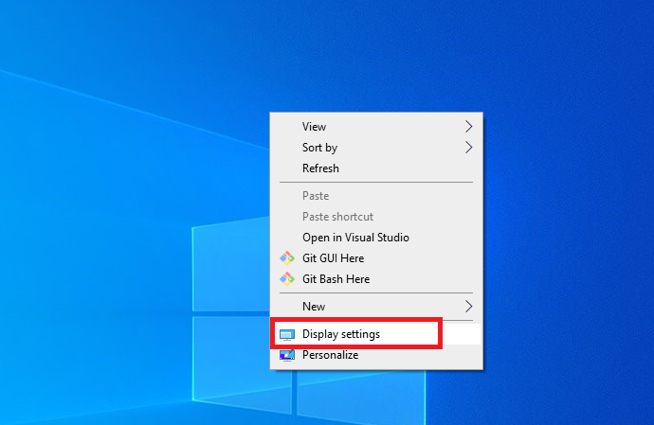

Set Scale and Layout as 100%

