**Image Click**

User will click on image by two ways either by using **Clip** option or using **Load from File** option.

**Step 1:** Right click on **Zap** icon and select Task Editor (or Double click on Zap icon to open the Task Editor).

**Step 2:** Drag and Drop **Image Click** action from the Activity panel. User will see the Activity panel on the left side of Task Editor.

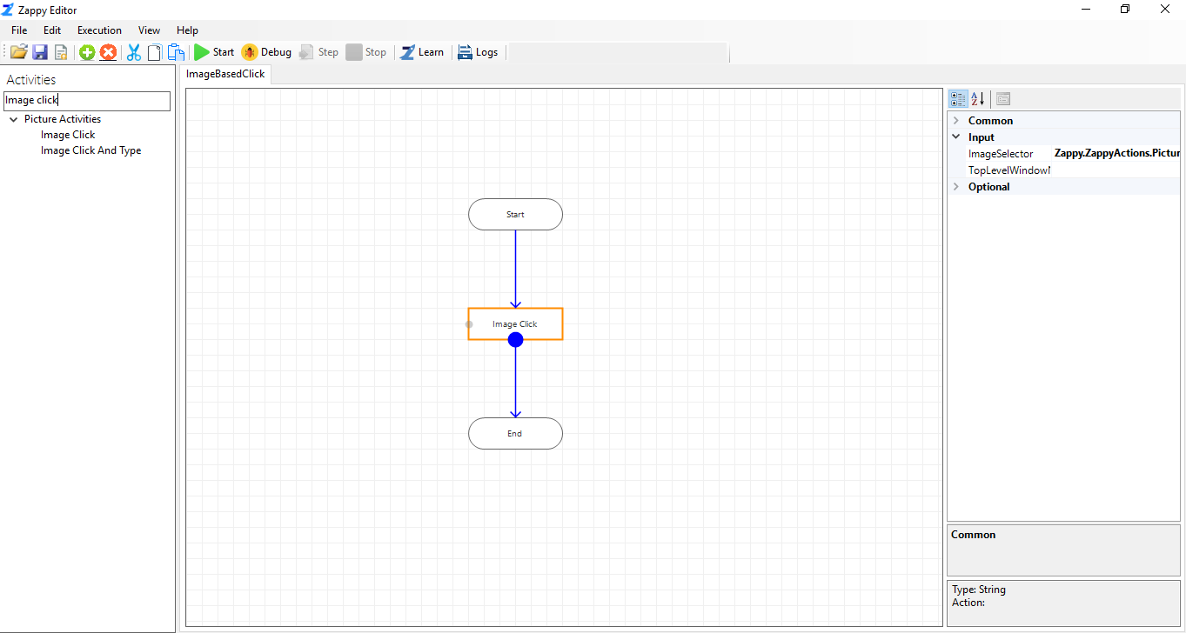

**Using Clip Option:**

* Click on  in front of **ImageSelector** and click on **Clip** to clip the image.

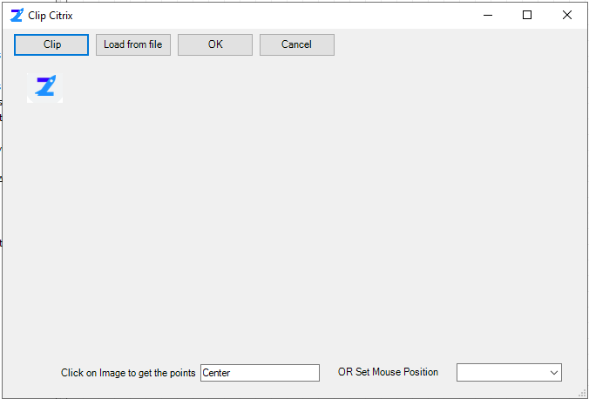

By default, the mouse position is set **Centre** as shown in above picture**.** Click on image to get image points or set mouse position from drop down menu like Centre, TopLeft, TopRight and so on. Then click on OK button.

**For example:** We clip 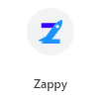 image from chrome.

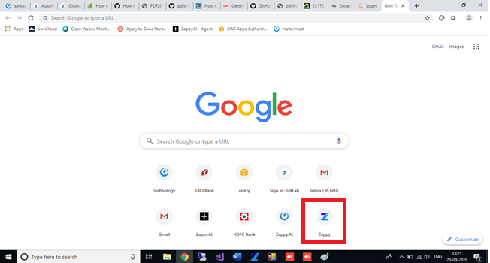

**Step 3:** Then **Save** the automation.

**Step 4**: Click on **Start** button to run the automation.

**Output:** Zap Automation will click on clipped image.

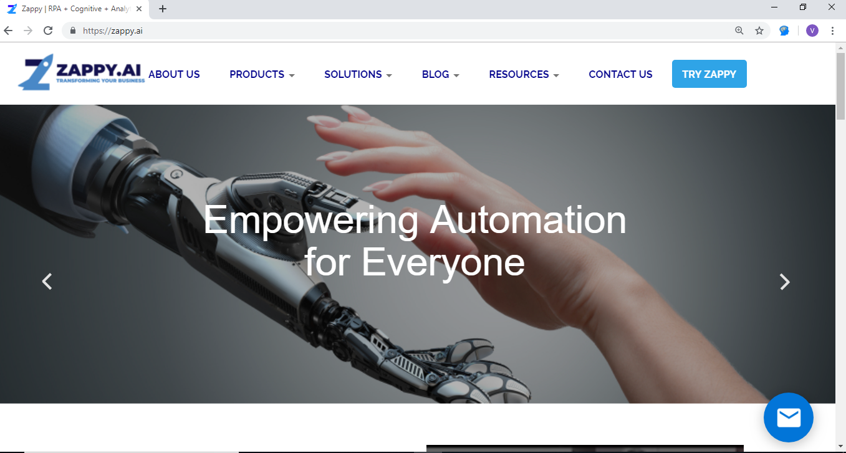

**Using Load From File option:**

* Click on  in front of **ImageSelector** and click on **Load From File** option to load the image.

**Example:** we have to open ZappyAI website. So, we have capture below image from chrome and save it.

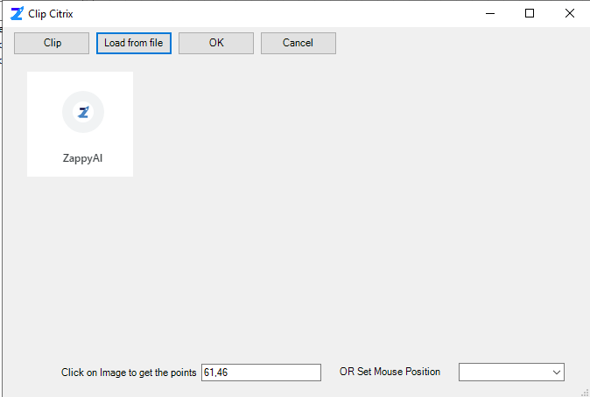

**Step 5:** Then **Save** the automation.

**Step 6**: Click on **Start** button to run the automation.

**Output:** Zap Automation will click on load image and open the website.

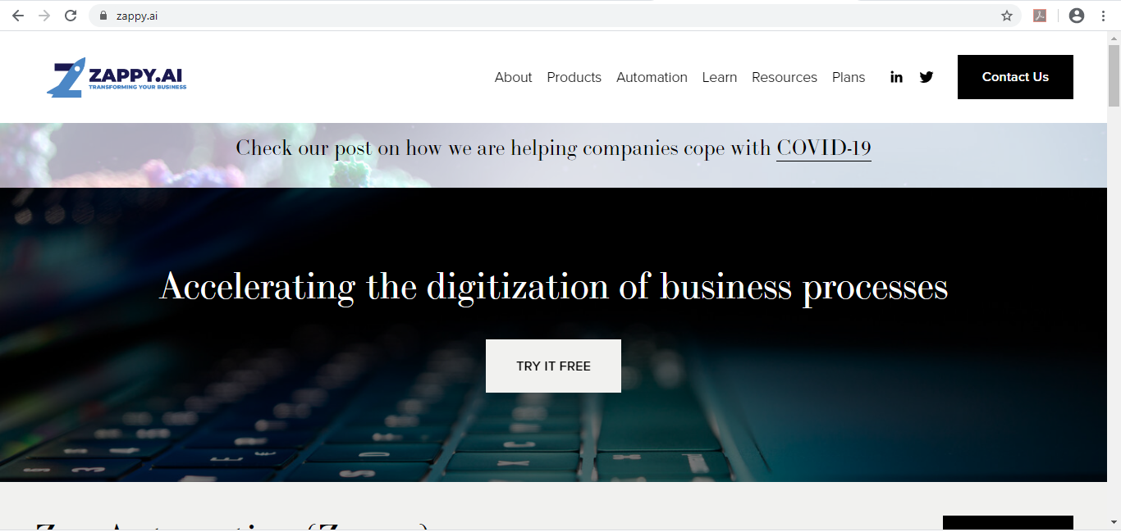

**Likewise, we can use Image Click action to automate our image-based automation.**

**Note:** Set your system **Scale and Layout** as 100%

Right click on Desktop and go to **Display settings**

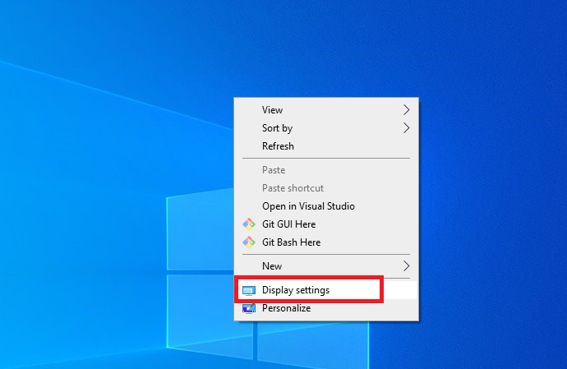

Set Scale and Layout as 100%

