**Automate Keyboard Action**

**Step 1:** Double clickon **GlobalKeyPress.zappy** to start the execution**.**

**Step 2:** Run Zappy Task window will open on screen. Now Click on **OK**.

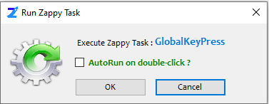

**Step 3:** After click on **OK, Zap** **Automation** will open the **Notepad** application and automatically write the content in Notepad.

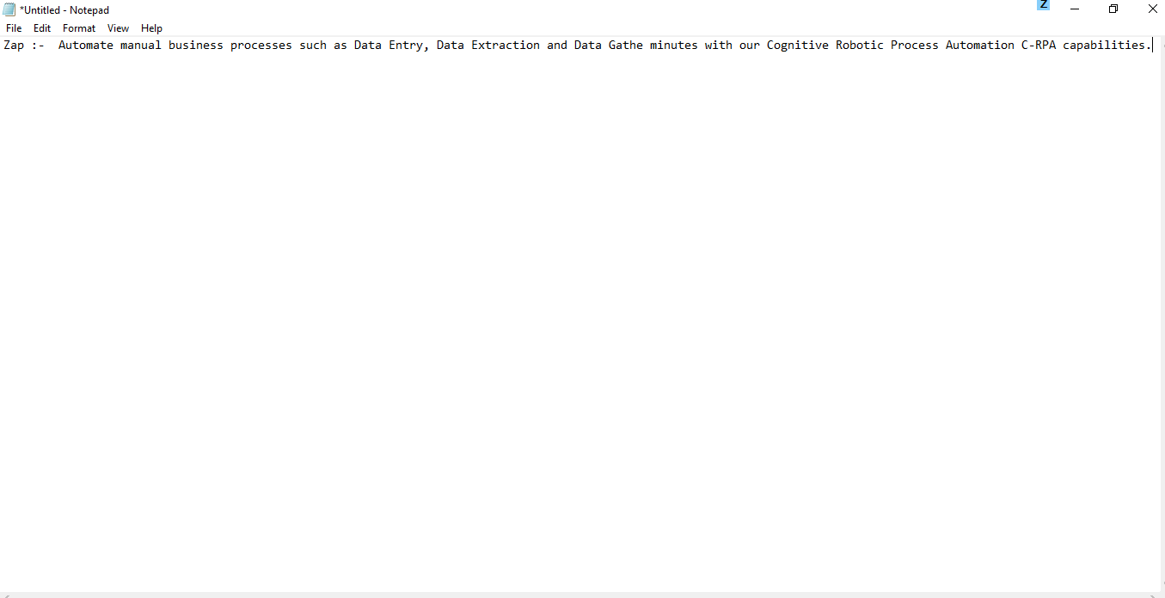

**In this way we can automate the any keyboard key.**

**How To Modify:**

**We can modify this automation in Task Editor.**

**Step 1:** Right click on **Zap** icon and select Task Editor (or Double click on Zap icon to open the Task Editor).

**Step 2:** Drag and Drop **Global Key Press** action from Activity panel. User will see the Activity panel on the left side of Task Editor.

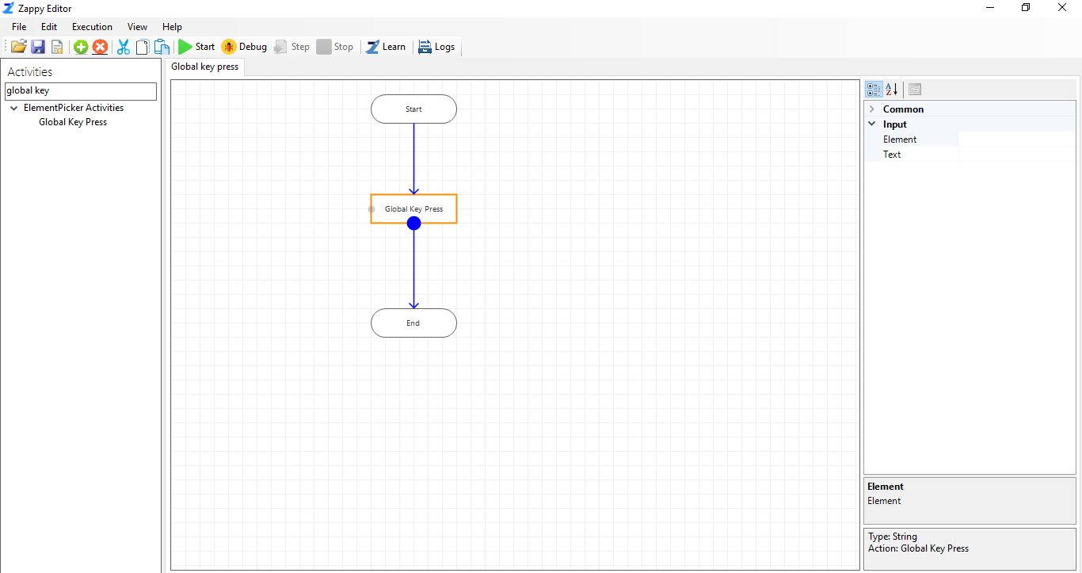

**Step 3:** Click on three  in front of Element property, new window will pop-up then click on **Pick** button thenpress **Control** button from keyboard to pick the element. Select Field from Name column which uniquely distinguish the picked element.

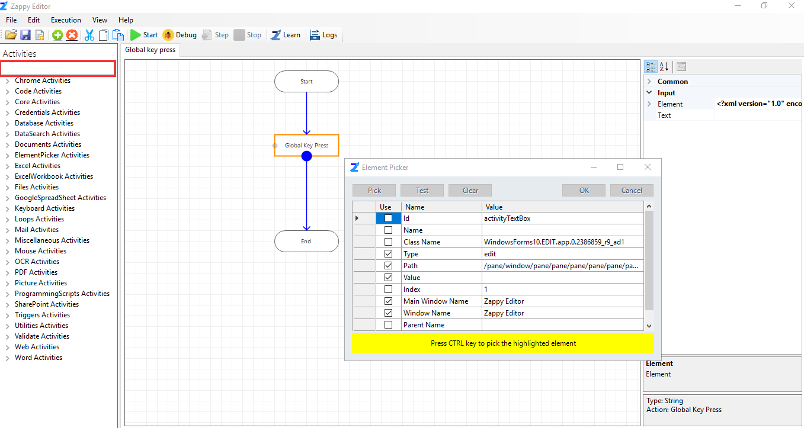

As shown in above picture, we have picked **Search Bar** from Zap Automation Task Editor.

**Step 4:** Then click on **Test,** you will see the message in the message box like “**The query matched 1 element**”. Now click on **ok**.

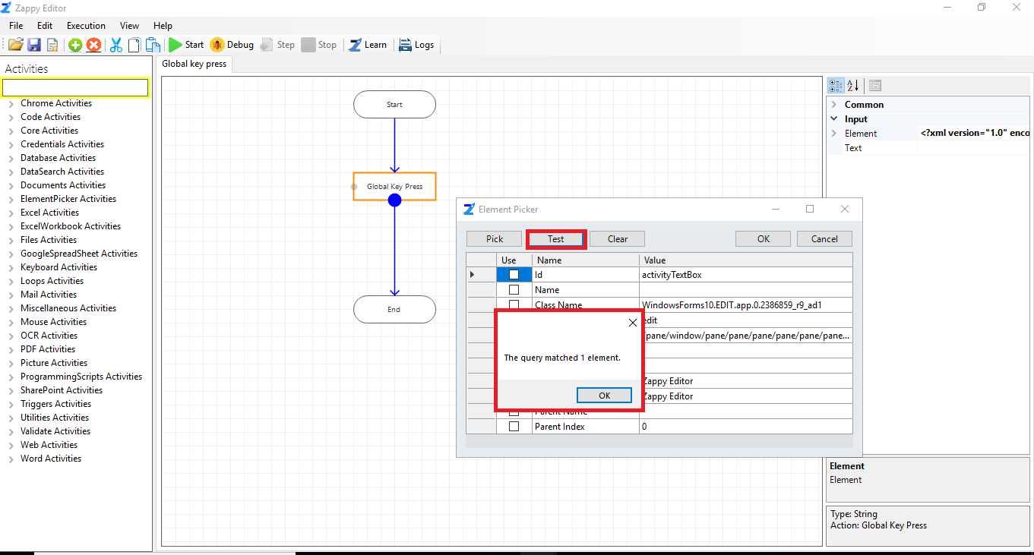

**Step 5:** Enter the text in front of **Text** field as shown.

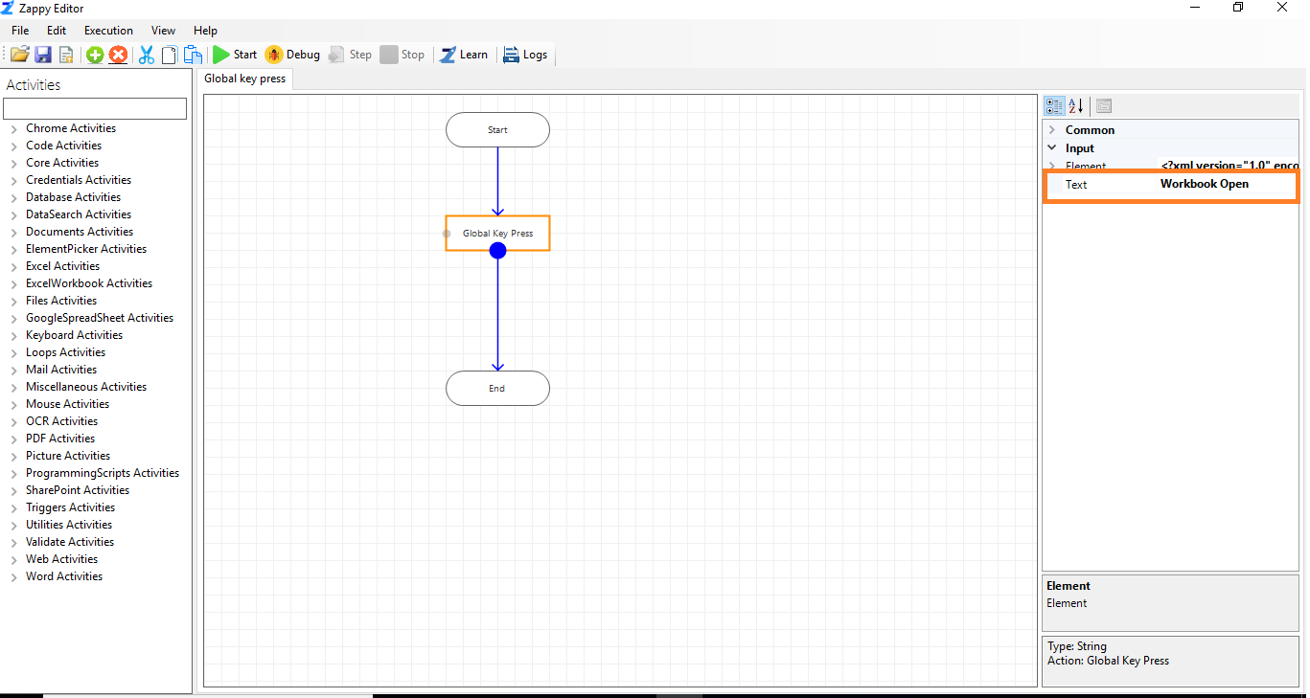

**Step 6:** Save the Automation and Start the execution.

**Output:** Zap Automation automatically search the picked element and write the text as shown.

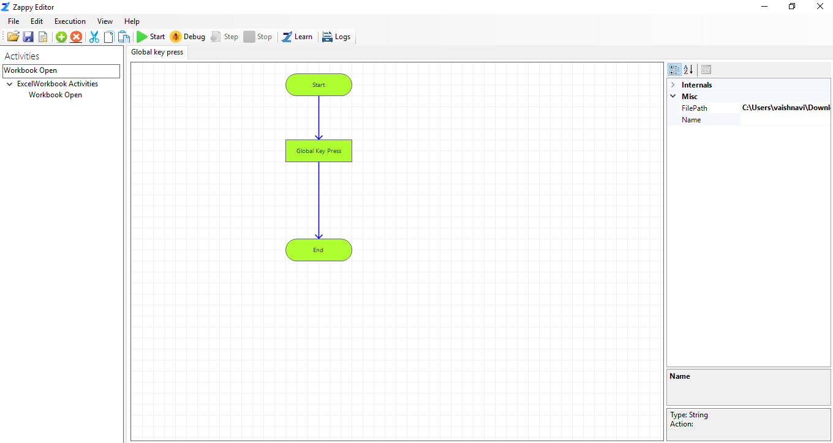

**In this way we can modify the automation.**