**Mouse Click on Selected Element**

**Step 1:** Right click on **Zap** icon and select the Task Editor (or Double click on Zap icon to open the Task Editor).

**Step 2:** Drag and Drop **Global Mouse Click** action from the Activity panel. User will see the Activity panel on the left side of the Task Editor.

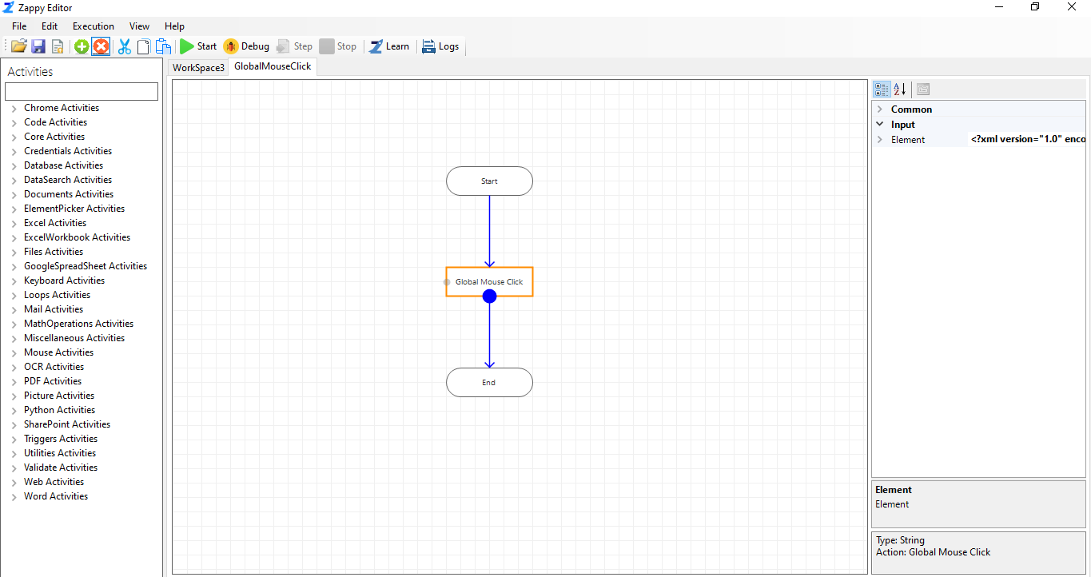

**Step 3:** Click on three  in front of Element property, a new window will pop-up. Then click on **Pick** button andpress **Control** button from keyboard to pick the element. Select Field from Name column which uniquely distinguish the picked element.

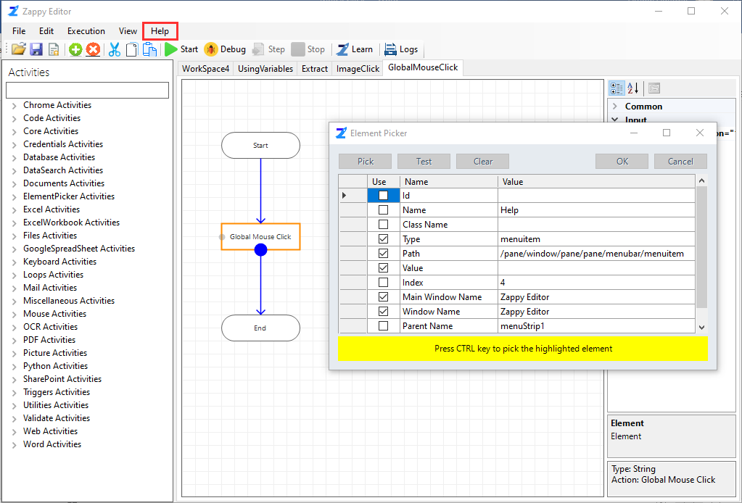

As shown in above picture, we have picked **Help** button from Zap Automation Task Editor.

**Step 4:** Then click on **Test,** you will see the message in message box like “**The query matched 1 element**”. Now click on **ok**.

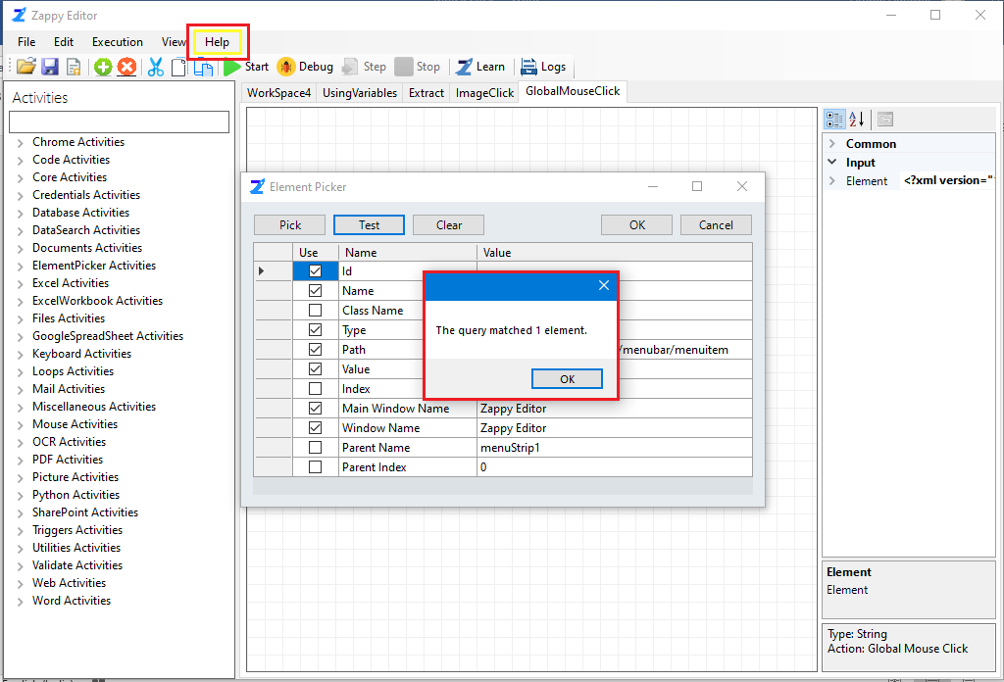

**Step 5:** Then save the automation by clicking on.

**Step 6**: Click on **Start** button to run the automation.

You will see the output, **Help button** will be clicked automatically.

