**Nested Function Call**

Nested function calls simply mean that one function can call another which in turn can call another. Please go through the following steps to run nested calls in zap task.

**Step 1:** Right click on Zap icon and select Task Editor (or Double click on Zap icon)

**Step 2:** Drag and drop **Run Zappy Task** Action from Activity Panel. User will see the Activity panel at left side of the Task Editor.

**Step 3**: Please enter DisplayName, then double click on “**Run Zappy Task**” action as shown in following picture.

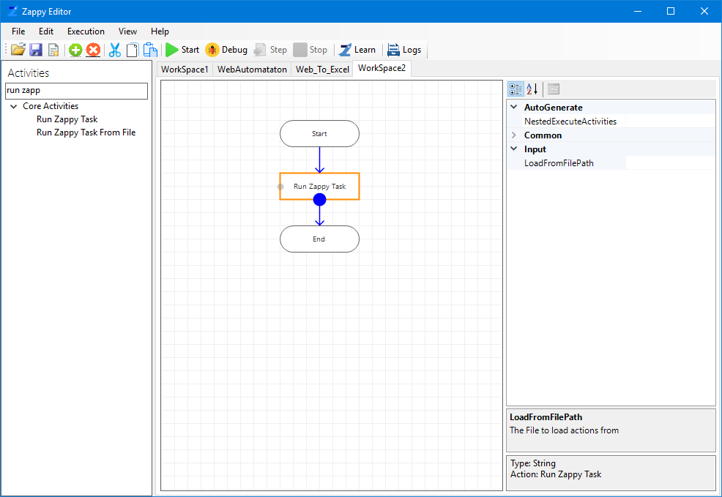

Double clicks on action

**Step 4**: Now the following window will open.

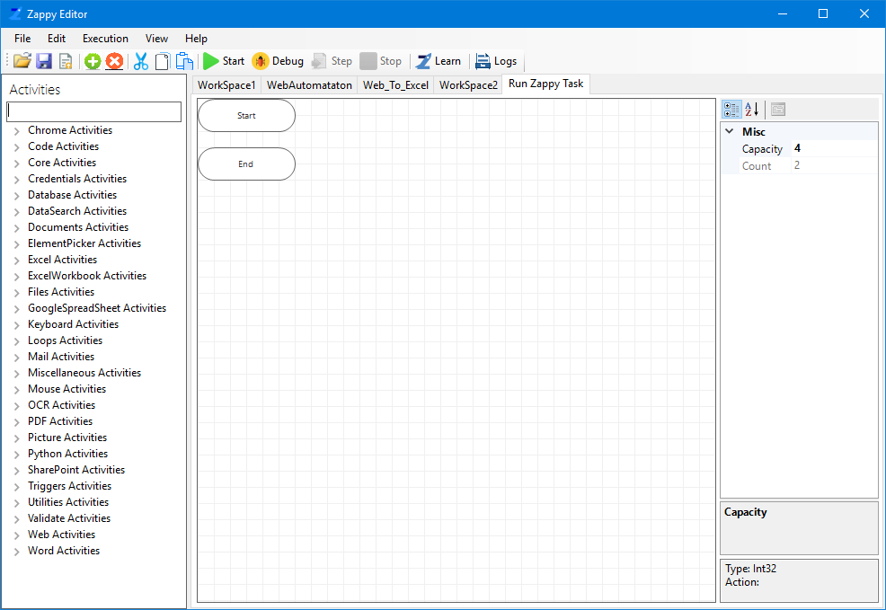

**Step 5**: Drag and Drop another action from Activity panel (Example: Message Box). Fill the details as shown in below picture.

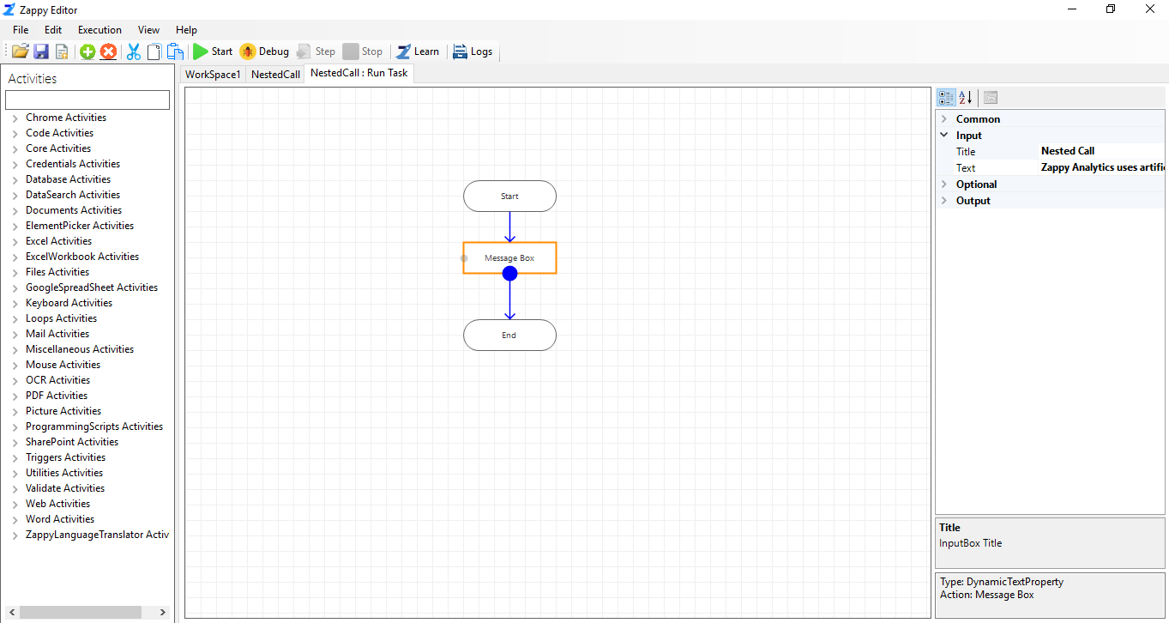

**Step 6:** Then click on **Save** button to save the automation.

**Step 7:** Click on **Start**. You will be able to see the **Output** as shown below.

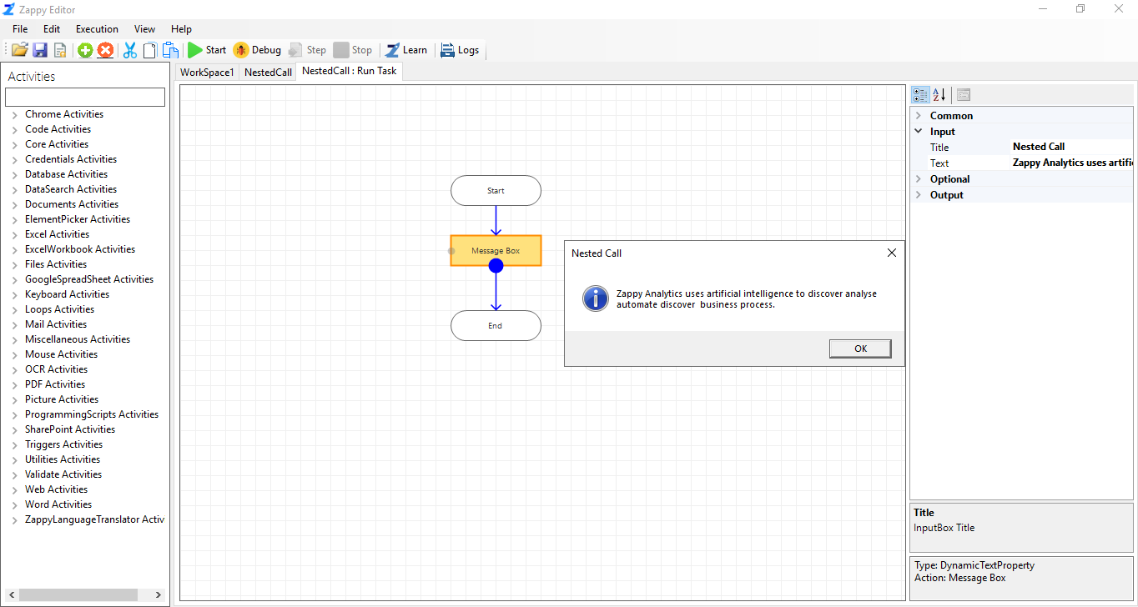

**Step 8:** You can see “**Successfully Executed Task**” message from Zap on successful execution.

Likewise, we can use **Run Zappy Task** action for any other Nested Call.