**How To Use Variable**

This document will explain you how to use variables.

Please go through the following steps to understand how to use variables.

**Step 1:** Right click on Zap icon at bottom right corner of your window and select Task Editor or double click on Zap icon.

**Step 2:** Open the **UsingVariable.zappy** task file.

**Step 3:** After dragging **Variable** action you have to enter the name of Variable in front of VariableName like **temp** and set variable value**.**

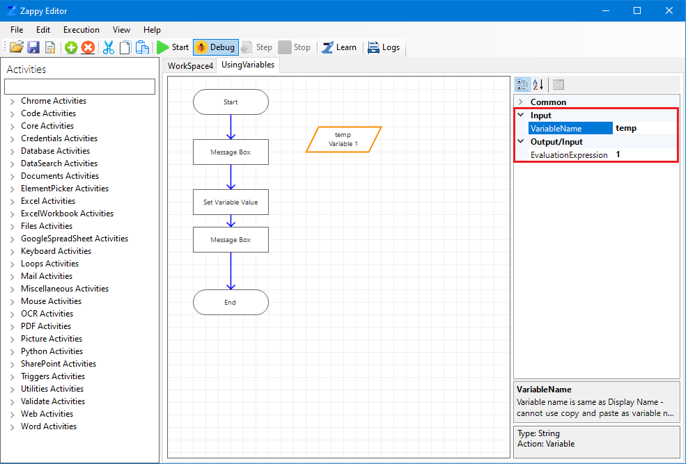

**Step 4:** After clicking on **Message Box** action, click on  in front of **Text** and search for **temp**, then select **EvaluationExpression** and click **OK**.

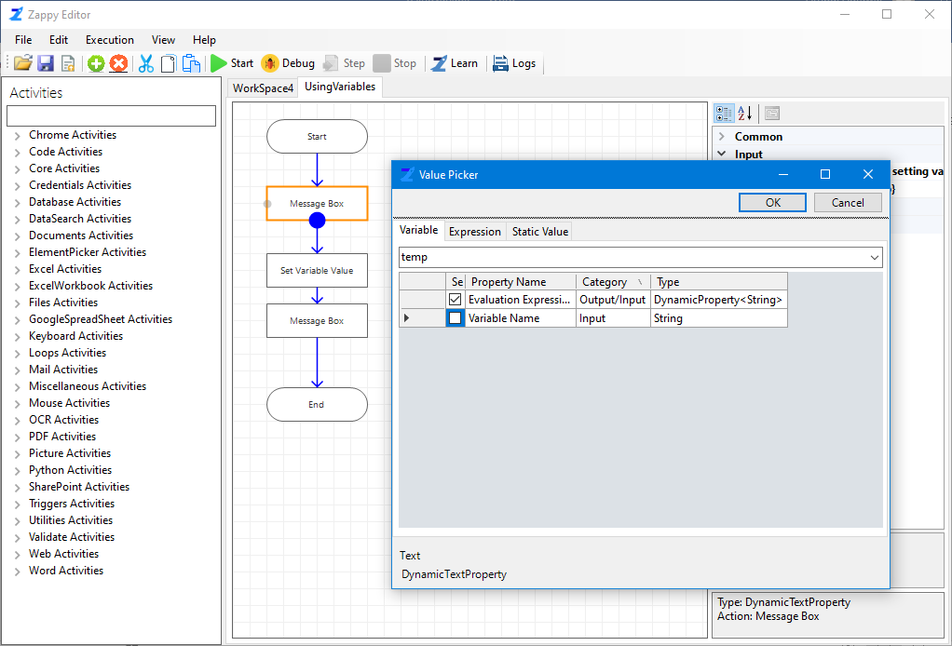

**Step 5:** If you want to change the temp variable value during execution, you have to assign new temp variable value by clicking on **Set Variable Value** and enterring the name of variable in front of **VariableName** and New value for temp variable in front of **VariableValue.**

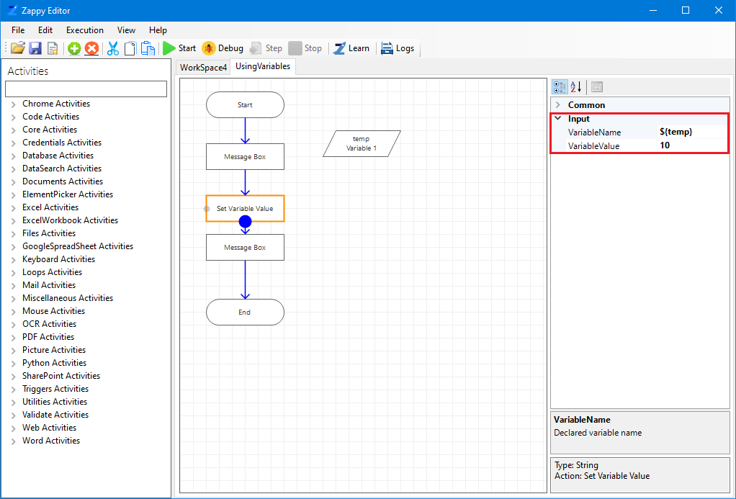

**Step 6:** If you want to see the new value for temp variable, use **Message Box**.

**Step7:** Click on **Start**. During execution we will see message box showing us the initial value of temp variable i.e. **1** and again second Message Box will be displayed showing us the New assigned value for temp variable i.e **10**.

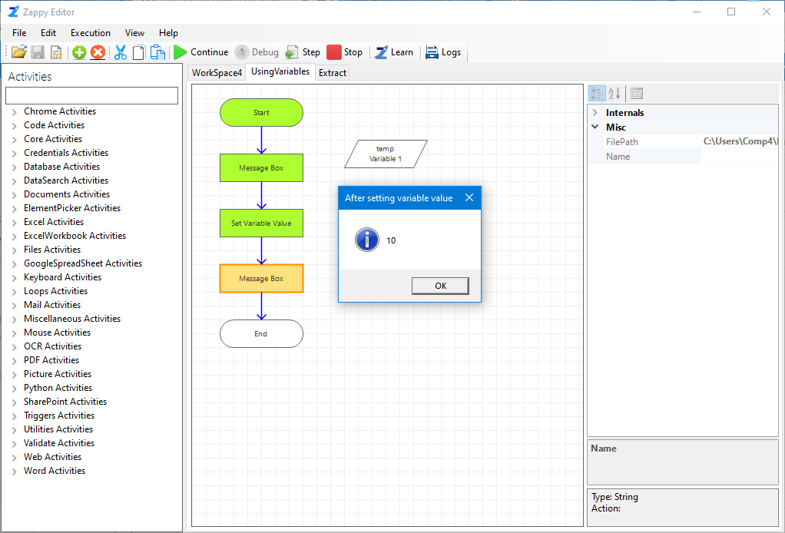

**Step 8:** You can see “**Successfully Executed Task**” message from Zap on successful execution on right bottom corner.