**Merge Multiple PDF**

Combine multiple PDF files into one single PDF document**.**

**Step 1:** Right click on Zap icon at bottom right corner of your window and select **Task Editor** or double click on **Zap** icon.

**Step 2:** Open **mergepdf.zappy** automation.

**Automation:**

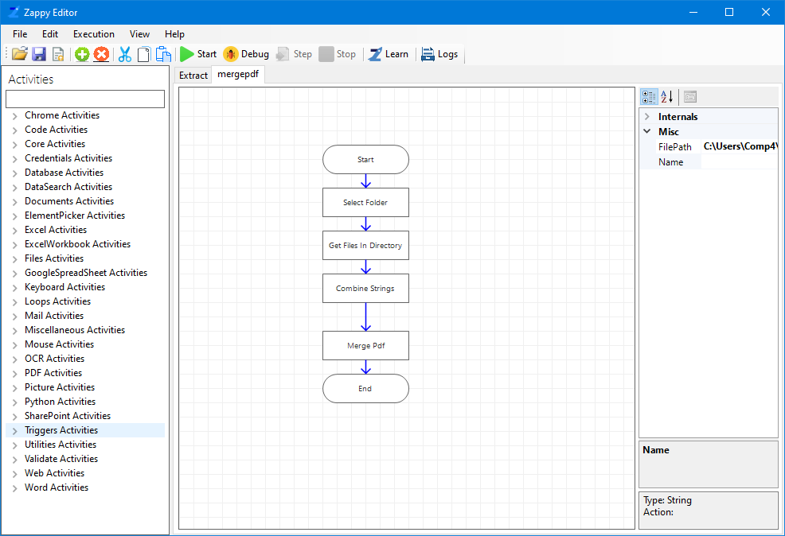

**Step 3:** To start the execution click on Start button on task editor.

**Step 4:** Select the PDF file folder.

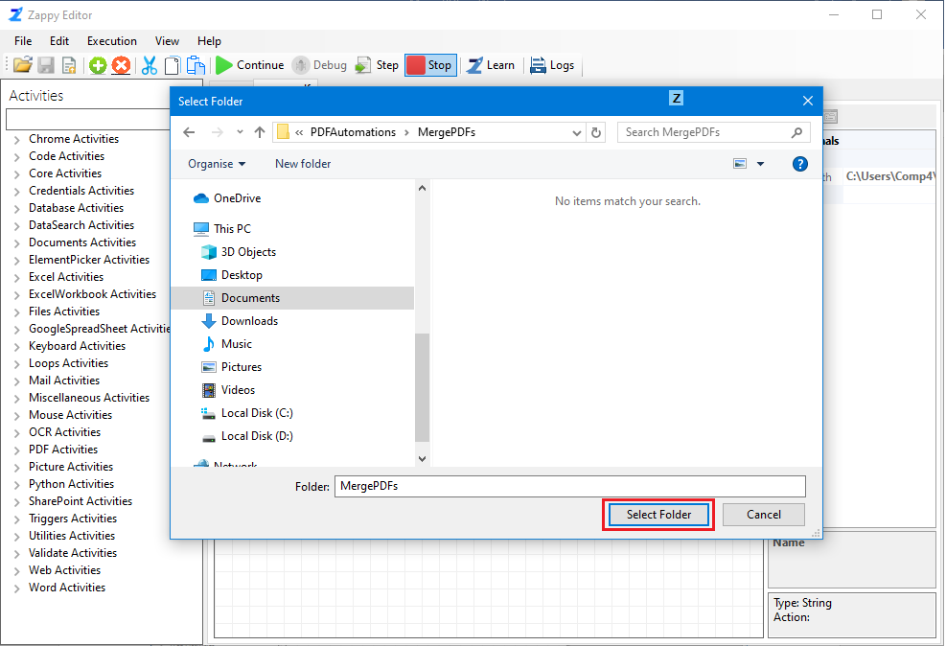

**Step 5:** You can see “**Successfully Executed Task**” message from Zap on successfull execution.

**Output: Merged Pdf file is created in same folder as the all PDF**

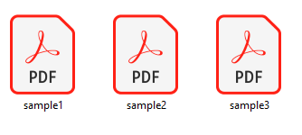 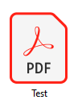

Merged PDF

Sample PDF files

**In this way we can use merged PDF’s automation to merge your pdf files**