## PDF To Word

This document will explain you how to convert PDF document into Word document.

**Step 1:** Double click on **PDFToWord.zappy** automation.

**Step 2:** **Run Zappy Task** window will pop up. Now Click on **OK**.

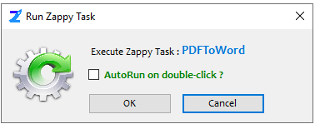

**Step 3:** Zap Automation shows another pop-up window on screen to select pdf document.

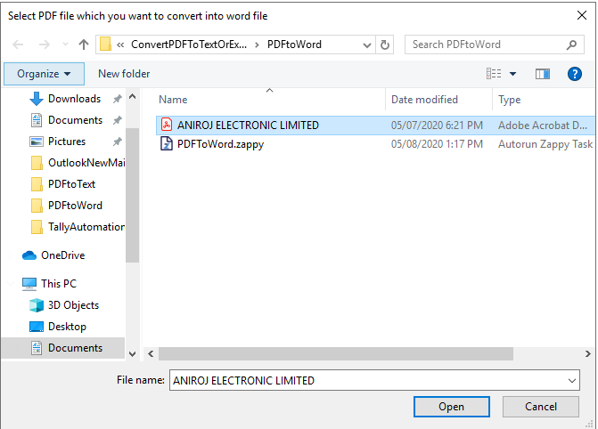

**Step 4:** You can see “**Successfully Executed Task**” at the bottom right corner.

**Output: Zap Automation will save the converted word file in same folder as of PDF.**

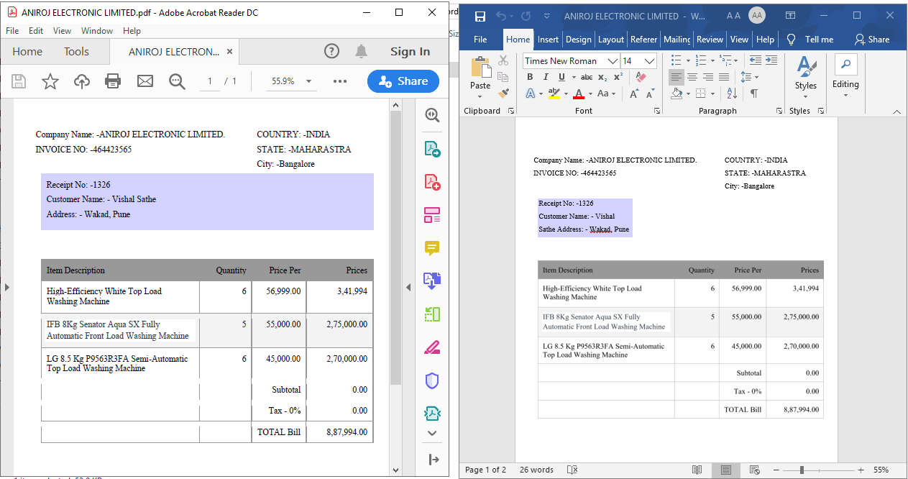

**In this way we can use this automation to convert any pdf document into word document.**