**PDF to Text Conversion using Zappy**

Step 1) User opens **PdfToTextConvertor.zappy** task from saved location and **double clicks** to Execute.

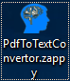

Step2) Zappy shows pop-up window on screen. Now Click on OK.

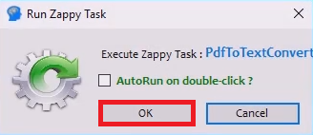

Step 3) Zappy shows another pop-up window on screen. Now Click on Select file.



Step 4) User navigates to the desired location to select the saved PDF file to convert.

then click on “**Open**” as shown in below.

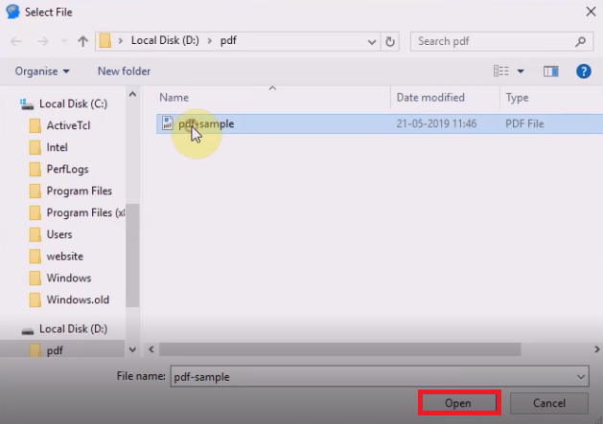

**Step5:** You can see “**Successfully Executed Task**” at bottom corner and also see the converted pdf file to Text file.

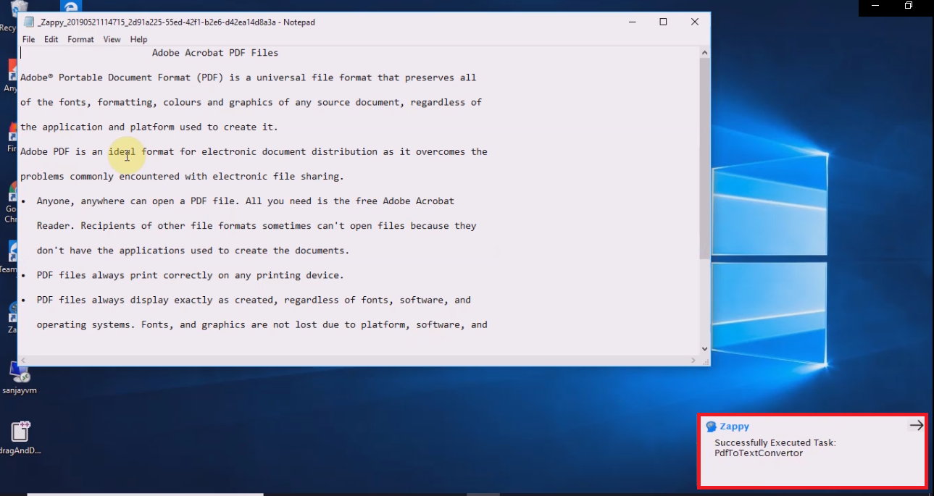

Step 6) You can see Converted Notepad consists exact copy of entire text from PDF file with formatting as shown in the video for reference.

