**Word To PDF Conversion**

This document will explain you, how to convert word documents to PDF.

**Step 1:** Right click on Zap icon at bottom right corner of your window and select **Task Editor** or double click on **Zap** icon.

**Step 2:** Open **wordtopdf.zappy** task file.

**Automation:**

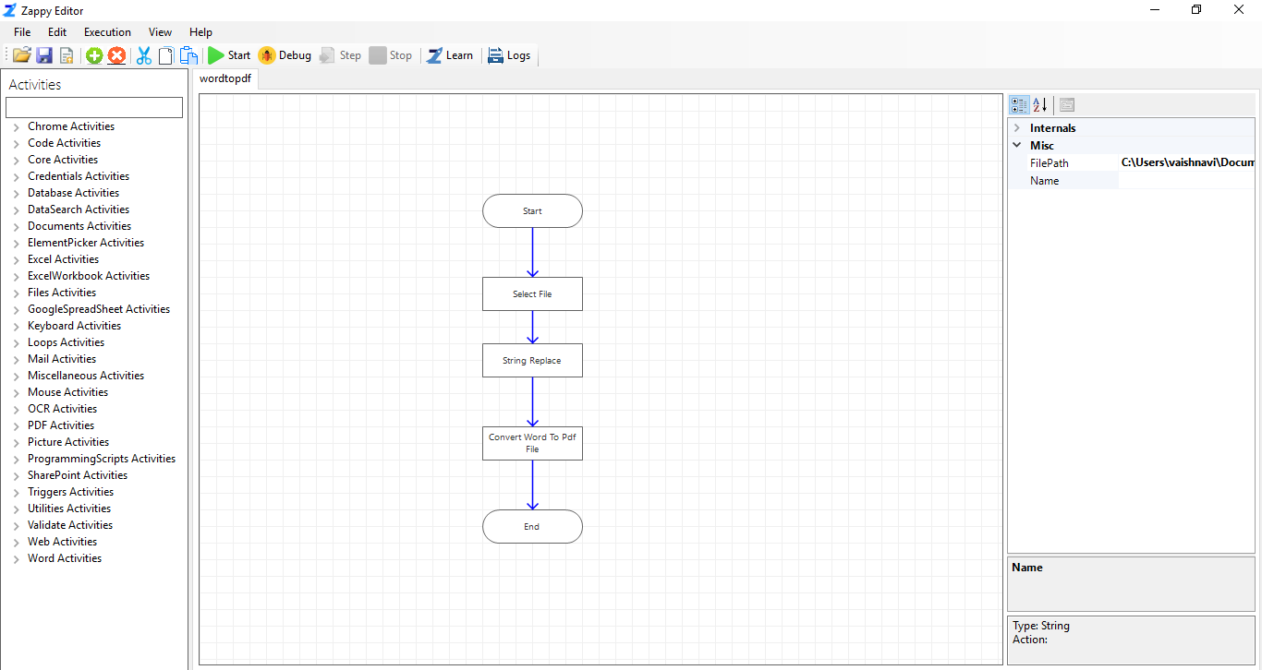

**Step 4:** Click on **Start**. Open file Dialog will pop-up, select the **word document** which user want to convert into PDF file.

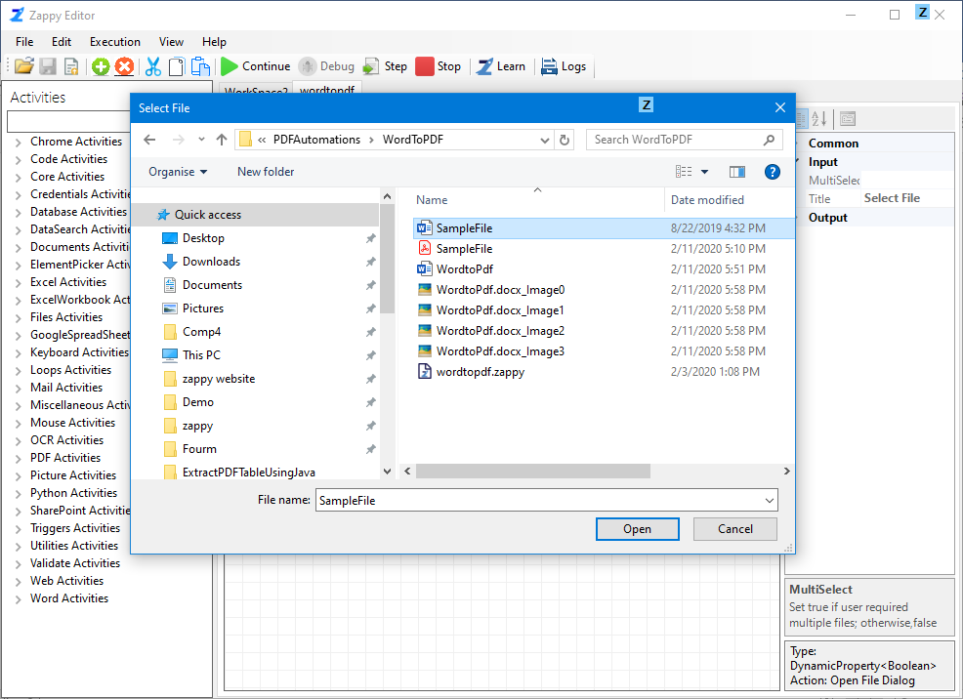

**Output:** In this way you can use **Word to PDF** automation for your file.

