**Exception Handling**

**Exception** is an error event that can happen during the execution of a program and disrupts its normal flow.

In this example we will understand how to handle exception in Zap.

**Step 1:** We will see a grey dot on left hand side of every action, which is used for exception handling.

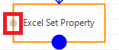

If you want to handle the exception then drag the grey dot and connect it to other action.

Example: We have connected grey dot to **Message Box** as shown below**.**

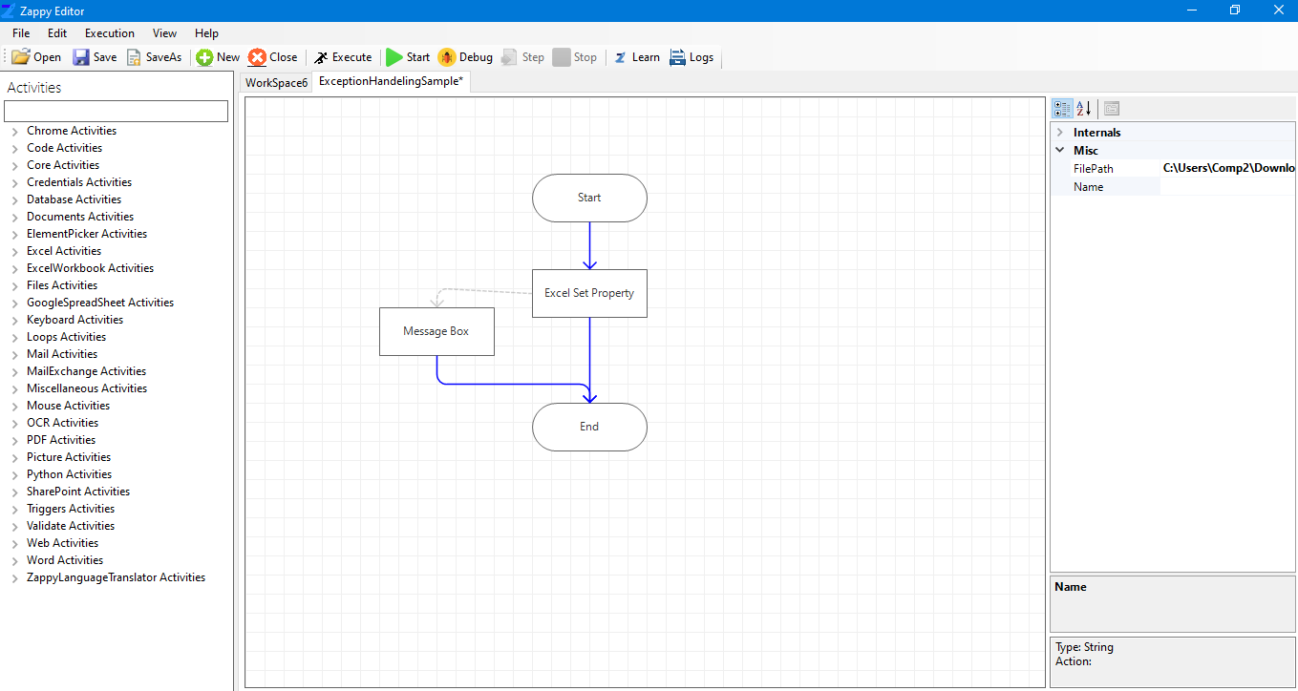

Use grey colour arrow to handle Exception.

**Step 2**: Exception can be handled by using either Message Box or any other action.

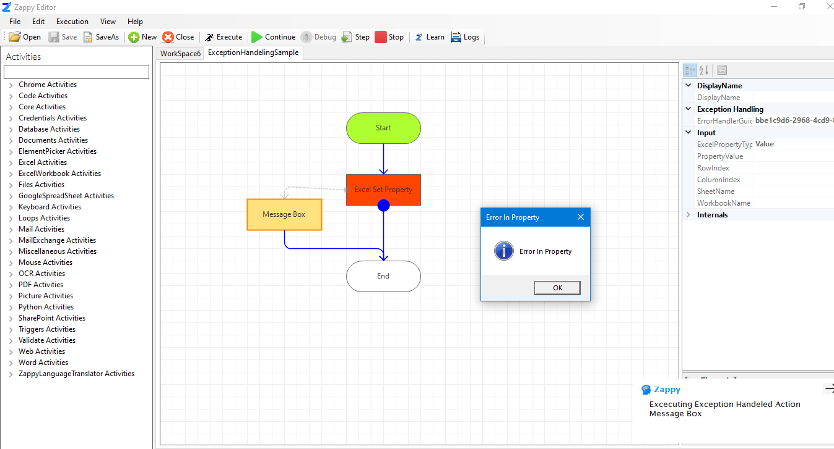

1. Error occurred in this action

3. Message of exception handling

2. Exception handle by using Message Box

**Step 3:** Here we can see automation is executed successfully with **Exception Handling**.

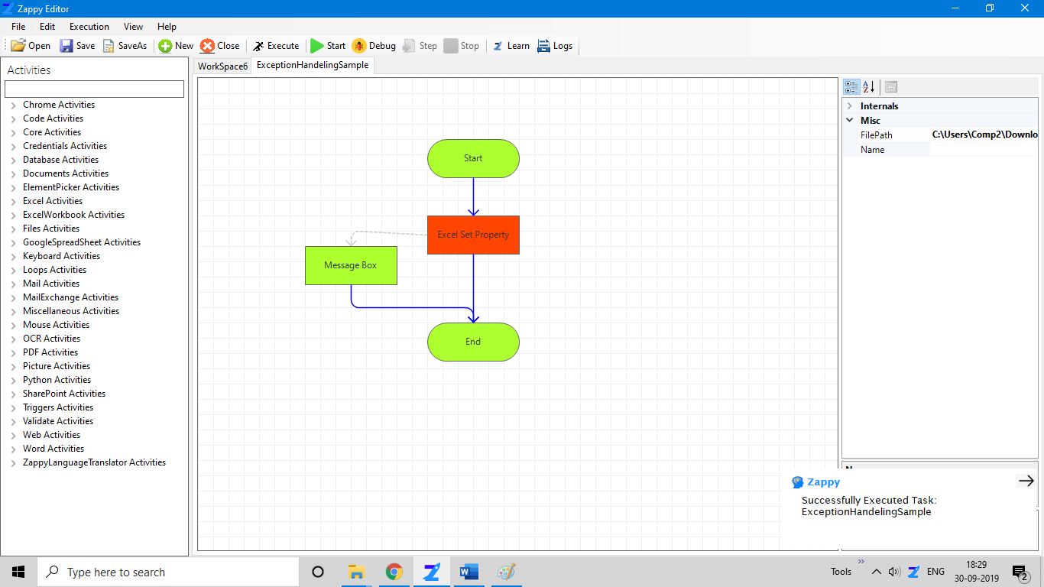

Here we get message **“Successfully Executed Task”**