**Date Time**

Please go through the following steps to run **DateTime.Zappy** file.

**Step 1:** Open **DateTime.Zappy** file.

**Step 2:** Click on **Run Script** action and set the properties.

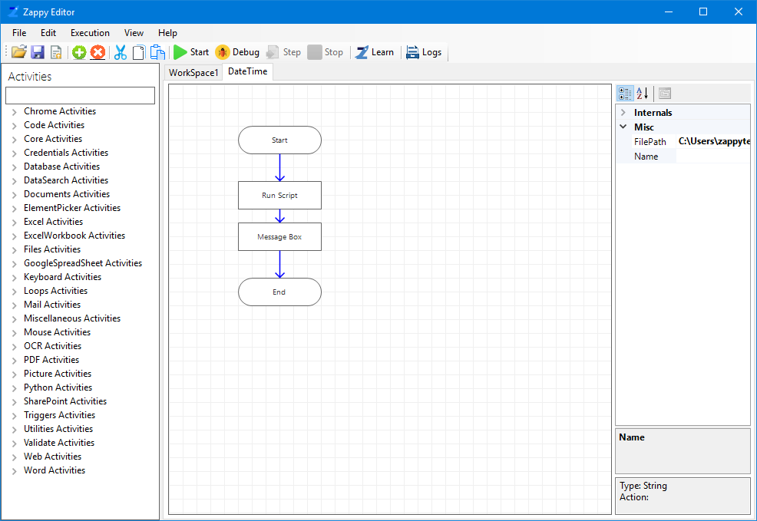

Here input script uses ***lambda Expression***.

It will display current date and time using the following lambda Expression.

lambda Expression- **(context, currentactivity) => {DateTime dt = DateTime.Now; return dt;}**

In Front of Script field click on 3 dots value Picker will open, write the lambda expression in Expression tab as shown below. Click on OK.

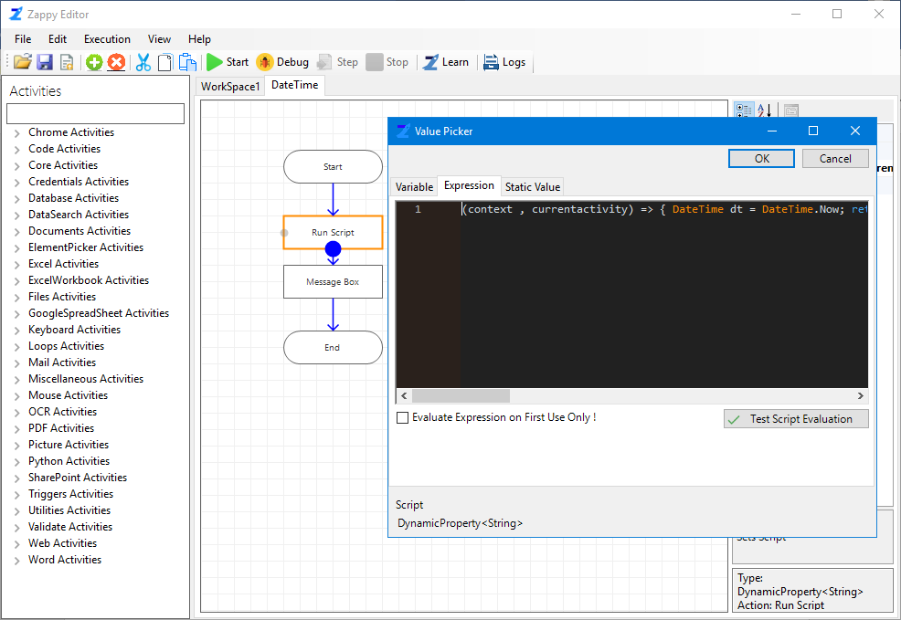

**Step 3:** Select **Message Box** to set properties.

In Text field set the reference of **Run Script** output.

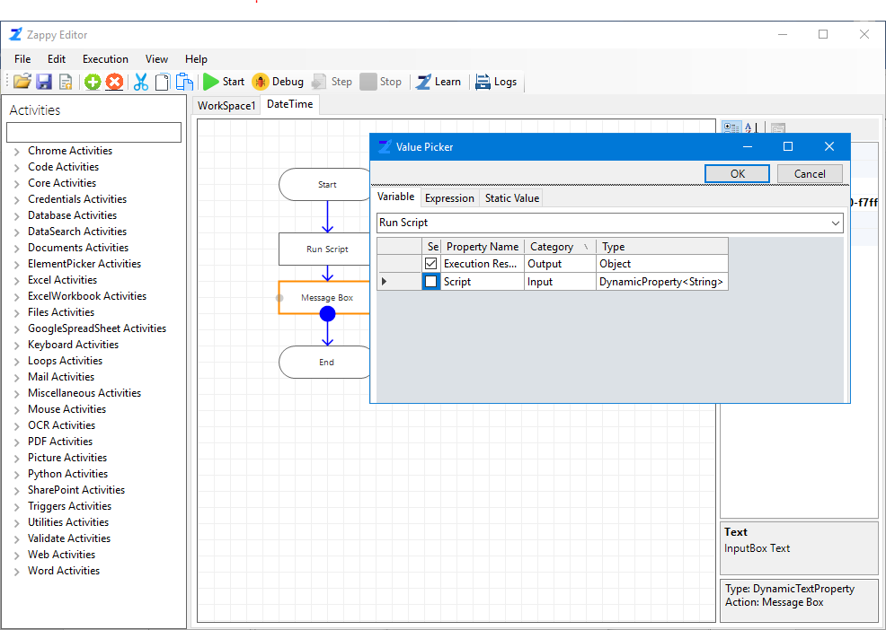

**Step 4:** Click on **Start** torun the automation.

**Step 5:** In the Message box **Current Date and Time** is displayed as shown below. Now Click on **Ok**.

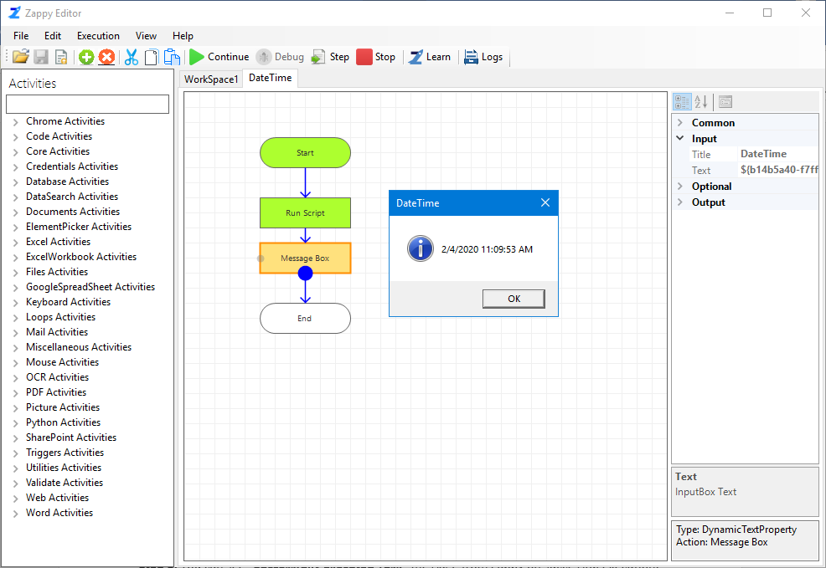

**Step 6:** You can see **“Successfully Executed Task”** message from Zap Automation on successful execution.