**Execute Python Script**

We write the python script for creating text file in ZappySample folder and write some content.

**Python Download Link:** <https://drive.zappy.ai/index.php/s/oVaJESwS0639YZs>

**Step 1:** Write python script and save it.

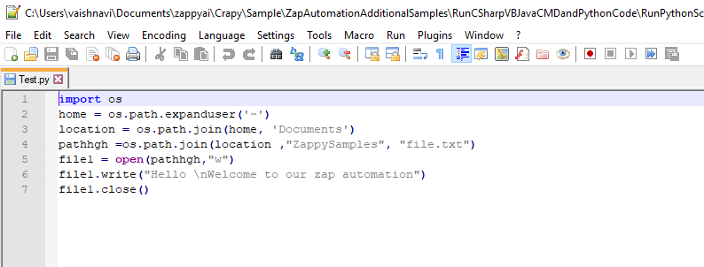

**Note:** Make sure Python path is set in **Environment variable.**

**[ To set Environment variable follow the below steps**

* **Right click on This PC and select properties**

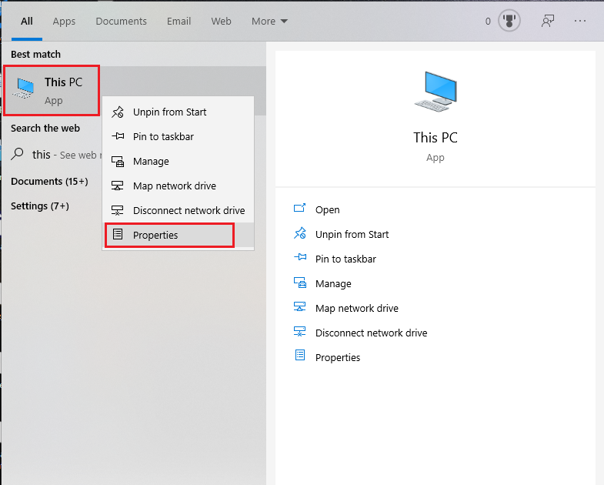

Select properties

Search This PC and perform right click on it

* **Select Advance system settings, system properties window will be pop-up select Advanced from opened window,**

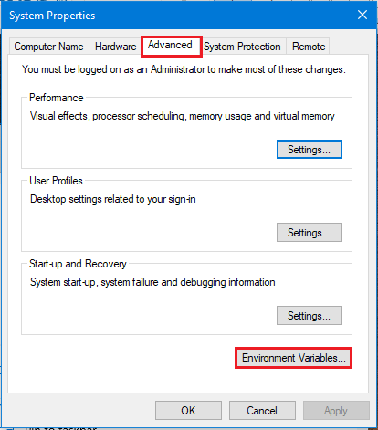

* **Select Path then click on Edit option**

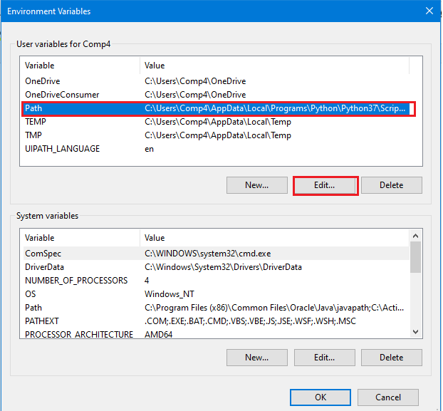

* **Edit Environment Variable window will pop-up, click on New to add the path of python. Python path copy form file explorer and paste here.**

**Step 2:** Double Click on **PythonRunScript.zappy** file.

**Step 3:** Run Zappy Task window will pop up. Click on OK.

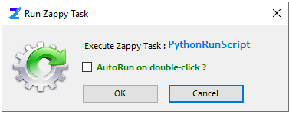

**Step 4:** Enter the Python.exe path in Input Box. Click on OK.

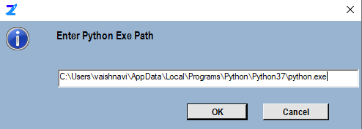

**Step 5:** Select the python script file. Click on Open.

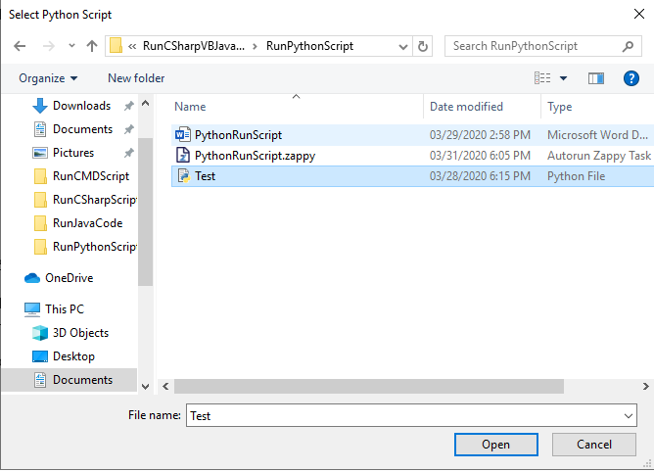

**Output:** Text file is created in ZappySample folder.

