**Execute VB Script.**

**Step 1:** Right click on Zap icon and select Task Editor (or Double click on Zap icon)

**Step 2:** Drag and drop **VB Run Script** Action from Activity Panel. User will see the Activity panel at left side of the Task Editor.

**Step 3**: Click on  in front of **Script** property, then write the **VB Script**.

Make sure **ExecuteMultipleStatements** property is **True**, if you want to execute multiple VB statements.

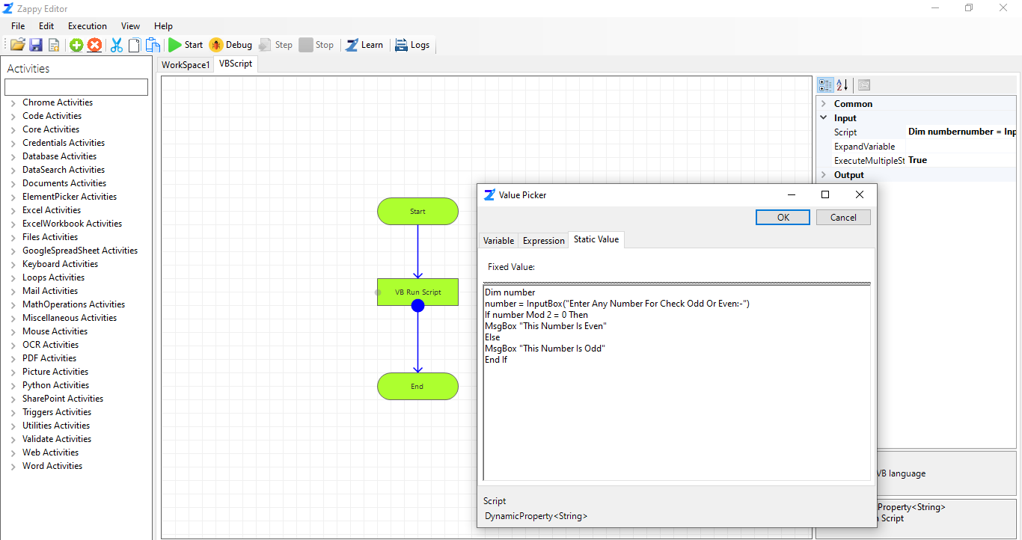

**Step 4**: Then click on **Save** button to save the automation.

**Step 5**: Click on **Start**. You will be able to see the **Output** as shown below.

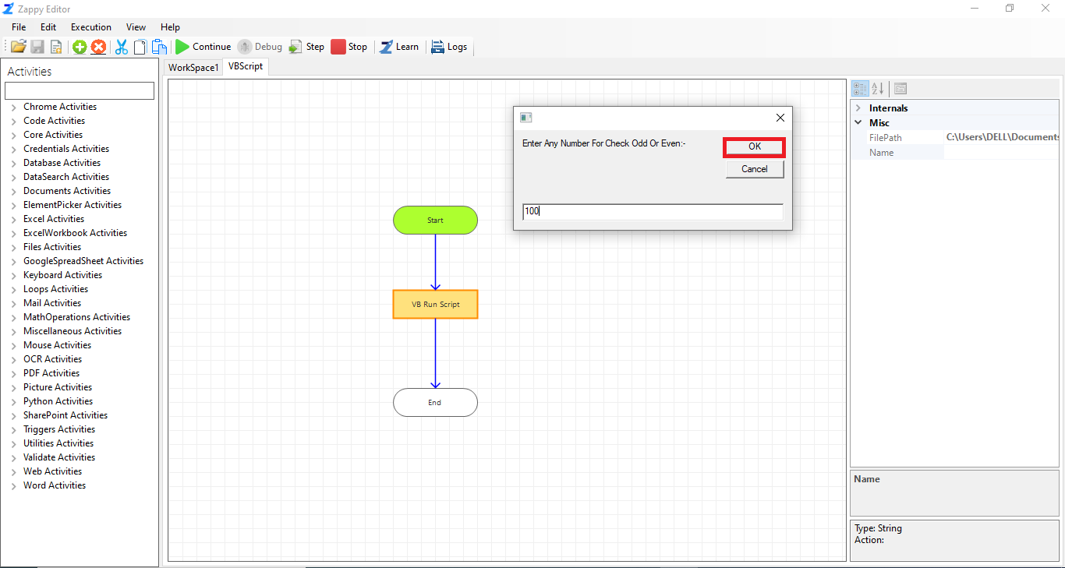 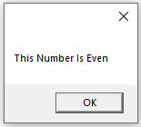

**Likewise, we can write and execute any VB script using Zap.**