Kyle Weekley May 7, 2021

**Node - Final Submission Documentation**

**Game Explanation and Audio Opportunities:**

Node is a “grid-based pipe connection active time battling” game prototype I’ve developed myself over the last few months. While a full version of the game would include an overworld for the player to walk through, the prototype currently focuses on the battle system. The player battles enemies by creating pathways through a grid system of blocks in the bottom half of the screen. An electric pulse runs from left to right at the very bottom of the screen, and energy from this pulse feeds into the player’s pathways, traveling along them. When energy reaches the top of the grid system, it lights up an action orb displaying the properties that the energy inherited from the path it traversed. The player attacks enemies by selecting actions and targeting enemies to deal damage. Different block types allow the player to perform different actions, from elemental attacks to healing.

Node takes place in a machine-filled, somewhat Tron-like world where the entire planet moves to the beat of this ever present pulse. The player is at least part machine, and they’re without allies in a hostile environment. The grid seen in the game’s battles is present as a wrist-mounted device on the player character’s arm.

Node’s battle system allows for a variety of interface sound effects that correspond to player inputs, several one-shot sounds, and a looping music track with dynamic elements tied to the state of the battle.

**Description of Implemented Sounds:**

Interface sounds include picking up, rotating, and placing blocks on the grid, as well as interacting with action orbs. I used quick, simple samples for these as the player will hear them often and in rapid succession.

Sound effects include normal, fire, ice, electric, and healing player actions, enemy attacks, and defeat sounds for the player and enemy. I used slightly longer, realistic samples for the elemental attacks. Healing posed an interesting challenge, and I did some research into other games to learn about what healing tends to sound like. I settled on a series of pleasant-sounding chimes. The enemy’s sounds were made from sections of a sampled power saw or something similar. This might seem a little odd with the way the enemy currently looks (I don’t have much experience with pixel art), but the intent was to portray an “angry” machine that revs up when attacking and slowly spins to a halt when defeated.

I ended up cutting a handful of sounds to reduce audio clutter. These included player and enemy sounds for taking damage, as these overlapped with the sound of the attacks themselves. I also cut a pinging sound that would play whenever a pulse was generated, as I felt that it interfered with the music track, which accomplished the same job by being in rhythm with pulses.

For the music track, I used multiple synths from the Helm plugin in Reaper on top of a collection of drum samples. My goal was to match the track’s BPM to that of pulse generation in-game. In a finished version of Node, different areas would have different pulse speeds and therefore different battle themes, but the current prototype has pulses generated once every 3 seconds or at 20 BPM. I composed the battle theme at 80 BPM so a pulse would generate once every four measures, and I made sure the theme and the pulses synced their start times in-game.

**FMOD Organization, Parameterization, and Mixing:**

I organized my assets into five groups: Battle Music, Interface, Sound Effects, Player, and Enemy. When mixing, I attempted to emphasize interface sounds and sound effects over music, since these sounds give the player helpful feedback on their inputs. The enemy was quite loud, and I went back and forth on how quiet it should become. Since the enemy is harming the player, I wanted the audio to draw the player’s attention to that threat. I ended up adding visual indicators to the start up and follow through of enemy attacks to complement the audio, and I believe this process worked well to convey the meaning behind the enemy’s sounds and a few others across the project.

The battle theme’s dynamic elements are tied to the player’s remaining health as a parameter. At 25% HP, the track’s drums are replaced by a heart beat and a two-tone beeping to indicate that the player is in danger. As their health drops closer to zero, the rest of the track becomes quieter, keeping the heartbeat and beeping in the forefront. The player’s health bar flashes in time with the beeps, which are timed to keep pace with the rest of the track.

I used ReaPitch to alter several sounds. The most obvious of these were on block placement samples. I felt that the “Remove Block” sound should be higher pitched, as the block is being raised off of the grid, while the “Place Block” sound should be lower pitched for the opposite purpose. I also used ReaEQ to remove some popping from the high end of these sounds, which were originally finger snaps. The heartbeat sound also saw a significant use of EQ and reverb changes to give it a low, echoey sound.

**Other Games and Mastering:**

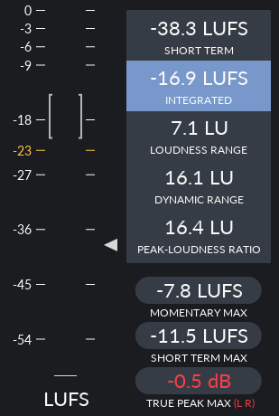

I analyzed two games that inspired Node in different ways. The first of these is the medieval MMO Old School RuneScape (OSRS), which inspired a lot of the grid-based organization and semi-active pacing of combat. I recorded a five minute segment of myself running through a fairly crowded area, with other players fighting monsters, casting spells, and crafting runes. These actions all produce sounds while a music track plays as well.

I noticed that most true peaks came from sound effects layering on top of one another. If four players cast a teleport spell at once, the sounds would compound and become much louder. I know from this class that FMOD can limit the number of simultaneous sounds from a category, which seems like a good solution to this issue. Unfortunately OSRS was made for browsers in 2004, so they likely don’t have access to such technology. The game was fairly loud overall at -16.9 LUFS.

My second game choice is Shin Megami Tensei III: Nocturne, a 3D turn-based RPG about summoning and battling demons. While Node uses a grid and energy paths that are absent from Nocturne, many of the resulting actions that players and enemies utilize are inspired by Nocturne’s battle system. I recorded an eight minute long segment of a boss battle with two phases. Characters make sounds when attacking, moving around the Battle UI produces a sound, and two music tracks (one for each phase) play in the background.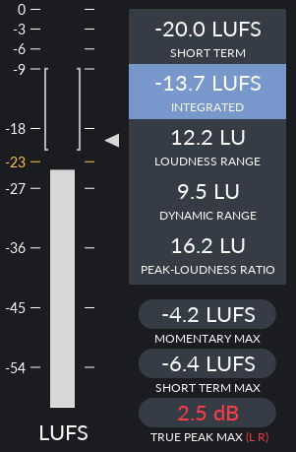

Nocturne heavily favors sound effects over music. When I sat idle and allowed the music to play on its own, the average was below -20 LUFS. Sound effects, however, were quite loud. I like this approach. As I stated earlier, the sound effects communicate information to the player, and for that reason I believe they should be easily heard over the music. The true peak of 2.5 LUFS came from an almighty type attack from the boss that hit everyone in my party. The volume definitely made me feel the power of the attack, but it might be a bit much. Nocturne was even louder than OSRS at -13.7 LUFS.

I aimed for a lower average of -19 LUFS with a focus on sound effects over music. I ended up lowering the levels of most sound groups in FMOD, as Node was closer to -16 LUFS at first. I lowered the volume of the enemy sounds the most, as their occurrence was out of the player’s control and they could smother more important audio information. With the added visuals I mentioned earlier, I still felt that the enemy’s behavior was clear to the player without overpowering other sounds.

**List of Audio Sources:**

**VST Plugins**

Helm - Matt Tytel - [Link](https://tytel.org/helm/)

MT Power Drum Kit 2 - Manda Audio - [Link](https://www.powerdrumkit.com/)

**Freesound Samples**

“Finger-snap-mono-01.wav” - newagesoup - [Link](https://freesound.org/people/newagesoup/sounds/364721/)

“Dbl click.mp3” - 7778 - [Link](https://freesound.org/people/7778/sounds/202312/)

“Wet Click” - Breviceps - [Link](https://freesound.org/people/Breviceps/sounds/448080/)

“Blip Wave” - Breviceps - [Link](https://freesound.org/people/Breviceps/sounds/452998/)

“Eflat-PulseLong.wav” - jessepash - [Link](https://freesound.org/people/jessepash/sounds/167142/)

“17.wav” - adcbicycle - [Link](https://freesound.org/people/adcbicycle/sounds/13921/)

“2.wav” - adcbicycle - [Link](https://freesound.org/people/adcbicycle/sounds/13930/)

“Fire Burning Loop” - midimagician - [Link](https://freesound.org/people/midimagician/sounds/249418/)

“Light woosh.wav” - sophiehall3535 - [Link](https://freesound.org/people/sophiehall3535/sounds/245933/)

“Electric Zap - Electricity” - Wakerone - [Link](https://freesound.org/people/Wakerone/sounds/393067/)

“wind3.wav” - eliasheuinck - [Link](https://freesound.org/people/eliasheuninck/sounds/29532/)

“Ice Cracking Sequence” - GregorQuendel - [Link](https://freesound.org/people/GregorQuendel/sounds/424993/)

“Girl Exhale.wav” - thatkellytrna - [Link](https://freesound.org/people/thatkellytrna/sounds/425781/)

“chime chords.wav” - flombles - [Link](https://freesound.org/people/flombles/sounds/501569/)

“The evil machine” - reklamacja - [Link](https://freesound.org/people/reklamacja/sounds/446157/)

This has been a wonderful class, and I’ve learned so much! I plan to continue work on Node throughout the coming summer and beyond, and I’ll be using everything I’ve learned in 670 and 671 to do so. Thank you, Professor, for teaching these courses, and I wish you the best in your future work outside RIT!