**Experiment No-3**

Date of Performance:

Date of Submission:

**Aim:** To Perform various GIT operations on local and Remote repositories using GIT

Cheat-Sheet

**THEORY :**

**What is GIT?**

By far, the most widely used modern version control system in the world today is Git.

##### Git is a mature, actively maintained open source project originally developed in 2005 by Linus Torvalds, the famous creator of the Linux operating system kernel.A staggering number of software projects rely on Git for version control, including commercial projects as well as open source.Developers who have worked with Git are well represented in the pool of available software development talent and it works well on a wide range of operating systems and IDEs (Integrated Development Environments).Having a distributed architecture, Git is an example of a DVCS (hence Distributed Version Control System).Rather than have only one single place for the full version history of the software as is common in once-popular version control systems like CVS or Subversion (also known as SVN), in Git, every developer's working copy of the code is also a repository that can contain the full history of all changes.

In addition to being distributed, Git has been designed with performance, security and flexibility in mind. Local repositories are physical, locally-managed repositories into which you can deploy artifacts. Using local repositories, Artifactory gives you a central location to store your internal binaries.Through repository replication, you can even share binaries with teams that are located in remote locations.

Remote repository in Git, also called a remote, is a Git repository that's hosted on the Internet or another network.

#### OUTPUT :

***PERFORMING VARIOUS GIT OPERATIONS***

trish@Trishs-MacBook-Air ~ % git init

Reinitialized existing Git repository in /Users/trish/.git/

trish@Trishs-MacBook-Air ~ % git --version

git version 2.39.3 (Apple Git-145)

trish@Trishs-MacBook-Air ~ % git status

warning: could not open directory '.Trash/': Operation not permitted

On branch main

No commits yet

Untracked files:

(use "git add <file>..." to include in what will be committed)

.CFUserTextEncoding

.DS_Store

.IdentityService/

.android/

.bash_history

.cache/

.config/

.cups/

.dart-tool/

.dart/

.dartServer/

.dbclient/

.editor.swp

.emulator_console_auth_token

.flutter

.flutter-devtools/

.gitconfig

.gradle/

.idlerc/

.ipython/

.jupyter/

.keras/

.lesshst

.local/

.matplotlib/

.mono/

.npm/

.oracle_jre_usage/

.pub-cache/

.swiftpm/

.swo

.swp

.templateengine/

.viminfo

.vscode-react-native/

.vscode/

.zprofile

.zsh_history

.zsh_sessions/

.zshrc

Applications/

Calibre Library/

Dark Gathering/

Desktop/

Documents/

Downloads/

Ichigo Mashimaro/

Library/

Movies/

Music/

My project/

Pictures/

Public/

Sakamoto_Days/

animdl/

diet_planner.py

flutter/

gitty/

my/

nltk_data/

node_modules/

package-lock.json

package.json

nothing added to commit but untracked files present (use "git add" to track)

trish@Trishs-MacBook-Air ~ %

trish@Trishs-MacBook-Air gitty % git config --global user.name "TrishankV"

trish@Trishs-MacBook-Air gitty % git config --global user.email tvashikar@gmail.com

trish@Trishs-MacBook-Air gitty % git config --global --list

user.name=TrishankV

[user.email=tvashikar@gmail.com](mailto:user.email=tvashikar@gmail.com)

trish@Trishs-MacBook-Air gitties % git init

Reinitialized existing Git repository in /Users/trish/gitty/gitties/.git/

trish@Trishs-MacBook-Air gitties % git status

On branch main

Untracked files:

(use "git add <file>..." to include in what will be committed)

.DS_Store

TriviaQuiz/

nothing added to commit but untracked files present (use "git add" to track)

rish@Trishs-MacBook-Air gitties % git add sepm2.docx

fatal: pathspec 'sepm2.docx' did not match any files

trish@Trishs-MacBook-Air gitties % git add sepm2.docx

trish@Trishs-MacBook-Air gitties % git status

On branch main

Changes to be committed:

(use "git restore --staged <file>..." to unstage)

new file: sepm2.docx

Untracked files:

(use "git add <file>..." to include in what will be committed)

.DS_Store

TriviaQuiz/

trish@Trishs-MacBook-Air gitties % git commit -m 'SEPM file commited'

[main c8aeb3c] SEPM file commited

1 file changed, 0 insertions(+), 0 deletions(-)

create mode 100644 sepm2.docx

trish@Trishs-MacBook-Air gitties % git status

On branch main

Untracked files:

(use "git add <file>..." to include in what will be committed)

.DS_Store

TriviaQuiz/

nothing added to commit but untracked files present (use "git add" to track)

trish@Trishs-MacBook-Air gitties % git add exp1.docx

fatal: pathspec 'exp1.docx' did not match any files

trish@Trishs-MacBook-Air gitties % git add sepm1.docx

trish@Trishs-MacBook-Air gitties % git status

On branch main

Changes to be committed:

(use "git restore --staged <file>..." to unstage)

new file: sepm1.docx

Untracked files:

(use "git add <file>..." to include in what will be committed)

.DS_Store

TriviaQuiz/

trish@Trishs-MacBook-Air gitties % git commit -m 'SEPM 1 file commited'

[main a91a19e] SEPM 1 file commited

1 file changed, 0 insertions(+), 0 deletions(-)

create mode 100644 sepm1.docx

trish@Trishs-MacBook-Air gitties % git status

On branch main

Untracked files:

(use "git add <file>..." to include in what will be committed)

.DS_Store

TriviaQuiz/

nothing added to commit but untracked files present (use "git add" to track)

trish@Trishs-MacBook-Air gitties % git log

commit a91a19eb670f7a4a93b3660a3808d58ae7fc40e2 (**HEAD -> main**)

Author: TrishankV <tvashikar@gmail.com>

Date: Fri Jan 26 17:06:57 2024 +0530

SEPM 1 file commited

commit c8aeb3c8feb7dd31b8b6360e71636081ba482814

Author: TrishankV <tvashikar@gmail.com>

Date: Fri Jan 26 17:04:14 2024 +0530

SEPM file commited

commit a91a19eb670f7a4a93b3660a3808d58ae7fc40e2 (**HEAD -> main**)

Author: TrishankV <tvashikar@gmail.com>

Date: Fri Jan 26 17:06:57 2024 +0530

SEPM 1 file commited

commit c8aeb3c8feb7dd31b8b6360e71636081ba482814

Author: TrishankV <tvashikar@gmail.com>

Date: Fri Jan 26 17:04:14 2024 +0530

SEPM file commited

trish@Trishs-MacBook-Air gitties % git log --oneline

a91a19e (**HEAD -> main**) SEPM 1 file commited

c8aeb3c SEPM file commited

c469495 Commit

a6cb554 (**temp/main**, **temp**) Express Commit

5a5ddbd Express Commit

804b34c (**origin/main**) Initial commit

trish@Trishs-MacBook-Air gitties % git log --oneline sepm2.docx

c8aeb3c SEPM file commited

trish@Trishs-MacBook-Air gitties % git remote add origin https://github.com/TrishankV/Sem-6/Sepm.git

error: remote origin already exists.

trish@Trishs-MacBook-Air gitties % git remote show origin

* remote origin

Fetch URL: https://github.com/TrishankV/Sem-6.git

Push URL: https://github.com/TrishankV/Sem-6.git

HEAD branch: main

Remote branch:

main tracked

Local ref configured for 'git push':

main pushes to main (fast-forwardable)

trish@Trishs-MacBook-Air gitties % git push -u origin main

Enumerating objects: 10, done.

Counting objects: 100% (10/10), done.

Delta compression using up to 8 threads

Compressing objects: 100% (8/8), done.

Writing objects: 100% (9/9), 779.06 KiB | 22.26 MiB/s, done.

Total 9 (delta 2), reused 0 (delta 0), pack-reused 0

remote: Resolving deltas: 100% (2/2), done.

To https://github.com/TrishankV/Sem-6.git

a6cb554..a91a19e main -> main

branch 'main' set up to track 'origin/main'.

trish@Trishs-MacBook-Air gitties % git pull remote

fatal: 'remote' does not appear to be a git repository

fatal: Could not read from remote repository.

Please make sure you have the correct access rights

and the repository exists.

trish@Trishs-MacBook-Air gitties % git pull

Already up to date.

trish@Trishs-MacBook-Air gitties % git fetch

trish@Trishs-MacBook-Air gitties % git merge origin/main

Already up to date.

trish@Trishs-MacBook-Air gitties % git log --oneline

a91a19e (**HEAD -> main**, **origin/main**) SEPM 1 file commited

c8aeb3c SEPM file commited

c469495 Commit

a6cb554 (**temp/main**, **temp**) Express Commit

5a5ddbd Express Commit

804b34c Initial commit

***PERFORMING VARIOUS GIT OPERATIONS USING GIT CHEAT SHEET***

Setup:

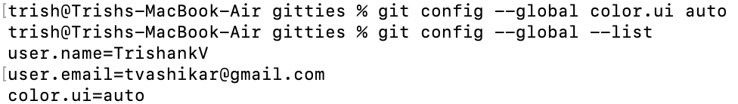

Setup & Init:

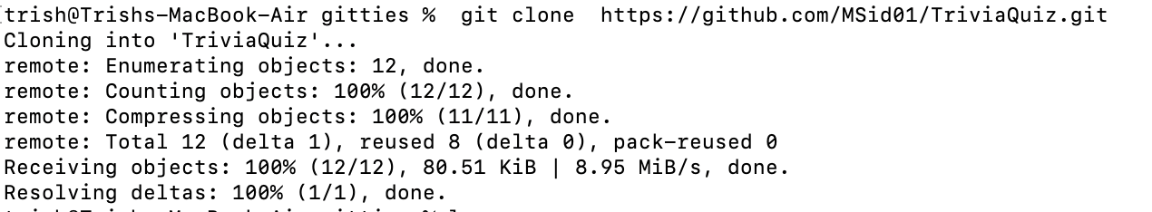

Stage & Snapshot:

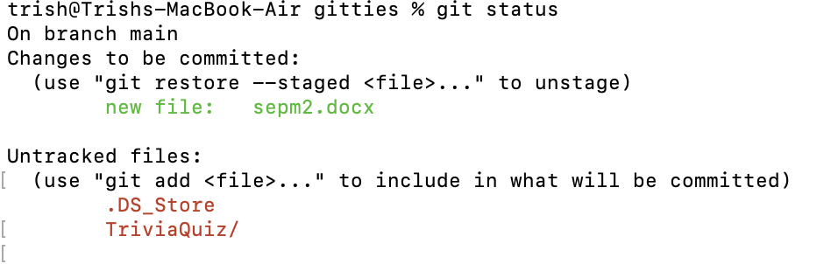





Branch & Merge



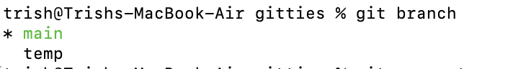



Inspect & Compare:

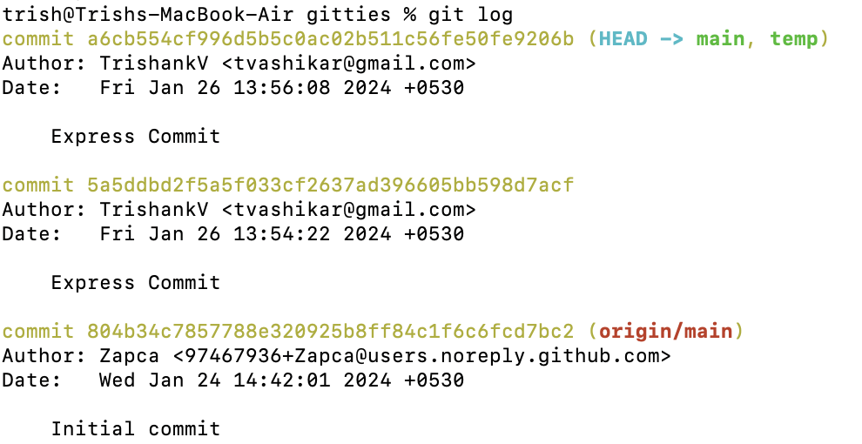

Tracking Path Changes:



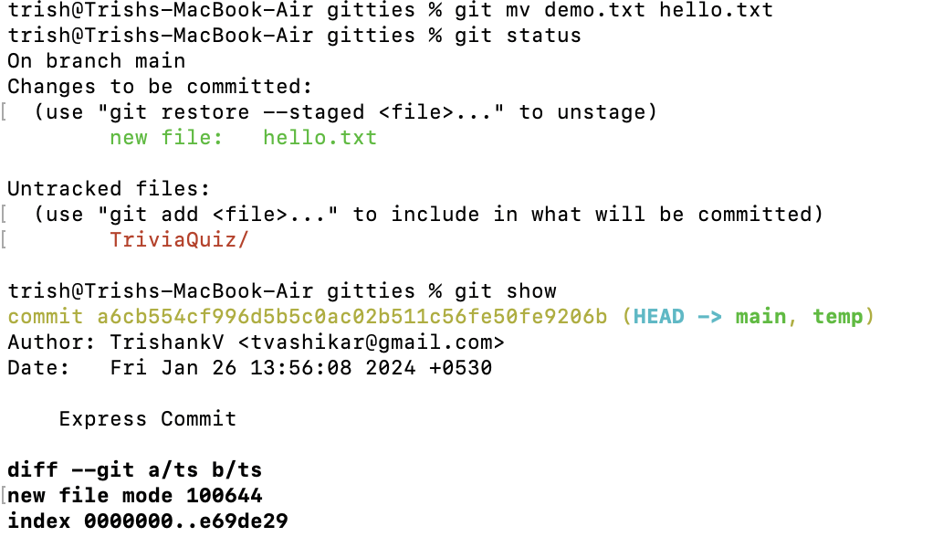

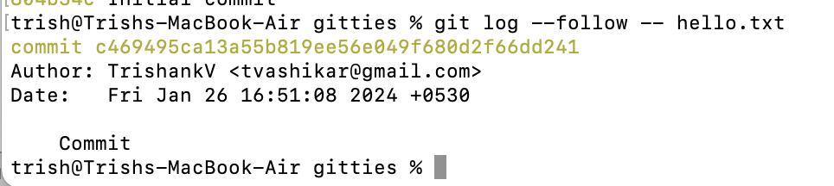



Share and Update:

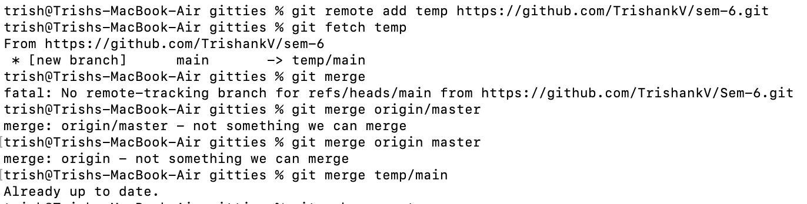

Rewrite History

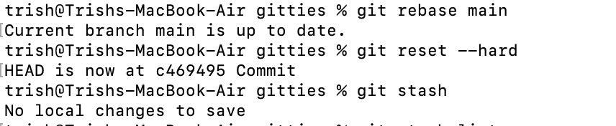

Temporary Commits

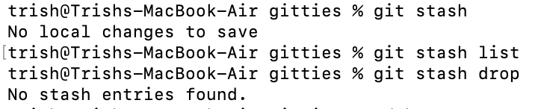

**CONCLUSION :** HENCE VARIOUS GIT OPERATIONS IN LOCAL AND REMOTE REPOSITORIES USING GIT CHEAT SHEET WERE SUCCESSFULLY STUDIED AND IMPLEMENTED.

**SIGN AND REMARK:**

**DATE:**

|  |  |  |  |  |
| --- | --- | --- | --- | --- |
| **R1 (3 Marks)** | **R2 (5 Marks)** | **R3 (4 Marks)** | **R4 (3 Marks)** | **Total (15 Marks)** |
|  |  |  |  |  |