Threshold = 0

1. 总体模型

重要性矩阵

Feature Gain Cover Frequency Importance

1: stock 0.46996059 0.43379216 0.30904519 0.46996059

2: sales 0.21149146 0.25136832 0.29692039 0.21149146

3: receipt 0.17345612 0.14853846 0.27154356 0.17345612

4: product 0.10543004 0.13718884 0.05841294 0.10543004

5: store 0.03966179 0.02911222 0.06407792 0.03966179

重要性图

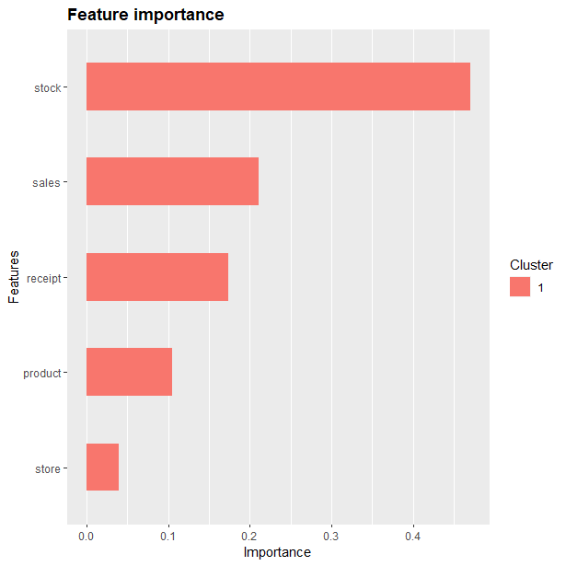

准确率

0.7099483

混淆矩阵

Reference

Prediction 0 1

0 546 206

1 243 553

Sensitivity Specificity Pos Pred Value Neg Pred Value

0.6920152 0.7285903 0.7260638 0.6947236

Precision Recall F1 Prevalence

0.7260638 0.6920152 0.7086308 0.5096899

Detection Rate Detection Prevalence Balanced Accuracy

0.3527132 0.4857881 0.7103027

混淆矩阵图

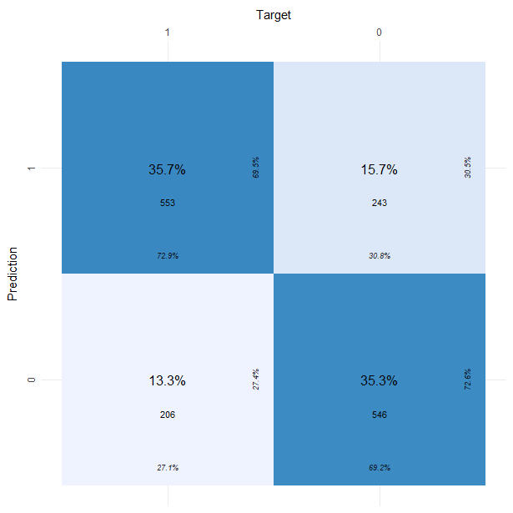

训练集ROC

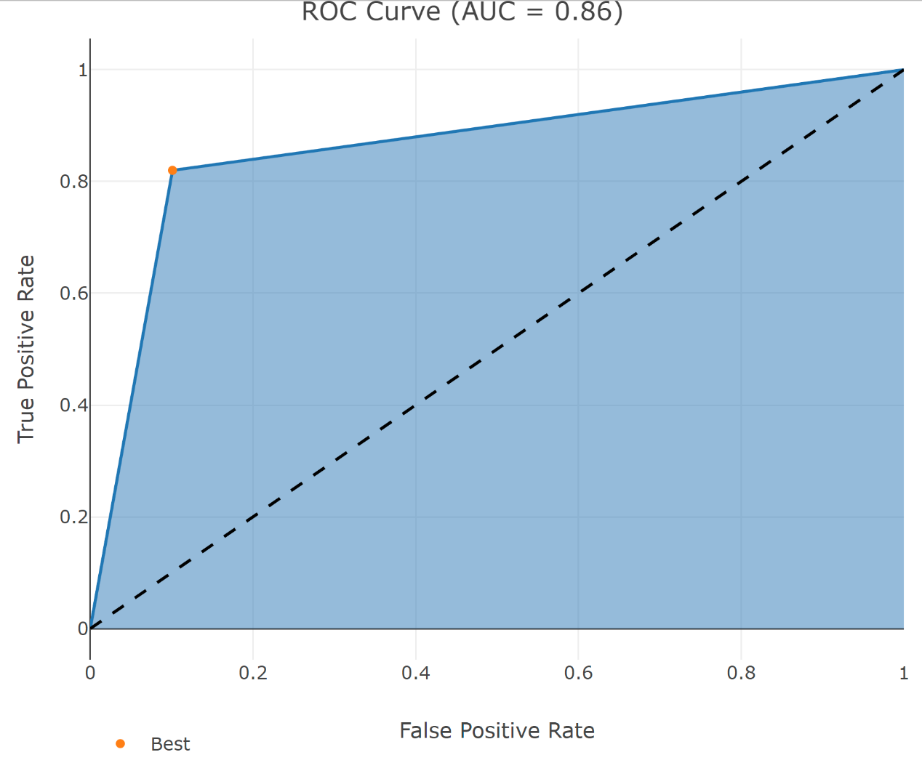

测试集ROC

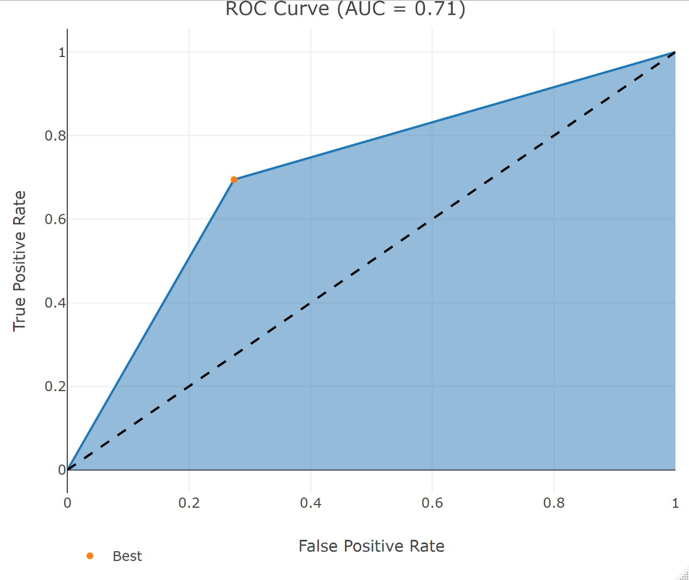

1. 番茄

重要性矩阵

Feature Gain Cover Frequency Importance

1: stock 0.4248877 0.4444322 0.3481637 0.4248877

2: sales 0.2952843 0.3096335 0.3333333 0.2952843

3: receipt 0.2798280 0.2459343 0.3185029 0.2798280

重要性图

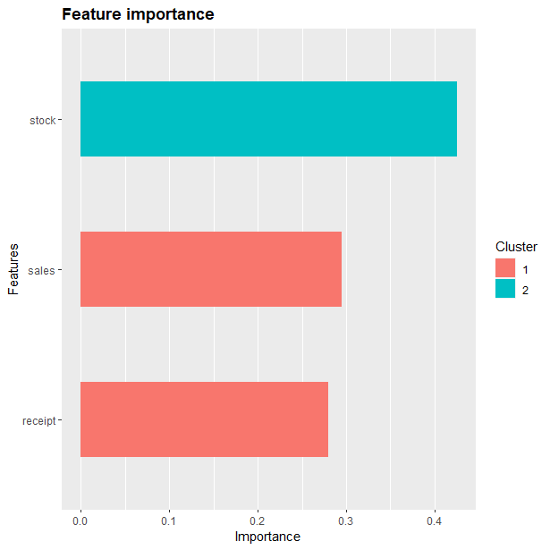

准确率

0.6708075

混淆矩阵

Reference

Prediction 0 1

0 25 83

1 23 191

Sensitivity Specificity Pos Pred Value Neg Pred Value

0.52083333 0.69708029 0.23148148 0.89252336

Precision Recall F1 Prevalence

0.23148148 0.52083333 0.32051282 0.14906832

Detection Rate Detection Prevalence Balanced Accuracy

0.07763975 0.33540373 0.60895681

混淆矩阵图

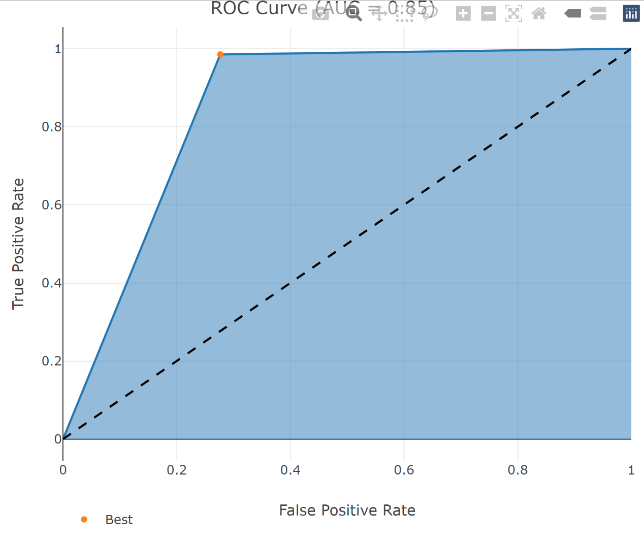

训练集ROC

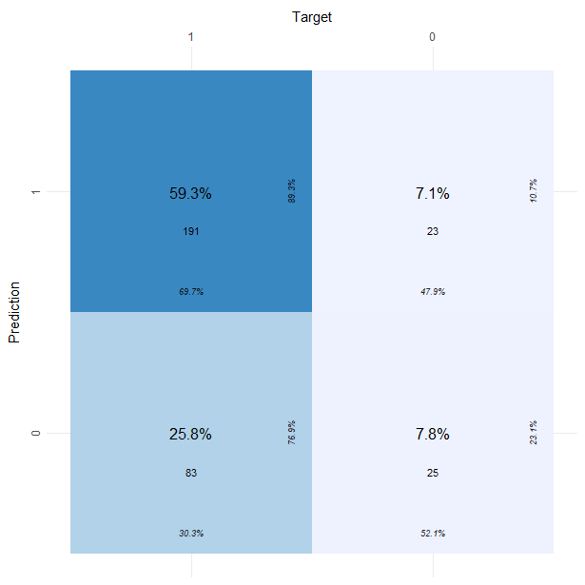

测试集ROC

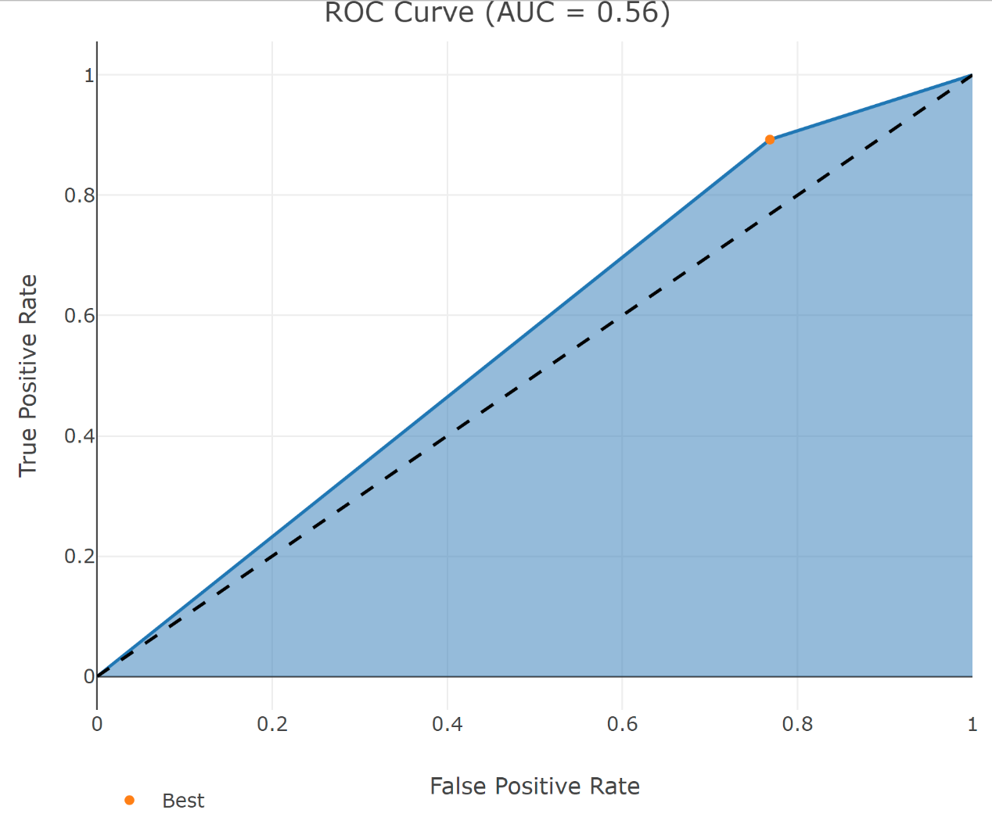

1. 胡萝卜

重要性矩阵

Feature Gain Cover Frequency Importance

1: stock 0.5124304 0.4809008 0.3652802 0.5124304

2: sales 0.2579226 0.3003130 0.3355705 0.2579226

3: receipt 0.2296470 0.2187862 0.2991493 0.2296470

重要性图

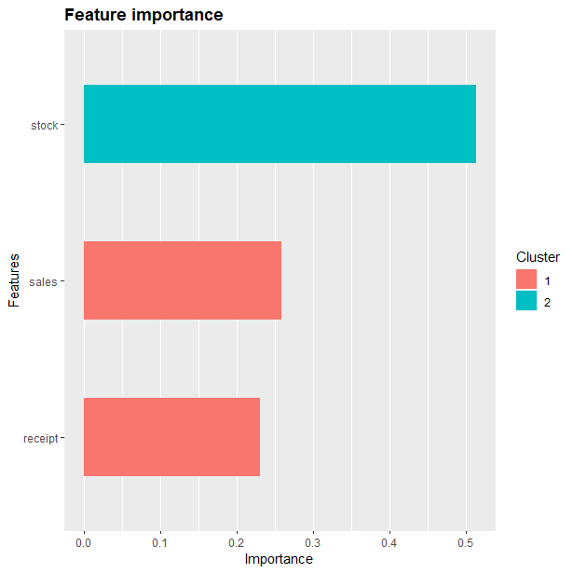

准确率

0.6503268

混淆矩阵

Reference

Prediction 0 1

0 91 50

1 57 108

Sensitivity Specificity Pos Pred Value Neg Pred Value

0.6148649 0.6835443 0.6453901 0.6545455

Precision Recall F1 Prevalence

0.6453901 0.6148649 0.6297578 0.4836601

Detection Rate Detection Prevalence Balanced Accuracy

0.2973856 0.4607843 0.6492046

混淆矩阵图

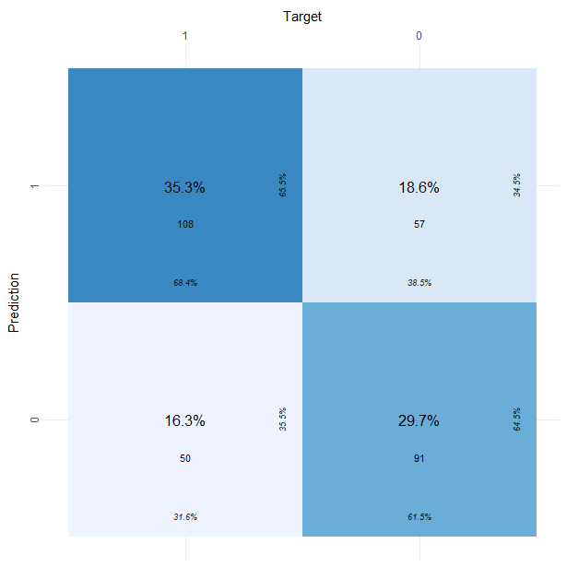

训练集ROC

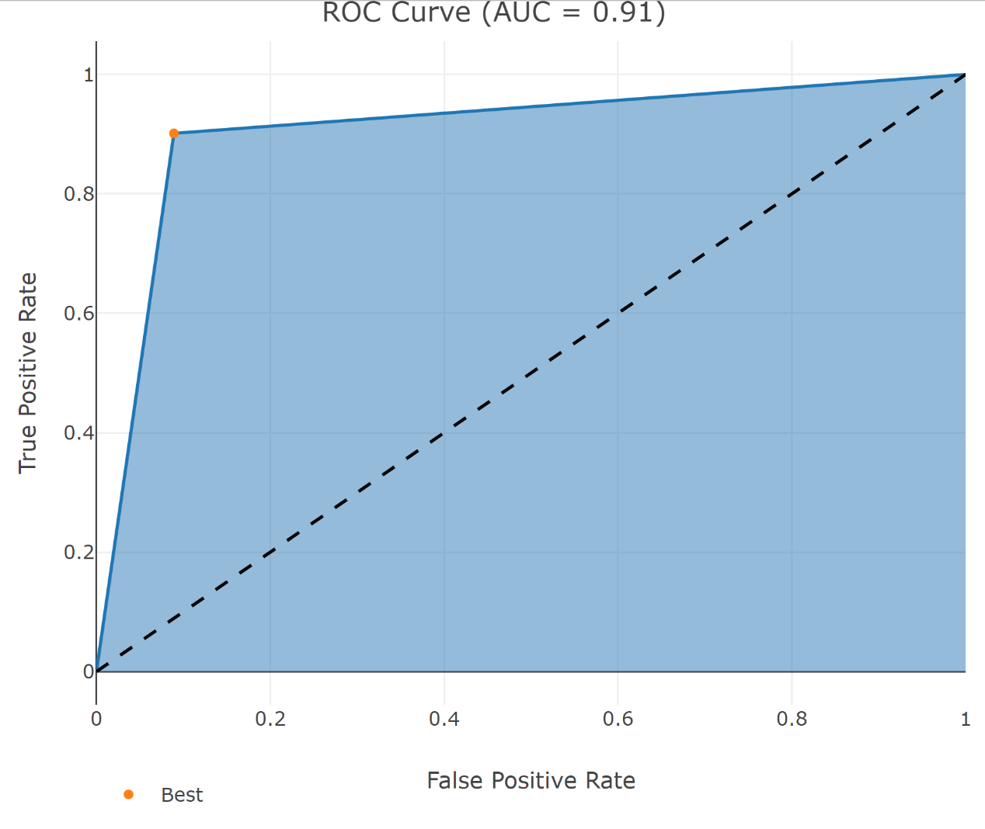

测试集ROC

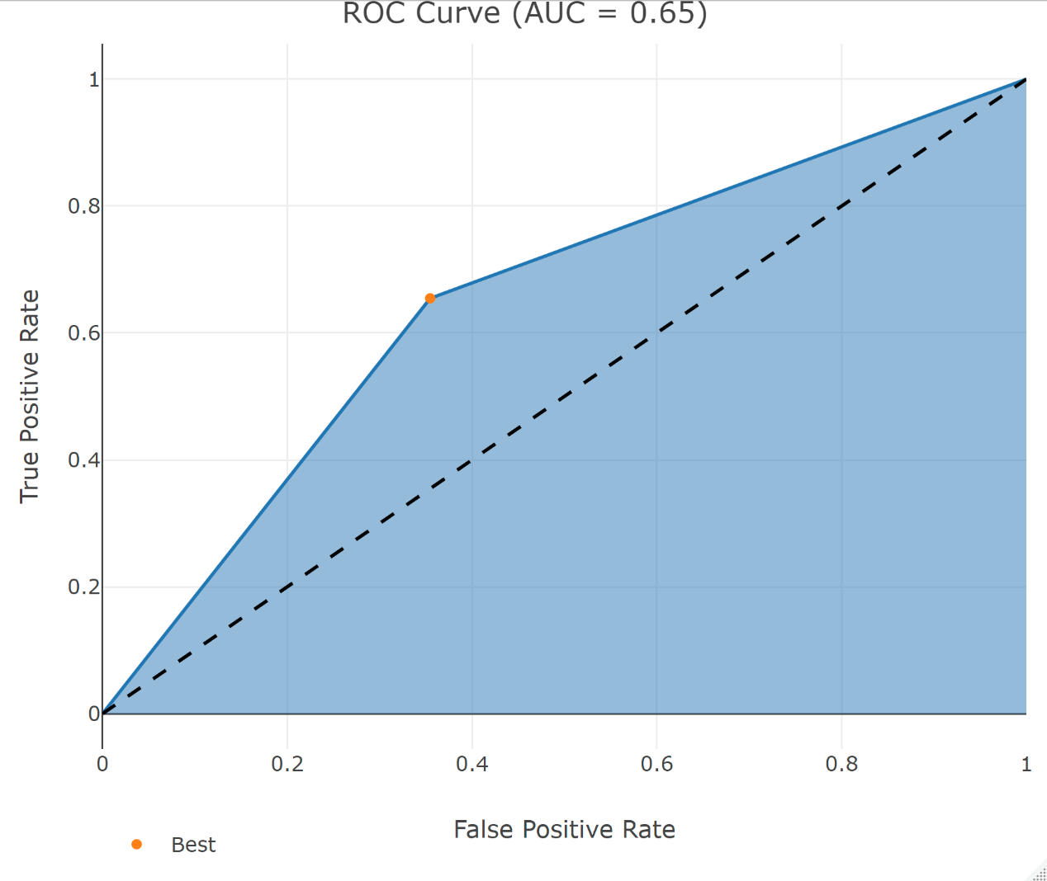

1. 山药

重要性矩阵

Feature Gain Cover Frequency Importance

1: stock 0.5060264 0.4703427 0.3728950 0.5060264

2: sales 0.2567513 0.2809783 0.3111619 0.2567513

3: receipt 0.2372223 0.2486790 0.3159431 0.2372223

重要性图

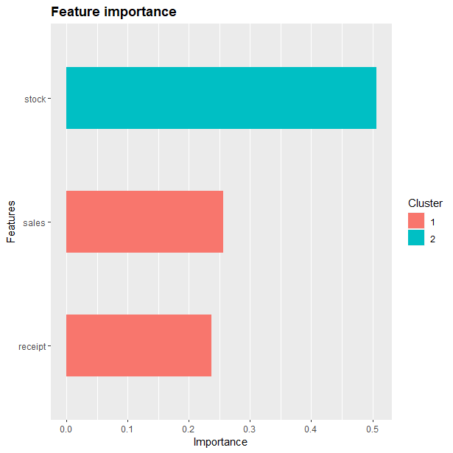

准确率

0.7192429

混淆矩阵

Reference

Prediction 0 1

0 119 35

1 54 109

Sensitivity Specificity Pos Pred Value Neg Pred Value

0.6878613 0.7569444 0.7727273 0.6687117

Precision Recall F1 Prevalence

0.7727273 0.6878613 0.7278287 0.5457413

Detection Rate Detection Prevalence Balanced Accuracy

0.3753943 0.4858044 0.7224029

混淆矩阵图

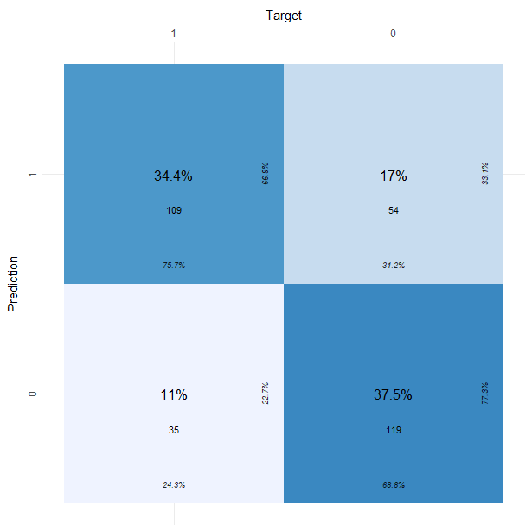

训练集ROC

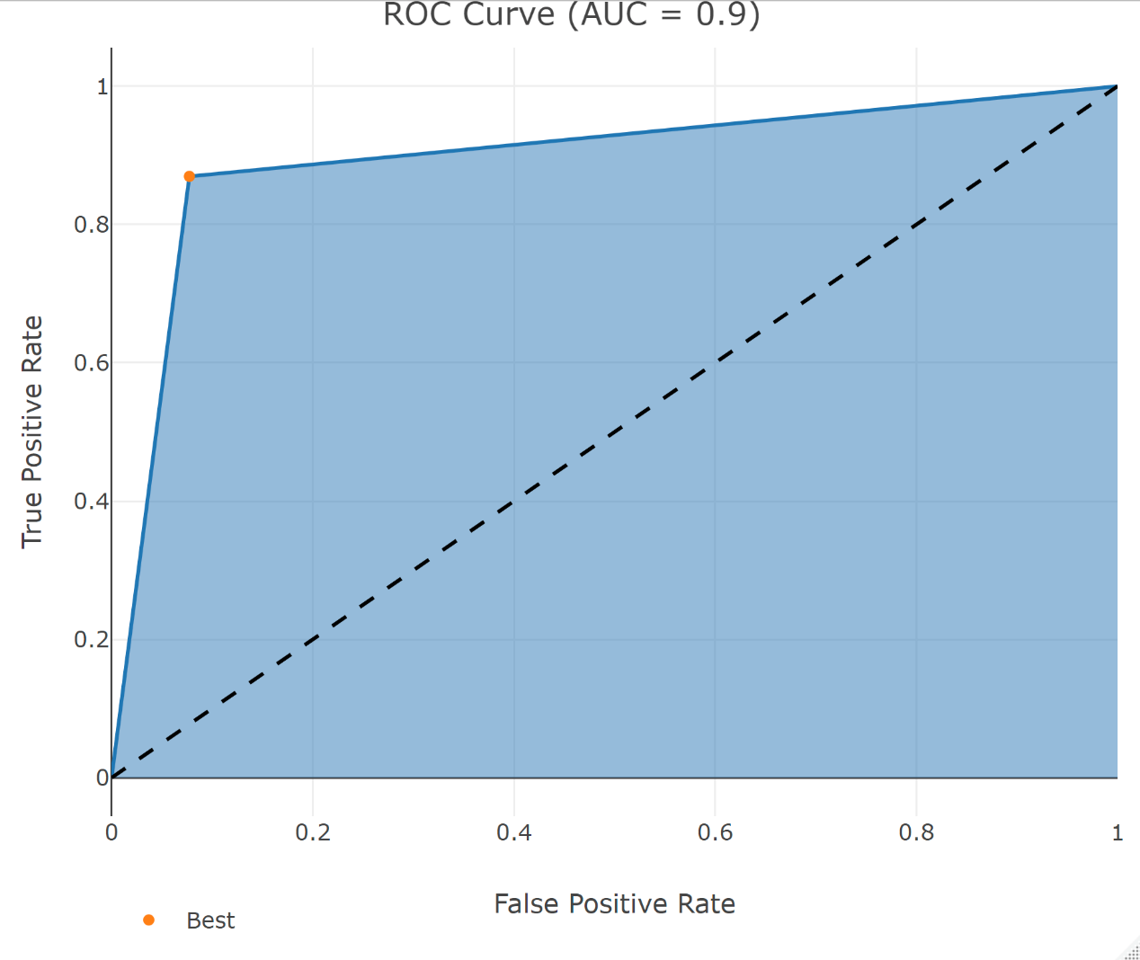

测试集ROC

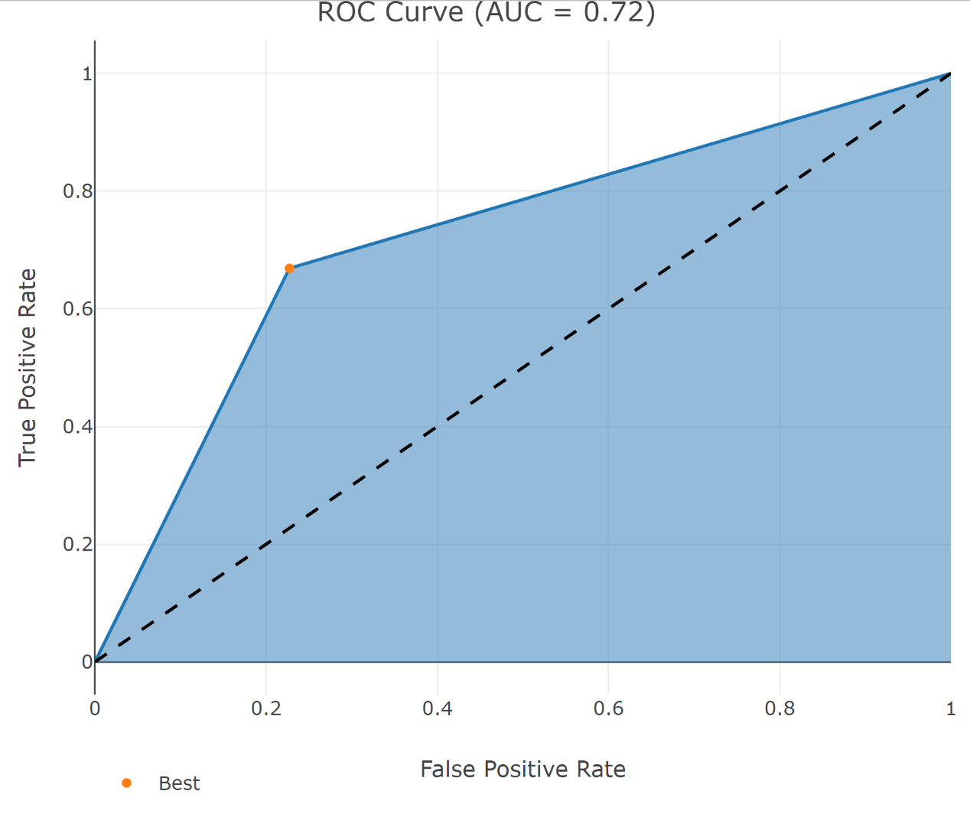

1. 土豆

重要性矩阵

Feature Gain Cover Frequency Importance

1: stock 0.5688530 0.4843745 0.3528179 0.5688530

2: sales 0.2326058 0.2839806 0.3252346 0.2326058

3: receipt 0.1985412 0.2316449 0.3219475 0.1985412

重要性图

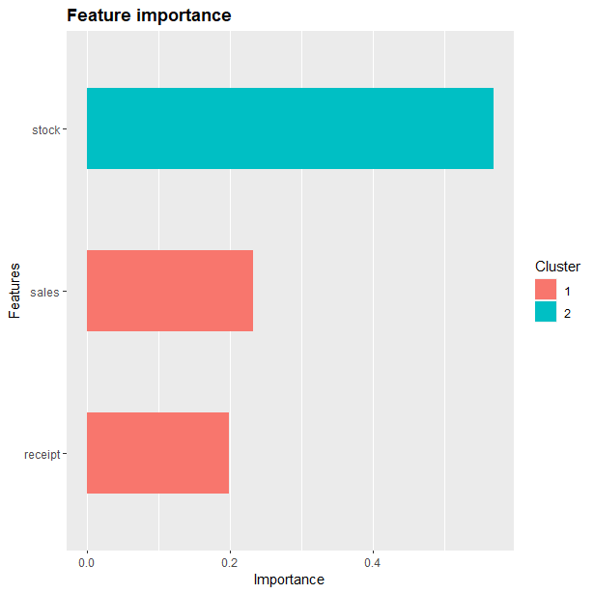

准确率

0.7711268

混淆矩阵

Reference

Prediction 0 1

0 135 25

1 40 84

Sensitivity Specificity Pos Pred Value Neg Pred Value

0.7714286 0.7706422 0.8437500 0.6774194

Precision Recall F1 Prevalence

0.8437500 0.7714286 0.8059701 0.6161972

Detection Rate Detection Prevalence Balanced Accuracy

0.4753521 0.5633803 0.7710354

混淆矩阵图

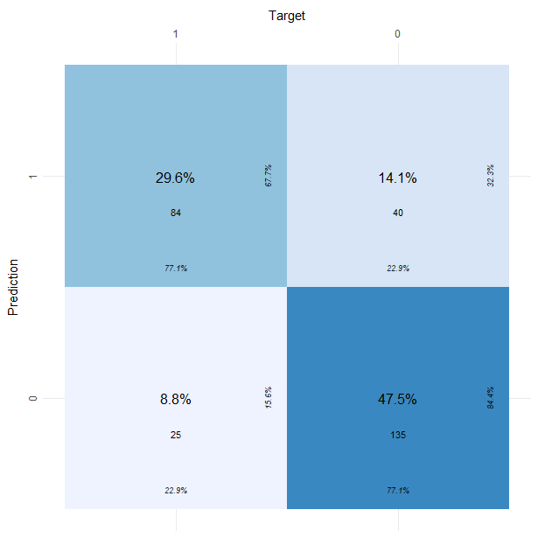

训练集ROC

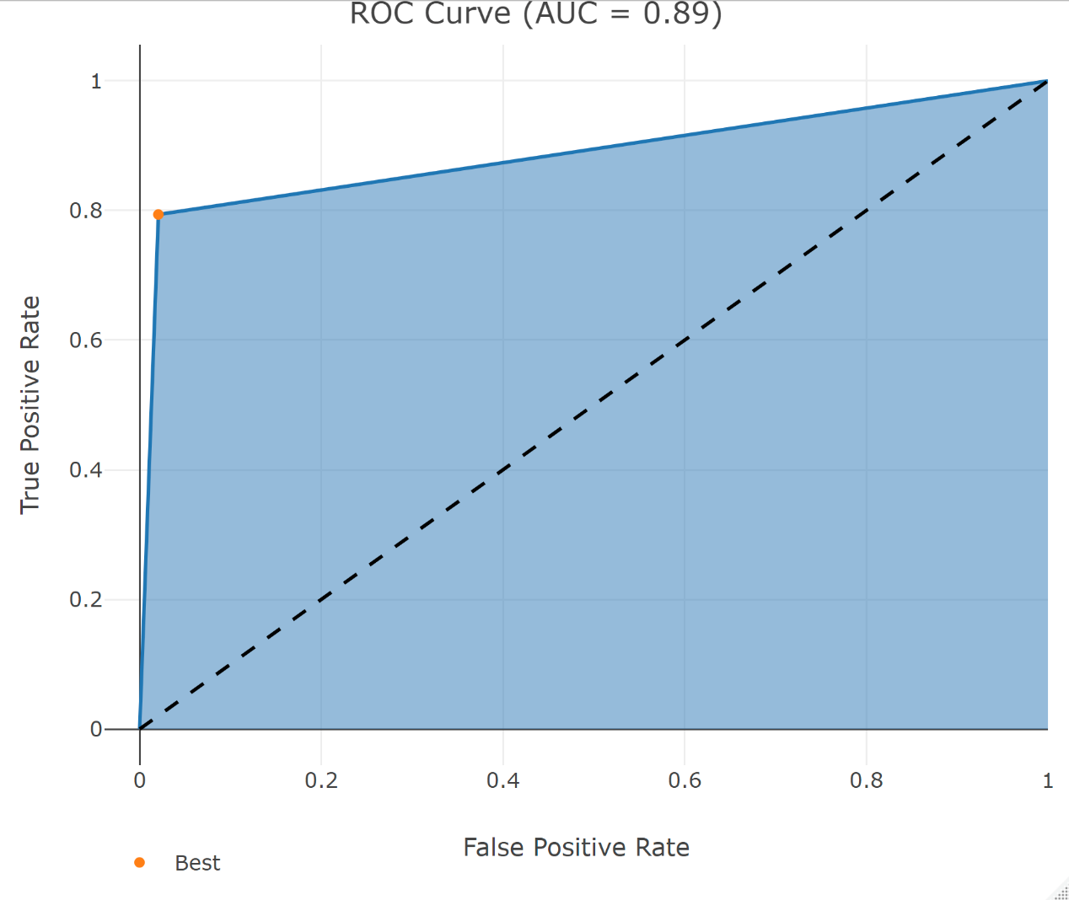

测试集ROC

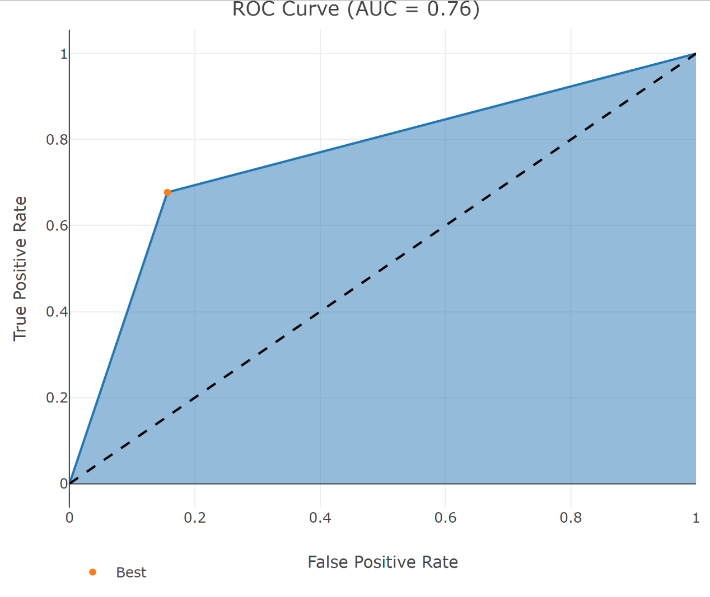

1. 洋葱

重要性矩阵

Feature Gain Cover Frequency Importance

1: stock 0.5751545 0.4765564 0.4036847 0.5751545

2: sales 0.2351740 0.3198379 0.3037466 0.2351740

3: receipt 0.1896715 0.2036057 0.2925687 0.1896715

重要性图

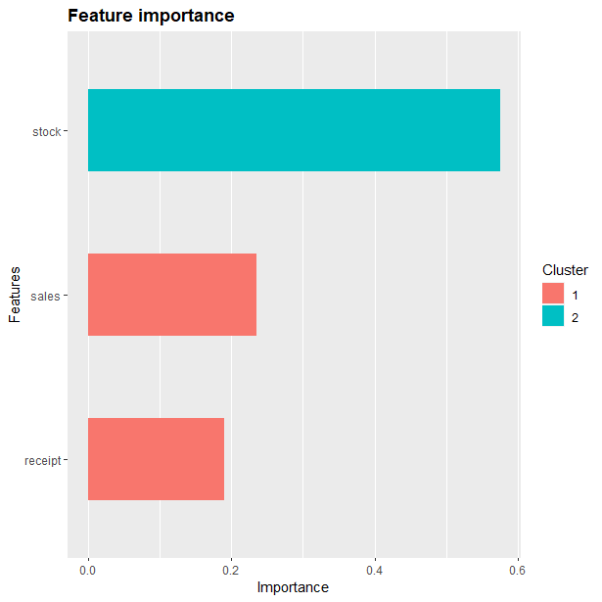

准确率

0.7617555

混淆矩阵

Reference

Prediction 0 1

0 169 20

1 56 74

Sensitivity Specificity Pos Pred Value Neg Pred Value

0.7511111 0.7872340 0.8941799 0.5692308

Precision Recall F1 Prevalence

0.8941799 0.7511111 0.8164251 0.7053292

Detection Rate Detection Prevalence Balanced Accuracy

0.5297806 0.5924765 0.7691726

混淆矩阵图

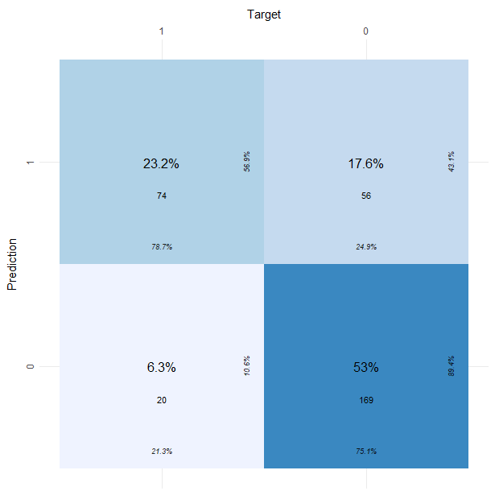

训练集ROC

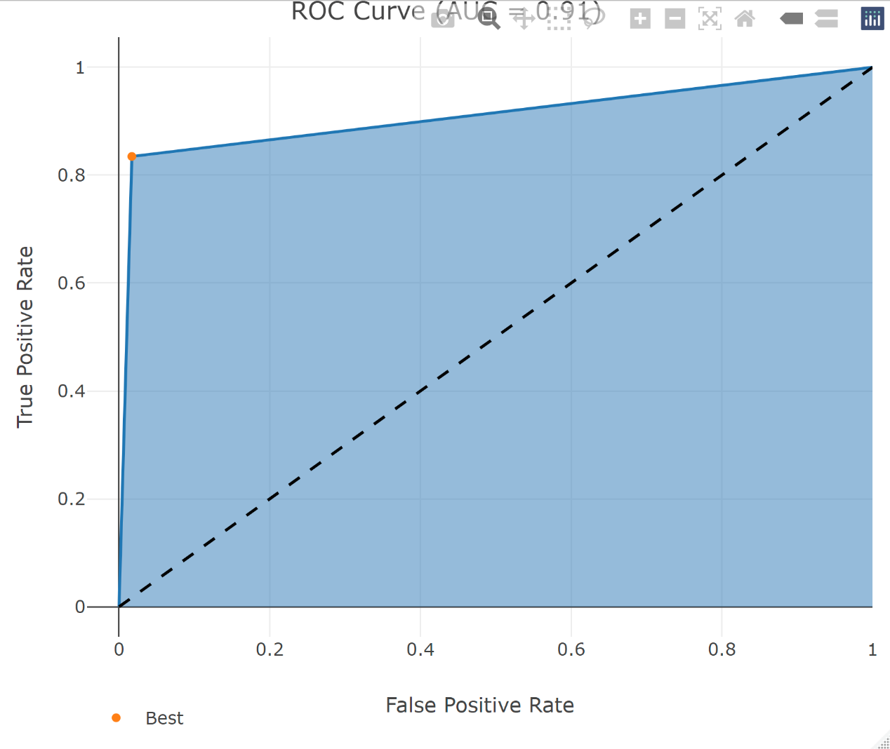

测试集ROC

