Threshold = 5

1. 总体模型

重要性矩阵

Feature Gain Cover Frequency Importance

1: stock 0.64603798 0.52330374 0.33570280 0.64603798

2: sales 0.15149086 0.23305105 0.26536959 0.15149086

3: receipt 0.13012933 0.15350321 0.25364994 0.13012933

4: product 0.03746897 0.05268717 0.07443891 0.03746897

5: store 0.03487286 0.03745483 0.07083876 0.03487286

重要性图

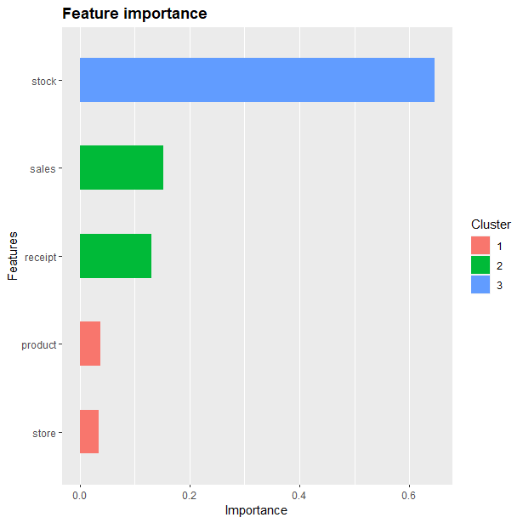

准确率

0.8249354

混淆矩阵

Reference

Prediction 0 1

0 691 74

1 197 586

Sensitivity Specificity Pos Pred Value Neg Pred Value

0.7781532 0.8878788 0.9032680 0.7484036

Precision Recall F1 Prevalence

0.9032680 0.7781532 0.8360557 0.5736434

Detection Rate Detection Prevalence Balanced Accuracy

0.4463824 0.4941860 0.8330160

混淆矩阵图

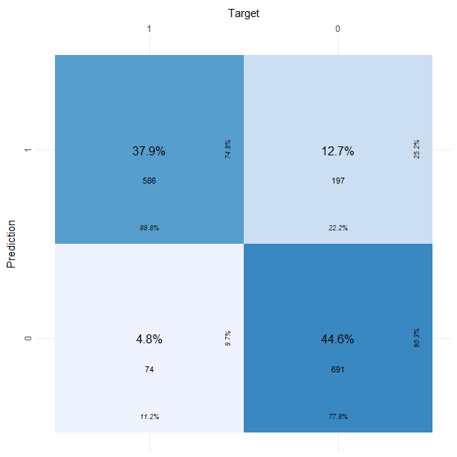

训练集ROC

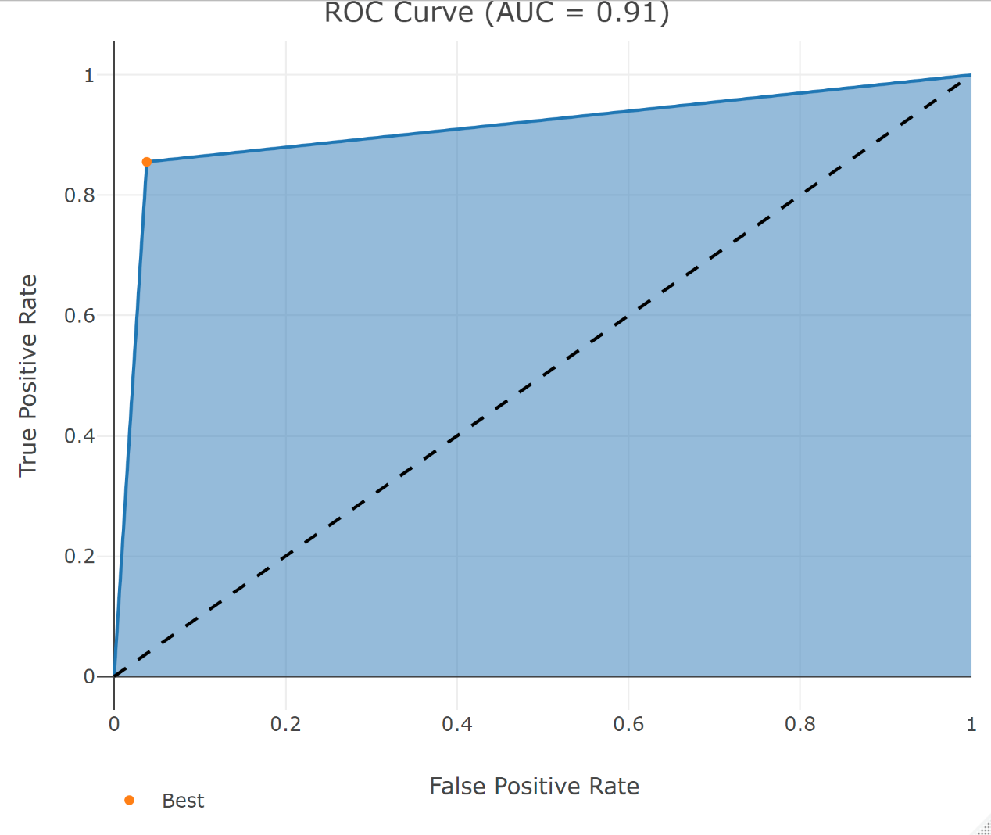

测试集ROC

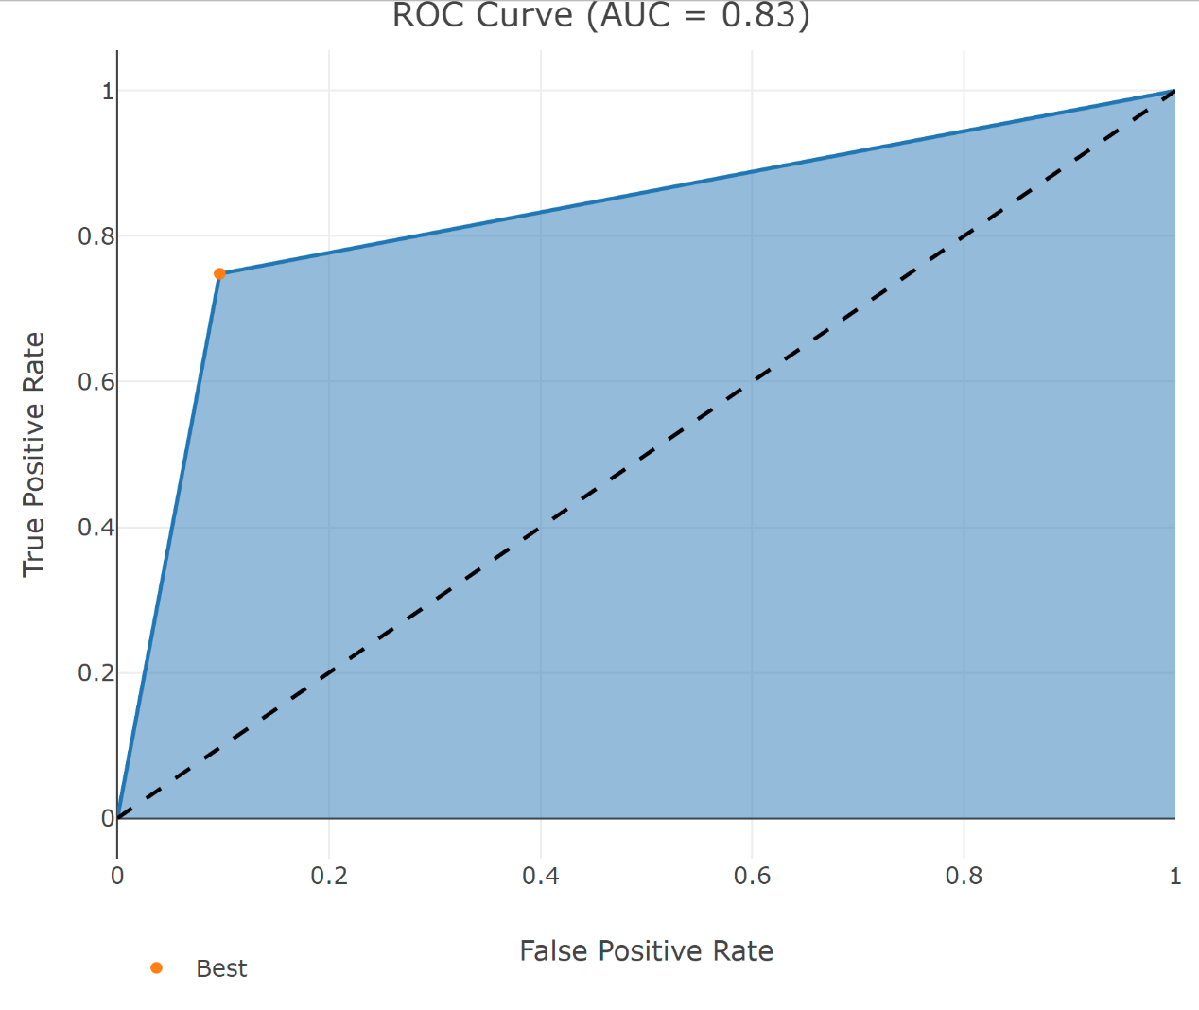

1. 番茄

重要性矩阵

Feature Gain Cover Frequency Importance

1: stock 0.6267694 0.5141068 0.3788945 0.6267694

2: sales 0.2025283 0.2723393 0.3223259 0.2025283

3: receipt 0.1707023 0.2135538 0.2987796 0.1707023

重要性图

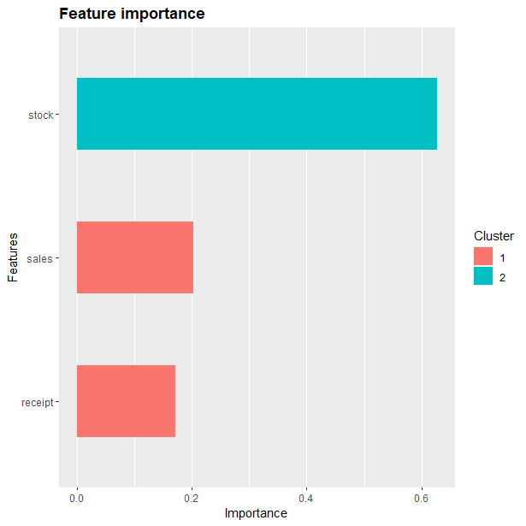

准确率

0.8621795

混淆矩阵

Reference

Prediction 0 1

0 158 11

1 32 111

Sensitivity Specificity Pos Pred Value Neg Pred Value

0.8315789 0.9098361 0.9349112 0.7762238

Precision Recall F1 Prevalence

0.9349112 0.8315789 0.8802228 0.6089744

Detection Rate Detection Prevalence Balanced Accuracy

0.5064103 0.5416667 0.8707075

混淆矩阵图

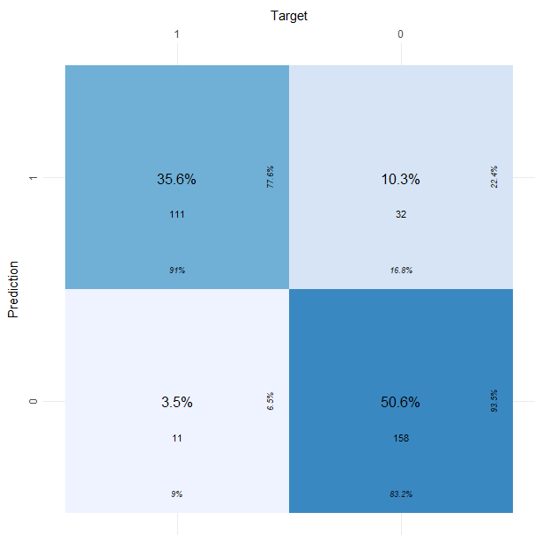

训练集ROC

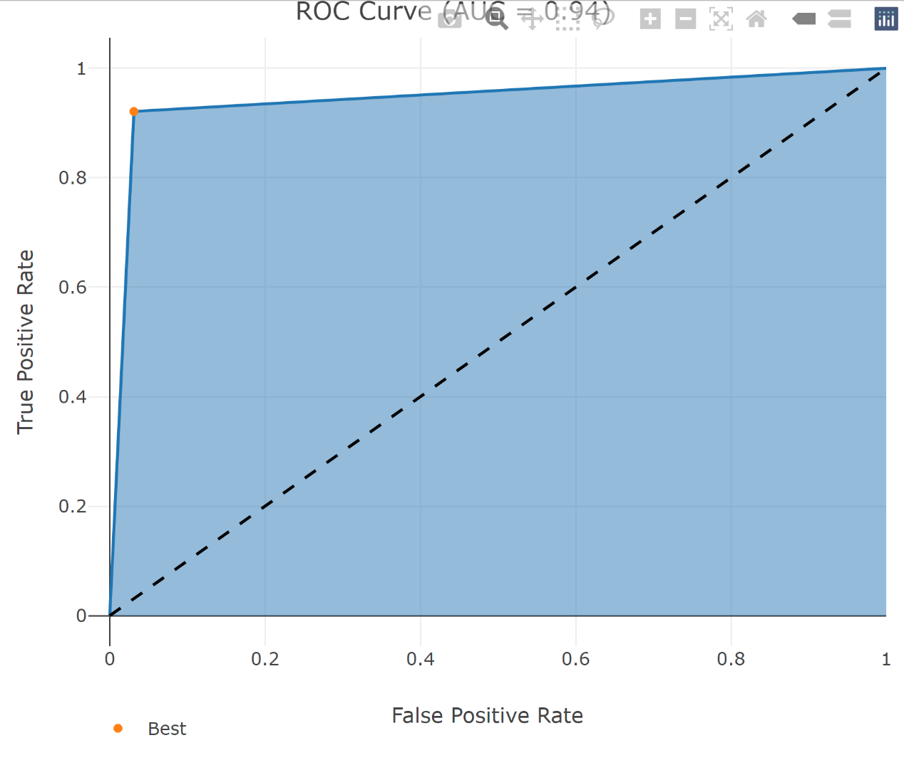

测试集ROC

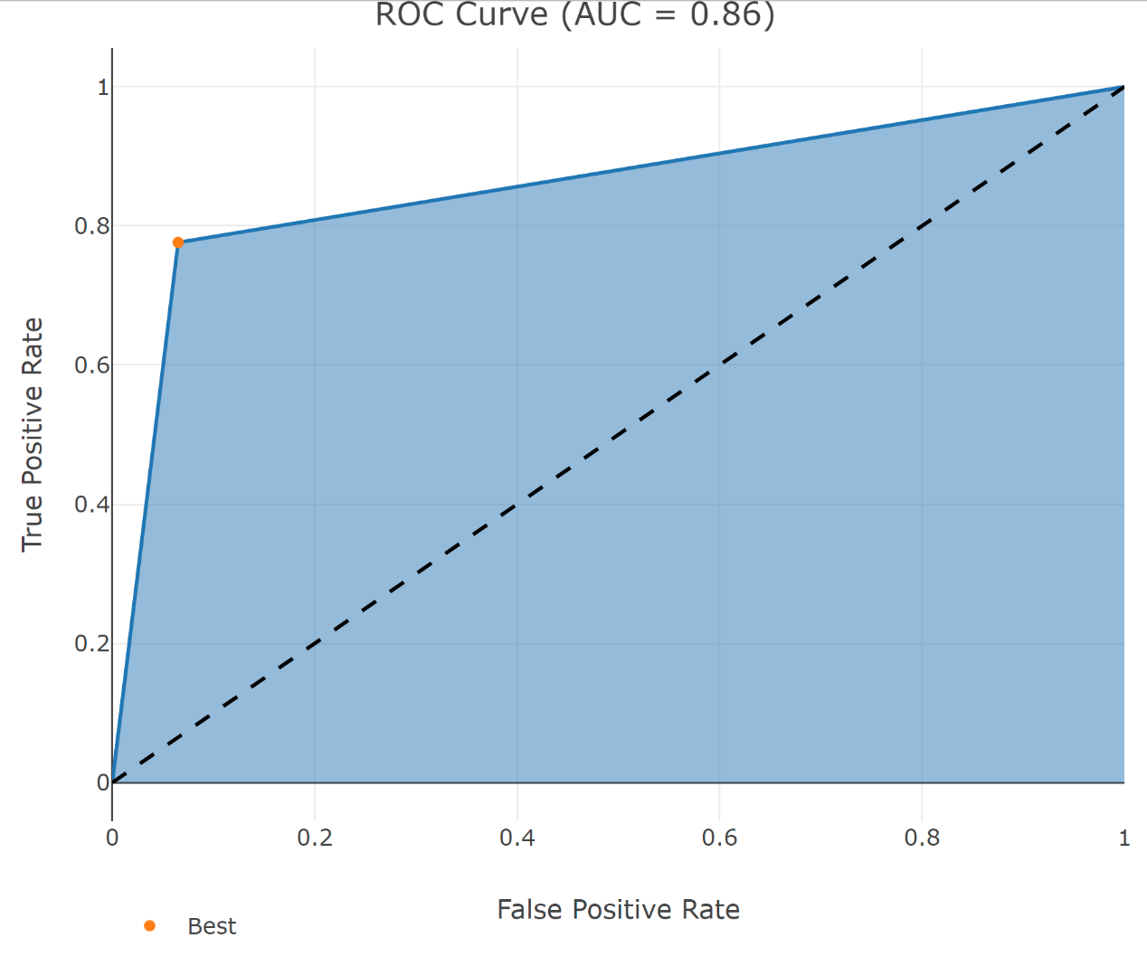

1. 胡萝卜

重要性矩阵

Feature Gain Cover Frequency Importance

1: stock 0.6114945 0.5035536 0.3992621 0.6114945

2: sales 0.2021799 0.2521805 0.2932642 0.2021799

3: receipt 0.1863255 0.2442659 0.3074737 0.1863255

重要性图

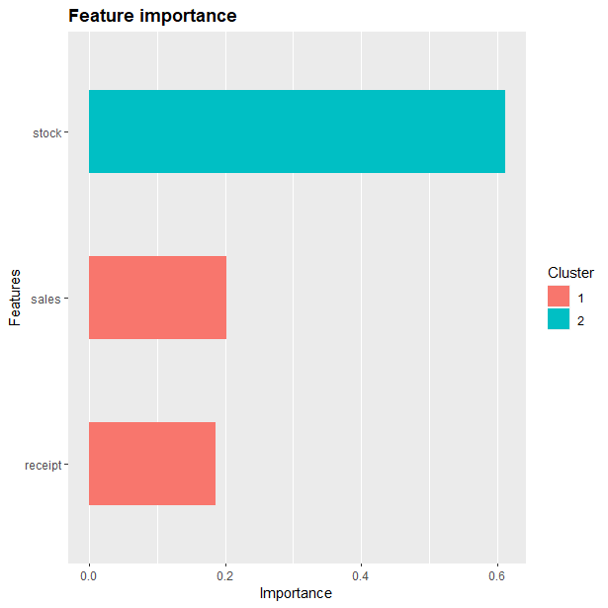

准确率

0.8106312

混淆矩阵

Reference

Prediction 0 1

0 133 21

1 36 111

Sensitivity Specificity Pos Pred Value Neg Pred Value

0.7869822 0.8409091 0.8636364 0.7551020

Precision Recall F1 Prevalence

0.8636364 0.7869822 0.8235294 0.5614618

Detection Rate Detection Prevalence Balanced Accuracy

0.4418605 0.5116279 0.8139457

混淆矩阵图

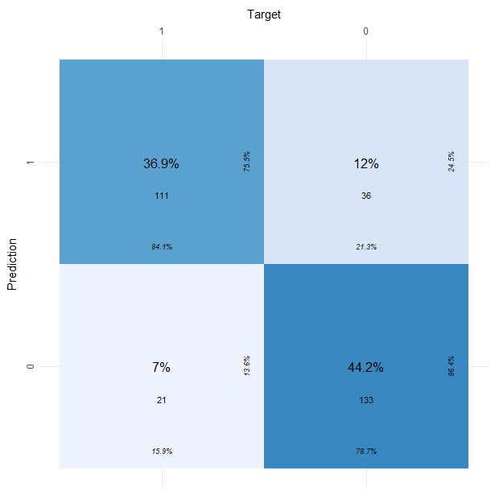

训练集ROC

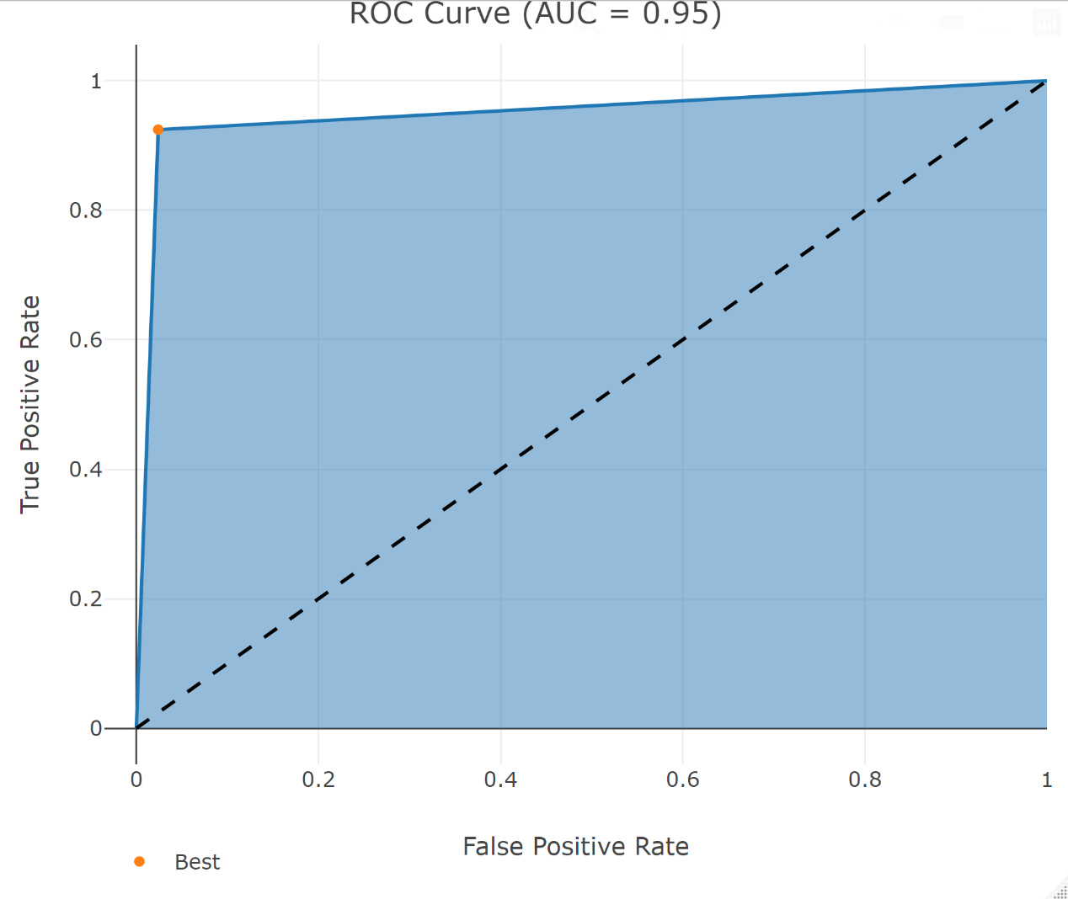

测试集ROC

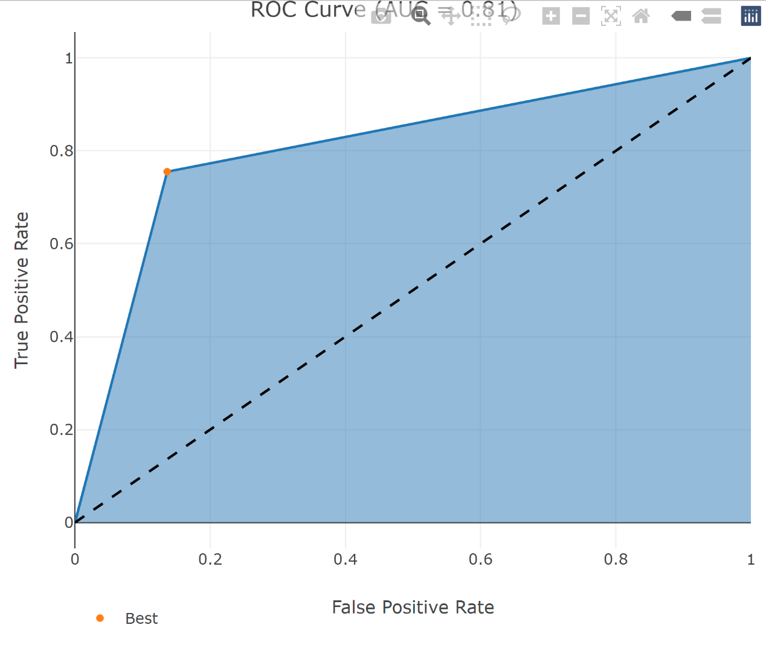

1. 山药

重要性矩阵

Feature Gain Cover Frequency Importance

1: stock 0.6469815 0.5697115 0.4106351 0.6469815

2: receipt 0.1834331 0.2138984 0.3037813 0.1834331

3: sales 0.1695854 0.2163901 0.2855836 0.1695854

重要性图

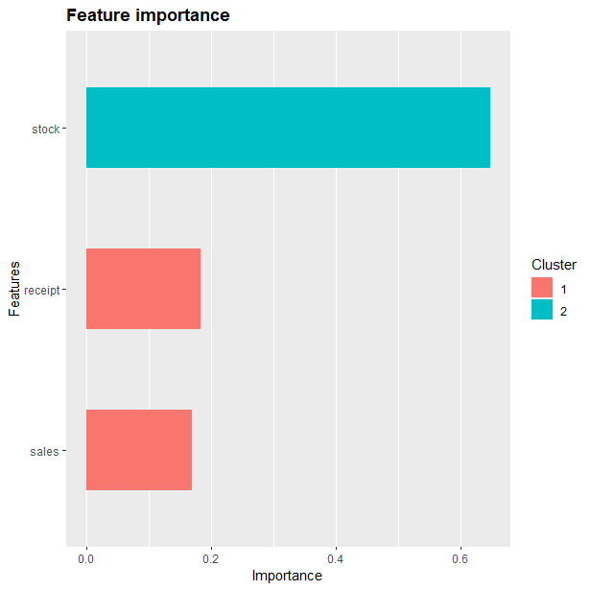

准确率

0.8349206

混淆矩阵

Reference

Prediction 0 1

0 121 26

1 26 142

Sensitivity Specificity Pos Pred Value Neg Pred Value

0.8231293 0.8452381 0.8231293 0.8452381

Precision Recall F1 Prevalence

0.8231293 0.8231293 0.8231293 0.4666667

Detection Rate Detection Prevalence Balanced Accuracy

0.3841270 0.4666667 0.8341837

混淆矩阵图

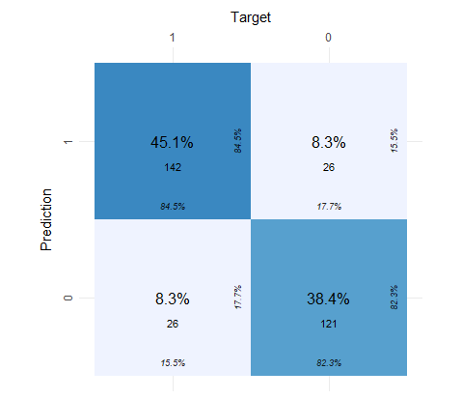

训练集ROC

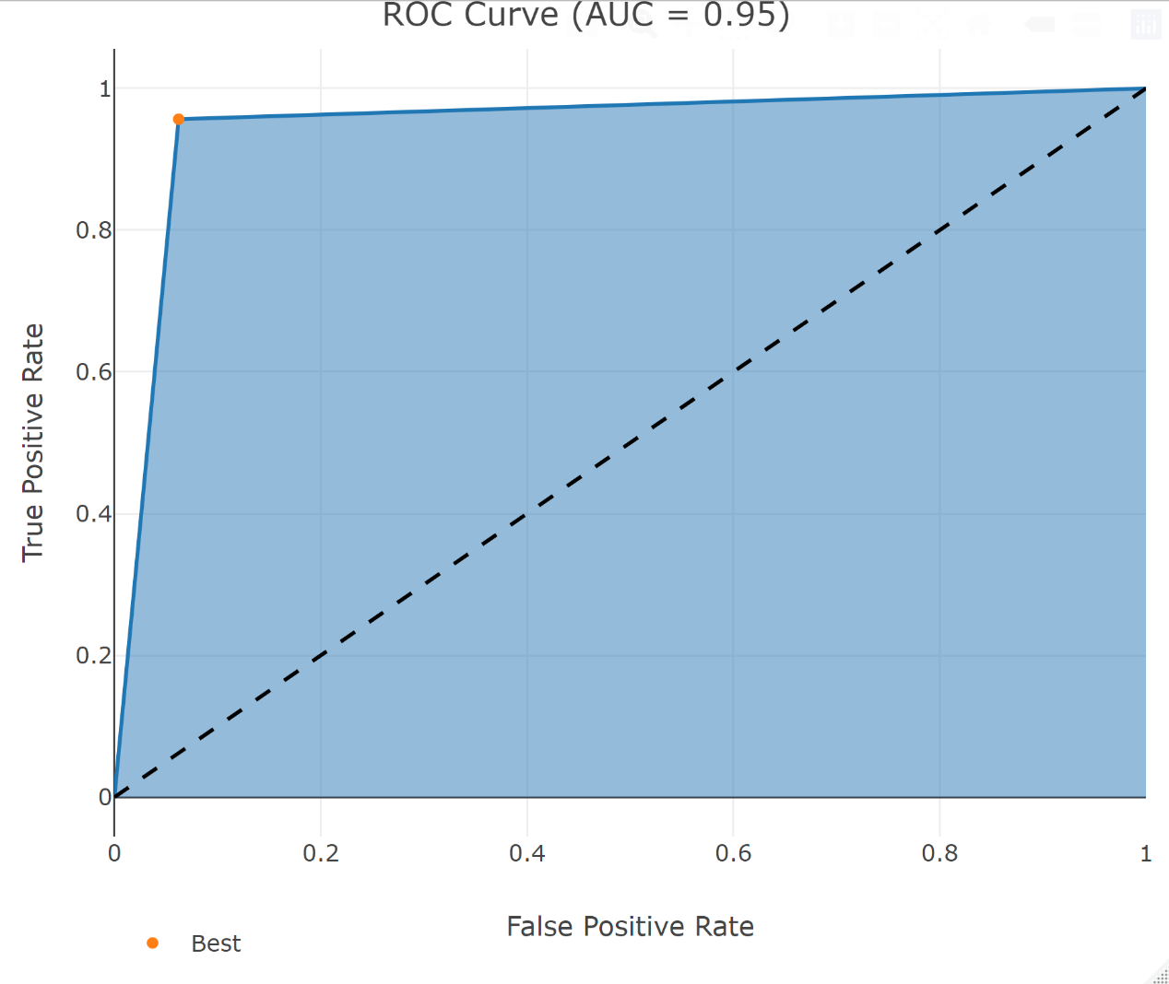

测试集ROC

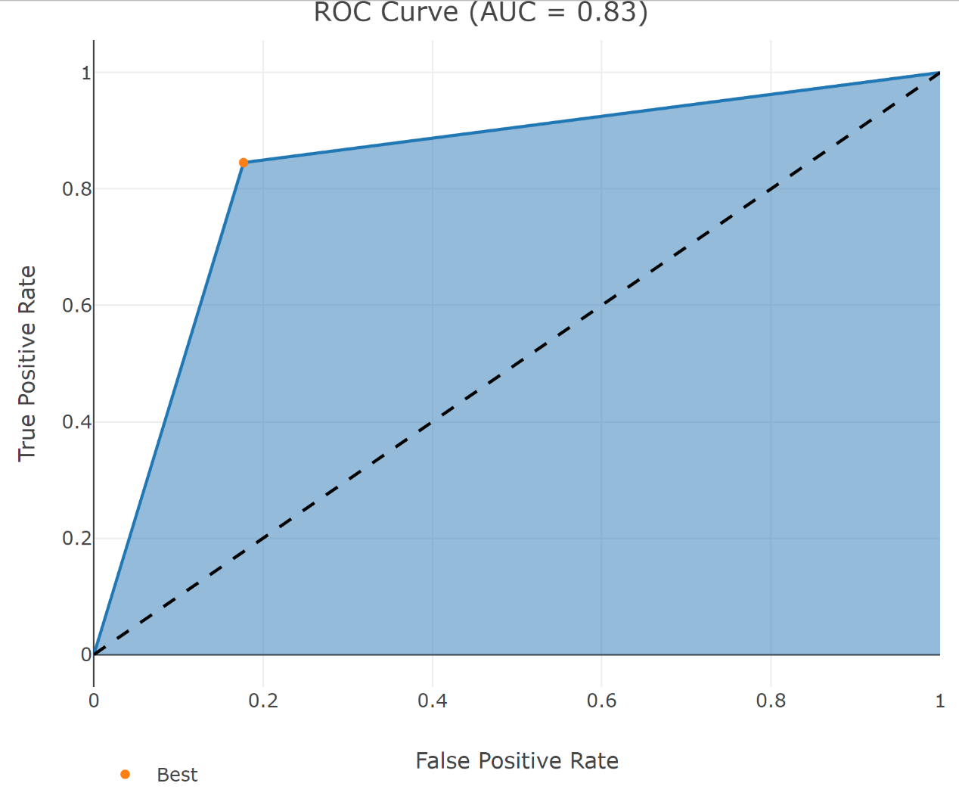

1. 土豆

重要性矩阵

Feature Gain Cover Frequency Importance

1: stock 0.6467721 0.5408295 0.3963164 0.6467721

2: sales 0.1902965 0.2586134 0.3085918 0.1902965

3: receipt 0.1629315 0.2005572 0.2950918 0.1629315

重要性图

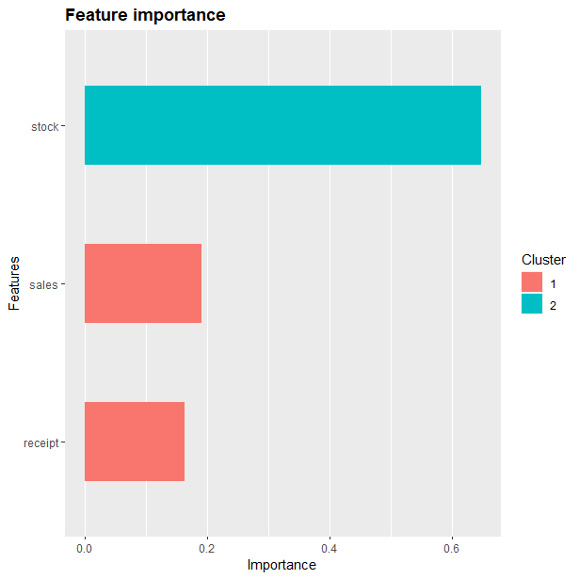

准确率

0.8093842

混淆矩阵

Reference

Prediction 0 1

0 117 32

1 33 159

Sensitivity Specificity Pos Pred Value Neg Pred Value

0.7800000 0.8324607 0.7852349 0.8281250

Precision Recall F1 Prevalence

0.7852349 0.7800000 0.7826087 0.4398827

Detection Rate Detection Prevalence Balanced Accuracy

0.3431085 0.4369501 0.8062304

混淆矩阵图

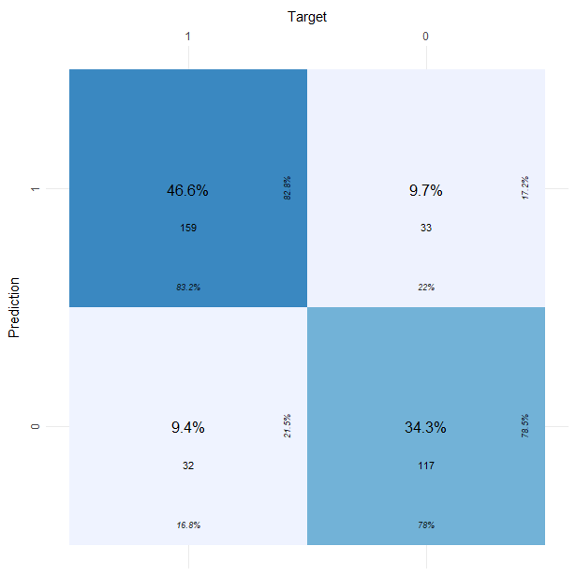

训练集ROC

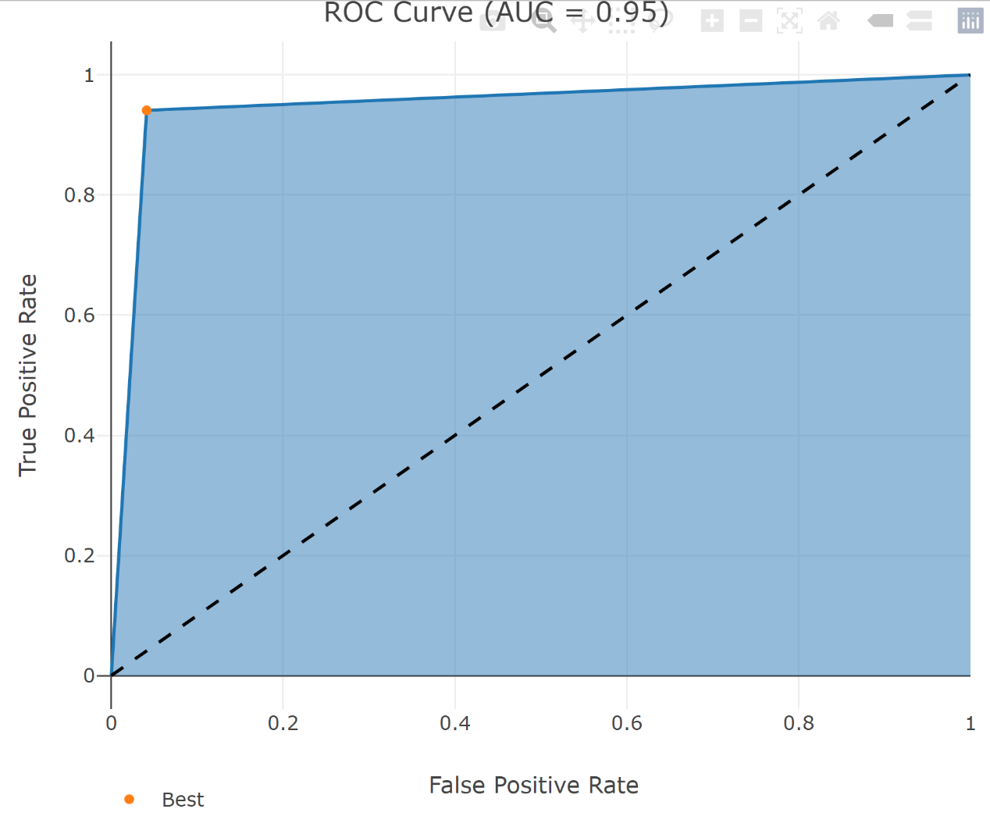

测试集ROC

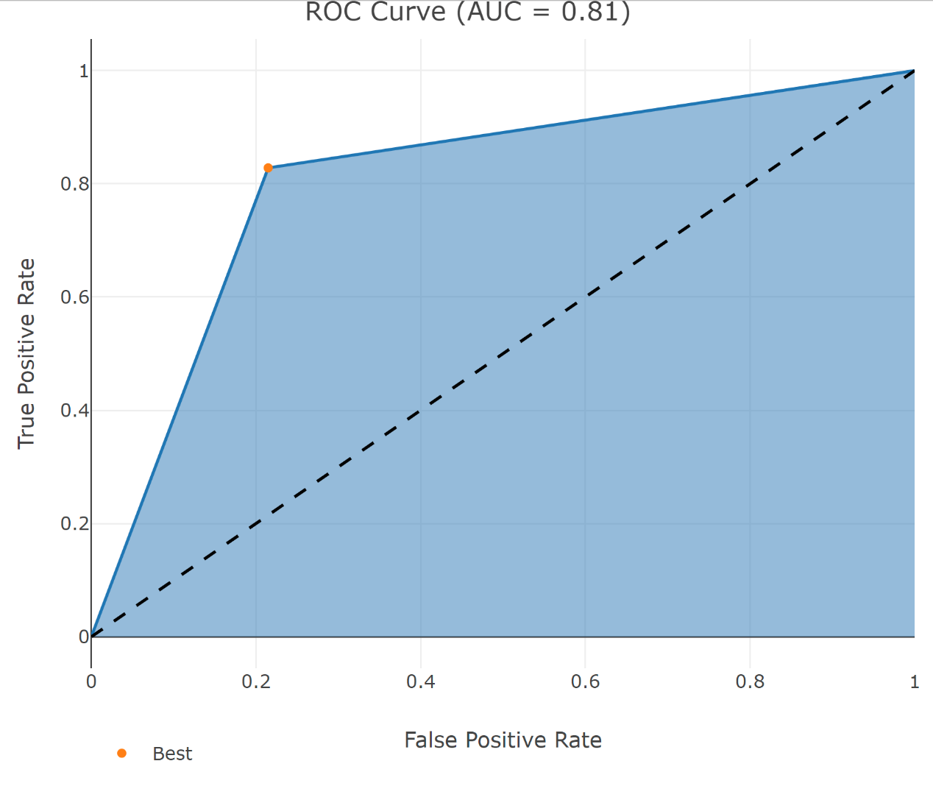

1. 洋葱

重要性矩阵

Feature Gain Cover Frequency Importance

1: stock 0.7084491 0.5782570 0.4447443 0.7084491

2: sales 0.1524993 0.2198555 0.2830952 0.1524993

3: receipt 0.1390516 0.2018875 0.2721604 0.1390516

重要性图

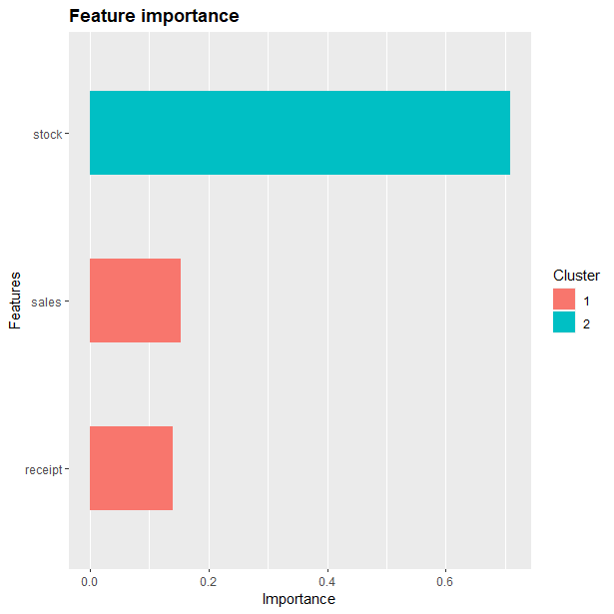

准确率

0.8888889

混淆矩阵

Reference

Prediction 0 1

0 138 8

1 23 110

Sensitivity Specificity Pos Pred Value Neg Pred Value

0.8571429 0.9322034 0.9452055 0.8270677

Precision Recall F1 Prevalence

0.9452055 0.8571429 0.8990228 0.5770609

Detection Rate Detection Prevalence Balanced Accuracy

0.4946237 0.5232975 0.8946731

混淆矩阵图

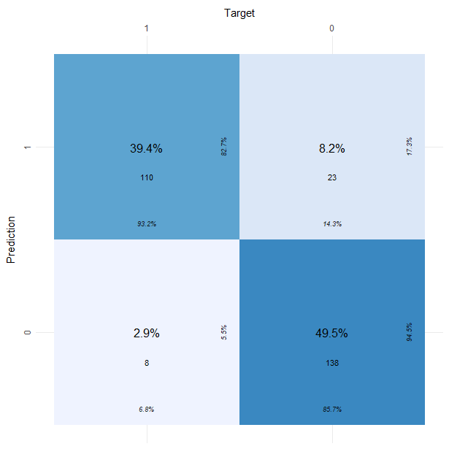

训练集ROC

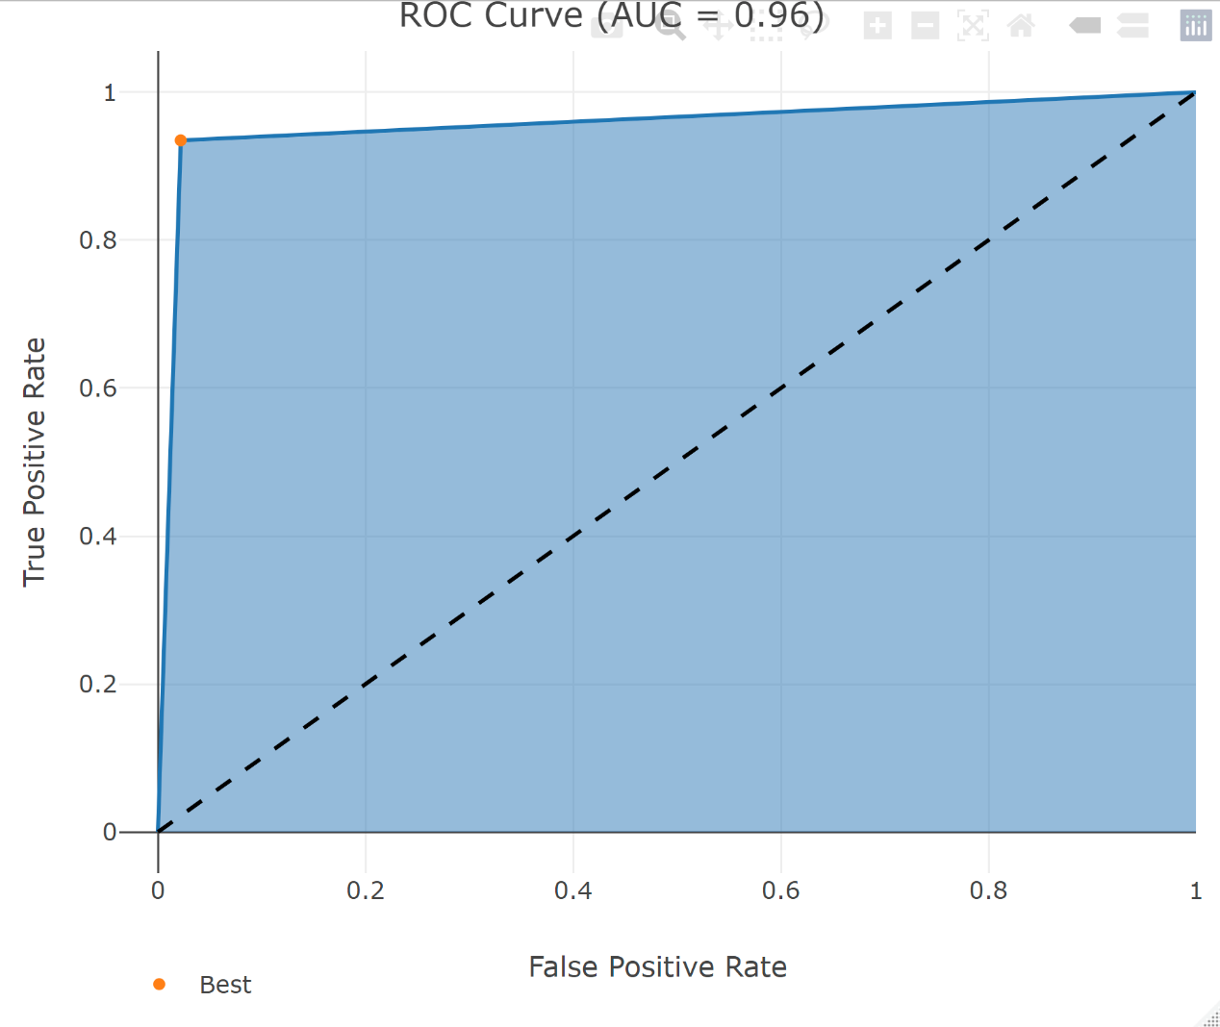

测试集ROC

