ePustaka Munshi: Smart Library System
with OCR Ledger Digitization
Wan Zafirzan Bin Wan Tarmizan Dr. Siti Nur Khadijah Aishah Binti Ibrahim
Malaysia-Japan International Institute of Technology Malaysia-Japan International Institute of Technology
Universiti Teknologi Malaysia Universiti Teknologi Malaysia
Email: wanzafirzan@graduate.utm.my Email: snk.aishah@utm.my
Abstract--School libraries that still depend on handwritten accession ledgers and manual circulation books face persistent problems in catalogue search, book-status tracking, borrowing control, and long-term preservation of historical records. This paper presents ePustaka Munshi, a smart library system developed for SMK Abdullah Munshi to modernize a paper-based secondary-school library workflow. The system integrates role-based access, book and copy cataloguing, student and member management, barcode-based borrowing and returning, bilingual interfaces, and an OCR-assisted workflow for digitizing the Buku Induk ledger. The implementation uses a React and TypeScript frontend, a Flask REST API, and Supabase PostgreSQL as the managed relational data layer. Handwritten ledger extraction uses Claude Vision as the primary vision-language model, with Tesseract retained as a traditional OCR baseline and page-orientation aid. Developed through Agile Scrum, the system provides a searchable catalogue, faster circulation, and a human-verified digitization process that protects legacy library records from direct blind import.
Keywords--smart library system; OCR ledger digitization; handwritten document transcription; barcode circulation; React; Flask; Supabase; school library.

I. INTRODUCTION
Library resource management is a daily operational requirement for supporting reading culture, reference use, and school administration. At SMK Abdullah Munshi, the library manages more than 7,000 books while still relying on physical ledgers, manual borrowing records, and fragmented spreadsheet data. Important information such as titles, authors, publishers, Dewey Decimal Classification numbers, accession records, and copy availability is therefore difficult to search and maintain consistently.
The manual process creates three connected problems. First, the handwritten Buku Induk is valuable but fragile, and searching it requires physical inspection. Second, borrowing and returning require repeated writing and manual status updates at the circulation counter. Third, previous digitization efforts did not provide validation, duplication checking, role-based permissions, or a reliable path for migrating old ledger rows into a live catalogue. Similar studies have shown that school-library modernization depends on centralized metadata, searchable records, and practical digital collection strategies [1], [6], [11].
This project therefore developed ePustaka Munshi, a web-based library management system with OCR ledger digitization. The goal is not only to replace paper with a database, but to fit the actual operating environment of a Malaysian secondary-school library, where teachers supervise, library prefects support counter work, students need simple catalogue access, and old handwritten records must be preserved before they degrade.
II. BACKGROUND AND RELATED WORK
Candidate solutions were reviewed against the needs of SMK Abdullah Munshi. Mature integrated library systems such as KOHA provide broad library functionality, while commercial systems offer managed support and specialized modules [2], [7]. However, these platforms can be too heavy for a small school library that needs fast deployment, low maintenance, and workflow-specific support. Spreadsheet-based approaches are easy to begin, but they do not enforce circulation rules, audit trails, or reliable catalogue migration.
The digitization component required special attention because handwritten documents remain difficult for classical OCR. Traditional OCR and image processing remain useful for printed or semi-structured text [5], [9], [13], [15], [16], but handwriting introduces variation in ink, spacing, orientation, language, and writing style. Recent research on vision-capable large language models indicates that such models can transcribe and structure historical handwritten records more effectively than conventional OCR in selected archival settings [4], and GPT-4V has also been quantitatively evaluated for OCR-like tasks [12]. These findings support a hybrid approach that combines model extraction with staff verification.
Table I. Comparison of Existing Library Digitization Alternatives
Alternative | Implication for SMK Abdullah Munshi
KOHA or full ILS | Powerful, but requires more administration than the school context can easily sustain.
Legacy desktop system | Familiar school-library category, but device-bound and risky for long-term maintenance.
Spreadsheet inventory | Simple, but weak for circulation status, permissions, validation, and auditability.
ePustaka Munshi | Tailored web workflow with OCR review, barcode circulation, roles, and managed cloud data.
III. METHODOLOGY
Agile Scrum was selected because the project involved evolving stakeholder expectations and uncertain OCR performance. The work was organized into four functional sprints: user and role management, book catalogue and inventory, ledger digitization, and borrowing or returning management. Each sprint produced a functional increment that could be checked against the real library workflow.
Requirements were gathered through stakeholder discussion with the school librarian and review of existing library artifacts, including the Buku Induk, borrowing records, and spreadsheet inventory. The findings were converted into functional requirements, non-functional requirements, use case descriptions, workflow diagrams, database entities, interface designs, and test cases. This process kept the system grounded in school practice rather than in generic library software assumptions.
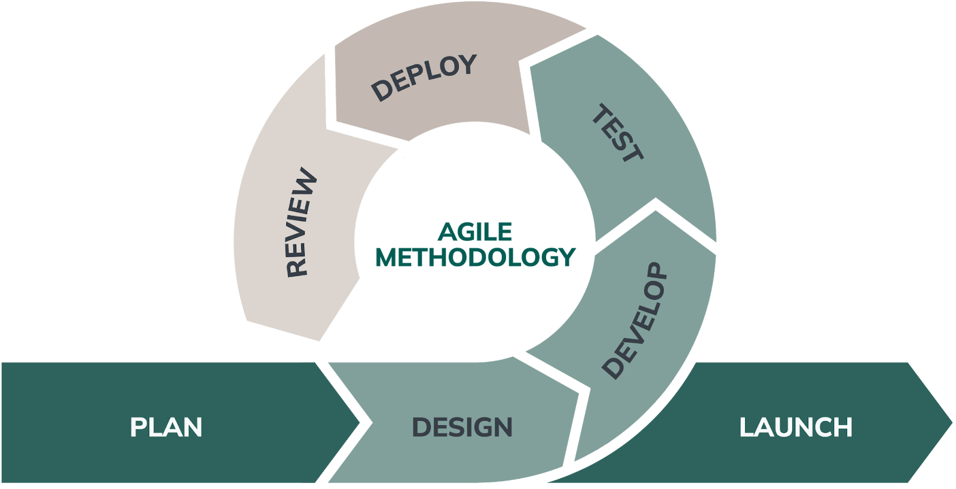
Fig. 1. Agile Scrum development lifecycle used to structure iterative system delivery.
IV. SYSTEM ANALYSIS
The main actors are Administrator, Librarian, Library Prefect, and Student. Administrators manage global settings, roles, and higher-risk operations. Librarians manage book records, student data, OCR jobs, and circulation monitoring. Library Prefects assist at the counter by scanning books for borrowing and returning. Students use the portal to view catalogue records, active loans, overdue status, and borrowing history.
The key requirement is the OCR verification workflow. Since handwritten extraction is imperfect, the system deliberately avoids direct automatic import into the catalogue. Instead, staff upload a ledger image or PDF, review extracted rows, correct field values against the source image, and commit only verified records. This human-in-the-loop pattern reduces the risk of permanently storing OCR mistakes.
Table II. Core Requirement Summary
Category | Requirement
Authentication | Route users to the correct role-based interface after secure login.
Inventory | Add, edit, search, filter, and manage book and copy records.
Digitization | Upload ledger pages, extract rows, correct OCR values, and commit verified data.
Circulation | Scan barcodes for borrowing, returning, renewal, overdue review, and status updates.
Reliability | Prevent low-confidence OCR output from entering the permanent catalogue without review.
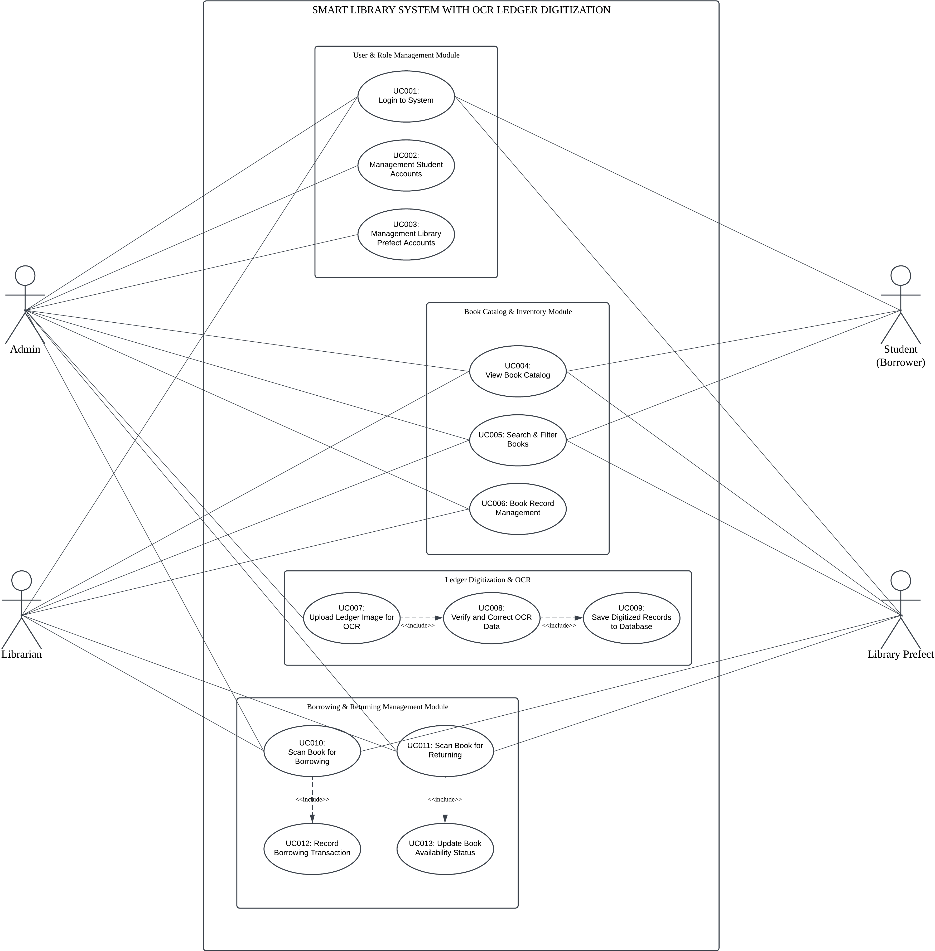
Fig. 2. Use case design showing role-specific access for library stakeholders.
V. SYSTEM DESIGN AND IMPLEMENTATION
The system follows a three-tier web architecture. The presentation layer is a React single-page application with module-based pages for authentication, catalogue browsing, user management, circulation, OCR review, and student access. The application layer is a Flask REST API that handles validation, authentication-related logic, business rules, and role permissions. The data layer is Supabase PostgreSQL, selected for managed relational persistence and cloud availability [14].
The database separates access control, membership, bibliographic data, physical copies, loans, OCR evidence, and digitized ledger archives. Book records store bibliographic metadata, while book-copy records store accession numbers, barcodes, condition, shelf location, and availability status. Loan records connect members, copies, handlers, due dates, renewals, and transaction status. OCR jobs preserve uploaded evidence, extracted rows, confidence values, correction history, and final commit status.
The interface prioritizes fast operation at the library counter. The barcode field remains easy to focus so a USB scanner can behave like keyboard input, while immediate visual feedback confirms a successful checkout or return. The OCR screen works as a verification workspace, showing the source image and extracted rows so the librarian can correct title, author, publisher, accession number, and classification values before import.
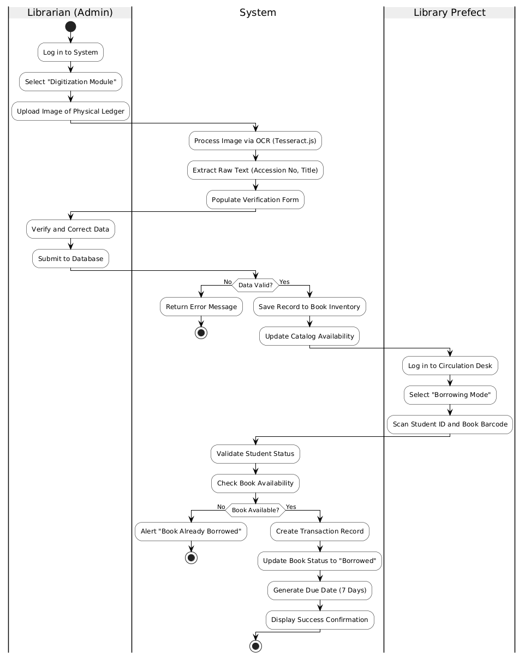
Fig. 3. High-level workflow showing how catalogue, OCR, and circulation activities connect.
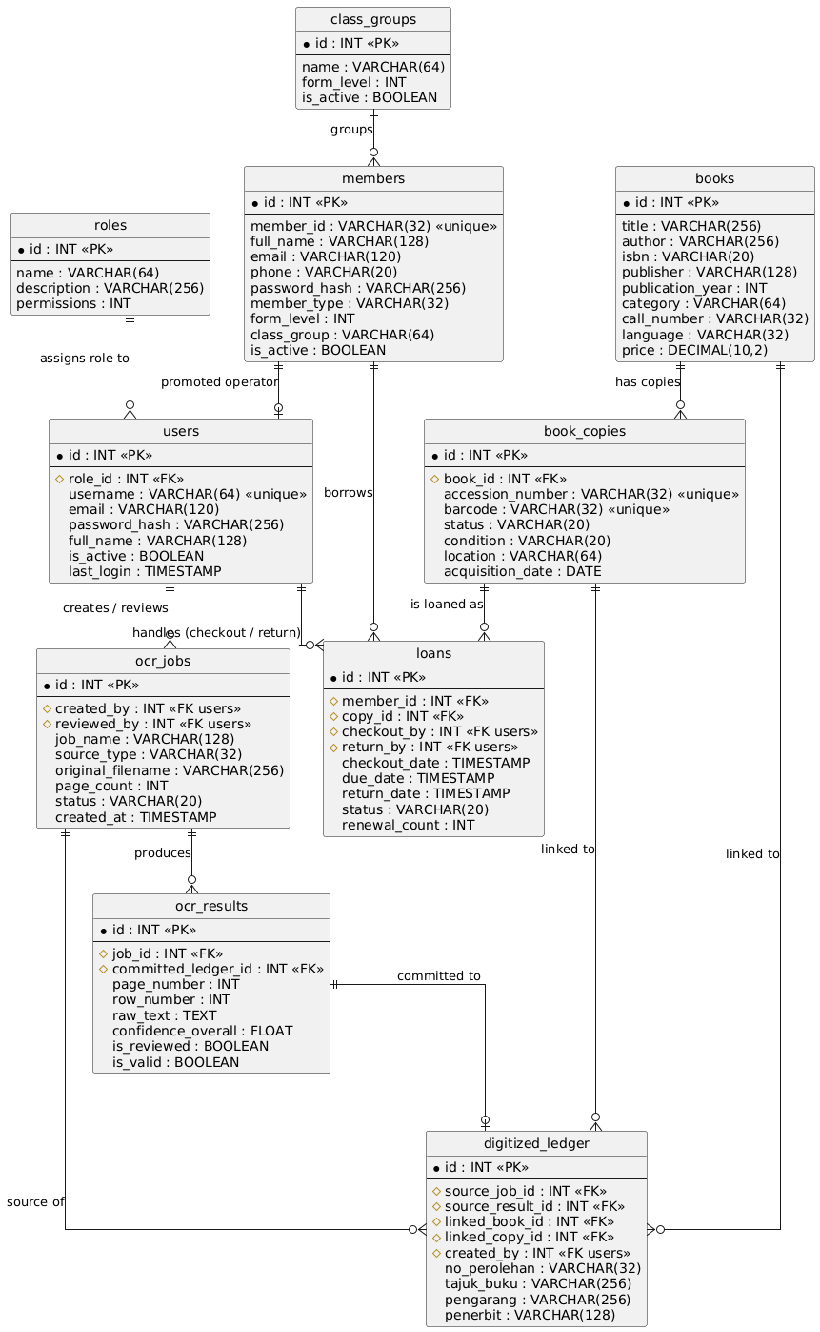
Fig. 4. Entity-relationship design showing the main persistence structure.
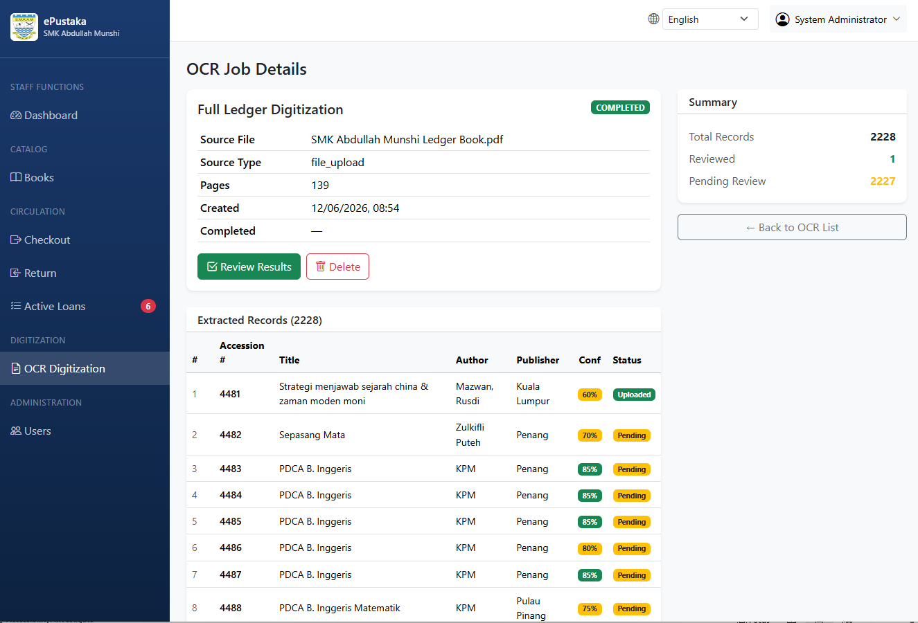

Fig. 5. OCR review interface where staff verify extracted ledger rows before committing records.
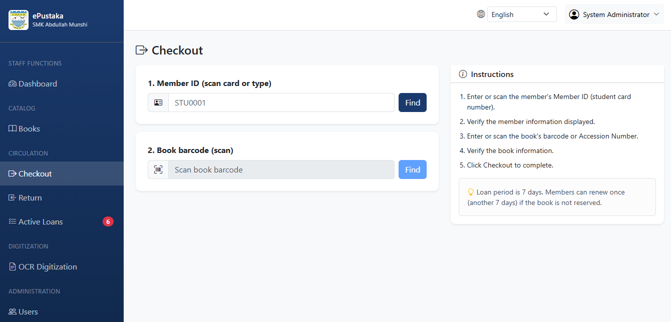
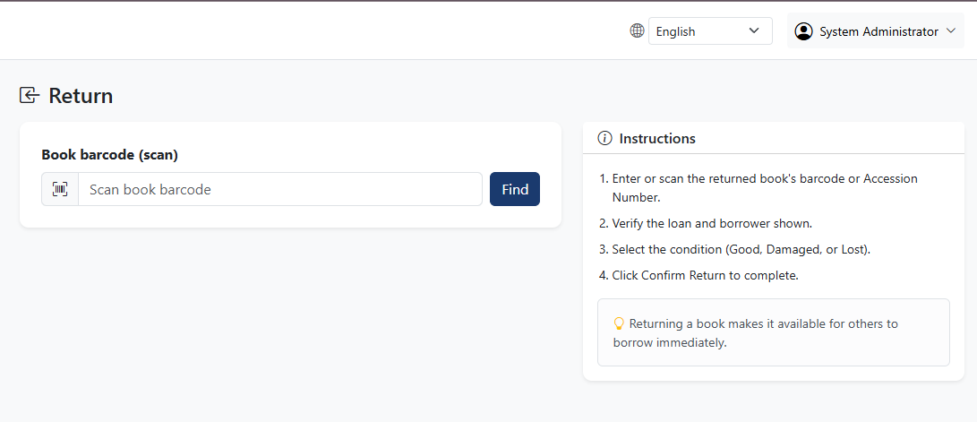
Fig. 6. Barcode circulation interface for fast borrowing and returning at the counter.
VI. TESTING AND EVALUATION
Testing covered functional workflows, integration behavior, OCR correction, and user acceptance activities. Functional tests checked login, catalogue search, user management, checkout, return, renewal, and OCR review. Integration checks focused on API-to-database behavior, especially where a circulation action must update both the loan transaction and the copy availability status.
The OCR scenario was treated as a critical validation case. When the engine produced an incorrect value, such as a misspelled title or uncertain classification field, the expected behavior was that the librarian could compare the result with the source image, edit the field, save the correction, and commit the verified record. This confirmed that OCR is used as an assistant rather than as an unchecked authority.
Table III. OCR Verification Test Case
Item | Description
Input | Ledger image with an OCR typo or missing bibliographic field.
Expected result | Source image and extracted fields are shown side by side for review.
Correction | Librarian edits the field and saves the reviewed row.
Pass condition | Corrected data is committed only after staff verification.
VII. RESULTS AND DISCUSSION
The completed system achieved the project objectives. The analysis and design activities documented the manual workflow and translated the library pain points into software requirements. The implementation delivered a working web system with role-based access, catalogue management, copy tracking, barcode circulation, OCR-assisted ledger digitization, and bilingual interface support. The evaluation confirmed that the core workflows behaved as intended and that OCR output could be corrected before permanent storage.
The most important design decision is the separation between extraction and commitment. This protects catalogue quality while still reducing the manual burden of retyping old ledger pages. The architecture also avoids the weakness of a single-computer desktop deployment because the database is hosted, relational, and easier to back up. At the same time, the system remains practical for a school because counter operations are simple and library prefects can assist under limited permissions.
VIII. CONCLUSION AND FUTURE WORK
ePustaka Munshi demonstrates how a school-specific library management system can combine ordinary operational features with a focused digitization workflow for historical handwritten records. By integrating a searchable catalogue, role-based administration, barcode circulation, and OCR-assisted ledger review, the system reduces reliance on fragile manual records while preserving the evidence needed for accurate catalogue migration.
Future work can move more of the OCR pipeline into a cloud-hosted or dedicated-server workflow, add borrowing analytics, support automated due-date reminders, provide reservation features, and integrate with school student information systems. These enhancements can build on the current architecture while keeping the system aligned with actual library operations.
ACKNOWLEDGMENT
The author expresses sincere appreciation to Dr. Siti Nur Khadijah Aishah Binti Ibrahim for supervision and guidance, and to Cikgu Farah Intan Nailah Binti Adanan and the SMK Abdullah Munshi library stakeholders for operational input, library context, and project feedback.
REFERENCES
[1] Alkhidmah Journal. (2023). Digital library management system study. Journal of Information Systems and Technology, 4(2), 45-58. https://ejurnalqarnain.stisnq.ac.id/index.php/ALKHIDMAH/article/view/501
[2] CDS Online. (n.d.). Open source library systems & digitisation. Retrieved October 15, 2025, from https://cdsol.com.my/web/open-source-library-systems-digitisation/
[3] Francis, S. A., & Sangeetha, M. (2025). A comparison study on optical character recognition models in mathematical equations and in any language. Results in Control and Optimization, 18, 100532. https://doi.org/10.1016/j.rico.2025.100532
[4] Humphries, M., Leddy, L. C., Downton, Q., Legace, M., McConnell, J., Murray, I., & Spence, E. (2024). Unlocking the archives: Using large language models to transcribe handwritten historical documents. arXiv. https://doi.org/10.48550/arXiv.2411.03340
[5] Imam Yuadi, Sigh, A. R., & Ullin Nihaya. (2024). Text recognition for library collection in different light conditions. TEM Journal, 266-276. https://doi.org/10.18421/tem131-28
[6] Lesmana, C., Santoso, D., & Mannanan, D. L. (2025). Development of web-based library system at SMP Negeri 3 Sungai Kakap. International Journal of Multi Discipline Science, 8(1), 43-51. https://doi.org/10.26737/ij-mds.v8i1.6719
[7] Libsys Malaysia. (n.d.). Library management system solutions. Retrieved November 2, 2025, from https://www.libsys.my/
[8] Memon, J., Sami, M., Khan, R. A., & Uddin, M. (2020). Handwritten optical character recognition (OCR): A comprehensive systematic literature review (SLR). IEEE Access, 8, 142642-142668. https://doi.org/10.1109/access.2020.3012542
[9] Multazam, A. E., Qashlim, A., & Sarjan, M. (2023). Image processing technology in book metadata extraction system using optical character recognition (OCR). Jurnal Sisfotek Global, 13(1), 1-7. https://doi.org/10.38101/sisfotek.v13i1.865
[10] Nazeem, M. (n.d.). Open-source OCR libraries: A comprehensive study for low resource language. https://aclanthology.org/2024.icon-1.48.pdf
[11] Putri Aisyah Hasibuan, Rahmat Fadhli, & Miftahunnisa' Igiriza. (2023). Redefining school libraries for the digital age: Developing comprehensive digital collection strategies. Jurnal Manajemen Pendidikan Jurnal Ilmiah Administrasi Manajemen Dan Kepemimpinan Pendidikan, 5(1), 58-68. https://doi.org/10.21831/jump.v5i1.60752
[12] Shi, Y., Peng, D., Liao, W., Lin, Z., Chen, X., Liu, C., Zhang, Y., & Jin, L. (2023). Exploring OCR capabilities of GPT-4V(ision): A quantitative and in-depth evaluation. arXiv. https://doi.org/10.48550/arXiv.2310.16809
[13] Smith, R. (2021). Tesseract.js documentation: Pure JavaScript OCR for 62 languages. Retrieved December 10, 2025, from https://tesseract.projectnaptha.com/
[14] Supabase. (2024). Supabase documentation: The open source Firebase alternative. Retrieved November 20, 2025, from https://supabase.com/docs
[15] Vamvakas, G., Gatos, B., Stamatopoulos, N., & Perantonis, S. J. (2008). A complete optical character recognition methodology for historical documents. Proceedings of the Eighth IAPR Workshop on Document Analysis Systems (DAS 2008), 525-532. IEEE. https://doi.org/10.1109/DAS.2008.73
[16] Wang, J. (2023). A study of the OCR development history and directions of development. Highlights in Science Engineering and Technology, 72, 409-415. https://doi.org/10.54097/bm665j77

