Bob Installation Guide
This guide will walk you through the process of installing Bob, IBM's AI-powered development assistant. The installation process is straightforward and should take approximately 5-10 minutes to complete.

Important Considerations:
Internal IBMer’s: Please ensure that you have set up a cloud support ticket to create a team for the Bobathon for Z.
Requirements:
- Premium Package for Z Add On
- List of client email addresses
- Dedicated Account with Admin Access
Table of Contents
Bob Installation Guide 1
Important Considerations: 1
IBM’er Set Up 1
Client Access 9
Install Bob 12
Launch BOB 13
Premium Package for Z 15
Troubleshooting 18
Installation Issues and Solutions 18

IBM’er Set Up

Following the completion of the cloud ticket, you will be alerted that that you have been added to the requested dedicated account.

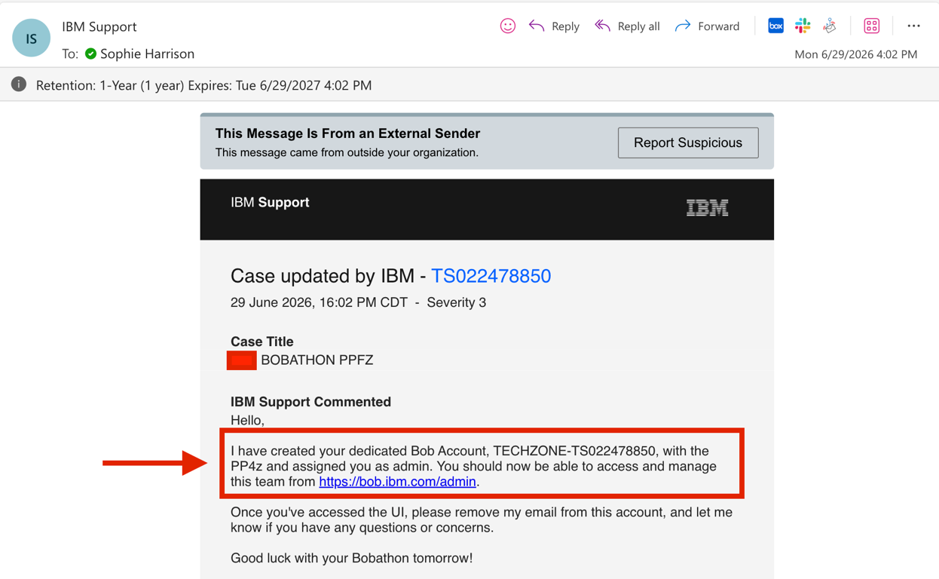

As an admin, you can access the Admin Console at https://bob.ibm.com/admin.
If prompted, sign in using your IBM ID and password.

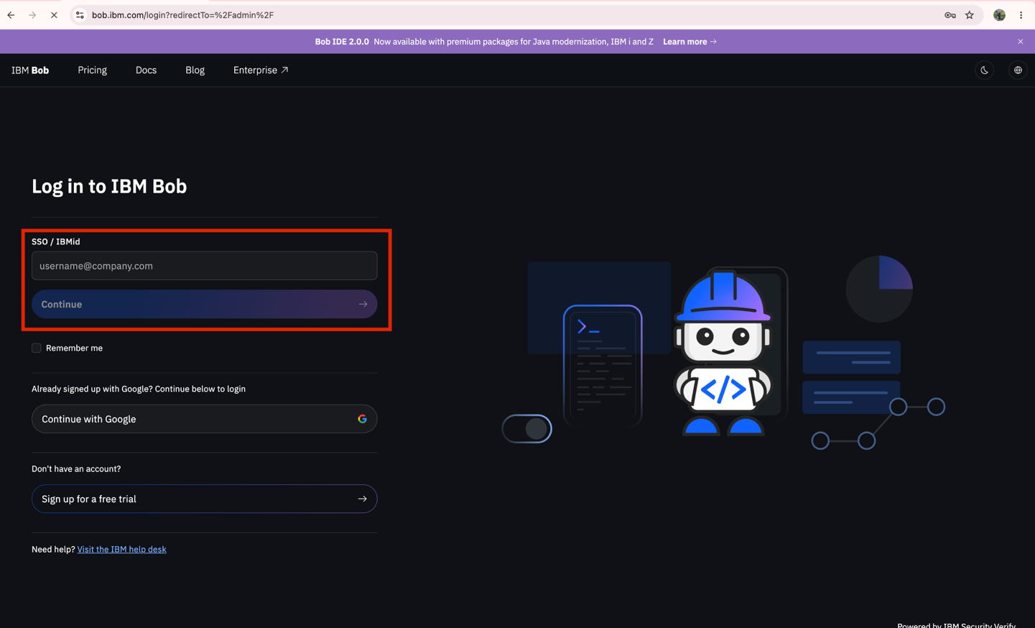

Within the Admin Console, use the team dropdown to switch to the team specified in the support ticket. Once the correct team is selected, click Continue.

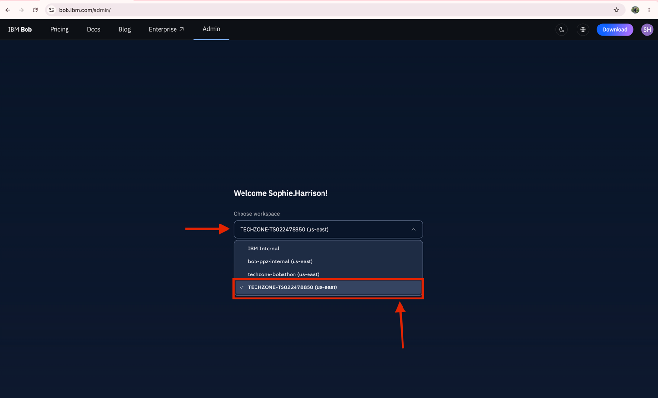

Select the Teams & Users tab from the left-hand menu. Then, select the Users icon in the top-right corner of the screen.

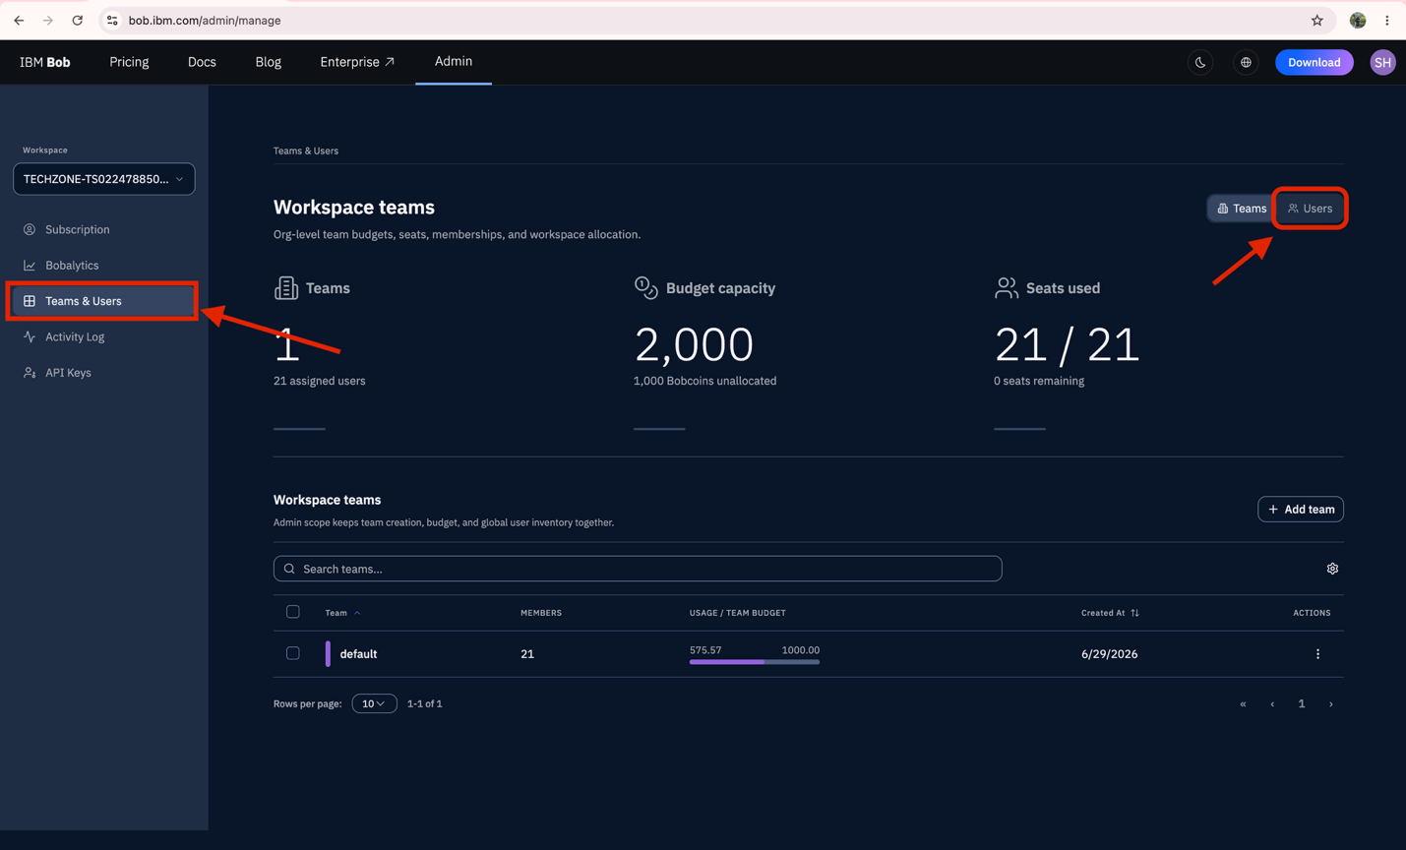

Select the + Users icon on the right of the Workspace users.
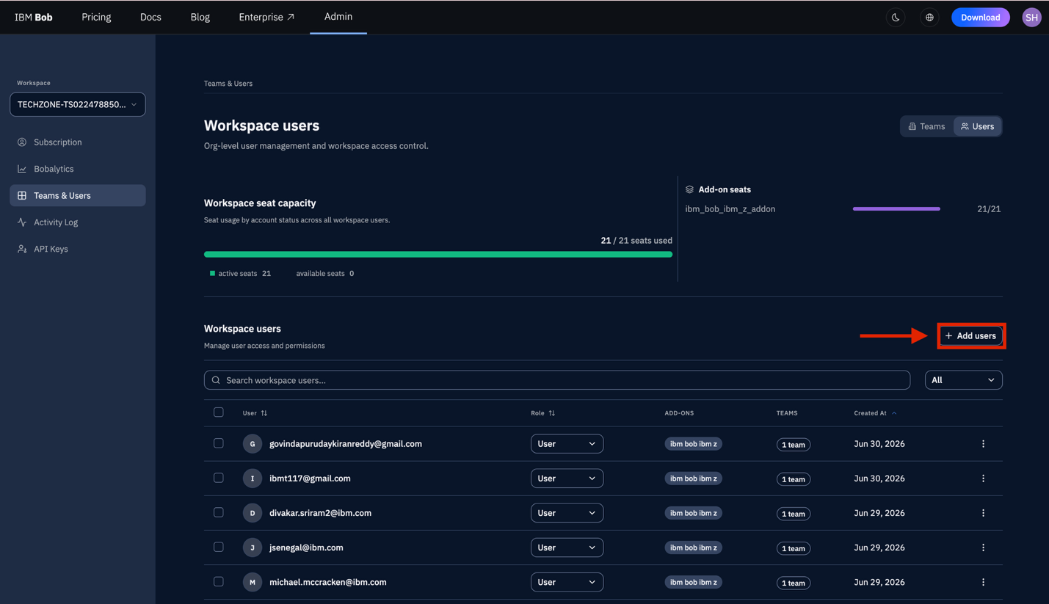

Please complete the following fields, then select Send Invite once finished:

Team | Select the default team or choose the team you created.
Invite by email or Bulk CSV Upload | Enter the email addresses of the users you would like to invite. If a user has not created a trial account yet, they will still receive an email from service@saas.ibm.
Role | Select the appropriate role for each user:  - Member – Recommended for standard users.  - Admin – Grants authorization to add users, add packages, and allocate tokens.
Allocation | Choose how many available tokens each user should have access to. You can either type in a specific number or use the per-member allocation toggle to select an amount.

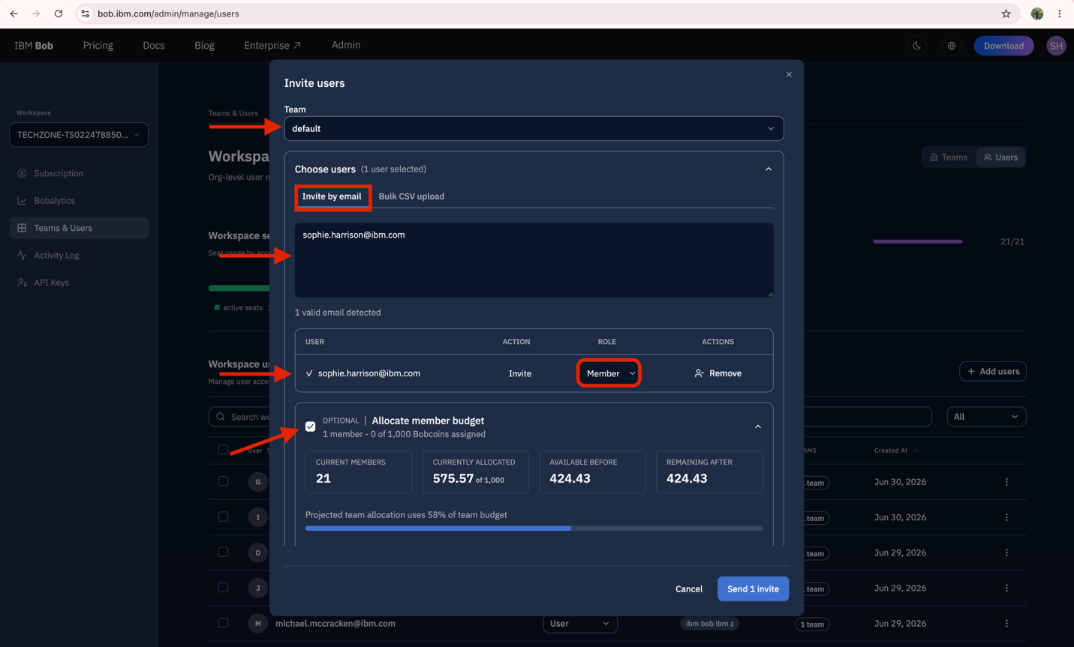
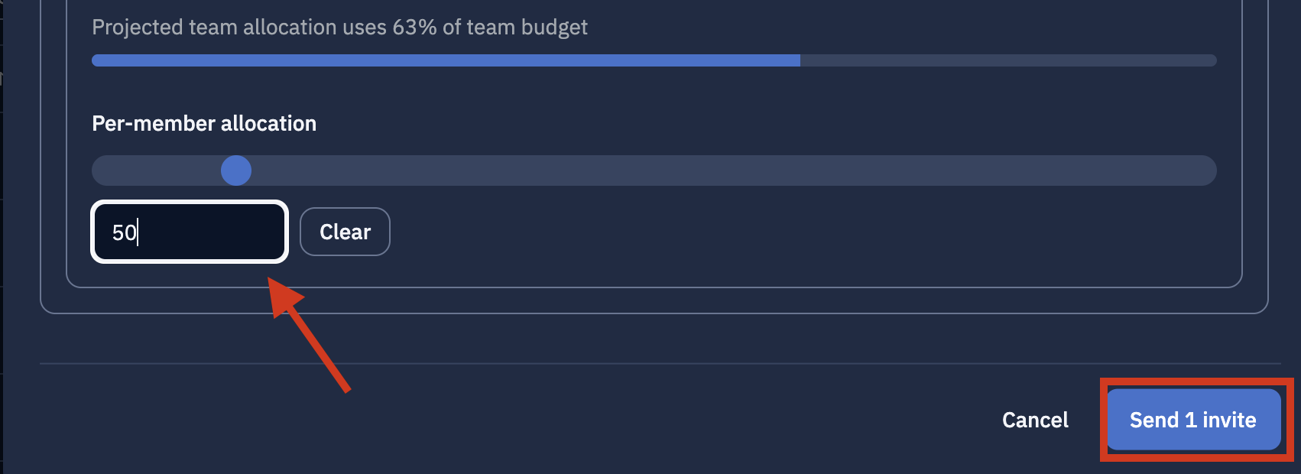

After adding the user, you will be redirected back to the Teams & Users tab. Under Workspace Users, you will see a list of all users you have added.

Important notes:
- You can search for a member using the search bar.
- You can filter users by Admin or Member role.

Find the user in the list. Please note that the Premium Package has not been added to the user yet. Click the email address of the user you would like to update.

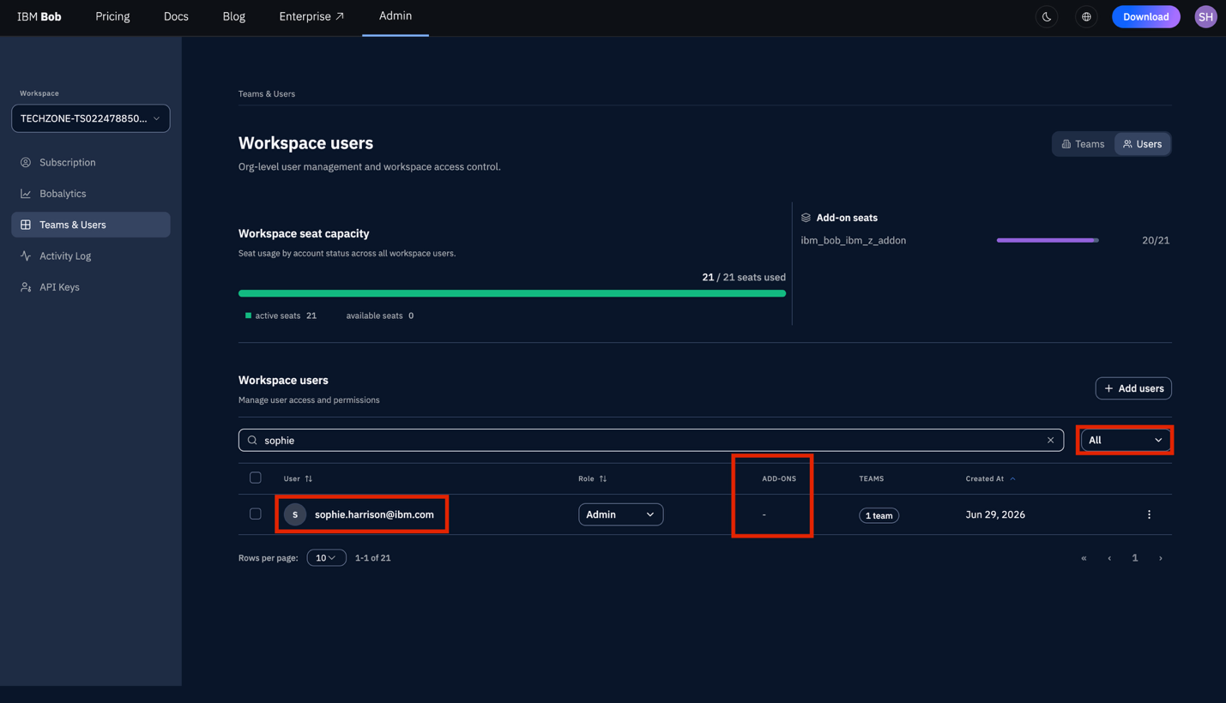

If you have not set an allocation, or need to add or remove tokens, you can update it here by selecting the pencil icon next to the Used / Allocation section under Team Membership.

Then, scroll down to Premium Add-ons.

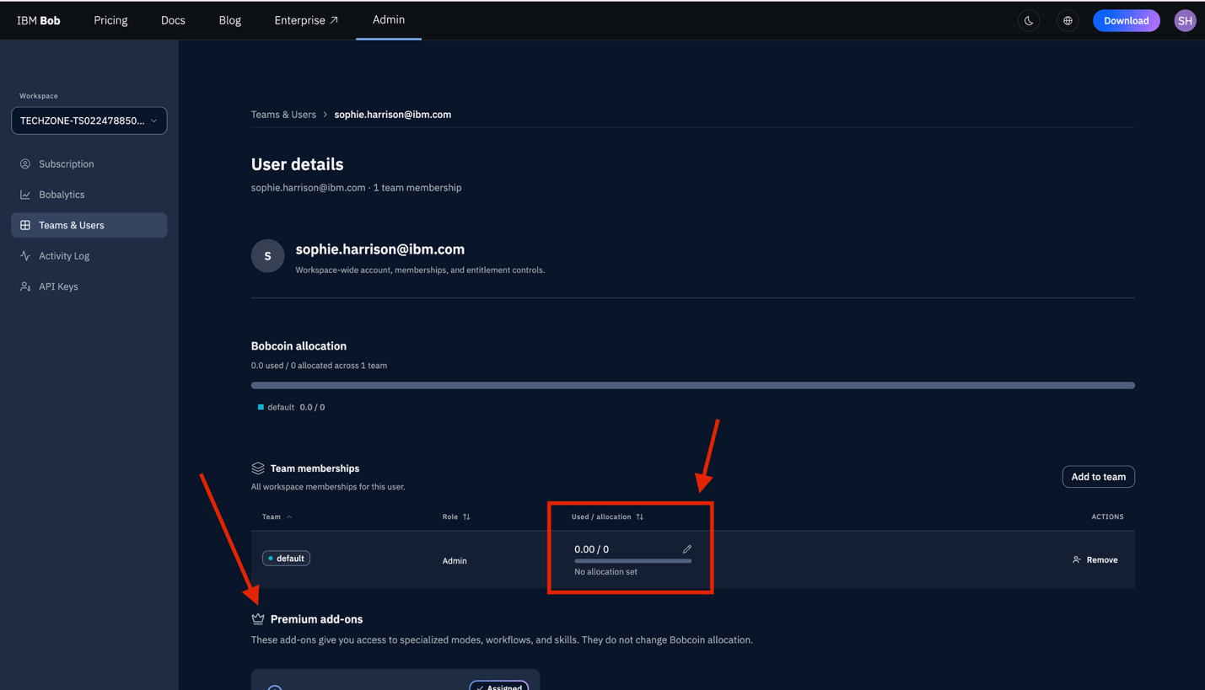

Under the ibm_bob_ibm_z_addon select the Assign button.

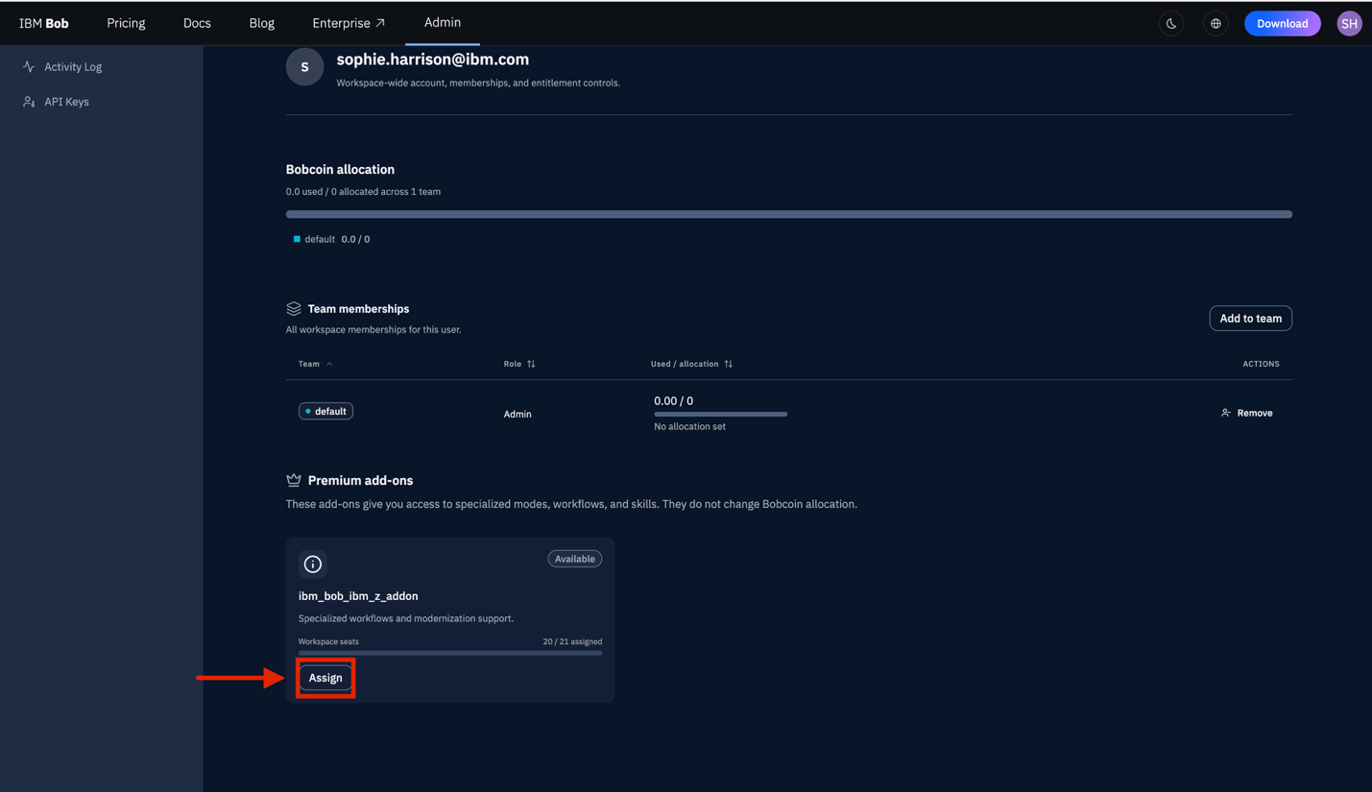

When completed you will see the following:

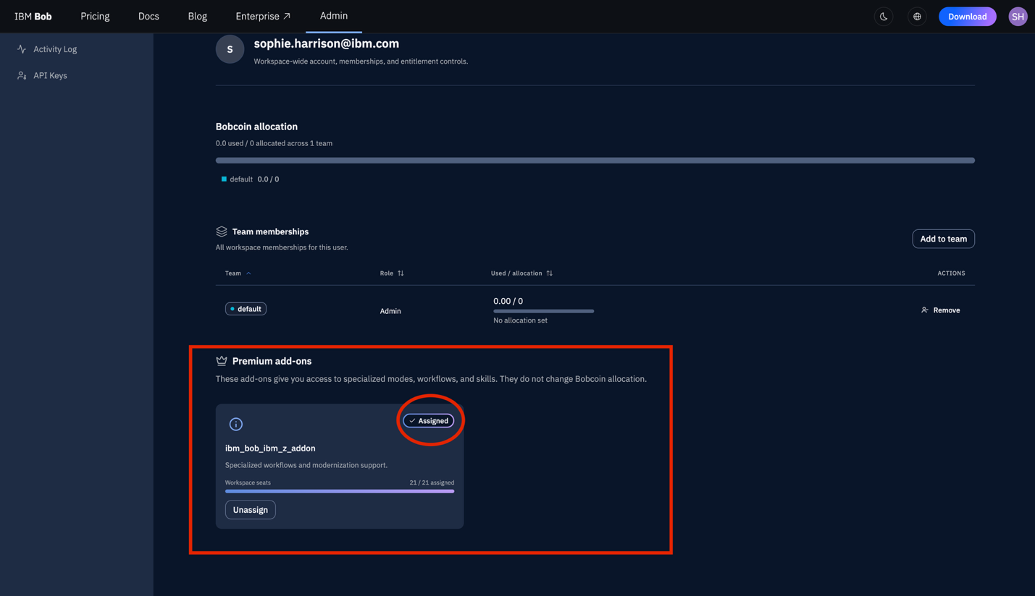

You’ll now see that the premium package will appear in the list of users under the Add-on’s section of each user.
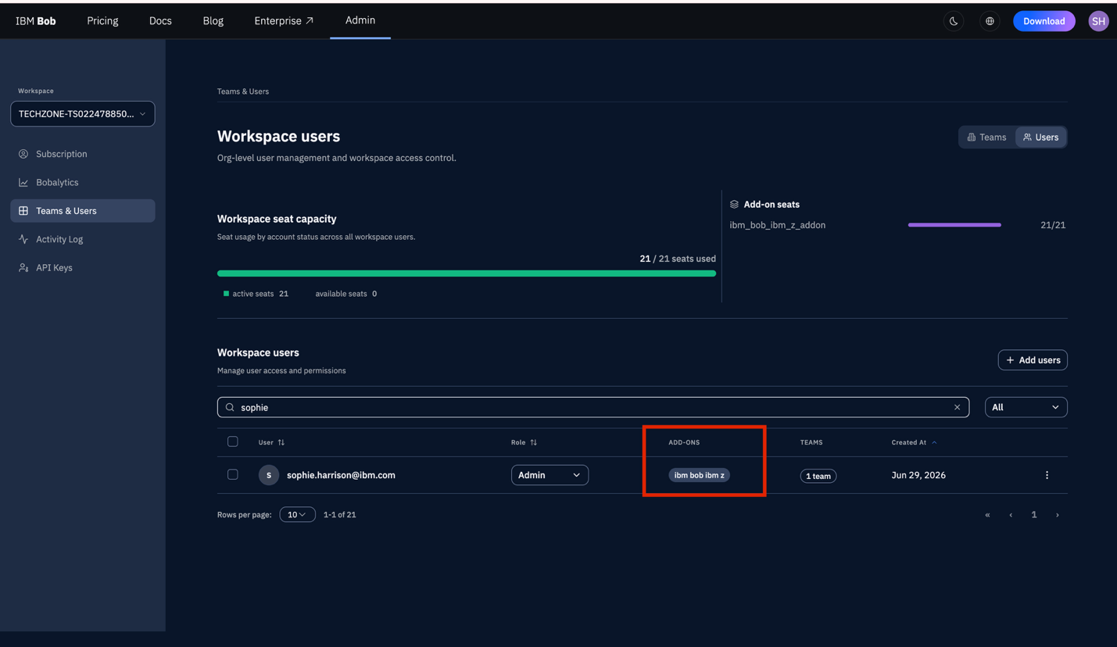

Client Access

Access the Bob UI

Navigate to your email, you should have received an email from service@saas.ibm. Please select the Download Bob icon at the bottom of the email.

The email should resemble the following:

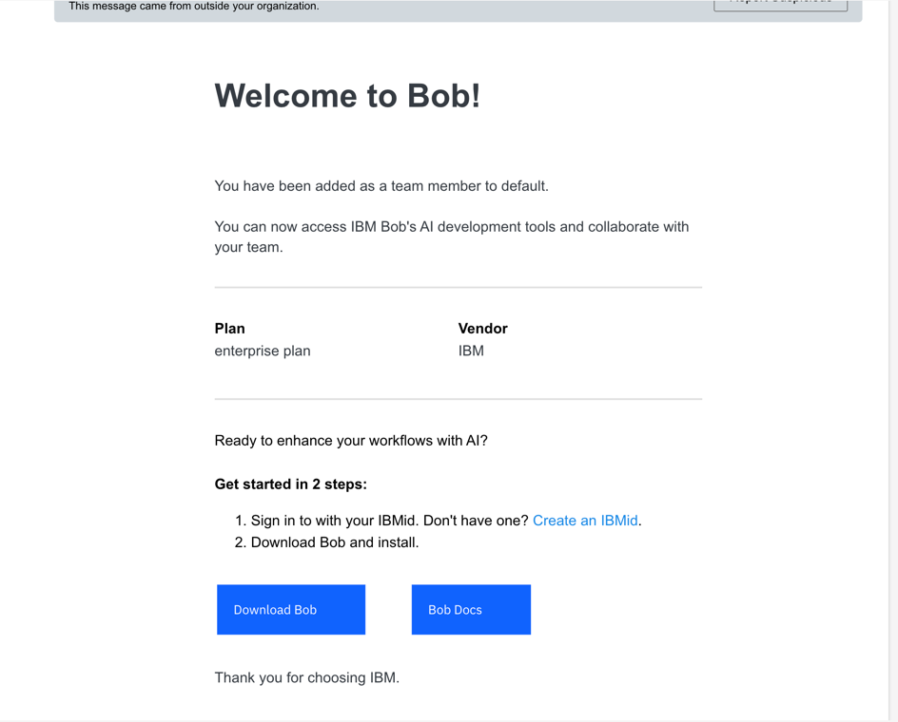

You will be redirected to https://bob.ibm.com/download
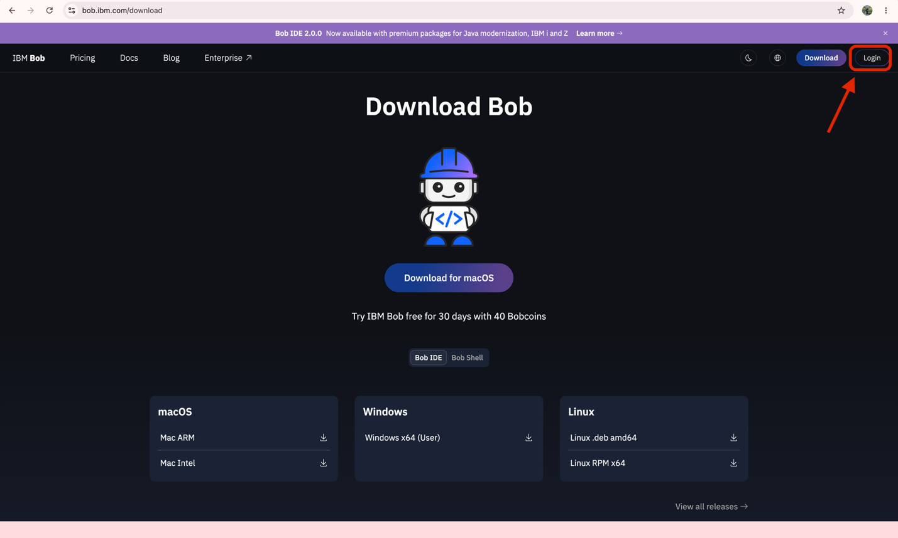

Sign Up or Log In

You will be presented with two options:

Option A: Sign Up (New Users)
If you don't have an IBM account:
- Fill in the required information:
  - Email address
  - Password
  - First and Last name
  - Country/Region
- Accept the Terms and Conditions
- Click "Next"
- Verify your email address by clicking the link sent to your inbox

Option B: Log In (Existing IBM Account)
If you already have an IBM account:
- Click on the "Log In" button
- Enter your IBM account credentials:
  - Email address
  - Password
- "Click "Log In"
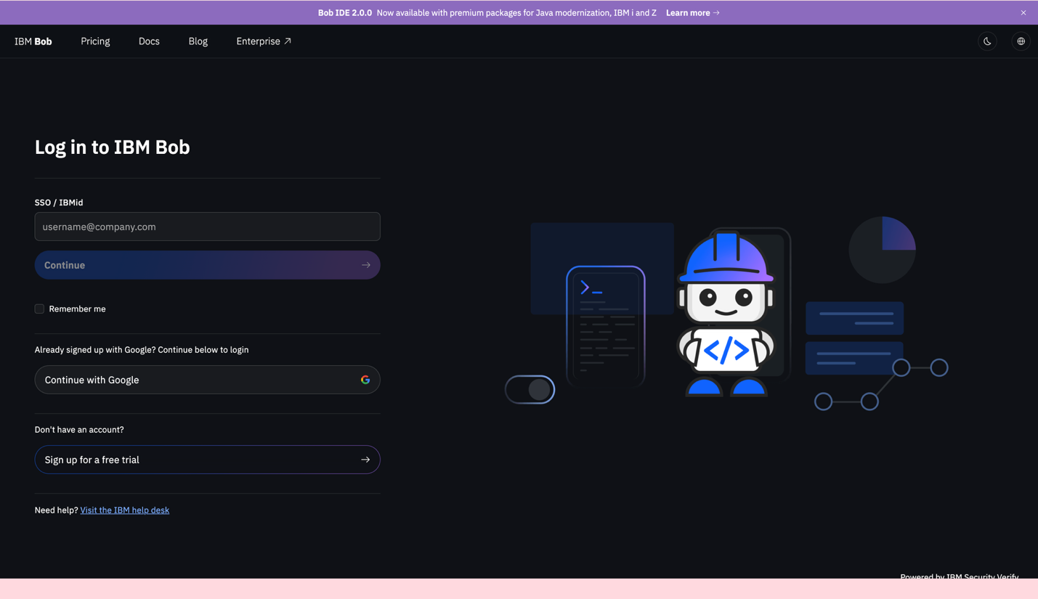

Download Bob

Access the Download Page. After successfully logging in or signing up, you will be automatically redirected to the Bob download page.

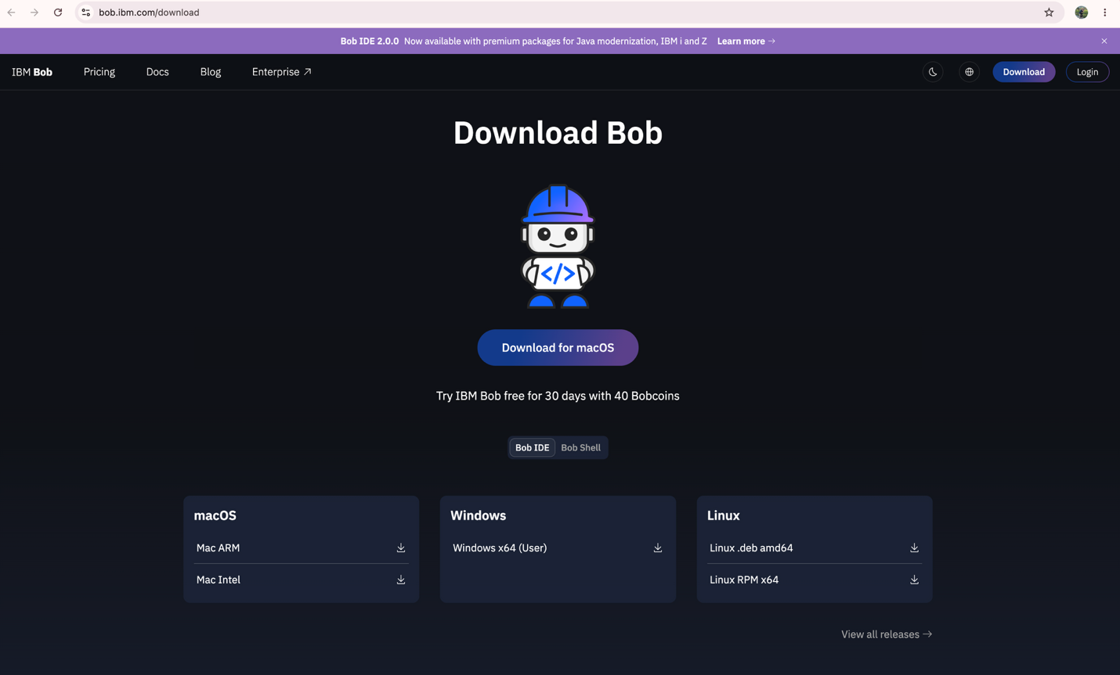

Select Your Operating System
The download page will typically detect your operating system automatically. If not, select your platform:
- Windows (Windows 10 or later)
- macOS (macOS 10.15 or later)
- Linux (Various distributions supported)

Download the Installer
- Click the "Download Bob" button for your operating system
- The installer file will begin downloading to your default downloads folder
- Wait for the download to complete
File Names by Platform:
- Windows: IBM-BobUserSetup-x.x.x.exe
- macOS: IBM-Bob-darwin-xxx-x.x.x+bobx.x.x.pkg
- Linux: IBM-Bob-linux-x.x.x.AppImage or .deb/.rpm

Install Bob

Windows Installation
- Locate the downloaded IBM-BobUserSetup-x.x.x.exe file in your Downloads folder
- Double-click the installer file
- If prompted by User Account Control (UAC), click "Yes" to allow the installation
- Follow the installation wizard:
  - Accept the license agreement
  - Choose installation location (default recommended)
  - Select additional options if prompted
- Click "Install"
- Wait for the installation to complete
- Click "Finish" to launch Bob

macOS Installation
- Locate the downloaded IBM-Bob-darwin-xxx-x.x.x+bobx.x.x.pkg file in your Downloads folder
- Double-click the PKG file to start the installer
- Follow the installation wizard:
  - "Continue" to proceed
  - Review and accept the license agreement
  - Select the installation destination (default recommended)
  - Click "Install"
- If prompted, enter your macOS administrator password
- Wait for the installation to complete
- Click "Close" when installation finishes
- Launch Bob from your Applications folder or Launchpad
- If prompted with a security warning:
  - Go to System Preferences > Security & Privacy
  - "Click "Open Anyway" for Bob
- Bob will launch and may request necessary permissions

Linux Installation
For .deb packages (Ubuntu/Debian):
sudo dpkg -i Bob-x.x.x.deb sudo apt-get install -f
For .rpm packages (Fedora/RHEL):
sudo rpm -i Bob-x.x.x.rpm
For AppImage:
chmod +x Bob-x.x.x.AppImage ./Bob-x.x.x.AppImage

Launch BOB

When Bob launches for the first time, you may be asked to:
- Log in with your IBM account credentials
- Grant necessary permissions (file access, etc.)

Please select the Log In button within the chat window on the right.

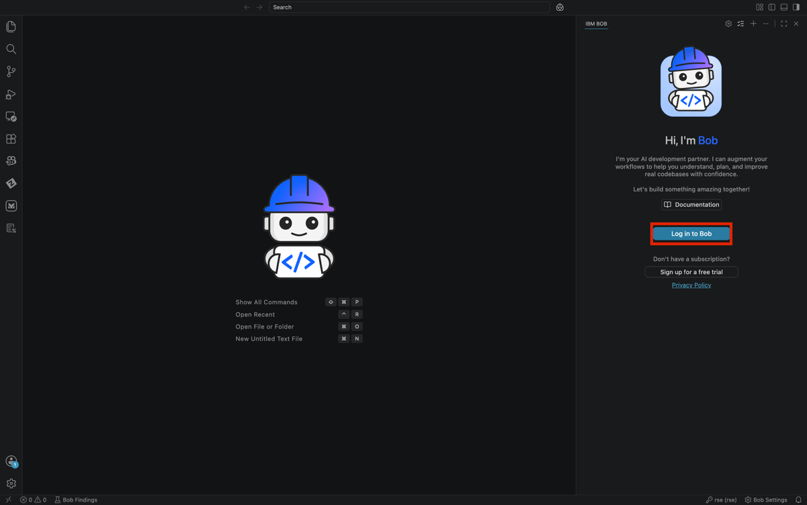

Please select the Open option, this will redirect you to the sign in window.
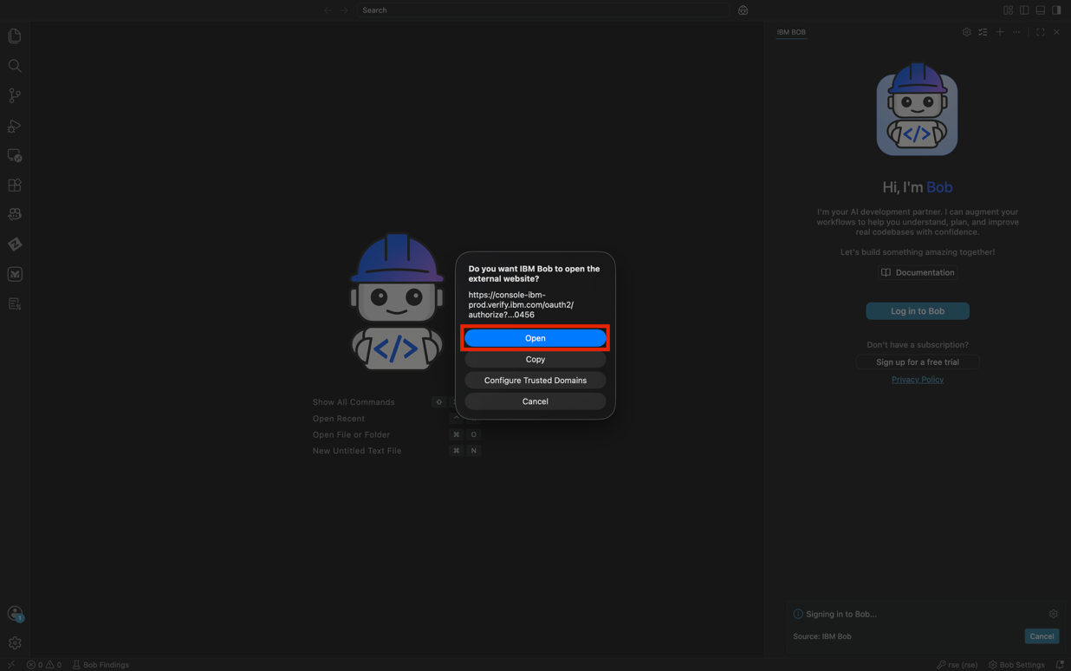

You will sign in with the email and password created in the Sign Up or Log In section of this guide.

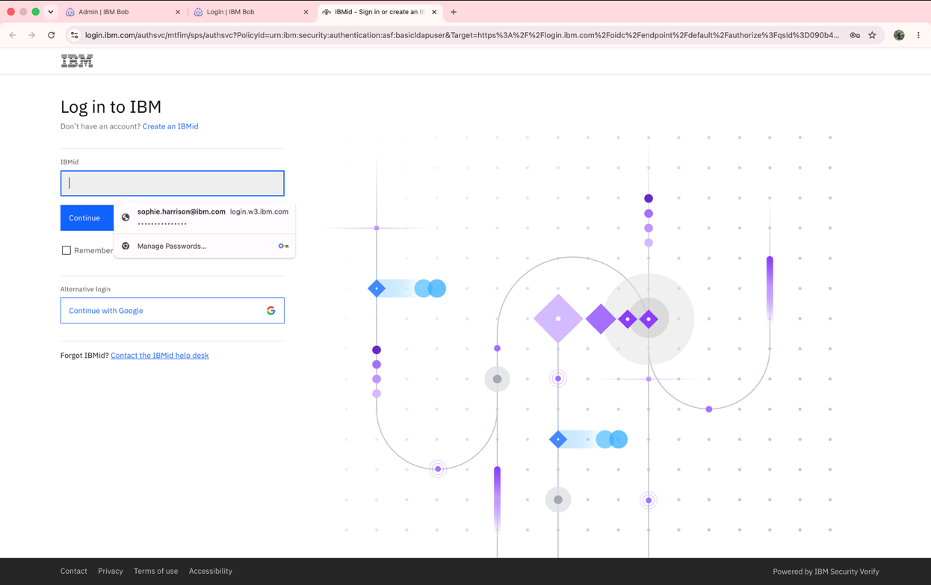
Once completed you will be redirected back to IBM Bob
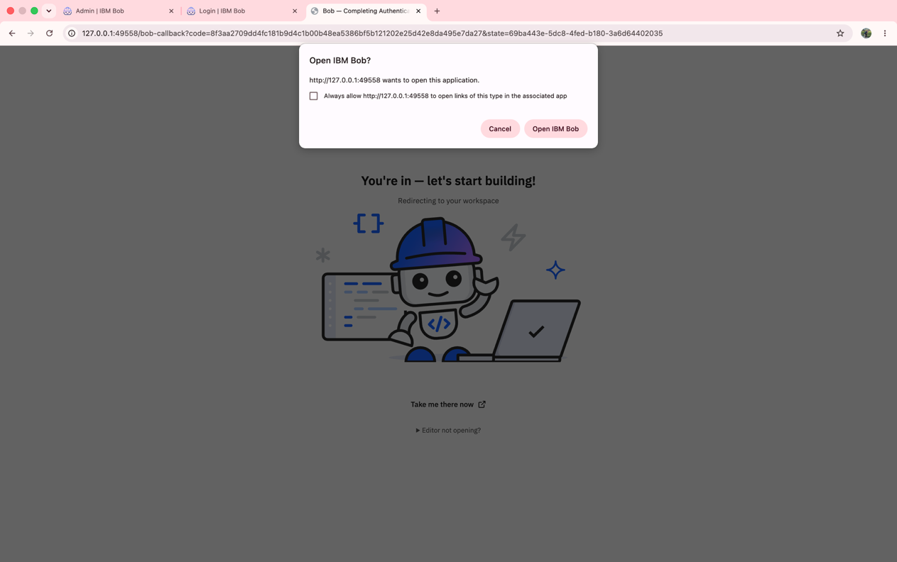

Congratulations you have signed in! Please take note of the chat window on the right.
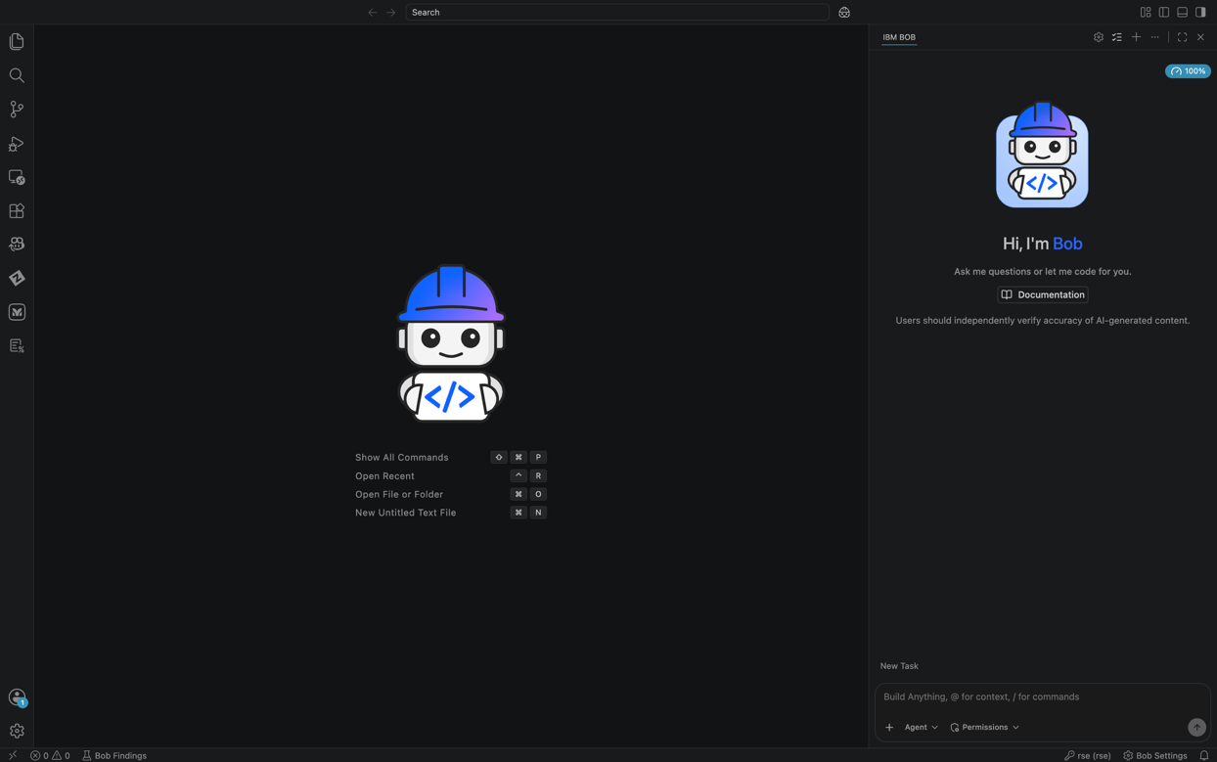

Premium Package for Z

Switch to the Bob for Z Team

Please select the wheel icon on the top of the chat window to access the settings.

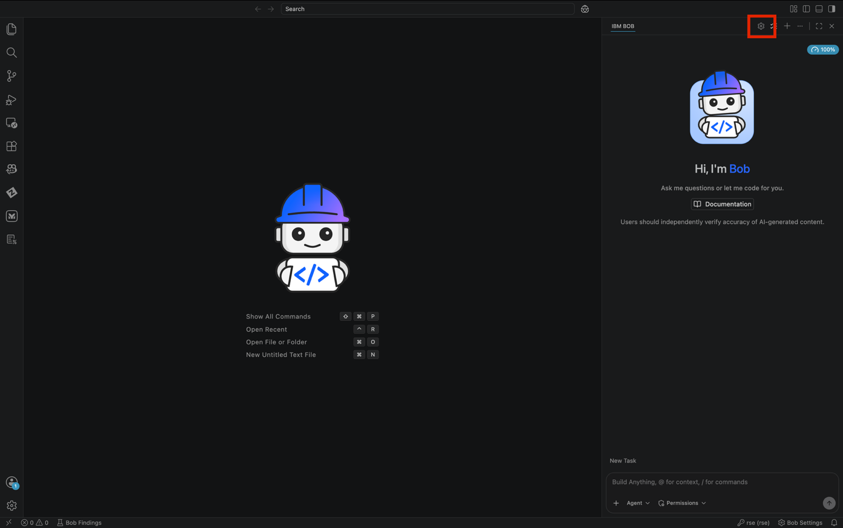

Under the settings, please select the general tab. There will be a section called Team, this contains a drop down, please select this.

At the moment you may your team name as IBM-trial or another name.

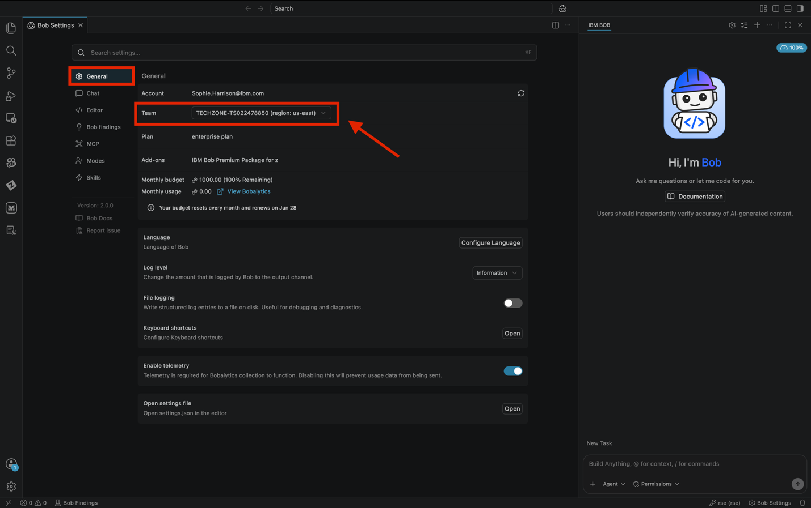

Under the drop down please select the team name your instructor has provided.

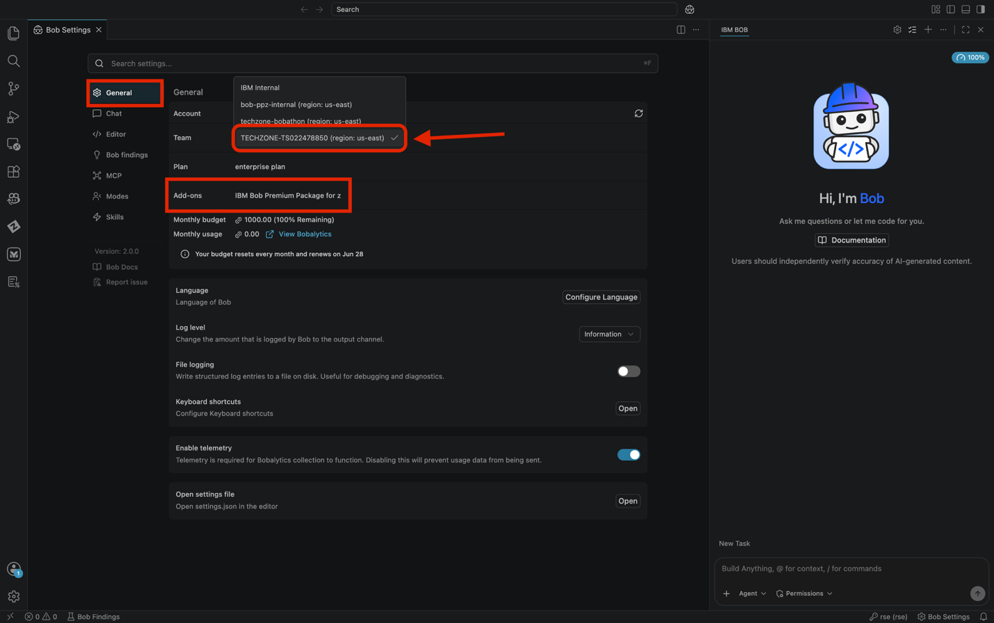

Once you select the provided team you may receive a notification asking to install the premium package, if prompted please select “Install”.

Within the chat window please select the Agent icon located on the bottom left. You will see the addition of Z Code and Z Architect mode.

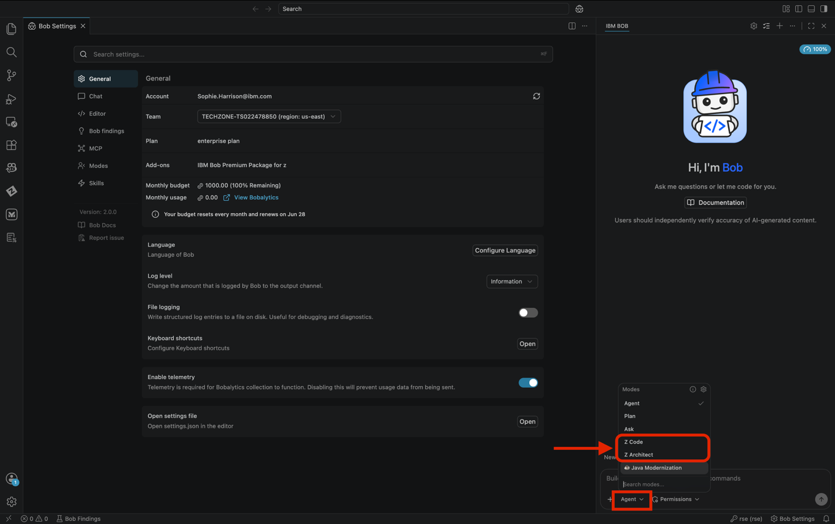

Troubleshooting

Installation Issues and Solutions

Issue | Solution
Issue: Installation blocked by security software | Solution:  - Temporarily disable antivirus software during installation  - Add Bob to your security software's whitelist  - Re-enable security software after installation
Issue: Cannot log in after installation | Solution:  - Verify your IBM account credentials  - Check if your account email is verified  - Reset your password if necessary at https://www.ibm.com
Issue: Bob won't launch (macOS) | Solution:  - Go to System Preferences > Security & Privacy  - Click "Open Anyway" for Bob  - Grant necessary permissions when prompted
Issue: The BOB Launched but chat window does not appear in the IDE (macOS) | - Reach out to IBMers for solution.
Issue: Permission errors (Linux) | Solution:  - Ensure you have proper permissions  - Run installation commands with sudo  - Check file permissions: chmod +x Bob-x.x.x.AppImage
Issue: Download fails or is interrupted | Solution:  - Check your internet connection  - Try downloading again  - Clear your browser cache and retry

