DILGR8RSP
User Manual
Recruitment, Selection, and Placement System
A walkthrough of the Recruitment, Selection, and Placement system for the three people who use it: the applicant filling out a profile, the administrator running the pipeline, and the panel member scoring an interview.

About this manual
DILGR8RSP runs the DILG's hiring pipeline end to end — from a candidate's first login through sifting, examination, panel interview, compliance, and oath‑taking. Three roles share the system, and each sees only what their part of the process needs.
This manual is organized the same way: one part per role. If you only need one, use the contents on the left to jump straight there — each part stands on its own.
Who this manual covers
Applicant: Registers, builds a profile, applies to postings, and tracks a single application through every stage.
Admin: Posts jobs, screens candidates, runs the exam and interview pipeline, and manages every account in the system.
Panel: Scores assigned applicants against the interview rubric and reviews their Personal Data Sheet.

PART I FOR APPLICANTS
From your first visit to the site through submitting an application and watching it move through the pipeline.

Step 1 — Create an account
Open the system and click Register on the login screen. Registration is a single guided flow of five steps — account, demographic profile, learning & development, awards, and documents — and you can only reach the job listings once it's complete.
Enter your email and a password of at least 8 characters, then continue. This creates your account immediately; the remaining steps build out your applicant profile.
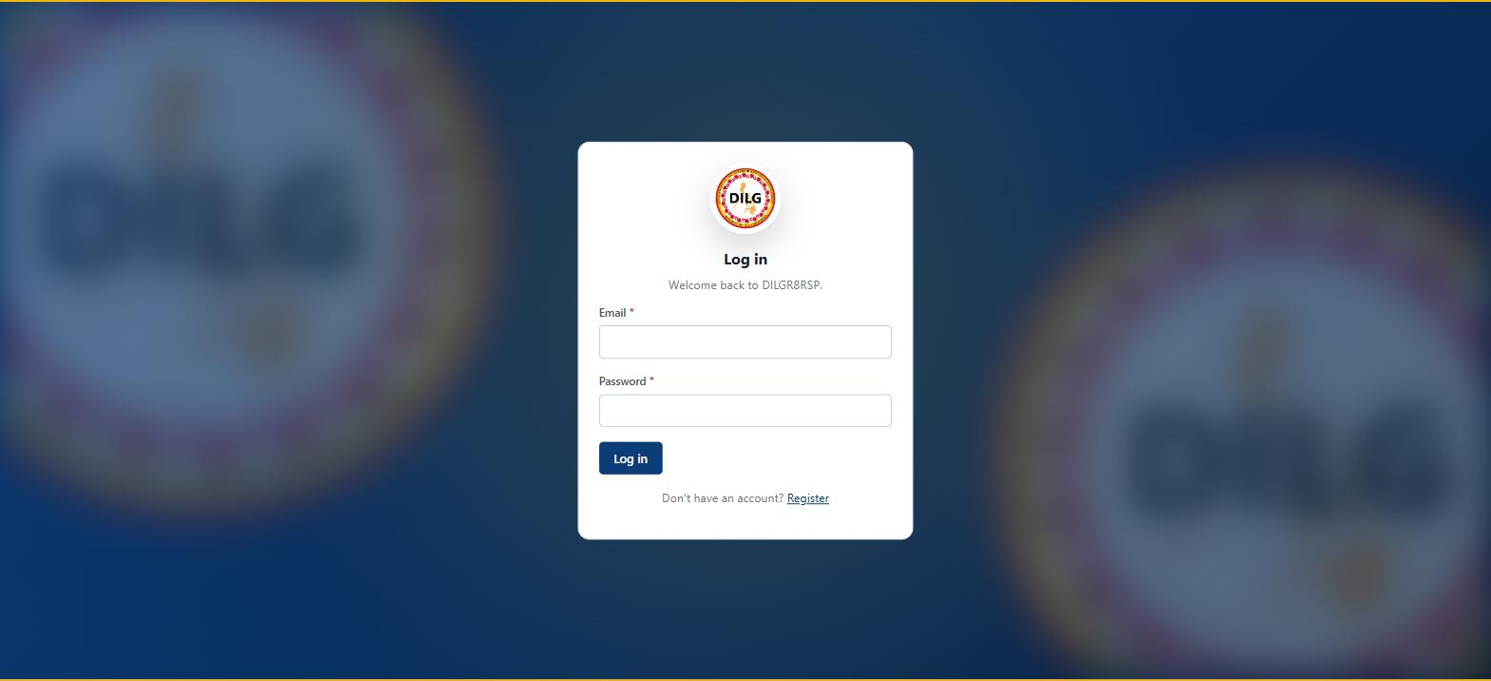
Fig. 1 — Login screen — existing applicants sign in here; new applicants follow the Register link

Step 2 — Fill in your Demographic Profile
Once your account exists, the wizard moves to your profile. Fields marked with a red asterisk — first name, last name, date of birth, contact number, and address — are required before you can continue.
If you hold a civil service eligibility, check &ldquo;I have a civil service eligibility&rdquo; to reveal the eligibility type field. Leaving it unchecked doesn't block you from registering — it just means your application is subject to manual validation by the administrator later, exactly as the on-screen notice explains.
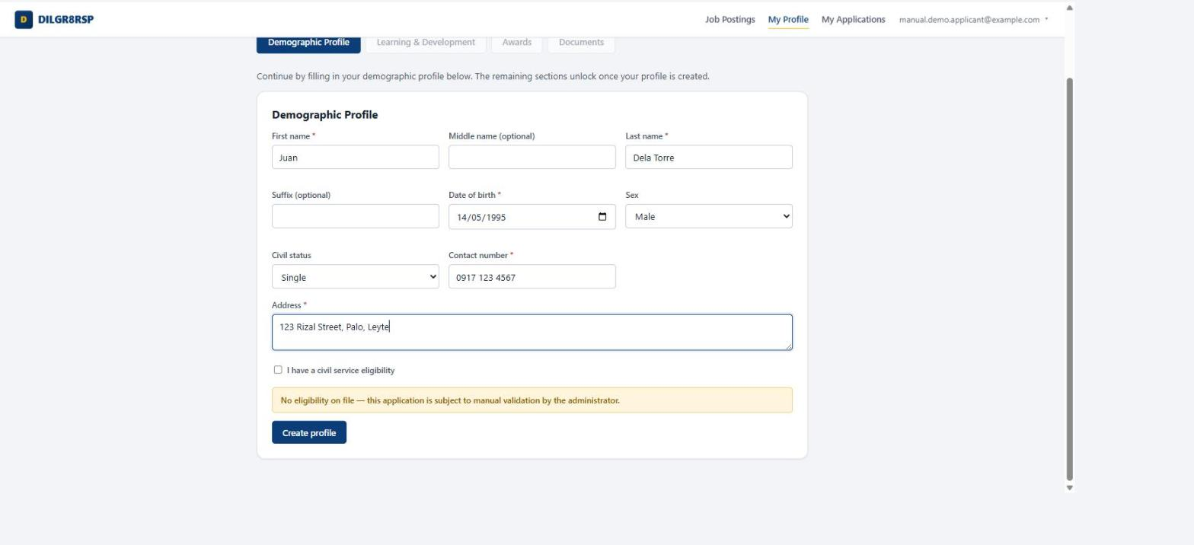
Fig. 2 — Demographic Profile — required fields are marked with a red asterisk

Step 3 — Add Learning & Development records
This step is optional — skip it entirely if you have no seminars or training to declare. For each entry you do add, you'll attach proof (a certificate of attendance, as PDF/JPEG/PNG) directly alongside it, since a claim without proof won't count toward your registration.
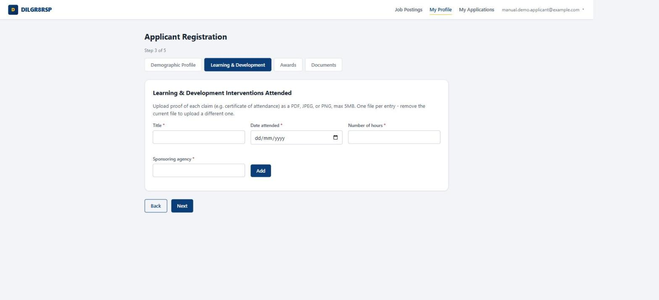
Fig. 3 — Learning & Development — optional, one proof file per entry

Step 4 — Add Awards or Commendations
Also optional, and structured the same way as Learning & Development: a title, the date awarded, the issuing body, and one proof file per award you list.
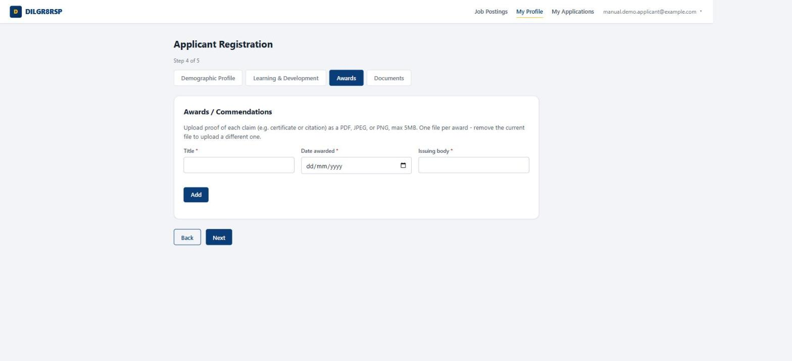
Fig. 4 — Awards / Commendations — also optional, same one-proof-per-entry rule

Step 5 — Upload your documents
The final step lists the full official checklist. Two are always required before you can finish registering:
Everything else on the checklist — performance rating, certificate of eligibility, transcript, diploma, and so on — is optional or only required if it applies to you (an eligibility certificate, for instance, is only required if you checked the eligibility box in Step 2). Your Application Letter isn't uploaded here at all: since it's addressed to a specific vacancy, you attach it later, when you actually apply.
Pick a document type, choose a file, and click Upload. Uploading a new file for a type you've already submitted replaces it — each type represents one current document, not a growing list.
- Required Personal Data Sheet (PDS) — PDF copy
- Required Personal Data Sheet (PDS) — Excel (CS Form 212) copy
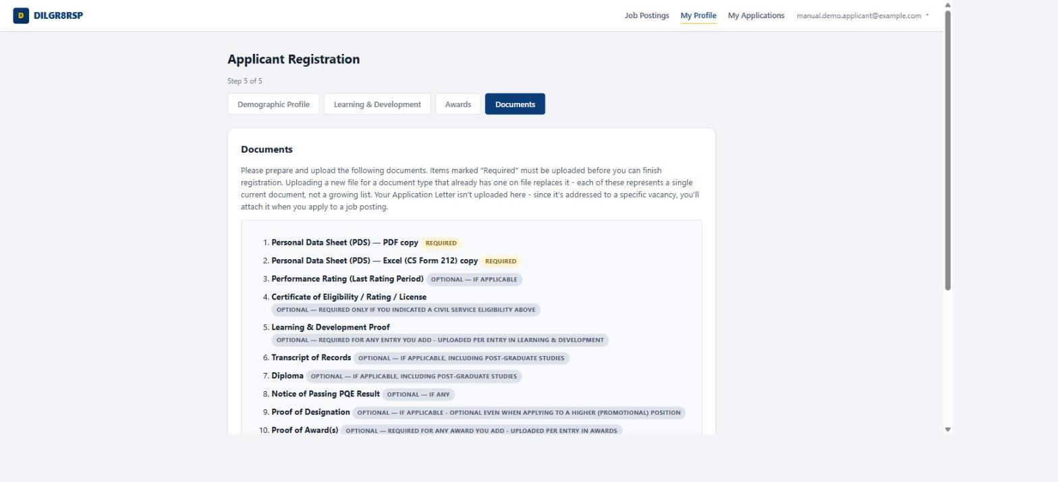
Fig. 5 — The full documents checklist — only the two PDS copies are always required

Step 6 — Browse job postings
Finishing registration takes you straight to the open postings. Each card shows the salary grade, monthly salary, and closing date at a glance.
If a posting requires a civil service eligibility you don't hold on file, its button reads Not eligible instead of Apply, with a note on exactly which eligibility is required — so you know before you try, not after a rejection.
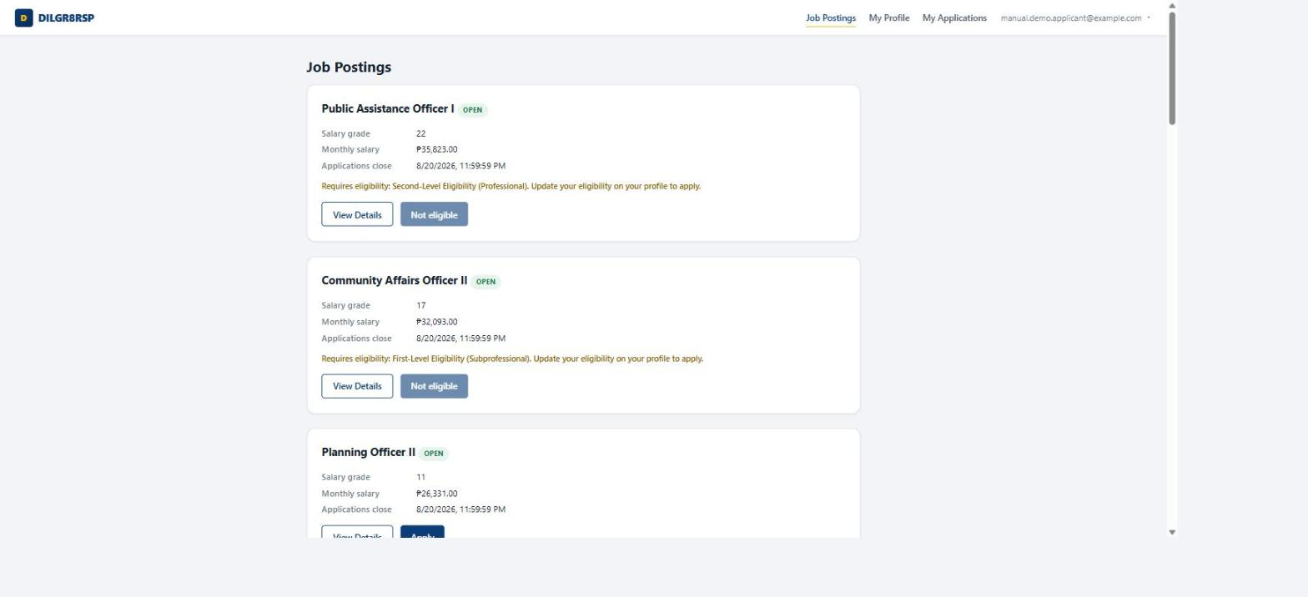
Fig. 7 — Job Postings — eligibility gating shows &ldquo;Not eligible&rdquo; before you waste a click

Step 7 — Read the full posting details
View Details opens the complete qualification standards — education, training, experience, eligibility — along with plantilla number, place of assignment, and the full list of duties and responsibilities, exactly as the official posting document lists them.
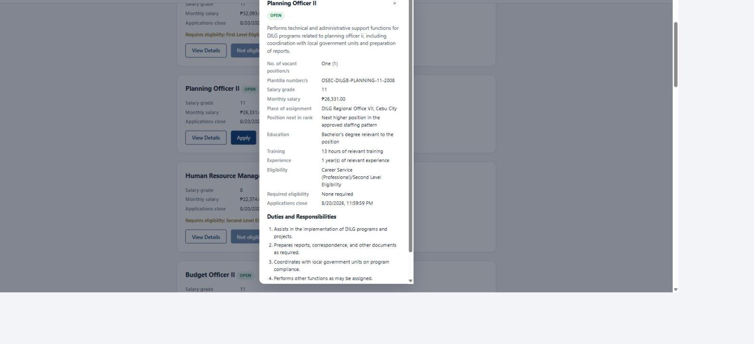
Fig. 8 — Posting details — the full qualification standards, straight from the official posting

Step 8 — Submit an application
Clicking Apply shows exactly who your Application Letter should be addressed to — the Regional Director, through the Human Resource Section head — and asks for the letter itself (PDF, JPEG, or PNG). This is the one document tied to this specific application rather than your general profile.
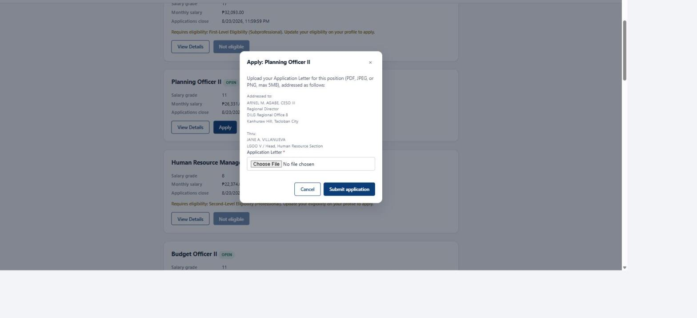
Fig. 9 — Applying — the Application Letter is the only document you attach at this step

Step 9 — Track your application
The My Applications page shows every application you've submitted against a seven-stage tracker, so you always know exactly where you stand.
- Submitted
- Sifting
- Pre-Qualifying Examination
- Evaluation of Applicants
- Compliance to Requirements
- Oath-Taking
- Hired
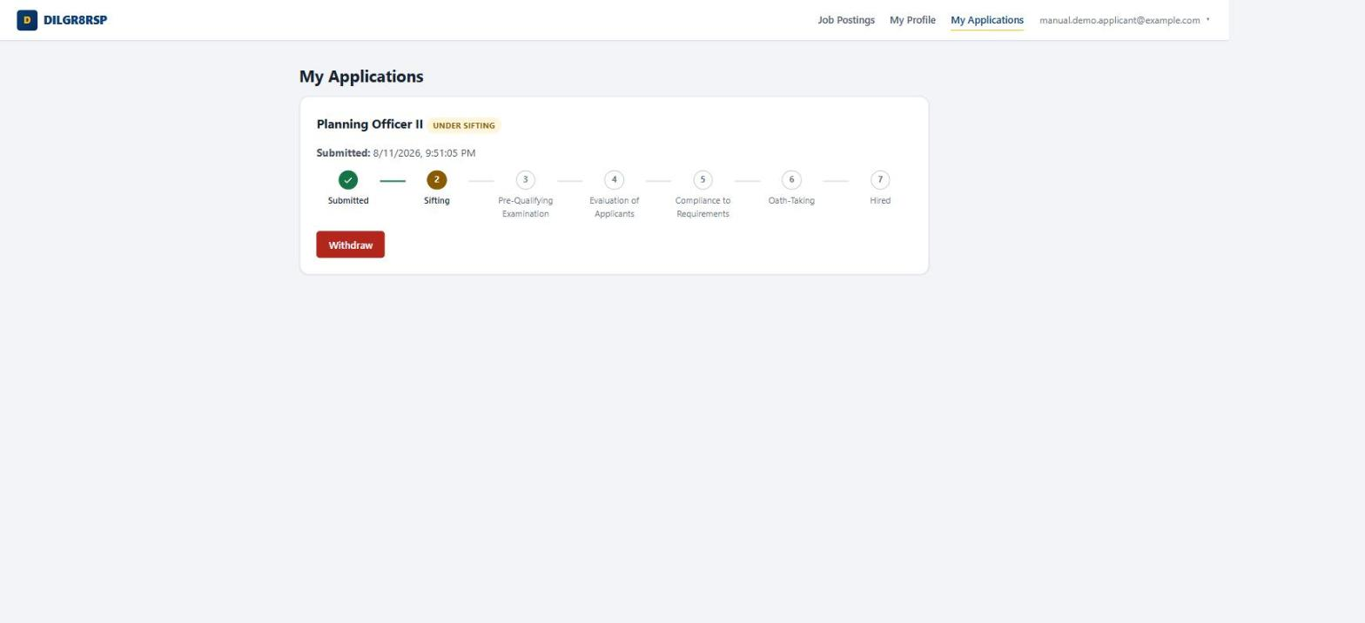
Fig. 10 — My Applications — this application has just entered Sifting

PART II FOR ADMINISTRATORS
Post the job, run the pipeline from sifting through interview scheduling, and manage every account and record along the way.

Step 1 — Start at the Dashboard
The Dashboard is the admin landing page: total applicants, job postings, applications, and users at a glance, a breakdown of applications by pipeline stage, the top postings by application count, and a feed of recent activity below the fold.
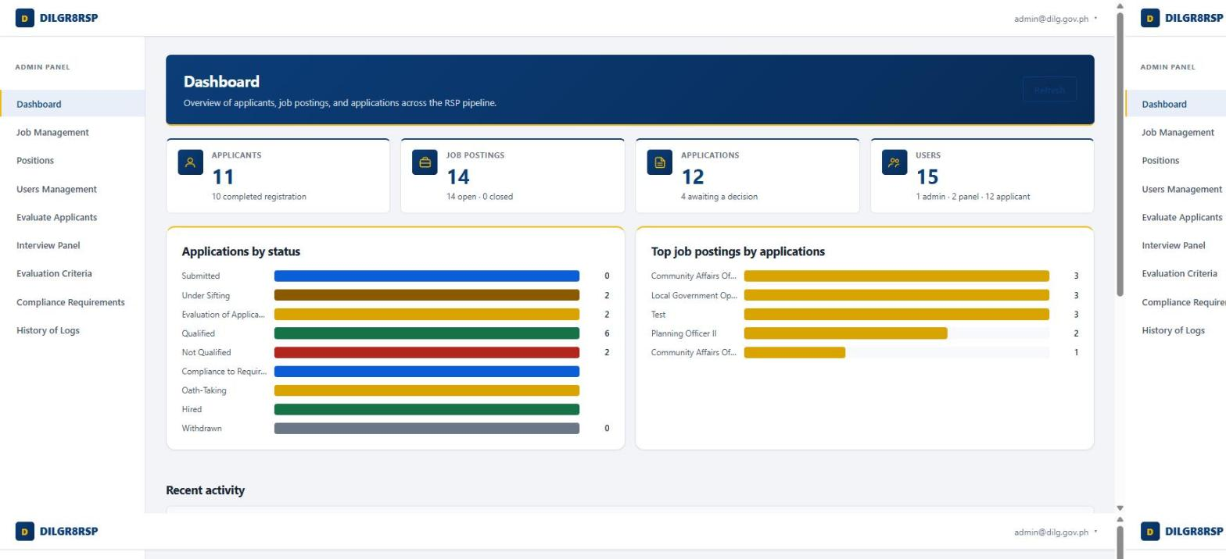
Fig. 11 — Dashboard — the admin landing page

Step 2 — Post and manage jobs
Job Management is where postings get created, edited, and closed. A posting captures every field the official document does — salary grade, plantilla number, place of assignment, duties — plus which civil service eligibilities, if any, an applicant needs to apply.
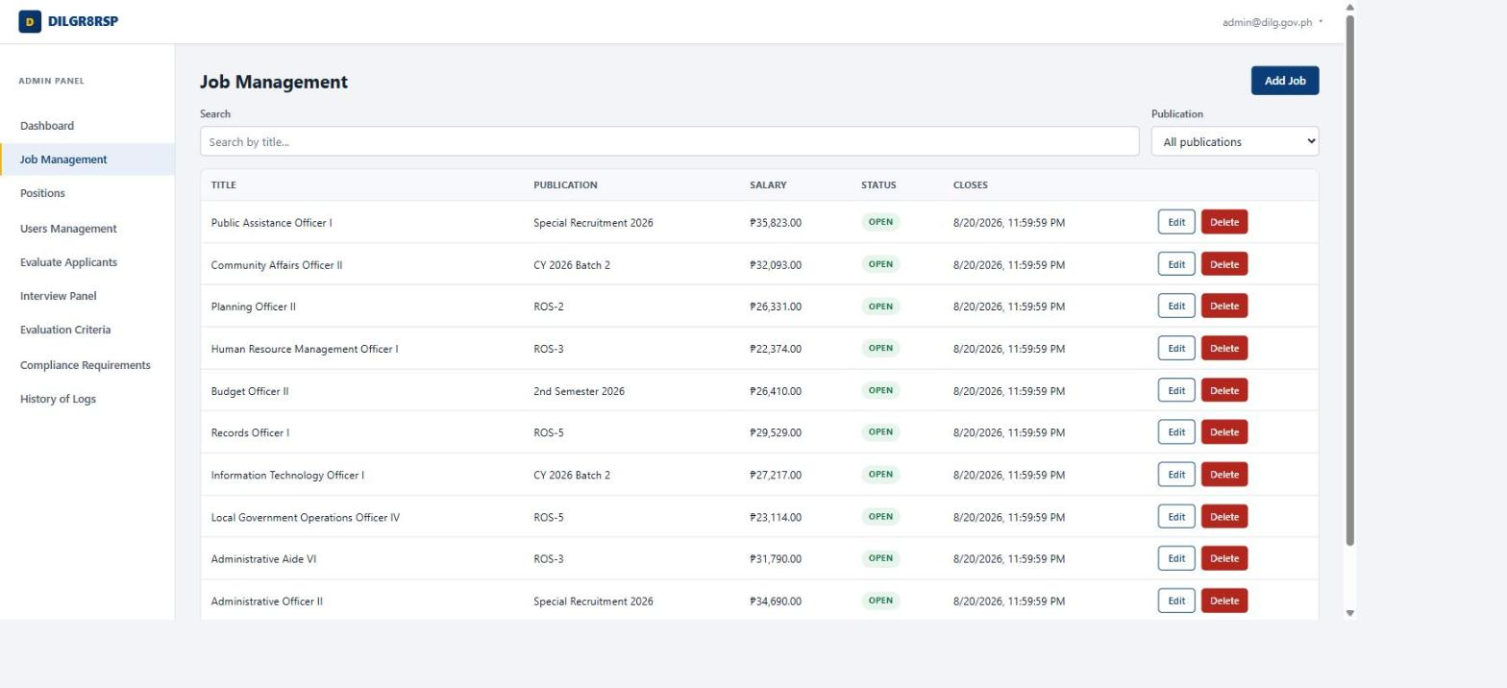
Fig. 12 — Job Management — every open posting, with Edit / Delete per row

Step 3 — Set up reusable Positions
A Position is a reusable template — a title you can pick from a dropdown instead of retyping, optionally carrying its own default panel of interviewers. Create a posting from a Position and that default panel is assigned to its interview board automatically, the moment the posting exists.
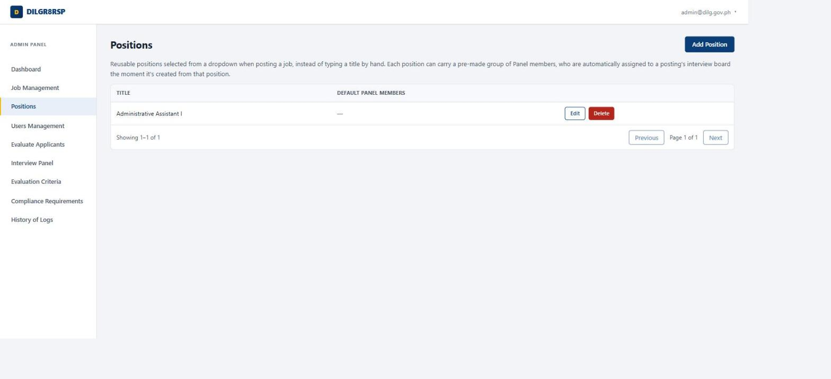
Fig. 13 — Positions — reusable titles that can carry a default interview panel

Step 4 — Manage accounts, including Panel accounts
Users Management is the only place Admin and Panel accounts get created — applicants always register themselves. Click Add User, choose a role, and set a password directly; there's no separate invitation step.
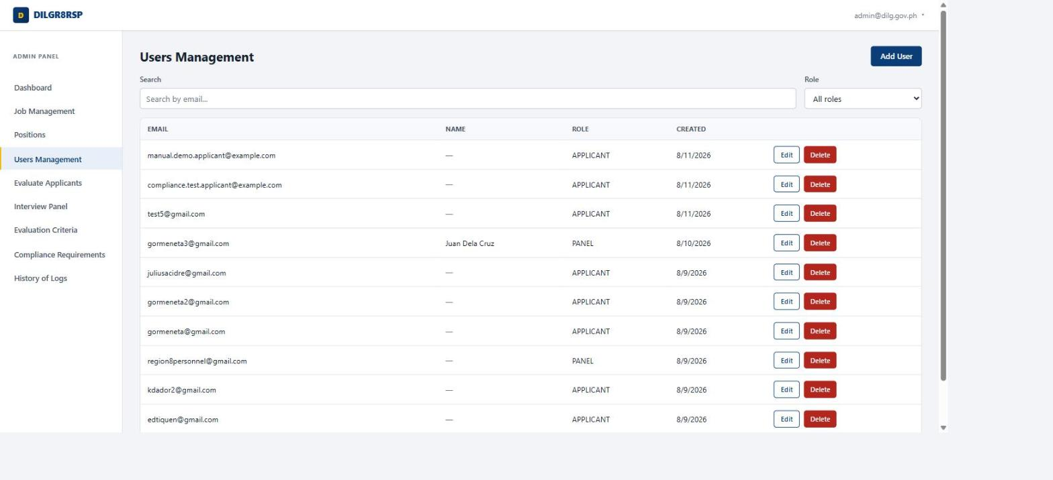
Fig. 14 — Users Management — every account in the system, filterable by role
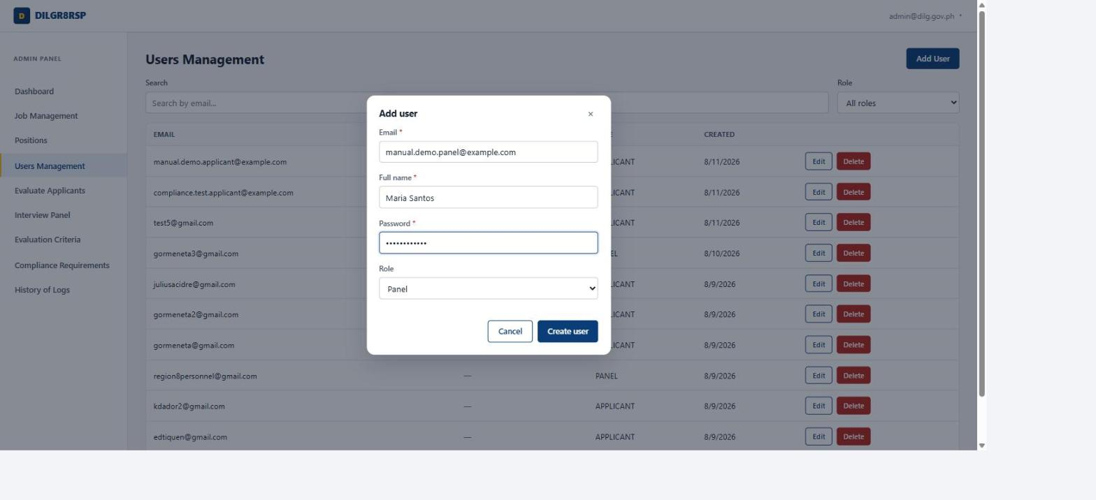
Fig. 15 — Adding a new Panel account — the same form creates Admin accounts too

Step 5 — Sift an application
Every submitted application lands in Evaluate Applicants already Under Sifting. Click Sift on a row to record whether the applicant meets the posting's qualification standards, with an optional remark.
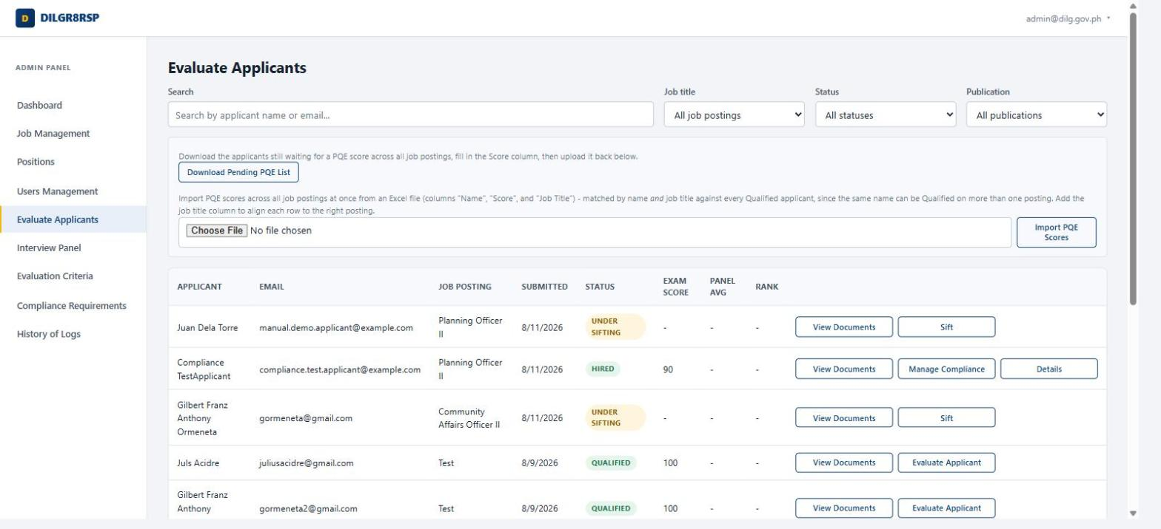
Fig. 16 — Evaluate Applicants — every application, across every posting, in one table
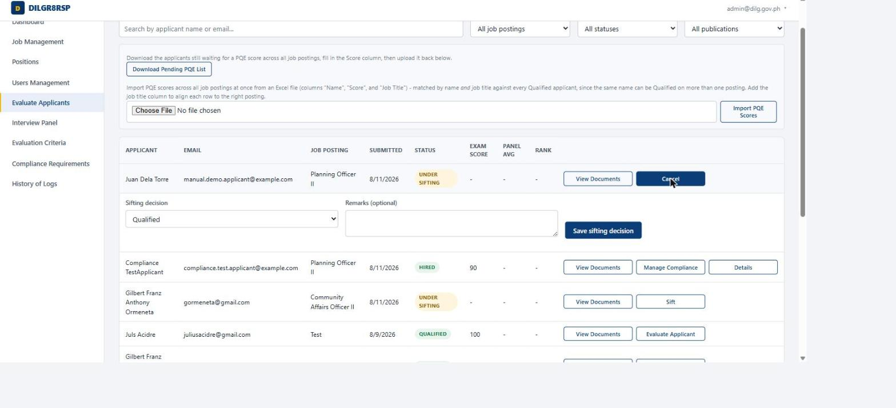
Fig. 17 — Recording a sifting decision — opens inline, right below the row

Step 6 — Record a Pre-Qualifying Examination score
Once an applicant is Qualified, the row's action becomes Enter PQE Score. Type a score from 0–100 directly, or use Import PQE Scores above the table to upload an entire batch from an Excel sheet at once — useful when a whole exam session needs recording in one pass.
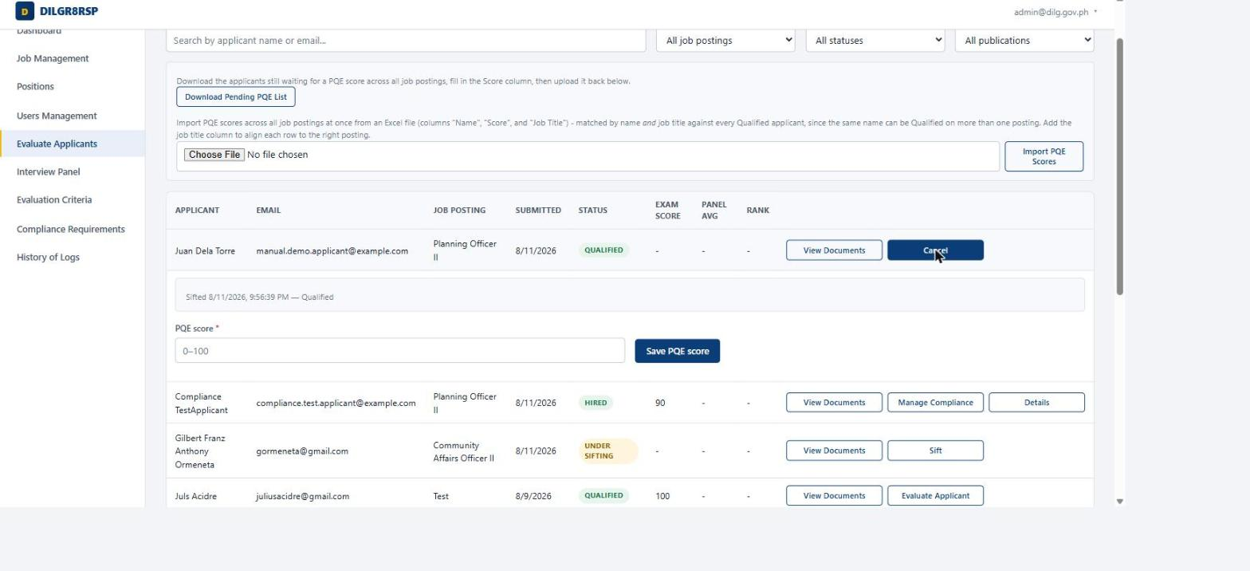
Fig. 18 — Entering one PQE score — or import a whole batch from Excel above the table

Step 7 — Schedule the interview
With a score on file, the action becomes Evaluate Applicant, which opens a scheduling form: date and time, an optional end time, venue, dress code, and any additional instructions — all of which go straight into the notification email the applicant receives.
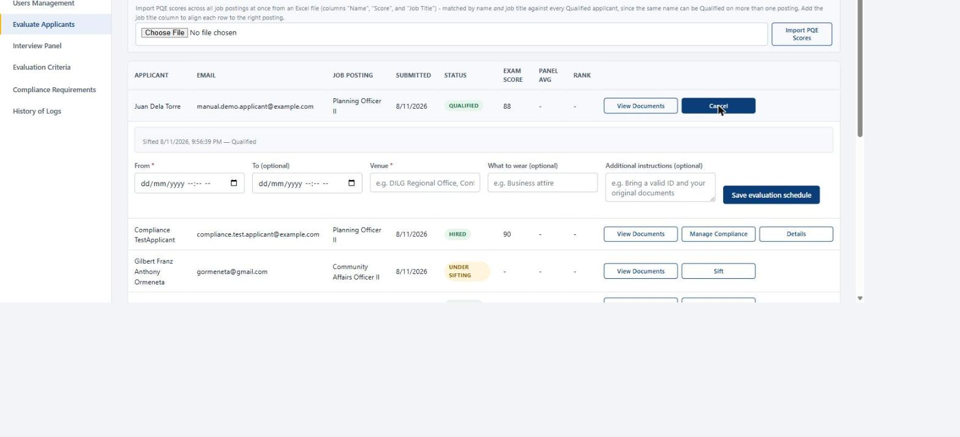
Fig. 19 — Scheduling the interview — every field here reaches the applicant's inbox
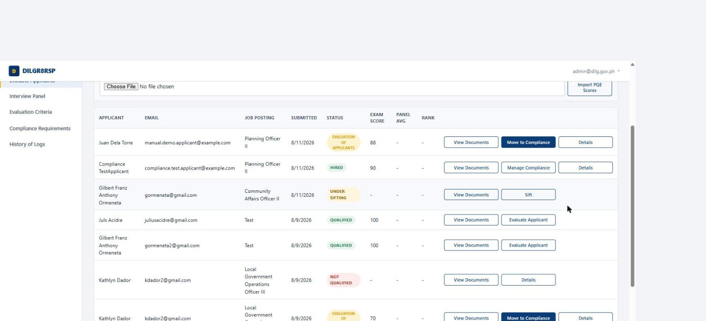
Fig. 20 — Once scheduled, the applicant's status advances to Evaluation of Applicants

Step 8 — Assign an interview panel
On the Interview Panel page, every applicant scheduled for interview appears with their posting's current board. A panel is assigned per posting, not per applicant — every panelist you assign can see and score every candidate under that same posting.
To assign several applicants at once, check their rows — the header checkbox selects the current page, and a Select all&hellip; matching filters link covers everyone across every page — then click Assign Panel to Selected. The dialog lists every distinct posting your selection touches and lets you pick which panelists to add to all of them in one action.
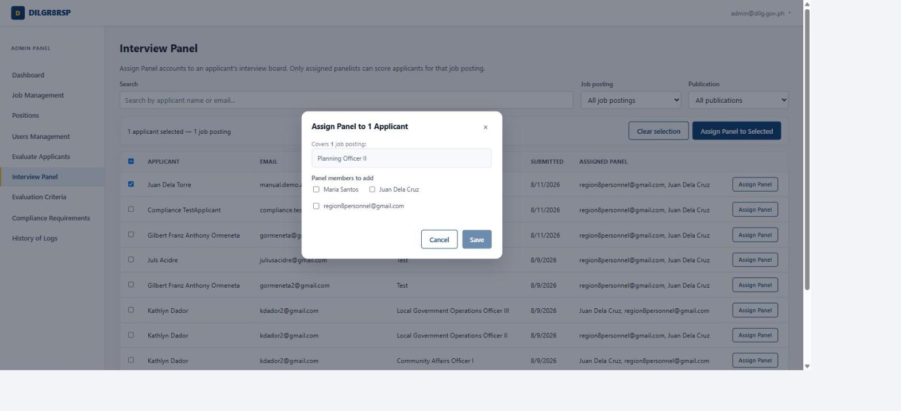
Fig. 21 — Bulk-assigning a panel — select applicants, then add panelists across every posting they touch

Step 9 — Maintain the interview rubric
Evaluation Criteria defines what panelists score against — each criterion has its own maximum score, which doubles as its weight in the applicant's total. A criterion that already has recorded scores can't be deleted, only deactivated, so past results stay intact.
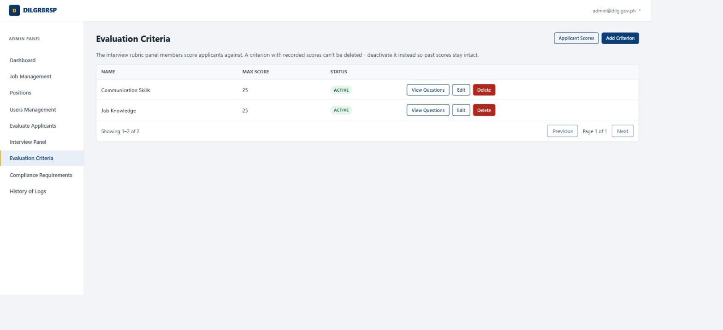
Fig. 22 — Evaluation Criteria — the rubric every panelist scores against

Step 10 — Manage the Compliance checklist
Compliance Requirements is the global, CSC-mandated documentary checklist every applicant must clear after passing interview — NBI Clearance, Medical Certificate, and anything else your office requires — before they're scheduled for oath-taking.
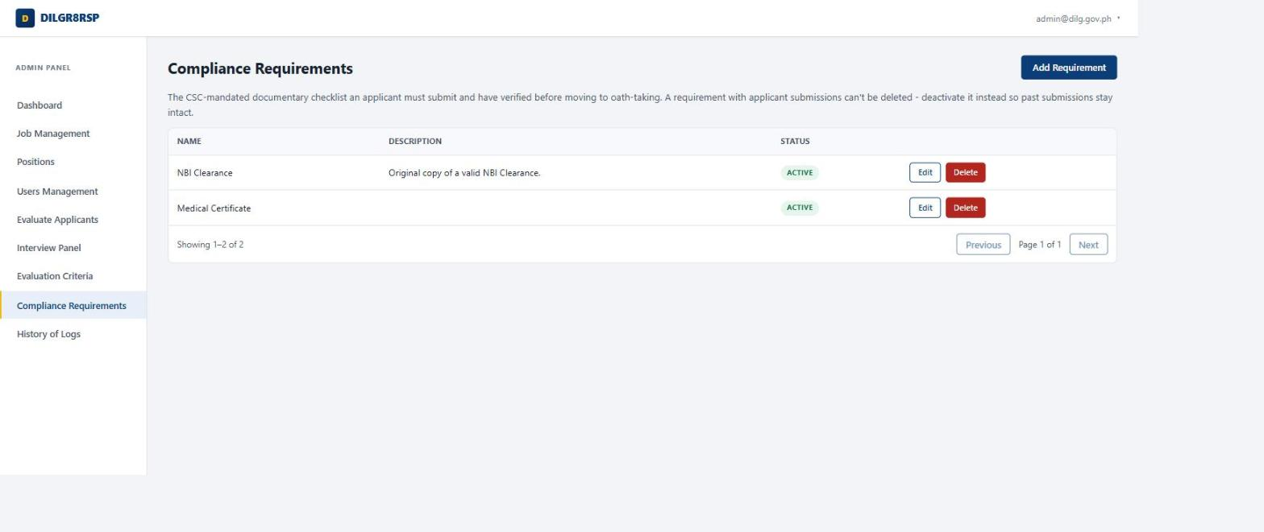
Fig. 23 — Compliance Requirements — the checklist applicants clear before oath-taking

Step 11 — Review the audit trail
History of Logs is a read-only record of every administrative action — who did what, and when — filterable by entity type. Nothing here can be edited or deleted, by design: it's the one place in the system meant to never change once written.
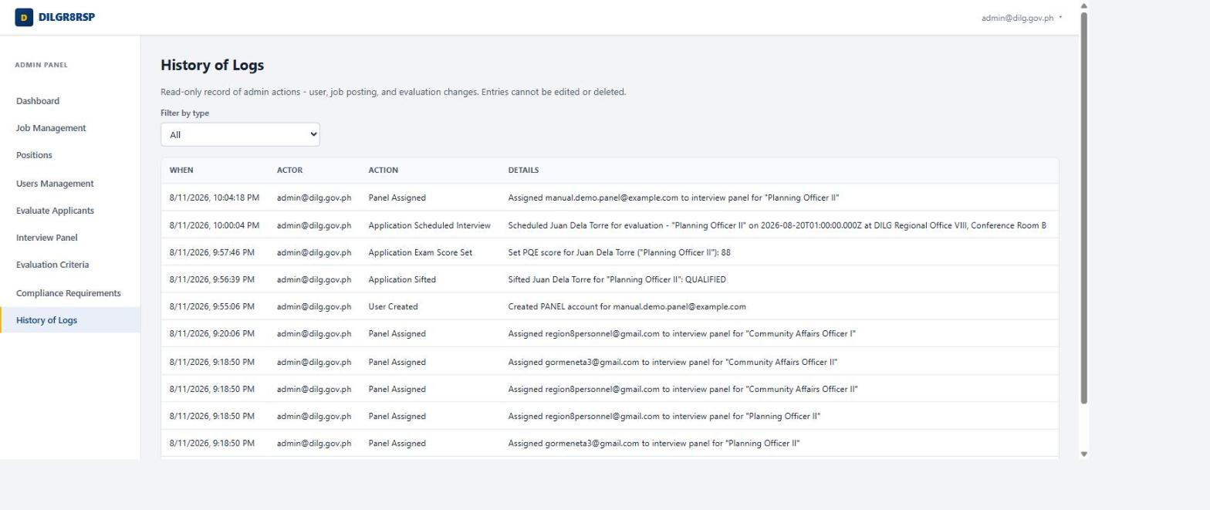
Fig. 24 — History of Logs — this exact sequence of actions, recorded automatically as they happened

PART III FOR PANEL MEMBERS
Everything a panelist needs lives on one page: the interview queue, the rubric, and the score you record for each applicant assigned to you.

Step 1 — Your interview queue
My Interviews lists every applicant scheduled for evaluation across every posting you've been assigned to as a panelist — nothing from postings you aren't on. Each row starts Pending until you record a score.
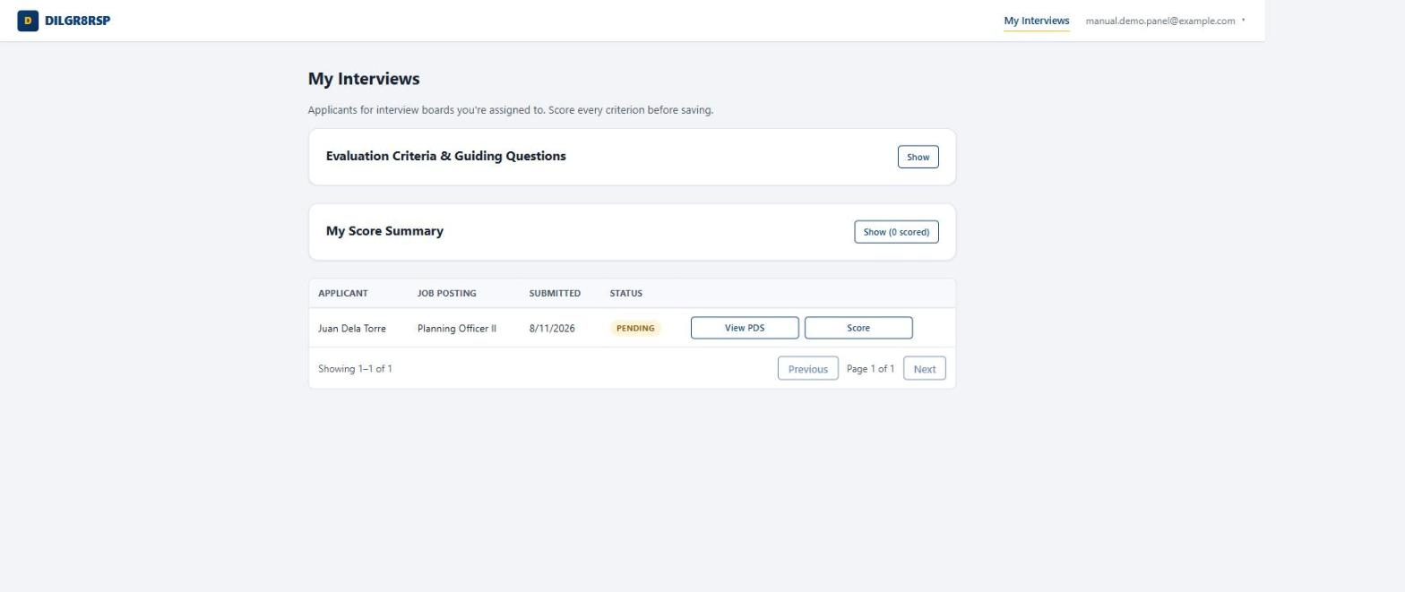
Fig. 25 — My Interviews — your assigned queue, nothing more

Step 2 — Check the rubric before you start
The collapsible Evaluation Criteria & Guiding Questions panel at the top of the page lists every active criterion and its maximum score, along with any guiding questions an admin has attached — a quick reference to keep every interview consistent.
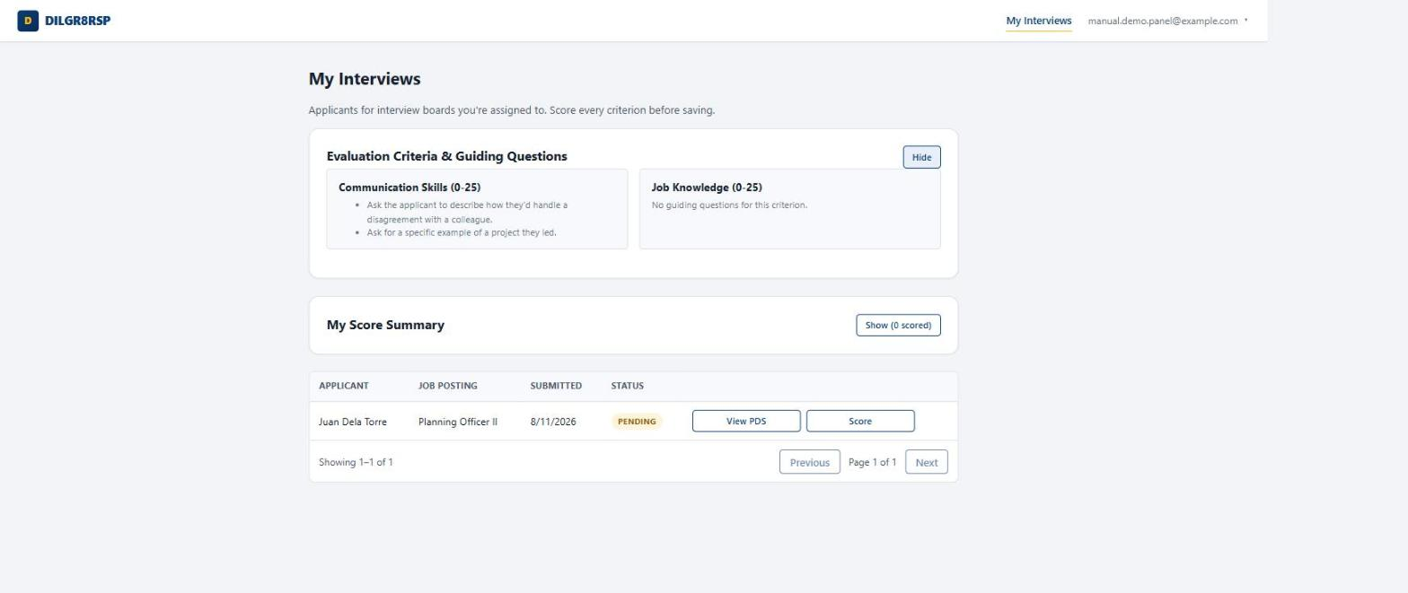
Fig. 26 — Criteria reference — expand it before the interview starts

Step 3 — Score the applicant
Click Score on a row to open the form in place: one numeric field per active criterion, plus an optional remarks box. Every criterion needs a score before you can save — there's no partial submission.
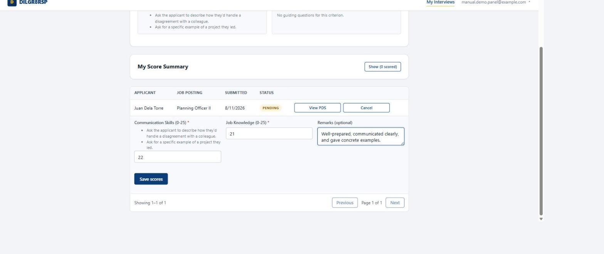
Fig. 27 — Scoring — one field per criterion, plus a remark

Step 4 — Review your score summary
The collapsible My Score Summary panel lists every applicant you've personally scored, with your own total for each — a private record of your own marks only, never another panelist's scores or the cross-panel average, which stays visible to admins alone.
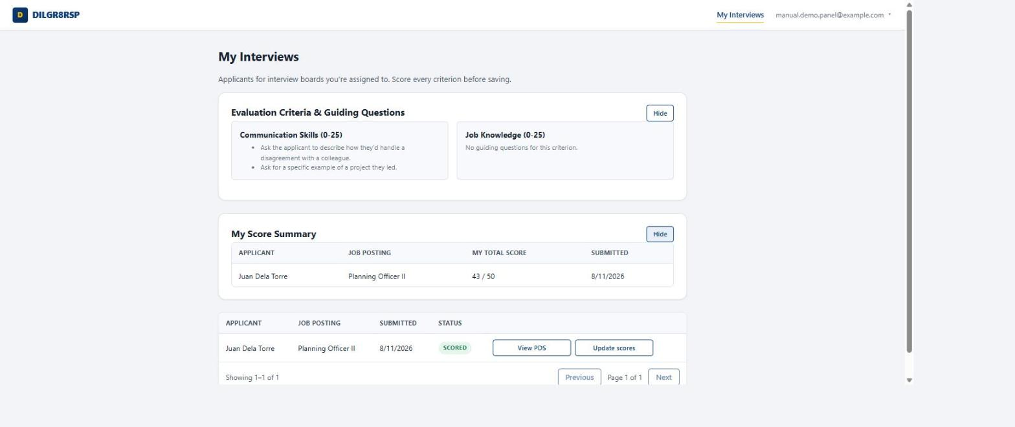
Fig. 28 — Score summary — your own marks, and the row now reads Scored

Step 5 — View an applicant's Personal Data Sheet
View PDS opens the applicant's Personal Data Sheet — and only the PDS, both the PDF and Excel copies. No other document on their profile is visible to a panelist, and the button only works for applicants you're actually assigned to interview.
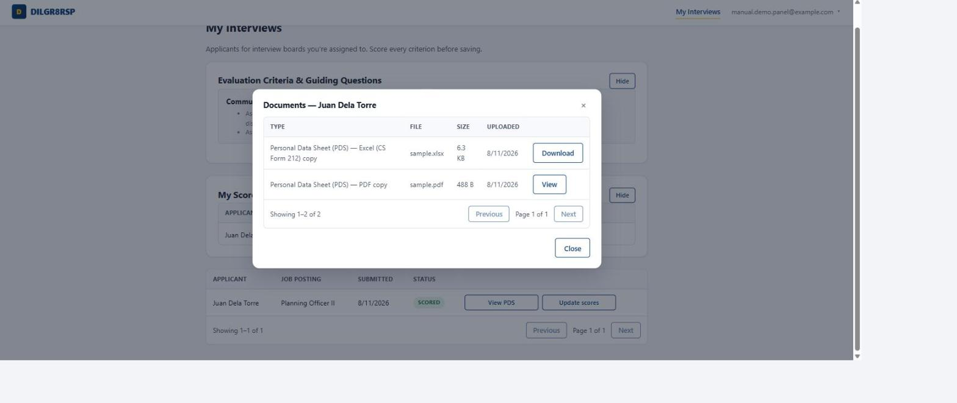
Fig. 29 — View PDS — scoped to exactly the PDS, and only for applicants assigned to you

Quick reference
Where to find each role's home page once you're logged in.
Role | Landing page | Path
Applicant | Job Postings | /jobs
Admin | Dashboard | /admin/dashboard
Panel | My Interviews | /panel/interviews

This manual was compiled by walking a single test applicant through the full pipeline — registration, application, sifting, examination, panel scoring — on the live DILGR8RSP system, so every screen shown here reflects real, working behavior rather than a mockup. Menu labels and field names may be refined over time; the underlying steps in this manual will still apply.

