Azure Deployment Documentation
ZaraProfileApi
ASP.NET Core Web API deployed to Microsoft Azure
Azure App Service, Azure SQL Database, GitHub Actions, Application Insights, Security, Backup Review, Azure Storage Account, Azure CLI Script, Key Vault, and Managed Identity
Student | Zara Rangkhoni
Application name | ZaraProfileApi
Azure App Service | zara-profile-api-free-2026
Region | Sweden Central
Public Azure URL | https://zara-profile-api-free-2026.azurewebsites.net/swagger/index.html

Teacher Requirements Covered
Requirement | Status | Evidence in this document
1. App Service + Web API + automated deployment | Completed | Sections 1.1–1.4
2. Application Insights logging and monitoring | Completed | Sections 2.1–2.2
3. Basic security: IP restrictions, HTTPS, backups | Completed / limitation documented | Sections 3.1–3.3
4. Step-by-step documentation | Completed | All sections with screenshots
5. Azure Storage Account | Completed | Sections 4.1–4.3
6. Azure Key Vault + Managed Identity | Partly completed / limitation documented | Section 6
Azure CLI scripting | Completed | Section 5 and azure-setup.ps1

Introduction
This documentation describes the steps used to create, deploy, monitor, and secure an ASP.NET Core Web API in Microsoft Azure. The application is called ZaraProfileApi and uses Entity Framework Core together with an Azure SQL Database named ZaraProfileDb to store profile information.
The documentation is organized step by step so that another person can follow the deployment process and understand how each Azure service was configured. The Azure resources are also scripted using Azure CLI and PowerShell in the file azure-setup.ps1, which is included in the GitHub repository.

1. Create an Azure App Service and Publish a Working Application
In this part of the assignment, an ASP.NET Core Web API was created and deployed to Azure App Service. The App Service provides the hosting environment for the ZaraProfileApi application and exposes it through a public Azure URL.

1.1 Create an Azure App Service via Azure CLI
The Azure App Service was created and configured to host the ASP.NET Core Web API. The App Service is named zara-profile-api-free-2026 and is hosted in the Sweden Central region. It was connected to the correct Resource Group and App Service Plan.
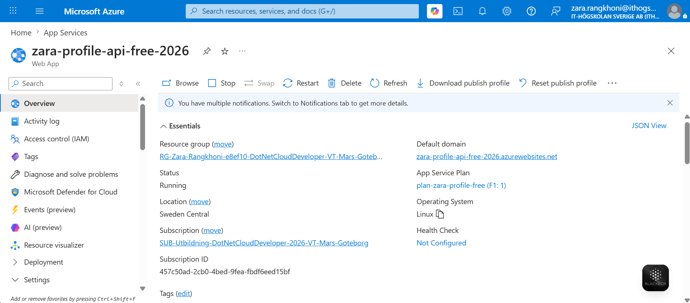
Screenshot: Azure App Service Overview. The App Service is running in Sweden Central and has a public Azure domain.

1.2 Create a Web API with Entity Framework Core
The application is an ASP.NET Core Web API with database connection through Entity Framework Core. The project contains a Profile model, an AppDbContext class, and a ProfilesController. The API supports basic CRUD functionality:
- GET profiles
- GET profile by ID
- POST new profile
- PUT update profile
- DELETE profile
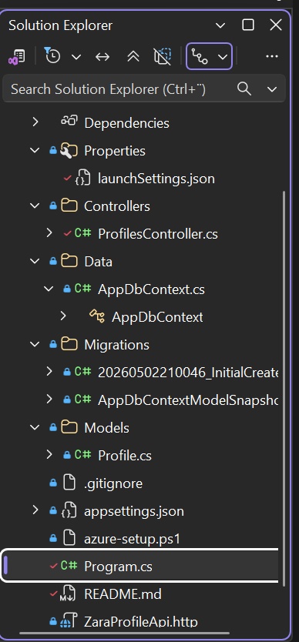
Screenshot: Visual Studio project structure. The project contains the model, database context, controller, migrations, and Program.cs.
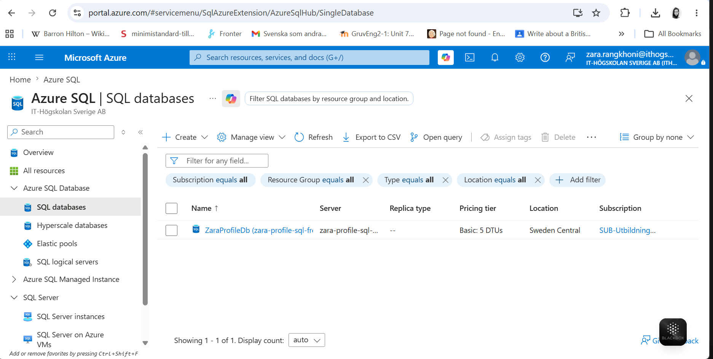
Screenshot: Azure SQL Database. The database ZaraProfileDb is hosted in Azure and connected to the Web API through Entity Framework Core.

1.3 Deploy the Application using GitHub Actions
The application was deployed automatically using GitHub Actions. A deployment workflow was configured in the GitHub repository. When code is pushed to the main branch, GitHub Actions builds the project and deploys it to Azure App Service.
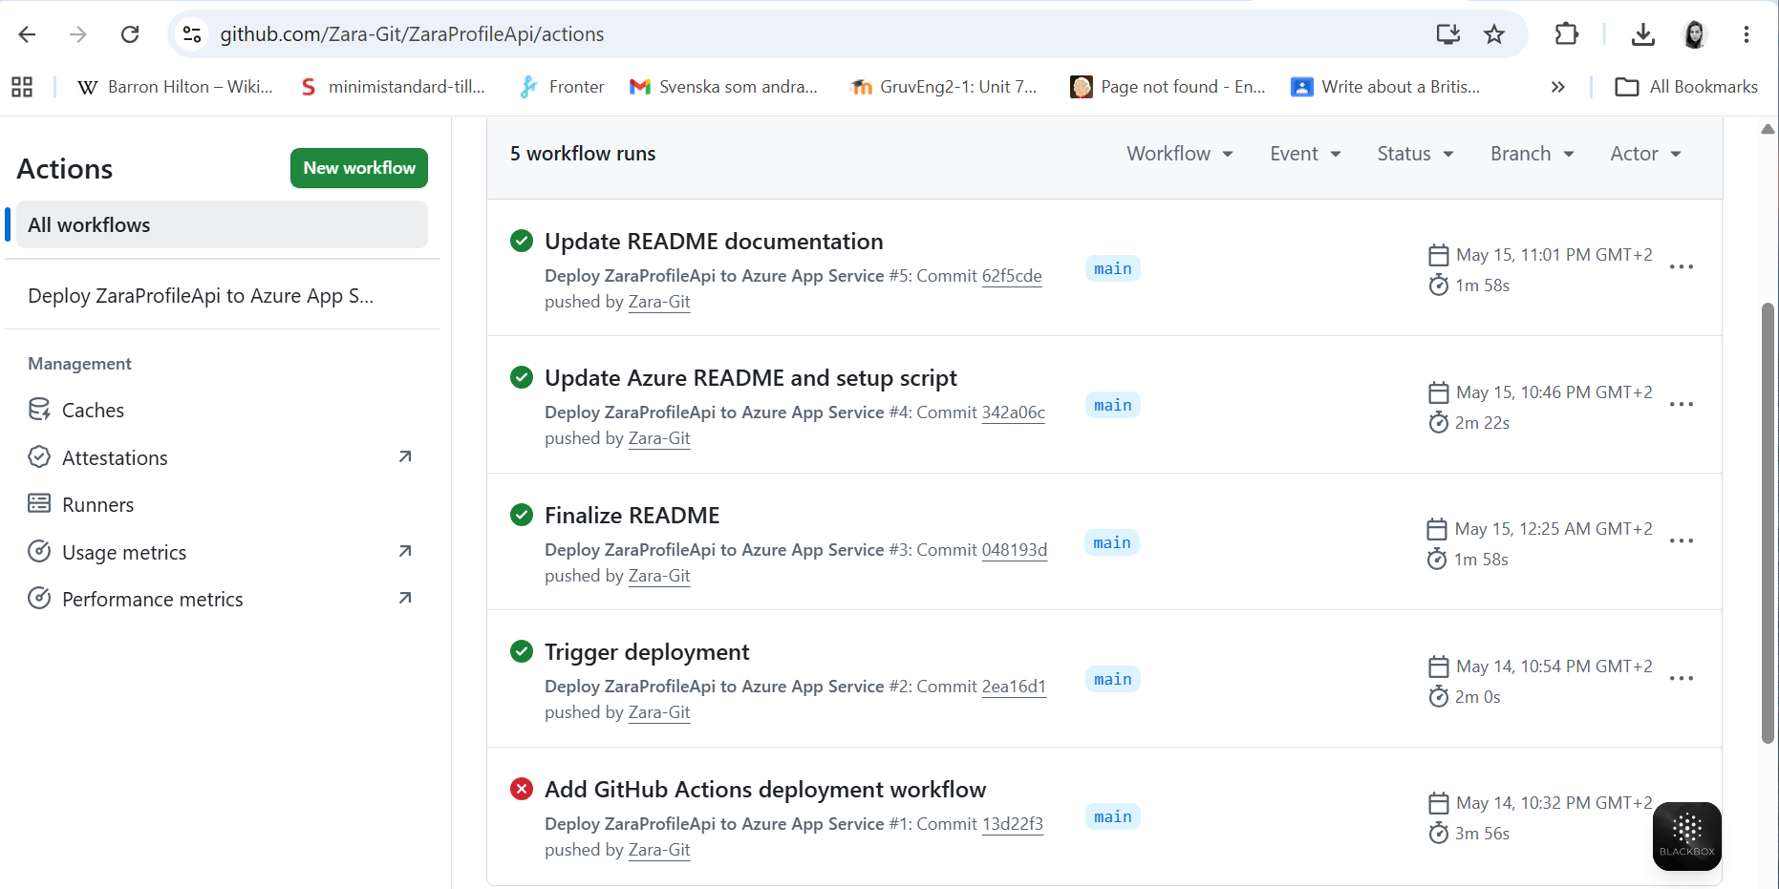
Screenshot: GitHub Actions successful deployment. Green check marks show successful workflow runs and deployments to Azure App Service.

1.4 Confirm that the Application Works on Azure
After deployment, the application was tested using the public Azure App Service URL and Swagger.
Swagger URL: https://zara-profile-api-free-2026.azurewebsites.net/swagger/index.html
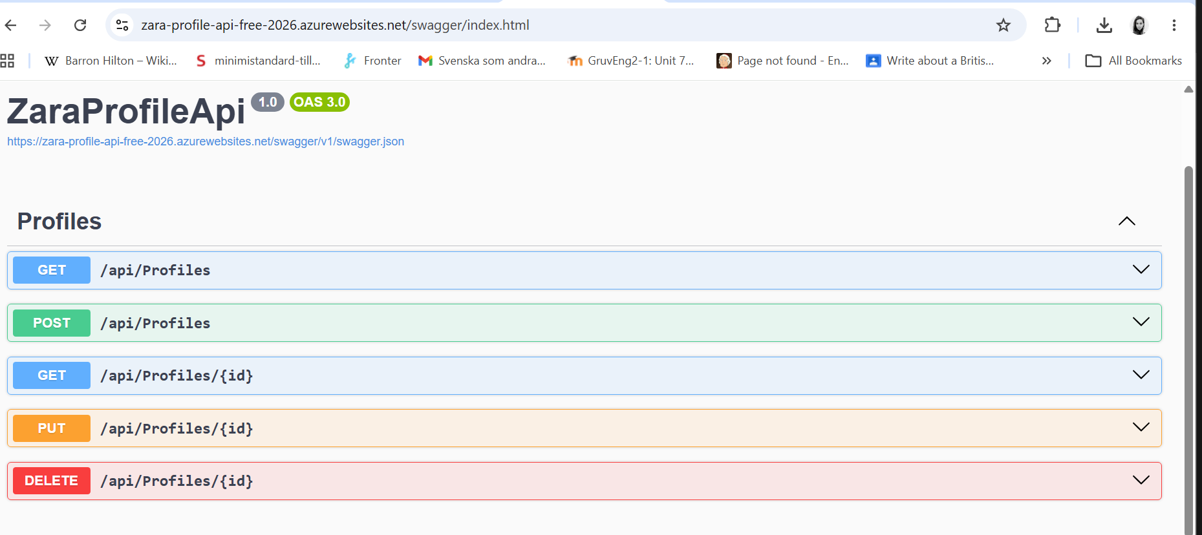
Screenshot: Swagger running from Azure App Service. The deployed Web API is running successfully and shows the available CRUD endpoints.

2. Use Application Insights for Logging and Monitoring
Application Insights was enabled for the Azure App Service to collect telemetry data from the deployed ASP.NET Core Web API. It collects information such as requests, response times, failures, and performance metrics.

2.1 Enable Application Insights
Application Insights was connected to the App Service using an Application Insights resource named appi-zara-profile-free.
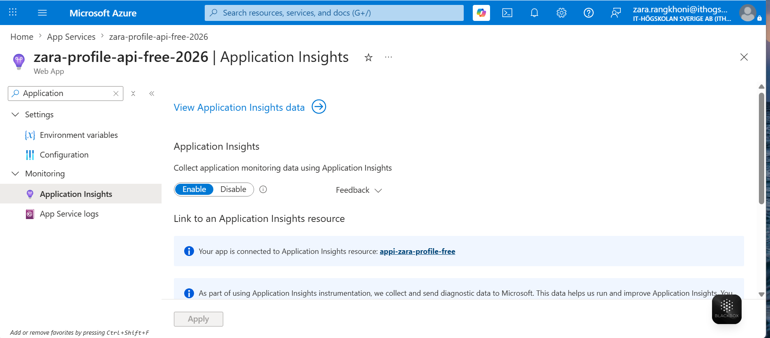
Screenshot: Application Insights enabled. Application Insights is connected to the Azure App Service.
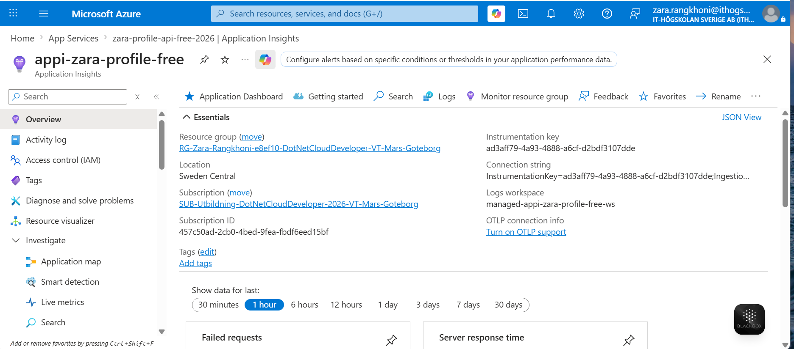
Screenshot: Application Insights Resource. The resource collects telemetry data from the deployed application.

2.2 Monitor the Application
The Live Metrics view was used to monitor the application in real time. It can be used to check incoming requests, request duration, failure rates, and overall application health.
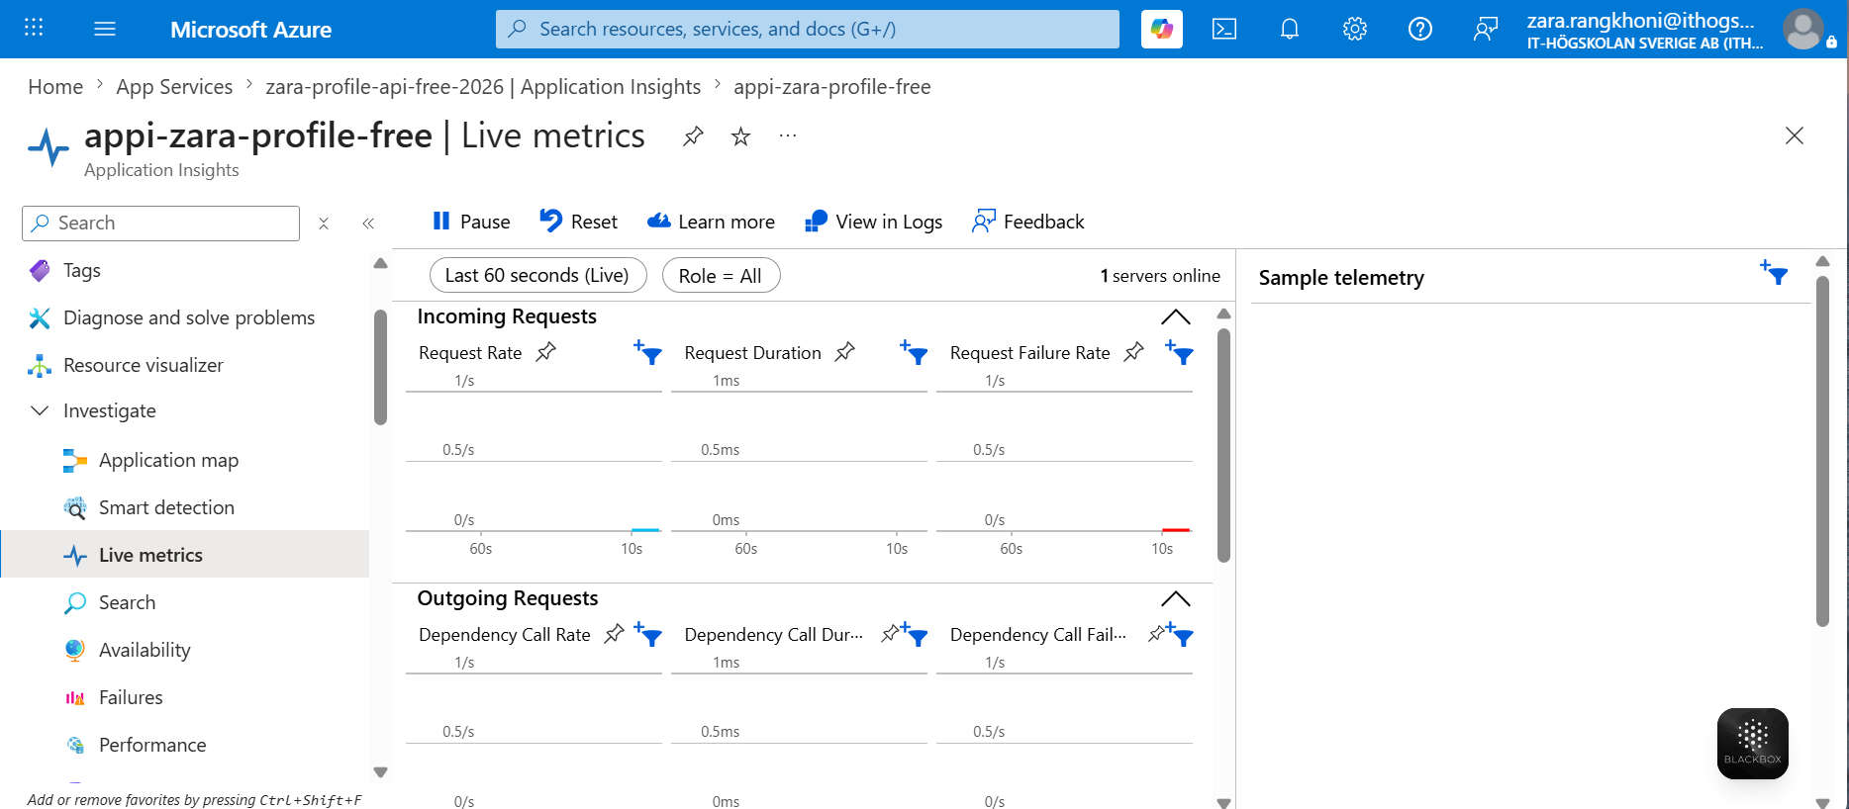
Screenshot: Application Insights Live Metrics. Live metrics show request rate, request duration, failure rate, and sample telemetry.

3. Implement Basic Security
Basic security settings were configured for the Azure App Service. This included IP access restrictions, HTTPS-only communication, and a review of backup configuration.

3.1 Configure IP Access Restrictions
IP access restrictions were configured in the App Service Networking settings. A rule named AllowMyIP was created to allow access from a specific IP address. This helps protect the application by limiting access to authorized users and networks. To fully enforce the restriction, the unmatched rule action should be set to Deny so that traffic from other IP addresses is blocked.
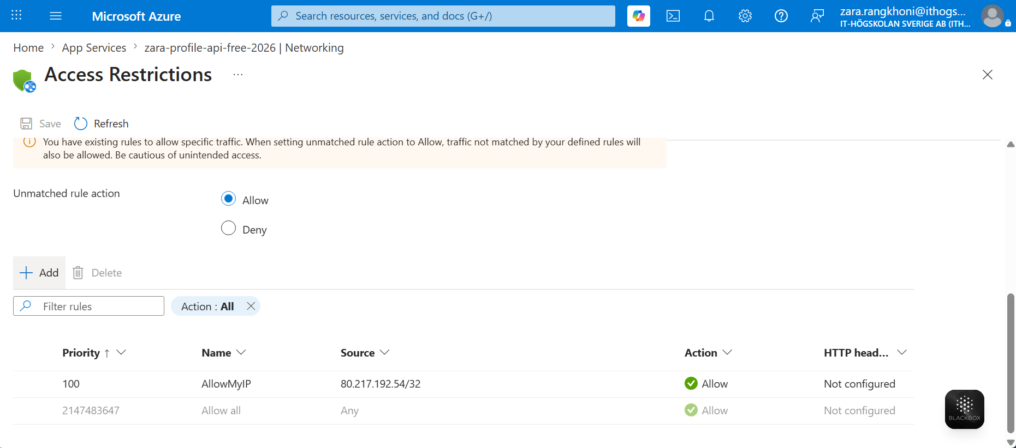
Screenshot: IP Access Restrictions. A rule named AllowMyIP was created to allow access from a specific IP address.

3.2 Enable HTTPS Only
HTTPS Only was enabled in the App Service general settings. This ensures that all communication between clients and the application is encrypted. The minimum TLS version was set to 1.2 for secure communication.
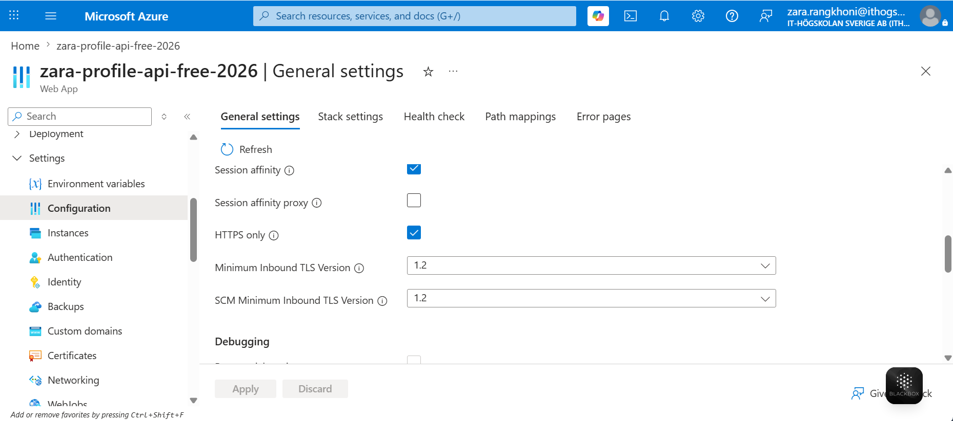
Screenshot: HTTPS Only enabled. HTTPS Only is enabled and the minimum TLS version is set to 1.2.

3.3 Review Backup Configuration
The Backup page was checked in Azure App Service. Azure showed that automated backup and restore features are available only on Basic and higher App Service Plans. Because this project uses the Free (F1) tier, scheduled daily backups could not be enabled.
In a production environment, the App Service Plan would be upgraded to a supported tier, and daily backups would be configured using an Azure Storage Account. This would allow the application to be restored if data loss or deployment issues occur.
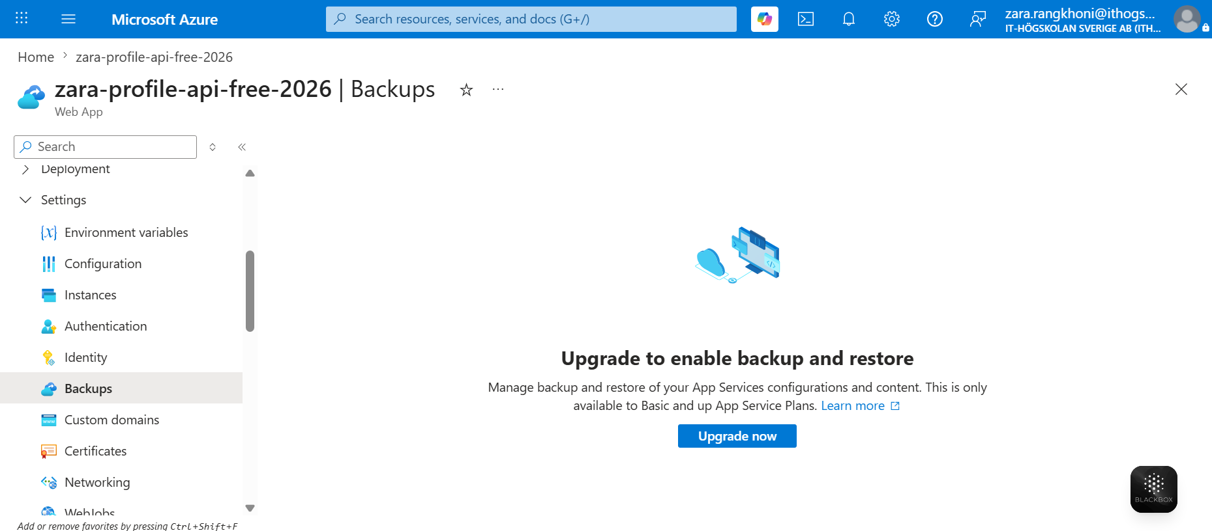
Screenshot: Backup Configuration. Backup and restore require a Basic or higher App Service Plan.

4. Use Azure Storage Account for Static Resources or Log Files
An Azure Storage Account was created to store static resources or log files separately from the Web API and database. This improves scalability and allows files to be managed independently from the application.

4.1 Create Azure Storage Account
A Storage Account named zaraprofilestfree26 was created in the same Resource Group as the application. The Storage Account was created as StorageV2 (General Purpose v2), with standard settings and storage in the Sweden Central region.
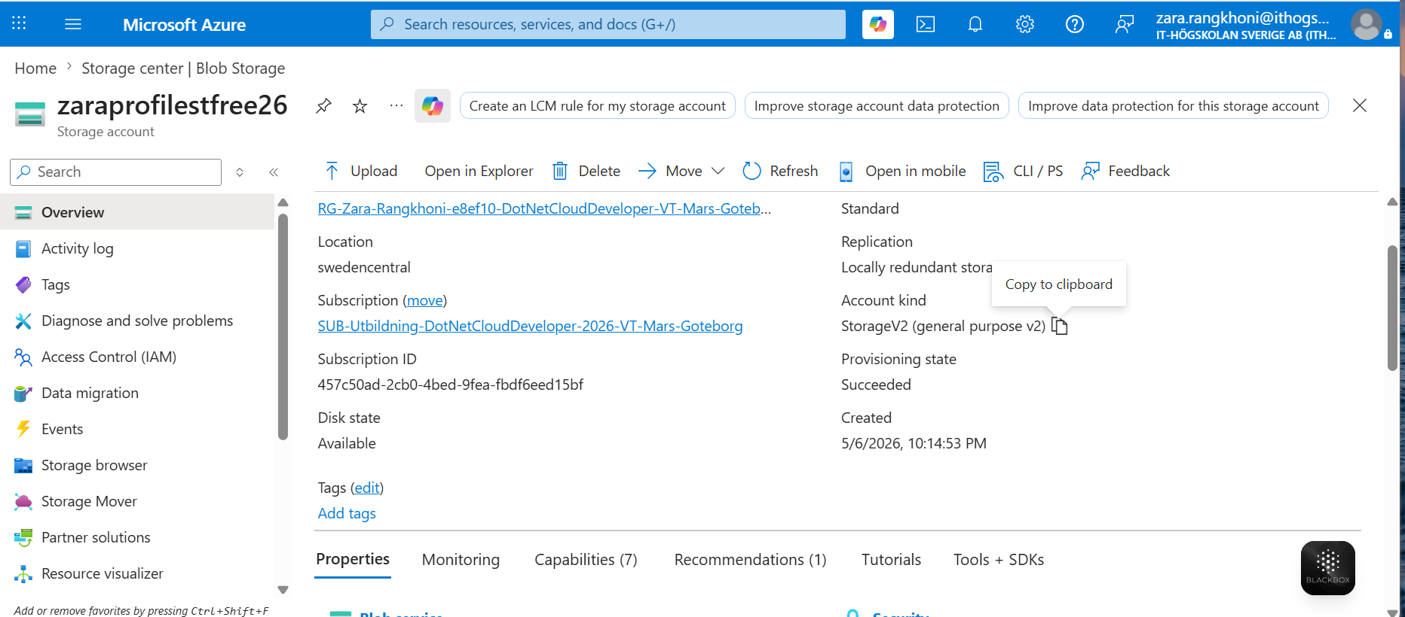
Screenshot: Azure Storage Account Overview. The Storage Account zaraprofilestfree26 is created in Sweden Central.

4.2 Create Blob Container
A Blob Container named static-files was created inside the Storage Account. The container is used to store static resources separately from the Web API and database.
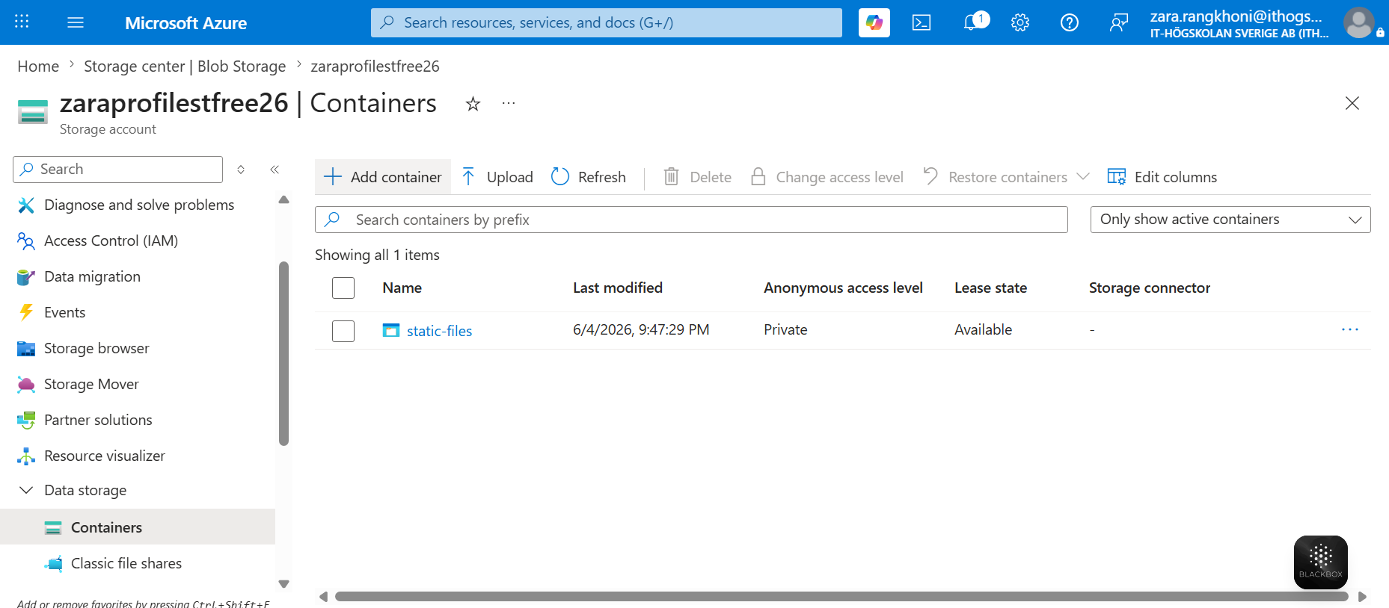
Screenshot: Blob Container (static-files). The container was created with private access level.

4.3 Upload a File to Azure Blob Storage
To verify that the storage works correctly, the file README.md was uploaded to the static-files container. After upload, the file could be seen in Azure Portal together with information about file size, blob type, access tier, and lease state.
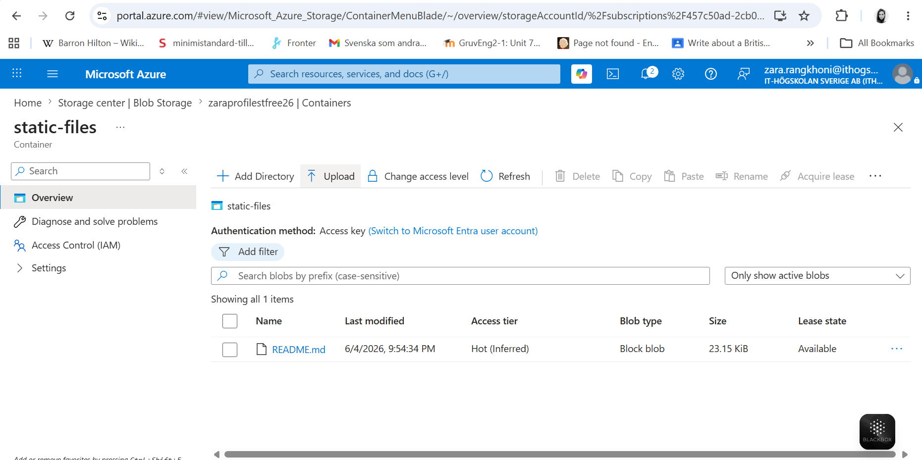
Screenshot: Uploaded file in Blob Container. README.md was uploaded successfully to Azure Blob Storage.

5. Azure CLI Script
The Azure resources used in this project were scripted using Azure CLI and PowerShell. The script file azure-setup.ps1 is included in the GitHub repository.
The script contains commands for creating and configuring the main Azure resources used in this project, including:
- Azure App Service Plan
- Azure App Service / Web App
- HTTPS Only
- Azure SQL Server
- Azure SQL Database
- SQL firewall rule
- Azure Storage Account
- Azure Key Vault
- Managed Identity
- Application Insights
- App Service application settings
- IP access restriction
The purpose of the script is to show how the Azure environment can be recreated using command-line instructions instead of only configuring resources manually in the Azure Portal.
Some steps were still verified manually in the Azure Portal and documented with screenshots, such as Swagger testing, Application Insights Live Metrics, Backup review, and uploading a file to Azure Blob Storage.
Automated daily backup could not be configured because the project uses the Free (F1) App Service Plan. Azure App Service backup requires a Basic or higher App Service Plan. This limitation was documented in the backup section.
Script file: azure-setup.ps1
GitHub repository: https://github.com/Zara-Git/ZaraProfileApi

6. Azure Key Vault and Managed Identity
Azure Key Vault was added to the Azure CLI script to store sensitive information, such as the SQL connection string. A Key Vault named kv-zara-prof-free26 was created.
Managed Identity was also enabled for the Azure App Service. This allows the App Service to access Azure resources more securely without saving credentials directly in the code.
The script tried to save the SQL connection string as a secret named SqlConnectionString in Key Vault. However, this step could not be completed because the student Azure account did not have enough RBAC permissions.
Because of this, the connection string was stored in the Azure App Service application settings instead. This limitation was documented.
- Key Vault: kv-zara-prof-free26
- Managed Identity: Enabled for zara-profile-api-free-2026
- Limitation: Secret creation failed because of RBAC permission limitations

7. Cleanup and Cost Note
The project was created as a low-cost class version using the Free (F1) App Service Plan where possible. Old test resources should be removed after testing to avoid unnecessary cost. Since the Resource Group was provided by the school, only project-specific resources should be removed if cleanup is required.

Summary
The ASP.NET Core Web API was successfully created, deployed, monitored, and secured in Azure. The application is hosted in Azure App Service, connected to Azure SQL Database through Entity Framework Core, and deployed automatically with GitHub Actions.
Application Insights was enabled for logging and monitoring, IP restrictions and HTTPS were configured for security, and backup configuration was reviewed. Azure Storage Account was also created and used to store a sample file in Blob Storage.
Azure Key Vault and Managed Identity were also included in the Azure CLI script. The full Key Vault secret integration could not be completed because of RBAC permission limitations, and this limitation was documented.
The screenshots in this documentation show each important step so that another person can understand and follow the deployment process.

