WEEK3 : Emulators, Virtual Machines and Containers

0. Assembler: Converts assembly language into machine code
1. Emulators
- Definition: An Emulator is A program that pretends to be a CPU and executes binary instructions in software
- Instruction Representation:
  - Machine instructions are stored in memory as sequences of bits/bytes (e.g., 01100100 10001100).
  - Opcode = operation code, stored in the high-order bits.
  - Operands = addresses or data fields, stored in the remaining bits.
- Assembly Language: Human-readable shorthand for machine code.
  - Example: ADD 4, 8, 12 instead of raw binary.
  - Requires an Assembler to translate into binary instructions.
- System Calls in Assembly (x86 example):
mov $4, %eax → sys_write system call.
mov $1, %ebx → file descriptor for stdout.
int $0x80 → software interrupt, enter kernel mode.
mov $1, %eax → sys_exit.
指令 | 阶段 | 意义
mov $4, %eax | 准备 | 设定系统调用号 = 4 (sys_write)
mov $1, %ebx | 准备 | 参数：文件描述符 = stdout
int $0x80 | 执行 | 进入内核，执行 write()
mov $1, %eax | 准备 | 设置系统调用号 = 1 (sys_exit)
int $0x80 | 执行 | 调用 exit()，结束程序

=统调用号 | 系统调用名称 | 功能
1 | sys_exit | 退出程序
2 | sys_fork | 创建进程
3 | sys_read | 读文件
4 | sys_write | 写文件
5 | sys_open | 打开文件
6 | sys_close | 关闭文件

寄存器 | 作用
%eax | 存放系统调用号
%ebx | 第 1 个参数
%ecx | 第 2 个参数
%edx | 第 3 个参数
%esi | 第 4 个参数
%edi | 第 5 个参数
%ebp | 第 6 个参数（有时）

- Bit Manipulation for Instruction Decoding:
  - Shift Right → to extract the opcode (e.g., >> 12).
  - Bit Mask (masking) + AND → to isolate address operands (e.g., & 0xF).
  - Why can the logical AND operation be used as a masking technique in binary operations?
→Because bits in the original number are preserved only where the mask has 1s
- Advantages:
  - Can emulate any instruction set (cross-platform compatibility).
- Disadvantages:
  - Extremely slow, since every instruction is interpreted step by step.

2. Virtual Machines (VMs)
- Definition: A Virtual Machine provides a complete emulation of a physical machine, including CPU instructions, memory management, I/O devices, and networking.
- Difference from Emulator:
  - Emulator = only CPU + basic instruction interpretation.
  - VM = full system emulation, capable of running an entire Operating System (OS).
  - VMs emulate not just the CPU, but also memory and I/O subsystems
- Examples of VM software:
  - Oracle VirtualBox (GPL, supports Intel x86/AMD64).
  - VMware Workstation / Fusion.
  - VirtualBox is the Virtual Machine software, Ubuntu is the guest OS running inside it, and MacOS is the host OS
  - 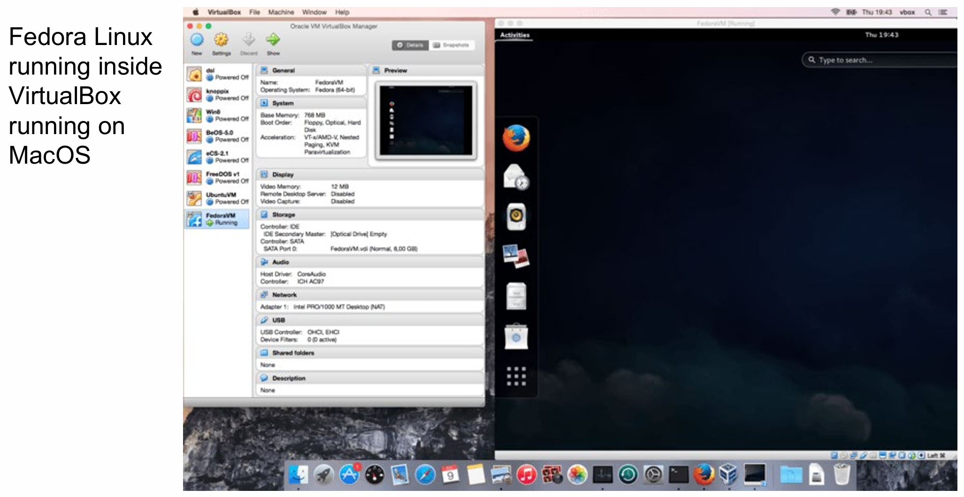
- Use Cases:
  - Running different Operating Systems (e.g., Ubuntu on Windows).
  - Running legacy software.
  - Isolation from malicious software (sandboxing).
  - Testing software in multiple target environments.
  - Cloud Computing: multiple VMs run on a single physical server (multi-tenancy).
- Performance:
  - Slower than native execution, but faster than pure emulators due to hardware virtualization support (Intel VT-x, AMD-V).

3. Containers
- Definition: Containers provide Operating System-level Virtualization. Instead of emulating hardware, they virtualize at the system call interface level.
- Mechanism:
  - Applications interact with the kernel only via system calls (e.g., open, read, write, fork).
  - A virtualization layer intercepts system calls and presents a customized namespace.
  - The application environment is important in containers. It defines the system calls and namespace the program can see, allowing containers to provide isolation and portability.
  - A container shares the host OS kernel and isolates applications, while a VM emulates a full operating
- Namespace Virtualization:
  - A container can redefine the root directory /, making the application see its own isolated file system hierarchy (/bin, /etc, /lib, /usr, etc.).
  - Achieved using chroot and Linux kernel namespaces (PID, NET, MNT, UTS, IPC).
- Docker:
  - Popular container runtime (developed by Docker Inc.).
  - Containers are lightweight compared to VMs (no full OS kernel replication).
  - Can easily start/stop, package, and migrate across systems.
- Advantages:
  - Lightweight, near-native performance.
  - Provides portability — applications carry their dependencies inside the container.
  - Widely used in Cloud Computing and DevOps for Continuous Integration/Continuous Deployment (CI/CD) pipelines.
- Limitations:
  - Share the same OS kernel → weaker isolation compared to VMs.

4. Comparison Table
名称 | 中文名 | 主要功能 | 模拟/隔离层级 | 举例 | 类比
Assembler | 汇编器 | 把汇编代码翻译成机器码（CPU能直接执行） | 指令层 | nasm, avr-as, gcc -S | 翻译官（汇编语言→机器语言）
Emulator | 仿真器 | 模拟硬件指令集（CPU、内存、I/O等），让一个平台的程序能在另一个平台上跑 | 硬件层 | QEMU, Bochs, AVR Simulator | 模拟整台电脑
Virtual Machine | 虚拟机 | 模拟整个操作系统环境，让多个系统运行在同一物理机上 | 操作系统层 | VirtualBox, VMware, Hyper-V | 在一台电脑里“装另一台电脑”
Container | 容器 | 使用宿主机的内核，但隔离进程、文件系统和网络环境 | 应用层 | Docker, LXC, Kubernetes Pod | 在同一厨房隔出多个独立灶台

┌────────────────────────────┐
│ Application (程序 / Shell / Browser) │ ← 运行在用户空间
├────────────────────────────┤
│ Container (容器，如 Docker) │ ← 隔离进程环境
├────────────────────────────┤
│ Virtual Machine (VM) │ ← 模拟整个操作系统
├────────────────────────────┤
│ Emulator (仿真器，如 QEMU) │ ← 模拟硬件 CPU/指令集
├────────────────────────────┤
│ Physical Hardware (真实机器)│ ← 最底层：CPU / 内存 / 硬盘
└────────────────────────────┘

Emulator → 模拟硬件
VM → 模拟操作系统
Container → 隔离应用环境
Assembler → 翻译语言

📌 Core Takeaways
- Emulators → good for cross-platform execution but very slow.
- Virtual Machines → full hardware abstraction, good for running multiple OSes, widely used in cloud infrastructure.
- Containers → lightweight virtualization, ideal for application portability and microservices in modern DevOps.
- A container shares the host OS kernel and isolates applications, while a VM emulates a full operating

