Lab 1: Introduction to Unix and Shell
Unix
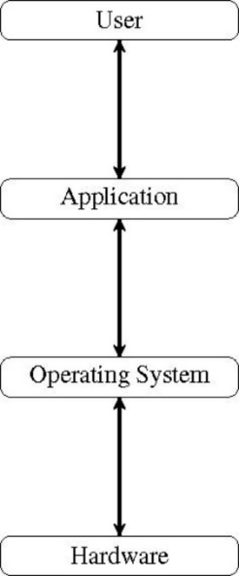
An operating system refers to a suite of software that makes the computer work. Specifically, the operating system provides services for the programs they run/execute.
The Unix operating system is made up of three parts:
- kernel
- shell and
- programs
The Operating System acts as an intermediary between the application and the hardware.

Kernel
The kernel of Unix is the core component of the operating system (OS). All other OS components rely on the kernel for essential services.
- allocates computational time to programs
- allocates computational memory to programs
- handles the file store and communications in response to system calls
System calls are requests from programs to the kernel for performing things on behalf of the program, e.g., print characters on the screen, write data to disk, etc.
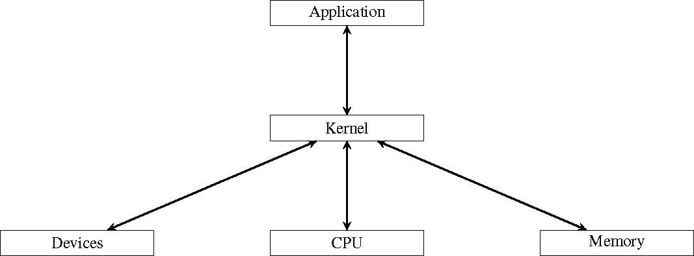
- The shell acts as an interface between the user and the kernel. When a user logs in, the login program checks the username and password, and then starts another program called the shell;
- The shell is a command line interpreter (CLI), just like the Python interpreter;
- The shell interprets the commands the user types in and arranges for them to be carried out. The commands themselves are usually programs. When a command terminates, the shell gives the user another prompt to indicate it is ready to accept more commands.
角色 | 描述 | 类比
命令解释器 (Interpreter) | 读取用户在命令行输入的命令，一条条解释执行(interpret)而不是先编译。 | Python 解释器：你输入 print("hi")，它立即执行。
脚本执行器 (Scripting Environment) | 把一连串命令写进一个 .sh 文件中，它按顺序执行→这就是 Shell Script。 | 像在 Python 里写 .py 文件一样。
3. 用户与系统的接口 (Interface) | 用户通过它调用系统命令（ls, cp, rm），间接使用系统调用（system call）与内核交互。 | 它是用户和内核之间的“翻译员”。
1. 绝对路径（Absolute Path）
- 定义：从文件系统的根目录 / 开始，一直到目标文件或目录的完整路径。
- 特点：
  - 路径是唯一的，不依赖你当前所在的工作目录。
  - 在任何地方输入同样的绝对路径，都能访问到同一个文件/目录。
- 例子：
- /home/user/info1112/tutorial1
- /usr/local/bin/python3
这里 / 是 Linux 文件系统的根目录，路径从根一路写到目标位置。

2. 相对路径（Relative Path）
- 定义：相对于你当前所在的工作目录（Current Working Directory，CWD）写出的路径。
- 特点：
  - 会依赖当前所在位置。
  - 更简短，但可能因为当前目录不同而指向不同的位置。
- 例子（假设当前目录是 /home/user）：
- info1112/tutorial1
- ../Documents
- ./script.sh
  - info1112/tutorial1 → 当前目录下的 info1112 文件夹里的 tutorial1 子目录。
  - .. → 上一级目录（/home）。
  - . → 当前目录本身。

对比总结表
对比点 | 绝对路径 | 相对路径
起点 | 根目录 / | 当前工作目录
是否唯一 | 唯一 | 依赖当前目录，不唯一
书写方式 | 从 / 开始 | 不以 / 开头
使用场景 | 跨目录、脚本中定位固定位置 | 当前目录附近的文件操作

In Linux, if your directory name contains a space (like "info 1112"), you need to either:

1️⃣ Use quotes
mkdir "info 1112"
2️⃣ Escape the space with a backslash \
mkdir info\ 1112

📌 Tip:
- Quoting is easier if there are multiple spaces or special characters.
- If you plan to work in the terminal often, it’s better to avoid spaces in directory/file names (use _ or - instead). For example:
mkdir info_1112
mkdir info-1112

Command | Meaning | Effect
ls -la | List all files (detailed) | Shows visible + hidden files
cd .. | Go up one level | Parent directory
cd / | Go to root | Top of filesystem
cd ~ | Go to home directory | User’s home
cd . | Stay in current directory | No change

