**MLOPS**

**Assignment 2**

**Name:** Zaraar Malik

**Roll Number:** 21i-2705

**Section:** AI-A

**Details of Front End**

I made the front end using the following 2 items :

* **HTML**
* **CSS**

I have a templates folder in my main directory. This folder contains 4 HTML files along with their styles inside the HTML files which are listed Below:

* **Register.HTML**
* **Login.HTML**
* **Forgot_password.HTML**
* **Reset_password.HTML**

The user first performs the Registration. The user has to enter 3 items in the Registration process which are listed below:

* **Username**
* **Password**
* **Security Answers**

Below is the image of the Registration Page:

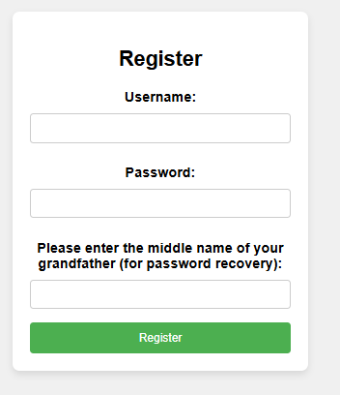

After the registration process, the user is re-routed to the Login page. The user has to enter the following 2 items on this page:

* **Username**
* **Password**
* **Option : Forgot Password**

The user cannot proceed further if incorrect Username or password is entered. An option of forgot password is also provided in-case the user wants to reset their password.

Following is the Login Page:

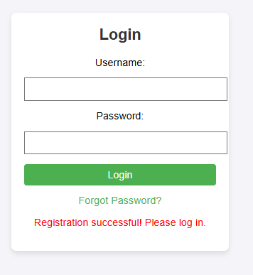

If the user correctly enters the login items, the page is re-routed back to the registration page.

In case of Forgot Password, the user is navigated to the Forgot Password page. Here the user has to enter the respective username and the answer of the Securtiy Question entered during the time of registration. If not, password reset cannot be performed. Following is the Forgot Password Page:

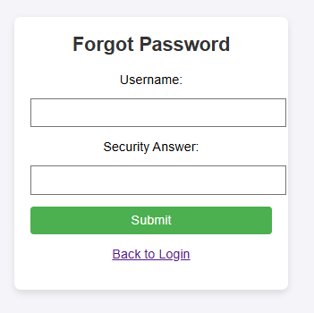

After this , the user is navigated to the Reset Password page which is shown below:

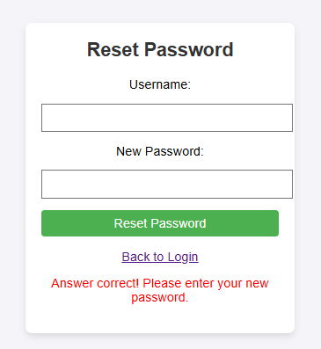

After this , the user is then navigated back to the Login page where successful login re-routes the user back to the registration page which is shown below.

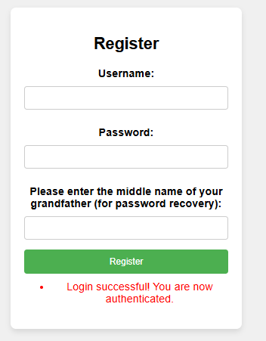

**Details of Back End**

For Back End, I used Flask which is used to move between the web pages and to store information in the database.

**Details of Database**

1. For database implementation, I installed mongoDB. It was extremely easy to implement. Following are the steps
2. **Install MongoDB**
3. **Make a Connection in the MongoDB**
4. **Make databse inside it**
5. **Copy the Database Client String**
6. **Use this to save the user information**