TRAFFIC MANAGEMENT

PHASE-3

SUBMITTED BY:

Naveen raj.e

Manimaaran.m

Sakthivel.s

Shanmugam.p

Sachin.m

INTRODUCTION:

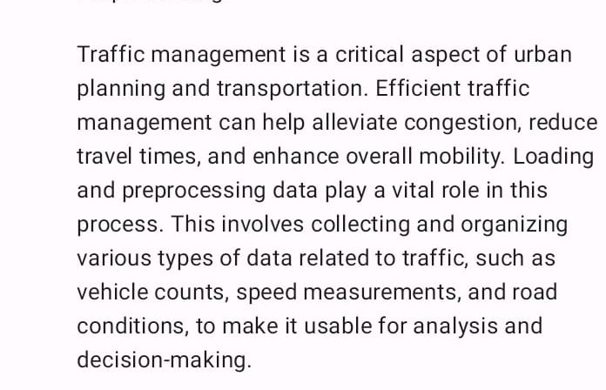

COMPONENTS AND REQUIREMENTS:

1. Data Source
2. Data collection tools
3. Data cleaning and validation
4. Data integration
5. Data transformation
6. Feature Engineering
7. Quality Assurance
8. Real-Time Processing
9. Data Storage
10. Analytics Tools
11. Machine Learning and predictive models
12. Data Security
13. Regulatory Compliance
14. Scalability
15. Data Documentation

PROGRAM:

import pandas as pd

import numpy as np

# Load the dataset (assuming it's in a CSV file)

data = pd.read_csv('traffic_data.csv')

# Data Cleaning and Validation

# Replace missing values or outliers with appropriate values or apply other cleaning techniques.

data['speed'].fillna(data['speed'].mean(), inplace=True)

# Data Transformation and Feature Engineering

# You can create new features, aggregate data, or convert time formats as needed.

data['hour'] = pd.to_datetime(data['timestamp']).dt.hour

# Quality Assurance (if needed)

# Perform any additional validation or error checks here.

# Real-time Processing (if applicable)

# For real-time processing, set up data ingestion from sensors or other sources.

# Data Storage

# Store the preprocessed data or send it to a database for later retrieval.

# Data Analysis

# You can use data analytics libraries like pandas, numpy, or data visualization tools like Matplotlib or Seaborn to analyze the data.

# Machine Learning and Predictive Models (if required)

# Implement machine learning models to predict traffic patterns or congestion.

# Further processing and analysis code can be added as per your specific needs.

*Abstract:*

Traffic management is a critical component of urban planning and transportation systems. Effective traffic management relies on the collection, loading, and preprocessing of vast amounts of data to make informed decisions and optimize transportation networks. This abstract provides an overview of the key processes involved in loading and preprocessing traffic management datasets.

The loading and preprocessing of traffic management datasets encompass several fundamental steps. Firstly, data must be collected from diverse sources, such as traffic sensors, cameras, and weather stations. These raw data may arrive in various formats and need thorough cleaning to ensure accuracy. Data integration is crucial to unify information from multiple sources, enabling comprehensive analysis. Transforming raw data into meaningful insights, through feature engineering and data aggregation, further enhances its utility.

Quality assurance plays a pivotal role in ensuring the data's accuracy and reliability. Real-time processing, vital for immediate responses to traffic events and incidents, requires special attention and systems. Effective data storage and access are essential for ongoing traffic management operations and decision-making.

Traffic management datasets often include traffic volume, speed, incident, weather, geospatial, historical, sensor, public transportation, pedestrian, and bicycle data. Loading and preprocessing these datasets allow authorities to enhance road safety, reduce congestion, and improve overall transportation efficiency.

While the process of loading and preprocessing traffic management datasets is complex, it forms the foundation for data-driven decisions that positively impact traffic flow, safety, and urban mobility. As technology advances, the ability to manage and analyze traffic data becomes increasingly critical in addressing the challenges of modern urban transportation.

CIRCUITDIAGRAM:

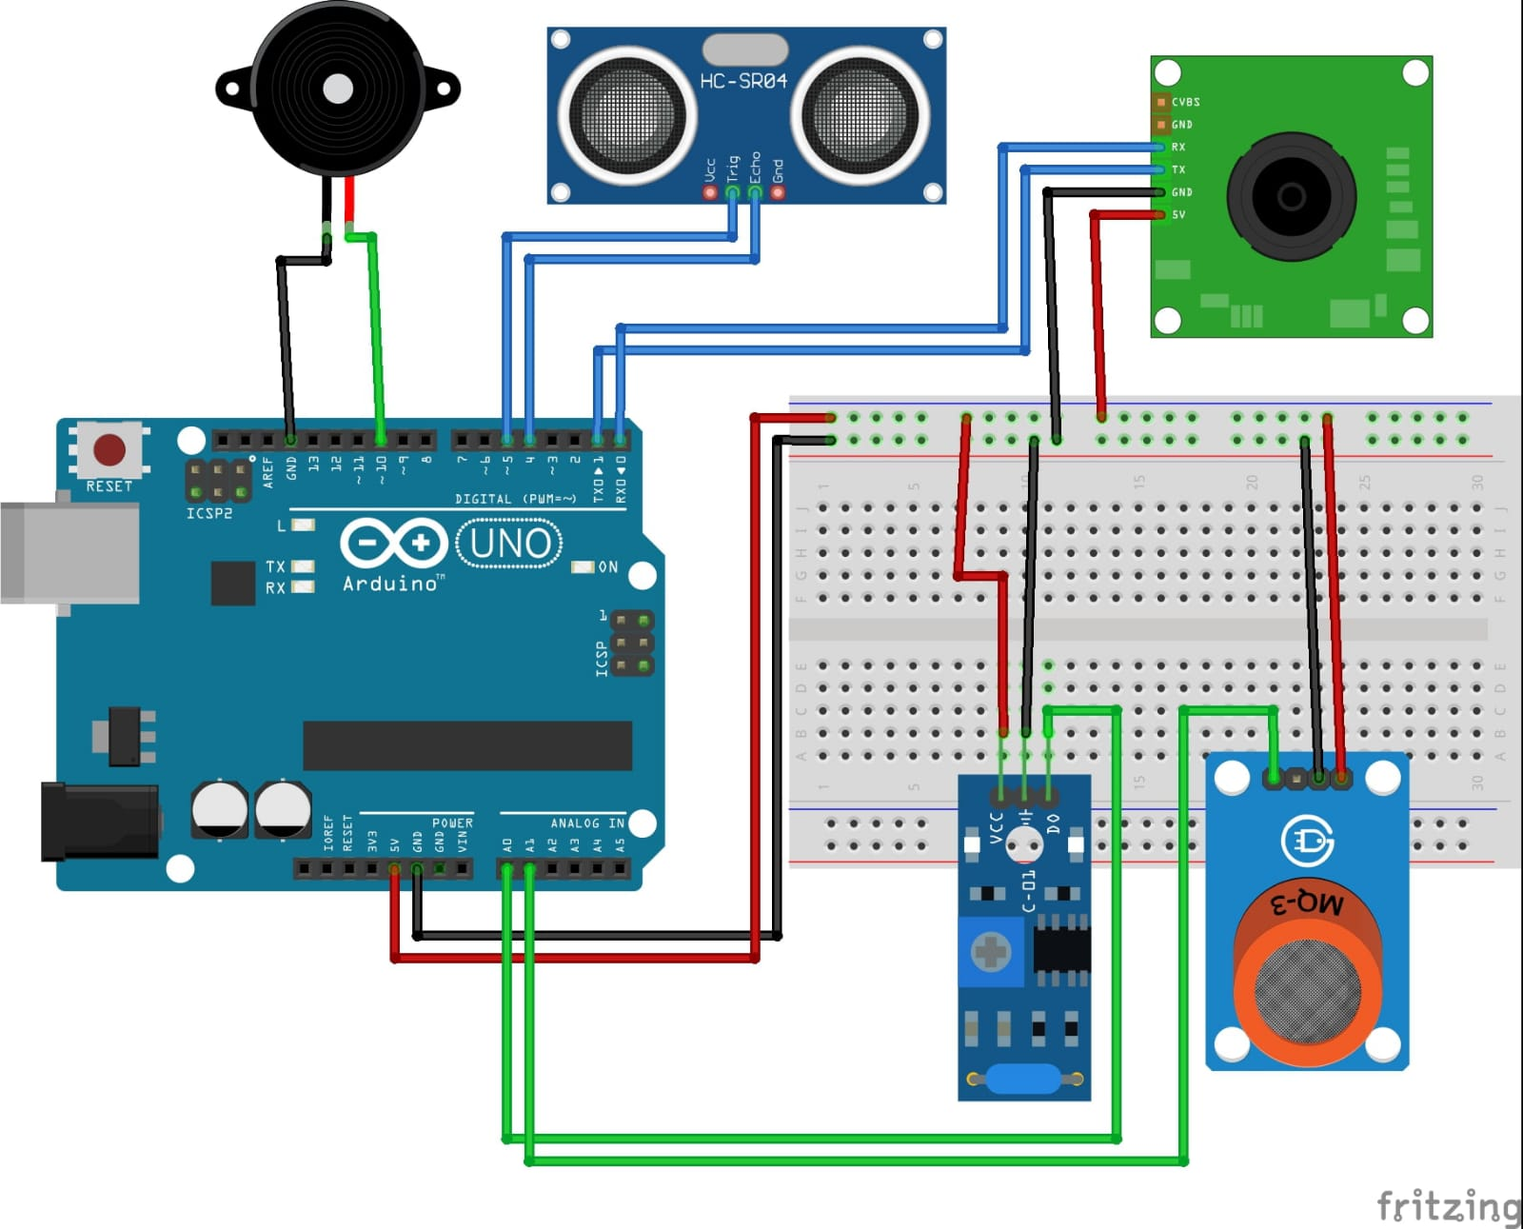

CONCLUSION:

Loading and preprocessing datasets are fundamental steps in the process of effective traffic management, contributing significantly to enhanced urban mobility, safety, and congestion reduction. In this conclusion, we recap the key takeaways and importance of these processes in the context of traffic management.