Typing Tutor



**Authors**

Abdullah Javed (UET/18-CS-30)

Danish Abbas (UET/18-CS-14)

Zarar Azwar Khalid (UET/18-CS-28)

Mehreen Fatima (UET/18-CS-53)

**Supervised By**

Mr Muhammad Wakeel Ahmad

**Department of Computer Science**

**UNIVERSITY OF ENGINEERING AND TECHNOLOGY**

**TAXILA**

January 2019

# **DEDICATION**

**Dedicated to**

**“The Teacher of the Universe”**

(Peace be Upon Him)

With whose existence

and

by having the charity of His knowledge

the cosmos got illuminated with the light of

insight and wisdom

and

The journey of human enlightenment was made possible.

# **Acknowledgement**

Praise to Allah Almighty, Lord of the worlds, the Merciful and the Beneficent, who gave us strength, thoughts, and co-operative people to enable us to accomplish this goal and fulfil the required functionalities.

This was all not possible without the guidance, continuous appreciation, and moral support by our honourable Supervisor **Mr Muhammad Wakeel Ahmad.** He was always there whenever we need his help and ideas. We are thankful to him, who made our concepts clearer.

At last, we would like to acknowledge all of the assistance and contributions of UNIVERSITY OF ENGINEERING AND TECHNOLOGY, TAXILA for supporting us with all that is needed starting from the books, and ending with the full care that it is providing us with, to help us to be professionals in the field of Information Technology.

# **DECLARATION**

We hereby declare that we have developed this application and accompanied the report entirely based on our efforts. Not any of the portion of the application work presented has been submitted of any application for any other qualification or degree of this or any other university or institute of learning.

**Students Name & Signature**

**Student 1 Student 2 Student 3 Student 4**

Abdullah Javed Danish Abbas Zarar Azwar Mehreen Fatima

_____________ ______________ _____________ _____________

# **CERTIFICATE OF APPROVAL**

It is to certify that the semester project of BS (CS) “**Typing Tutor”** was developed by **Abdullah Javed, Danish Abbas, Zarar Azwar Khalid** and **Mehreen Fatima** under thesupervision of “**Mr Muhammad Wakeel Ahmad**” and that in his opinion; it is in scope, fully adequacy and of quality of the degree of Bachelors of Science in Computer Sciences.

**External Examiner**

**Supervisor**

Mr Muhammad Wakeel Ahmad Rao

Lecturer, Computer Science Department

UET, Taxila

**Head of Department**

Dr Adeel Akram

Department of Computer Science

UET, Taxila

# **ABSTRACT**

In today’s lifestyle, it’s practically not possible for everybody to be adept at typewriting. Some appropriate introduction of typewriting words on any device ought to be introduced. Computers play a significant role in each field. By employing a pc, several things can be written in a very well-organized and economical manner with none concern of mistakes.

Our main goal is to facilitate our users so that they are going to be able to open the pc employing a keyboard while not retardation down their speed yet as creating as minimum mistakes as doable whereas writing expeditiously. Here we have got used the ideas of information Structures to attain our goal. The project is an implementation within the type of a game sometimes that maybe content by the kids to extend their intelligence yet as getting adept at typewriting. Whenever an individual is doing one thing for the first time, he becomes baffled, however, gets to understand it in a matter of time. Our goal is to build to form the most effective use of this universal human psychological science by creating an individual apply typewriting words in a very quick yet as the economical manner and not make mistakes whereas typewriting.

What is more, our application can modify the use of error checking balances so that mistakes while typewriting, will be reviewed. It can be a smooth application. Thus, its correct implementation is a supply of satisfaction for the scholars together with the academics because it can save plenty of their time and facilitate them while typewriting on pc systems and not waste plenty of their time.

Contents

DEDICATION 2

Acknowledgement 3

DECLARATION 4

CERTIFICATE OF APPROVAL 5

ABSTRACT 6

Chapter No.1 Introduction 9

Problem Statement 9

Algorithm 9

Explanation 9

Objectives 10

Motivation 10

User-Interface 11

Typing pace 11

Typing Valid Word of certain Length 11

Chapter No.3 Language and Data Structure 12

Introduction to language: 12

Why we use Java Language? 12

JAVA API, JDK, and IDE: 13

Introduction to Data Structures used: 13

Array List: 13

**Implementation of Array List** 13

Chapter No.4 Concepts, Tools and Techniques 14

Java Swing GUI Tool Kit for User-friendly GUI 14

Exception Handling 14

**Hardware Details** 14

**Software Details** 14

Chapter No.5 Development 15

Development Stages 15

**Set String in the label of Array List.** 15

**Getting input in textfield** 15

**Checking the errors:** 17

**Changing the color of words** 18

**Searching for possible words of different length** 18

**Show the result summary:** 19

**Time calculation:** 20

Chapter No.6 GUI and Class Diagram 22

Introduction: 22

GUI 23

**The Main User-Interface** 23

**Output Results** 24

Project Lesson: 25

Game: 26

Test Simple: 27

Test Advance: 28

Conclusion 28

References 29

# Chapter No.1 Introduction

## Problem Statement

In the actual game, humans use their mental intelligence while typing letters. There was a need to develop an efficient and intelligent algorithm to keep a person focused on a given string of letters while typing. All the possible words formed must be valid and accurate, which is the main objective of our desktop application typing tutor. In this project, the time-space complexity of the algorithm matters a lot, and this can be challenging, and we need to put it in our consideration. The other part of our project is to show the words typed by the user for future error corrections and to make the application highly efficient and user-friendly.

## Algorithm

The algorithm that we have used is given below:

1. Store all the words in the array of labels.
2. Get text from the user in textfield.
3. Compare each both string bit by bit.
4. Calculate the total time and errors and sent it into the jframe of result.

## Explanation

This project typing tutor helps to increase the speed of typing. The lessons are stored are build in taken from the internet sources. When the typing tutor start the user get input in textfield.

After that the compiler check it bit by bit and then show the output.

This is a user-friendly application, so its proper implementation will be a source of satisfaction for the students along with the teachers as it will save a lot of their time. It can be further implemented to make proper use of its interface and helping users in finding out whether the word typed is correct in the future.

## Objectives

While developing this desktop application, the main objectives that we had in our mind were:

1. Making application user-friendly.
2. Making application responsive and descriptive.
3. The time complexity of the algorithm, and it’s efficiency.
4. The validity of words.

## Motivation

The Motivation behind this project was to help the students in improving their typing speed very efficiently and logically. The students who are related to a field where they need good typing speed which is the good impression for their personality. This project will also help the persons who are doing jobs and can easily practice typing without getting bored along the way as well as learn typing at home and without wasting their time and practising whenever they are free. This project will help a person to learn to type, which will be helpful for them in practical life.

Chapter No.2 Functionalities

## User-Interface

Our user interface is straightforward and user-friendly. It is not made up of gaudy adornments or unnecessary elements. It is evident and understandable.

## **Typing pace**

The main functionality of our project is that it helps a person to type a word and help him continue at his own pace. The user will be asked to input the word displayed on-screen while his speed will be measured according to time. The program will allow a person to type without much difficulty and will help him maintain his speed without any fear or any kind of psychological pressure.

## **Typing Valid Word of certain Length**

Another functionality of our project is that it also prints words of specific length formed from given the string. The user is asked for the length of the words he/she wants to see, and then on the click of a button, those specific length words are being printed on the console.

**Performance Report:**

A report is made after a person completes a task. He is given a brief overview of his performance according to his typing speed as well as it’s correctness.

# Chapter No.3 Language and Data Structure

**Operating system:** Window XP, 7, Vista, 8, 8.1 and 10

**Programming Language:**  JAVA

**Data Structures:** Array List and Arrays

## Introduction to language:

In 1991 Sun Microsystem started a project to develop a language that is the platform-independent means once the program is compiled, then it can be run on any computer.

After four years in 1995, the C/C++ developers developed java language. The first name of the language was "Oak" after sometimes its change and converted into java.

In 2010 Oracle bought the Sun Microsystem, and it also bought the java programing language with its assets, and now Oracle is managing and running the java language.

## Why we use Java Language?

This software is implemented in java because java gives the facility of portability and many more facilities. The java programming language gives benefits like platform-independent, object-oriented, Encapsulation, portability, inheritance, efficient and competent performance, and provide services for increasing performance and more. The main benefits of the java programming language given below,

* Inheritance
* Polymorphism
* High Performance
* Good Graphical User Interface
* Encapsulation
* Platform independent

## JAVA API, JDK, and IDE:

For running or compiling the java language, java uses JAVA SE. There are many versions of Java SE, but the latest one is Java SE 8.

Oracles release the new version of Java SE with the Java Development Toolkit (JDK). For Java SE 8, the latest JDK is JDK 1.8, which is also called Java 8 or JDK 8.

The Java API is the collection of the built-in classes form which a developer can be used in their programs by just importing that class form its package.

## Introduction to Data Structures used:

In our project, we use the three types of data structures

## Array List:

An array list is a particular type of arrays that do not have the problem of its size. In this type of array, you can add as many elements as you want. Java built-in class "ArrayList" provides us such type of array. Java ArrayList class extends the AbstractList class, which implements the List interface. The List interface extends Collection and Iterable interfaces in hierarchical order.

### **Implementation of Array List**

In our project, we use the array list type of data structure for holding data. All the valid possible English words are searched through the file and then stored in Array List. This type of data structure helped us in managing many data on English words.

# Chapter No.4 Concepts, Tools and Techniques

In the development of this project, we have used certain programming concepts that were necessary for the implementation. Some concepts helped us in making this application more efficient. Following are the concepts that were used in developing this project:

## Java Swing GUI Tool Kit for User-friendly GUI

Swing is a GUI widget toolkit for Java. It is part of Oracle's Java Foundation Classes – an API for providing a graphical user interface for Java programs. The swing was developed to provide a more sophisticated set of GUI components than the earlier Abstract Window Toolkit.

## Exception Handling

The **Exception Handling in Java** is one of the dominant mechanisms to handle runtime errorsso that normal flow can be maintained.

### **Hardware Details**

The following are the hardware requirements needed to run this application efficiently.

1. Computer
2. Minimum 4 GB RAM

### **Software Details**

Following are the Software tools that helped us in developing this Application

1. NetBeans
2. Eclipse

# Chapter No.5 Development

In this chapter, we will discuss how we developed this project. In this application, the user is asked to input random characters. Following are the functions performed by our application as a response to the input characters:

1. Set string in the label array.
2. Getting input from user.
3. Check all the input from user.
4. Change colour of the keys.
5. Show summary.

Fig 1.6

## Development Stages

### **Set String in the label of Array List.**

In this stage the the string of lesson is inserted in labels.

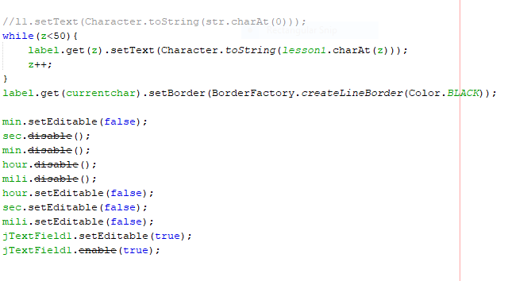

### **Getting input in textfield**

In this stage the user enters the text in textfield.

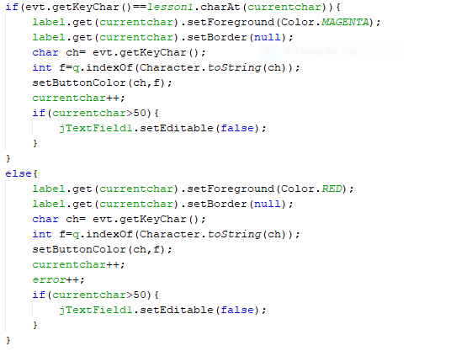

Fig 1.8. Inserting Words in Tree

### **Checking the errors:**

In this stage the compiler compare each bit with the array of lesson.



### **Changing the color of words**

In this stage the wrong words get red color and correct word get green color.

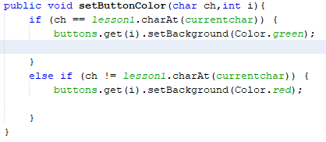

Fig 2.1 Printing all the possible words

### **Searching for possible words of different length**

Our application provides its users with the functionality of finding all the possible words of a certain length of their own choice that can be formed through the input characters. A combo-box is provided to users in which the user selects length. Then a series of switch cases transfer the control of the program to different functions made for searching words of different lengths. The functions find the words of length equal to the cash value. For a certain length, we have different **search, print**, and **length count** functions. The following figure shows the length count function for the word of length thirteen.

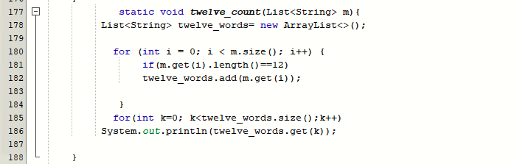

Fig 2.2 Function to check the length of words

This length count is called in the body of the search function. The following figure shows the body of **search_Twelve_Word(TrieNode root, boolean Hash[], String str)** function in which the above length count function is called.

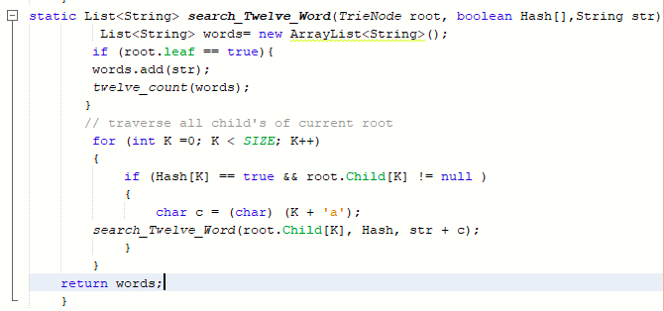

### **Show the result summary:**

After calculation of errors the and calculation of time the result calculated and shows in result.

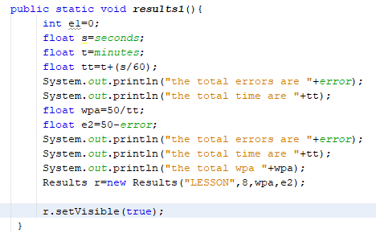

Fig 2.4 Function to create a pdf file

**Time calculation:**

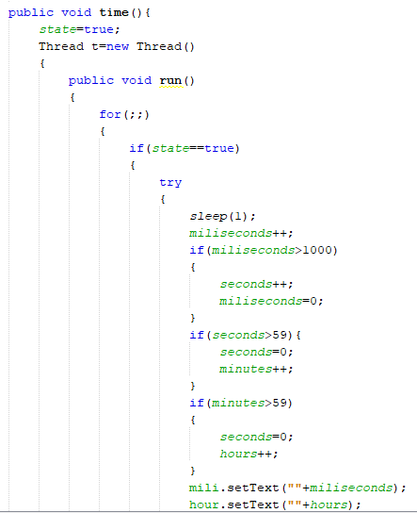

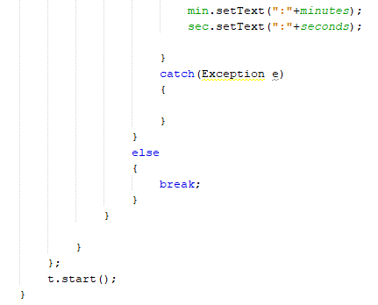

Fig 2.9 Function for retrieving definitions from Hash Mao

Fig 2.8 Reading Words’ Definitions

# Chapter No.6 GUI and Class Diagram

## Introduction:

This chapter includes the flow charts, class diagrams, and some screens shots of our projects. Flow charts show how control moves in our programs.

A graphical user interface (GUI) is an interface through which a user interacts with electronic devices such as computers, hand-held devices, and other appliances. This interface uses icons, menus, and another visual indicator (graphics) representations to display information and related user controls, unlike text-based interfaces, where data and commands are in the text. GUI representations are manipulated by a pointing device such as a mouse, trackball, stylus, or finger on a touch screen.

The class diagram is the basic structure of our project that how we assemble our data and work in OOP. In software engineering, a class diagram in the [Unified Modeling Language (UML)](https://en.wikipedia.org/wiki/Unified_Modeling_Language) is **a type of static structure diagram** that describes the structure of a system by showing the system's classes, their attributes, operations (or methods), and the relationships among objects.

The GUI screenshots give you the different look of our program in different input and outputs.

## GUI

### **The Main User-Interface**

To provide a user-friendly environment for the users, we have created a straightforward and descriptive graphical user interface. The main user-interface contains the logo of the application.

On the right side of the interface, we have provided the user with some rules that they need to follow during the execution of the application. On the left side, we have provided the user with specific options home,Lessons, Game ,Exit and tests. The following figure shows the main user-interface of the application.

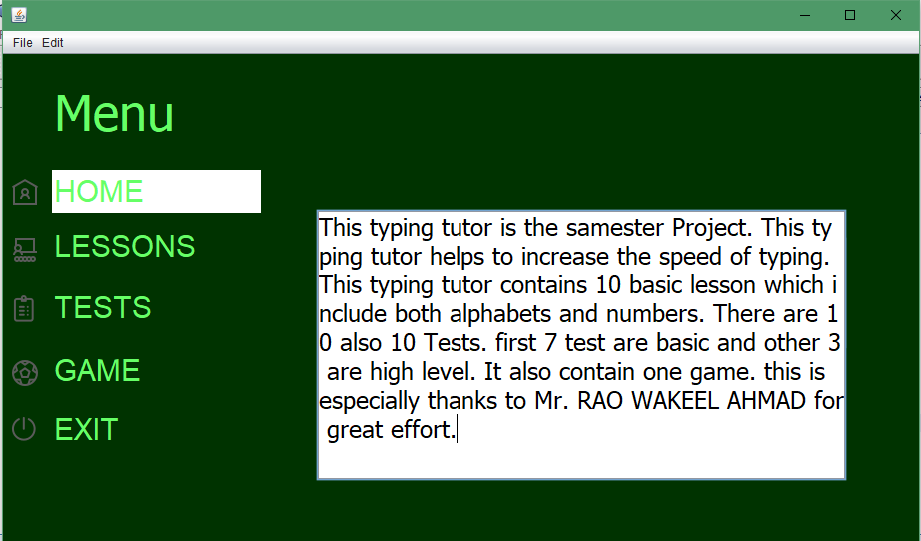

Fig 3.0 Main User-Interface

### **Output Results**

The figure shows all possible valid words that can be formed when the user enters random characters.

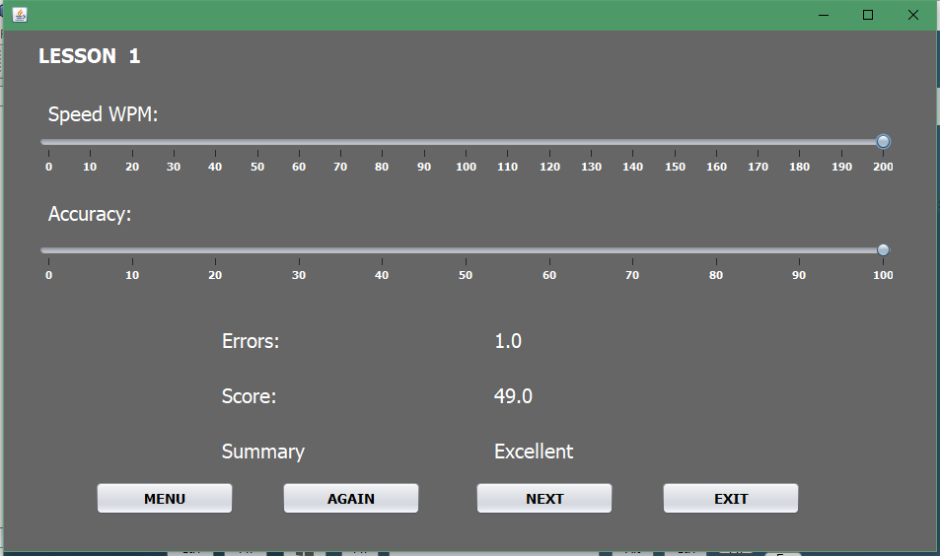

Fig 3.2 All possible words formed.

## Project Lesson:

The following is the class diagram of our project.

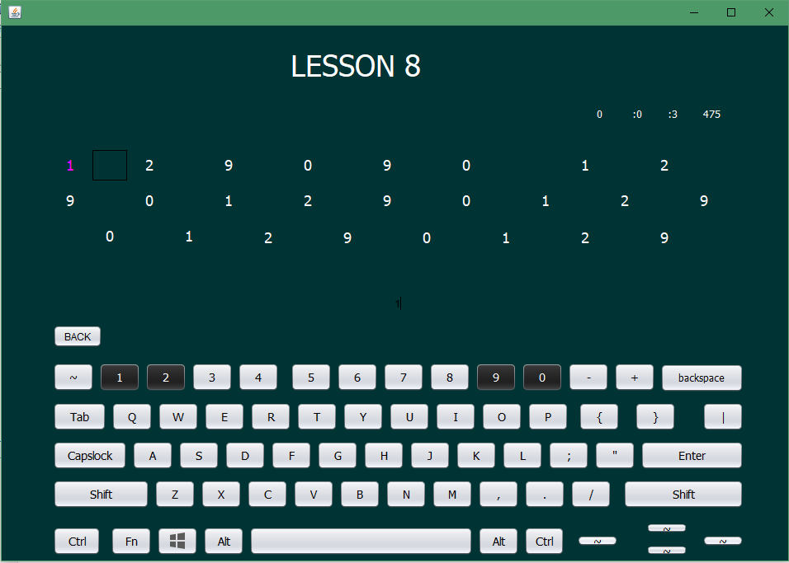

## Game:

The game of typing is as follow:

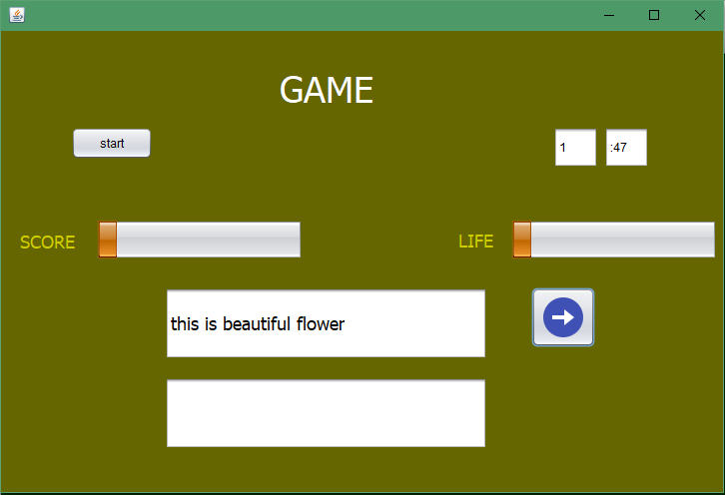

## Test Simple:

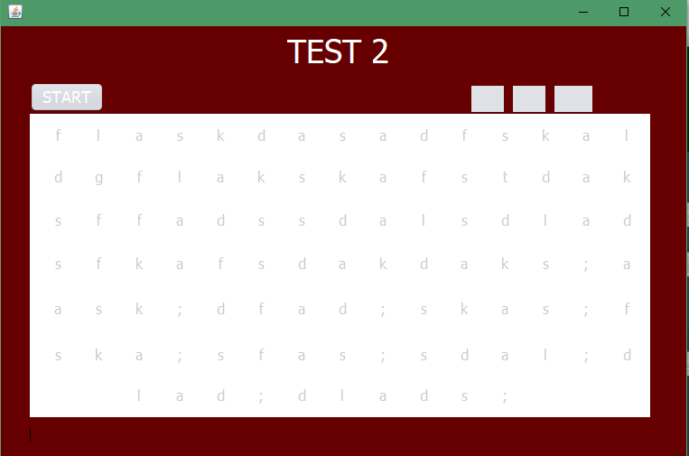

## Test Advance:

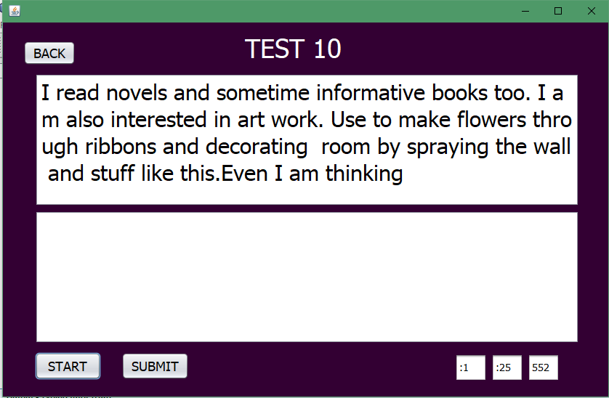

# **Conclusion**

The main functionality of our project is that it helps a person to type a word and help him continue at his own pace. The user will be asked to input the word displayed on-screen while his speed will be measured according to time. The program will allow a person to type without much difficulty and will help him maintain his speed without any fear or any kind of psychological pressure.

# **References**

1. <https://docs.oracle.com/javase/tutorial/>
2. <https://developer.oxforddictionaries.com>
3. <https://www.geeksforgeeks.org>
4. https://www.javatpoint.com/java-arraylist
5. <https://stackoverflow.com/questions/5015844/parsing-json-object-in-java>
6. <https://github.com/dwyl/english-words>
7. <https://www.javatpoint.com/java-hashmap>
8. <https://convertio.co/txt-csv/>
9. <https://answers.splunk.com/answers/521487/how-to-use-a-csv-file-lookup-to-filter-out-data.html>
10. <https://stackoverflow.com/questions/5282999/reading-csv-file-and-storing-values-into-an-array>
11. https://www.howtogeek.com/348960/what-is-a-csv-file-and-how-do-i-open-it/
12. Lectures Provided by Instructor