GEN-Z DIGITAL STOREFRONT · ISE_WE_0201_58
Entity-Relationship Diagram
Full-Project Database Schema · genz_digital_storefront

Project | A Modern Digital Storefront for Gen-Z
Database | genz_digital_storefront (MySQL 8, InnoDB, utf8mb4)
Scope | 21 tables across 4 modules: EP-01, EP-02, EP-03, EP-04
Source of truth | genz-backend/genz-backend/db/schema.sql
Team | IT24101208 Warnakula S P (Scrum Master) · IT24101437 Sashorinth N · IT24103841 Razni Ahamed B S

How to Read This Diagram
This diagram uses crow's-foot notation, the standard convention for relational entity-relationship diagrams. Every entity box, column, key and relationship shown is copied directly from the live database schema (db/schema.sql) — nothing here is a conceptual approximation drawn after the fact.

Reading an entity box
- The table name is the header.
- PK marks the primary key column(s).
- FK marks a foreign key column, with an outline instead of a solid fill.
- PK/FK marks a column that is simultaneously the primary key and a foreign key — e.g. inventory_stock.product_id, a strict one-to-one relationship with products.
- A small boxed letter beside a foreign key (e.g. “A”) marks a reference to a table in a different module — see the Cross-Module References table on page 4.
- Italic text beneath the keys summarises the remaining columns and any notable rule.

Reading a relationship line
- A double tick ( ∥ ) sits at the “one” side of the relationship — the parent table, whose primary key is being referenced.
- A crow's foot ( ⌓ ) sits at the “many” side — the child table, whose foreign key column points back to the parent.
- A solid line means the foreign key is NOT NULL — every child row must reference a parent.
- A dashed line, and a small circle before the crow's foot, mean the foreign key is nullable — the relationship is optional (e.g. carts.customer_id). The Actor Identity pattern — moderation_logs.actor_id is NULL precisely when the actor is Owner/Admin rather than a named Staff account — is a cross-module reference, listed in the Cross-Module References table.

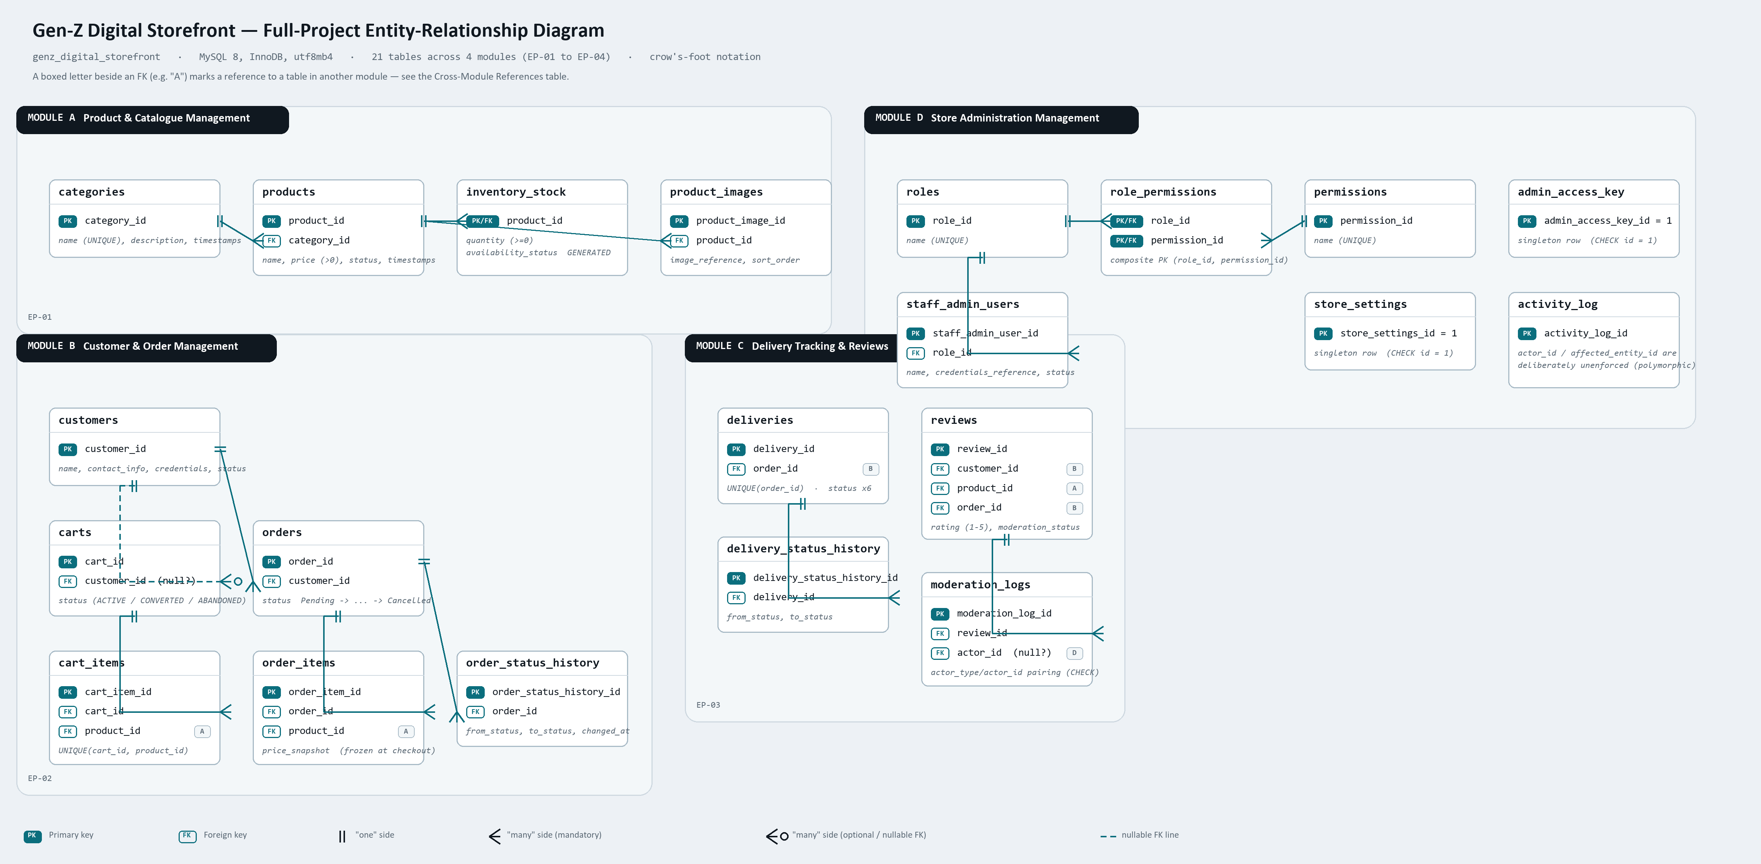

Cross-Module References
Foreign keys that point at a table drawn in a different module are marked on the diagram with a small boxed letter rather than a long connecting line, to keep the diagram readable. They are listed here in full.
Referenced table | Referenced by
products [A] | cart_items.product_id (B)  order_items.product_id (B)  reviews.product_id (C)
customers [B] | carts.customer_id (B)  orders.customer_id (B)  reviews.customer_id (C)
orders [B] | deliveries.order_id (C)  reviews.order_id (C)
staff_admin_users [D] | moderation_logs.actor_id (C)

All 21 Tables
Mod | Table | Purpose
A | categories | Product categories (men's clothing, boys' clothing, perfumes)
A | products | The product catalogue
A | inventory_stock | Per-product stock quantity; availability_status is a generated column
A | product_images | Image references attached to a product
D | roles | Named roles assignable to Staff accounts
D | permissions | Named permissions checked by requirePermission()
D | role_permissions | Junction table: which permissions each role has
D | staff_admin_users | Staff/Admin accounts (login not yet implemented)
D | store_settings | Singleton row: store name, contact info, WhatsApp number
D | admin_access_key | Singleton row: hashed Owner/Admin access key
D | activity_log | Central audit trail written by every module
B | customers | Customer accounts
B | carts | One active cart per customer
B | cart_items | Line items in a cart
B | orders | Customer orders, Pending through Cancelled
B | order_items | Line items in an order; price frozen at checkout
B | order_status_history | Audit trail of order status transitions
C | deliveries | One delivery per order, tracked through 6 statuses
C | delivery_status_history | Audit trail of delivery status transitions
C | reviews | Verified-purchase star ratings and written reviews
C | moderation_logs | Audit trail of review approve/reject/delete actions
Source: genz-backend/genz-backend/db/schema.sql. Columns beyond primary/foreign keys are summarised on the diagram rather than fully enumerated, to keep each entity box readable; the complete column list, data types and constraint definitions for every table are in the schema file itself.

