How is Angular 2 different from Angular 1? Ensure your response references the improvements in Angular 2

Angular 2 is a complete rewrite of Angular 1 and is different architecture from the original version. Also, Angular 2 is component based instead of model-view-controller of Angular 1. Using $variable from Angular 1, instead you use components in Angular 2 leading to clearly defined inputs and outputs. From the website differencebetween.net a great image can be found that sums up the key differences between the two different versions of Angular.

Fig. 1

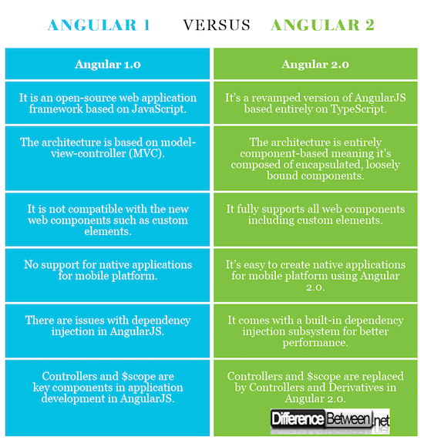

Figure from [differencebetween.net](http://www.differencebetween.net/technology/difference-between-angular-1-and-angular-2/)