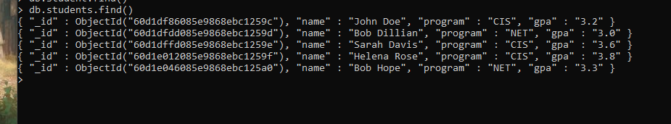

NOT SURE IF THIS WHAT YOU REALLY WANTED

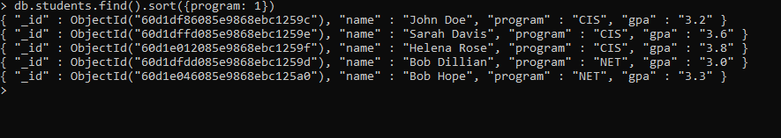

SORTED BY PROGRAM

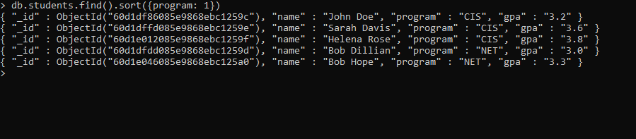

GREATER THAN 3.0

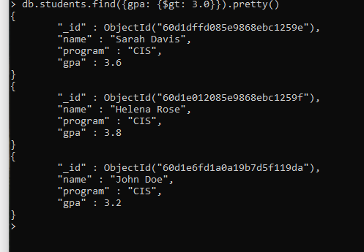

ADD .5 POINTS TO EVERYONE’S GPA BUT DON’T GO OVER 4.0

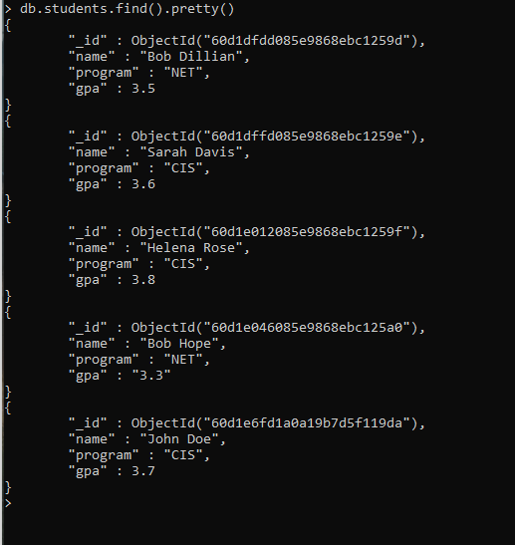

ADD NEW ATTRIBUTE TO EACH COLLECTION NAMED ADVISOR

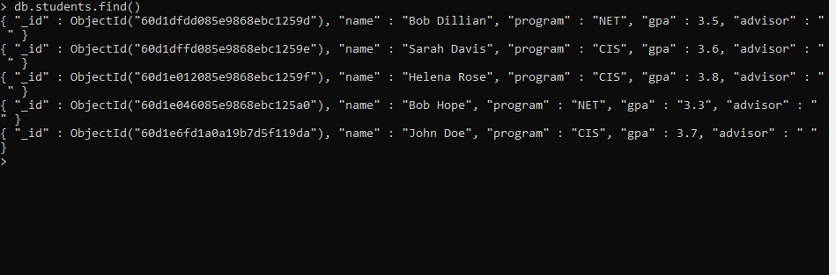

SET THE ADVISOR TO LABUDZIK FOR ALL CIS AND BELLET FOR ALL NET STUDENTS

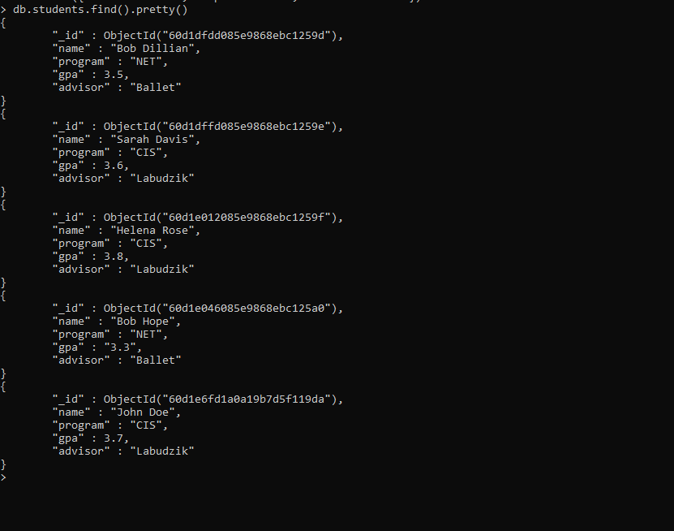

DELETE THE NET STUDENTS

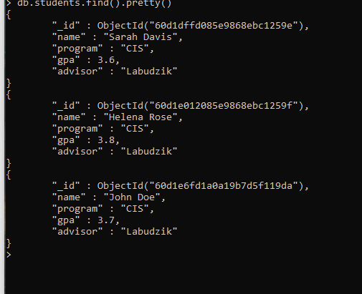

db.students.update({sudent_gpa:({$gte: 3.5}},{$inc: {sudents_gpa: -1}}