**Course Tata - AWS Certified Developer - Associate**

**email = [External] Actualización Sala de Teams | Bootcamp AWS Certified Developer – Associate | 1er Grupo**

email = [External] MLT | Bootcamp en español + certificación | AWS Certified Developer – Associate

**email = [External] ¡ES HOY! - NETEC | Confirmación y accesos al Curso 241128 AWS-DEV LIM**

**Link Teams:** [**https://teams.microsoft.com/l/meetup-join/19%3ameeting_MTM1OTczYjEtZTBiMS00ODk4LThjMzctNDFkNGFlMzlmYWVk%40thread.v2/0?context=%7b%22Tid%22%3a%22c0d4f0b3-9edd-4cee-b7f9-caf9a448f665%22%2c%22Oid%22%3a%22ce8a9cdf-1fcc-4e4e-a815-d599cd09d0ca%22%7d**](https://teams.microsoft.com/l/meetup-join/19%3ameeting_MTM1OTczYjEtZTBiMS00ODk4LThjMzctNDFkNGFlMzlmYWVk%40thread.v2/0?context=%7b%22Tid%22%3a%22c0d4f0b3-9edd-4cee-b7f9-caf9a448f665%22%2c%22Oid%22%3a%22ce8a9cdf-1fcc-4e4e-a815-d599cd09d0ca%22%7d)

contacto: Lesly Vargas

[lesly.vargas@netec.com.pe](mailto:lesly.vargas@netec.com.pe), cel = +51 941 426 727

verificar materiales y laboratorio en @tcs.com

crear cuenta @tcs.com

acceder a la plataforma con el código privado

asunto: control documentario

Ver este correo: [controldocumental@netec.com](mailto:controldocumental@netec.com)

Para habilitar correo crear ticket help desk.

* Link del material

<https://us-east-1.student.classrooms.aws.training/class/vXotLc2aYyQdD3eBizrKZT>

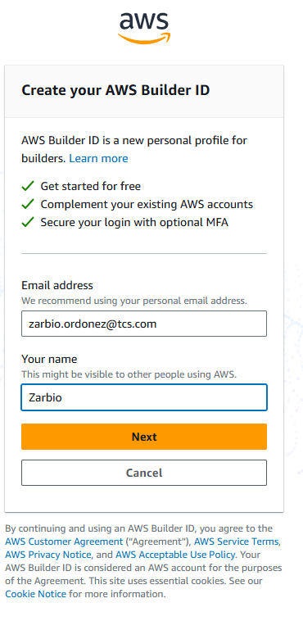

user = [zarbio.ordonez@tcs.com](mailto:zarbio.ordonez@tcs.com)

pwd = Serafines@2026

* Solicitud de examen

email = [External] Fw: NETEC EXAMEN DE CERTIFICACION

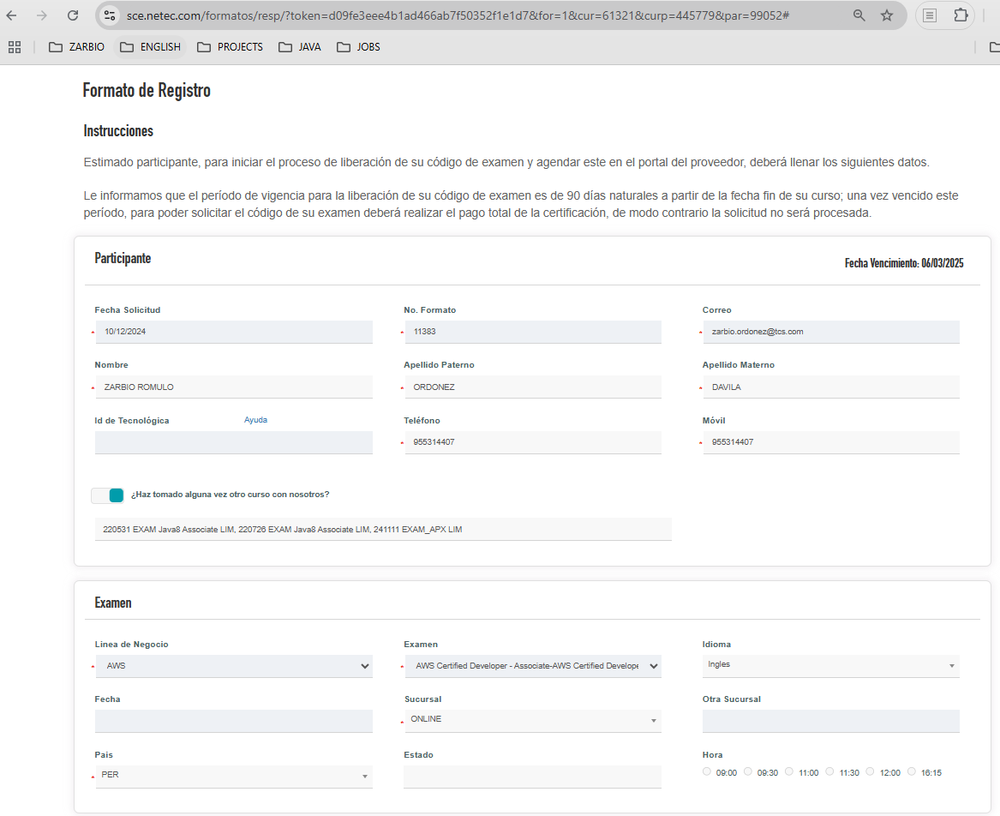

* **Voucher del examen: Email [External] AWS Bootcamp | Voucher otorgado para la certificación**

**Vigencia del voucher: 04 de febrero del 2025**

**Meta para dar el examen hasta: 17 de enero del 2025**

**AGENDAMIENTO EXÁMENES AWS.pdf**