Unit Testing
- Why write Unit Test?
- Make sure that the code works.
- Code works with valid and invalid input parameters.
- Code works now and in the future.
- Other code still works even after you made changes.

- F.I.R.S.T Principle
Fast: Unit tests run fast
Independent: Unit tests are independent
Repeatable: Unit tests are repeatable
Self-validating: Unit test validates itself
Thorough & Timely: Cover edge cases

- Advantages
Reduce bugs when changing the existing functionality.
Reduces costs of Testing as defects are captured in very early phase.
Improve design and allows better refactoring of code.
- Unit Testing Lifecycle
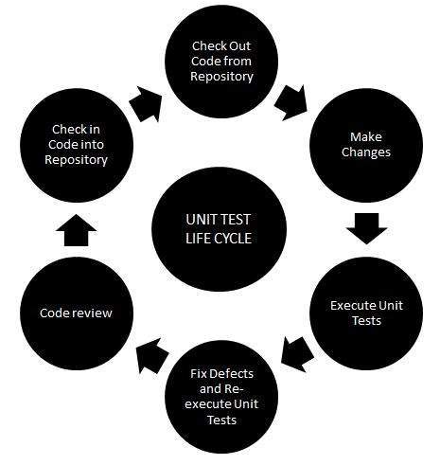
- Techniques
Black Box Testing
White Box Testing
Gray Box Testing
- Testing Pyramid

- Unit tests
Testing isolated small pieces of code with Fake or Mock dependencies. Run before any other test.
Testing a functionality of a Unit in isolation.
Involves mock only the main layer (e.g.: Web Layer).
- Integration Tests
Tests use real objects instead of mocks of fake objects. Can interact with database, HTTP connections, servers, communicate with internal or external systems.
Involves all three layers, so no mocking of any layer or any object will be done.
- End-To-End Testing / UI Testing
Testing software functionality from beginning to end. Write automated UI tests. e.g.: invoke button clicks.

- Test Driven Development - TDD
Is the process in which test cases are written before the code that validates those cases.
  - TDD Life Cycle
- Red: write Unit test that fails.
- Green: write application code to make Unit Test pass.
- Refactor: Clean up. Improve Unit Test and Application code.
- Repeat: repeat above steps until all your functionality is implemented.

  - TDD – Three Laws
- No Production code without failing test.
- Just enough test to make code fail.
- Just enough code to make test pass.

  - Best Practice
Don’t create a long list of different assertions in a single method. Have one test method to test one specific functionality and have one strong assertion for it.
https://www.geeksforgeeks.org/test-driven-development-tdd/
https://www.geeksforgeeks.org/test-driven-development-using-junit5-and-mockito/
\junit\JUnitUtils
- Data-Driven Testing – DDT
Is Parameterized testing by applying some conditions like verified inputs.
Types depends of the format of the data: Comma Separated Values (CSV) files, Excel Sheets, Database Tables, Script Arrays, Table Variables.
https://www.geeksforgeeks.org/difference-between-data-driven-testing-and-keyword-driven-testing/
- Automated Software Testing
https://www.tutorialspoint.com/software_testing_dictionary/automated_software_testing.htm
- Functional testing vs Non-Functional testing:
Functional testing | Non-Functional testing
Verifies the operations and actions of an applications. | Verifies the behavior of an application.
Based on customer’s requirements. | Based on customer’s expectations.
Based on business requirements.  Involves: checking of User interface, APIs, Database, Security, client/server applications and functionality of the applications under test. | Based on the performance requirements., usability, reliability.
Helps to enhance the behavior of the application. | Helps to improve the performance of the applications.
Easy to execute manually or using automation. | Hard to execute manually.
Tests what the product does. | Describes how the product does.
Examples:  - Unit Testing  - Smoke Testing  - Integration Testing  - Regression Testing  - User Acceptance  - Localization  - Globalization  - Interoperability | Examples:  - Performance Testing  - Load Testing  - Stress Testing  - Scalability Testing  - Volume Testing  - Usability Testing  - Compliance Testing  - Portability Testing  - Disaster Recover Testing
Real example:  Check the login functionality. | Real example:  Check the dashboard should load in 2 seconds.  Check how many people can simultaneously login into a software.
Tools:  - Rational Robot (IBM)  - Coded UI (Microsoft)  - Selenium (Open Source) | Tools:  - Load Runner (HP)  - Jmeter (Apache)
Is performed before the non-functional testing.

https://www.geeksforgeeks.org/differences-between-functional-and-non-functional-testing/
https://www.guru99.com/functional-testing-vs-non-functional-testing.html#:~:text=Functional%20testing%20is%20based%20on,the%20performance%20of%20the%20software.
- Framework for automated testing for Java
JUnit, Mockito, Guava, Spring, TestNG
JUnit is a standard unit-testing framework for Java. JUnit 5 is based in Java 8.

TestNG is used for Integration testing.

Mocking is a way to test the functionality of a class in isolation.

- JUnit
- JUnit 5 (last version 2024)
https://junit.org/junit5/
- JUnit Parameterized Test
JUnit 4
Execute the same test case again and again with different values.
https://www.w3schools.blog/parameterized-test-junit
- samples
https://www.geeksforgeeks.org/junit-testcases-for-credit-card-validation-as-a-maven-project/?ref=ml_lbp
https://www.geeksforgeeks.org/junit-writing-sample-test-cases-for-studentservice-in-java/
- Mockito
https://site.mockito.org/
https://javadoc.io/doc/org.mockito/mockito-core/latest/org/mockito/Mockito.html

Mockito is an open source testing framework for Java released under the MIT License. The framework allows the creation of test double objects (mock objects) in automated unit tests for the purpose of test-driven development (TDD) or behavior-driven development(BDD).

Mockito also provides some annotations for reducing boilerplate code.

Mocks all the methods of that interface (inclusive default methods).

Operations: Mock, Fake, Spy, Stub

https://www.toptal.com/java/a-guide-to-everyday-mockito#:~:text=With%20Mockito%2C%20you%20create%20a,form%20of%20a%20changed%20state.

- samples:
https://www.geeksforgeeks.org/how-to-test-java-list-interface-methods-using-mockito/
- Code Coverage
  - Export Code Coverage Report
In IntelliJ IDEA:
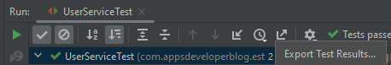
  - Export Test Report using Maven
unit testing\mockito\MockitoUtils
- Unit Testing and Integration Testing in Spring Boot Application
\unit testing\springboot
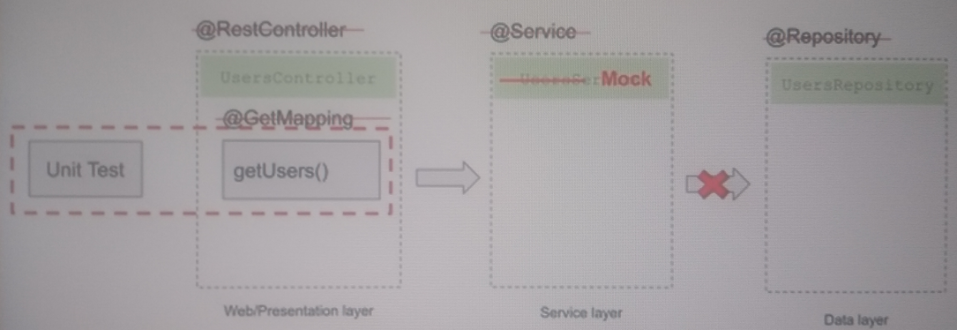
Spring framework allow to test each layer of our application architecture separately.
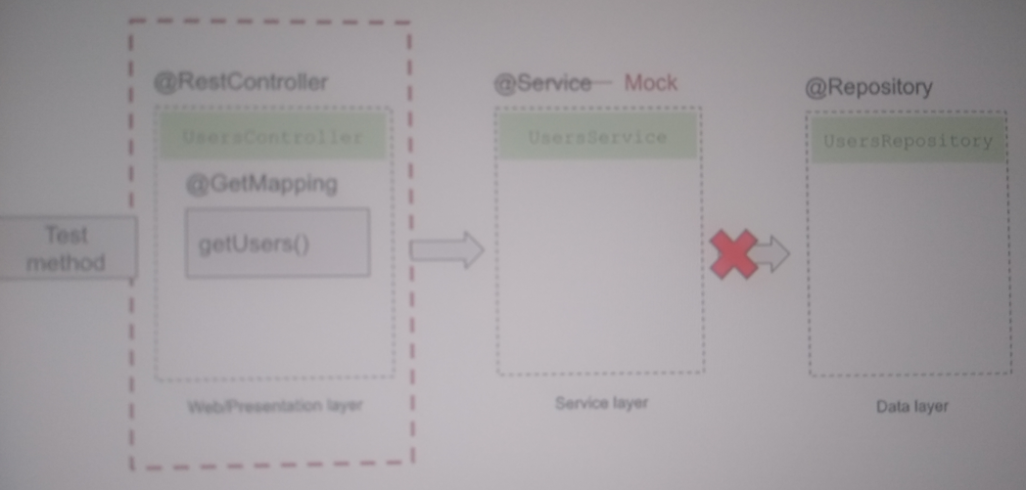
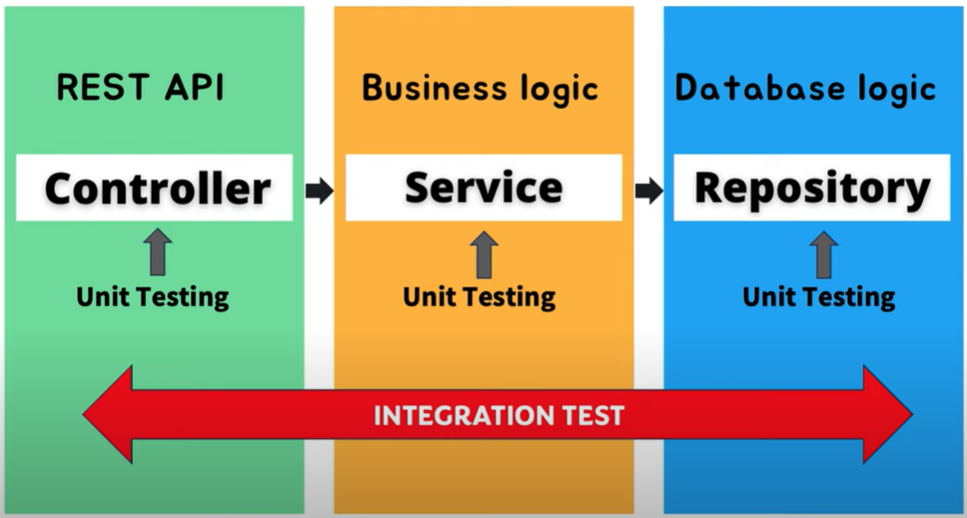
@SpringBootTest: build the context for testing, by default will not start a web server.
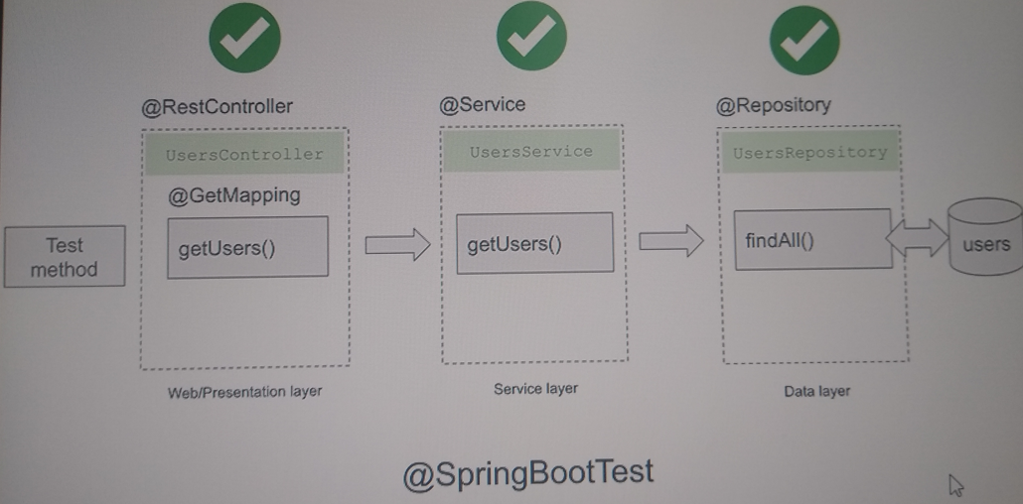
- Automate unit testing generation
Machinet AI: https://plugins.jetbrains.com/plugin/17510-machinet-ai-gpt-4-chat-and-unit-tests
- Courses
- Testing Java with JUnit 5 & Mockito
https://tcsglobal.udemy.com/course/testing-java-code-with-junit-5-and-mockito/learn/lecture/31481676#overview
- References
Write test cases in IntelliJ IDEA
https://www.geeksforgeeks.org/how-to-write-test-cases-in-java-application-using-mockito-and-junit/

Unit Testing
https://www.tutorialspoint.com/software_testing_dictionary/unit_testing.htm

D:\ROMULO\PROJECTS\tech\backend\java\unit testing\utils\JUnitMockitoUtils
D:\ROMULO\PROJECTS\tech\backend\java\springboot\projects\bck\spring-boot-javaguides

Continuous Integration and Continuous Development tools

