Email
- Habilitar acceso de aplicaciones poco seguras
Enter to this link:
https://myaccount.google.com/lesssecureapps
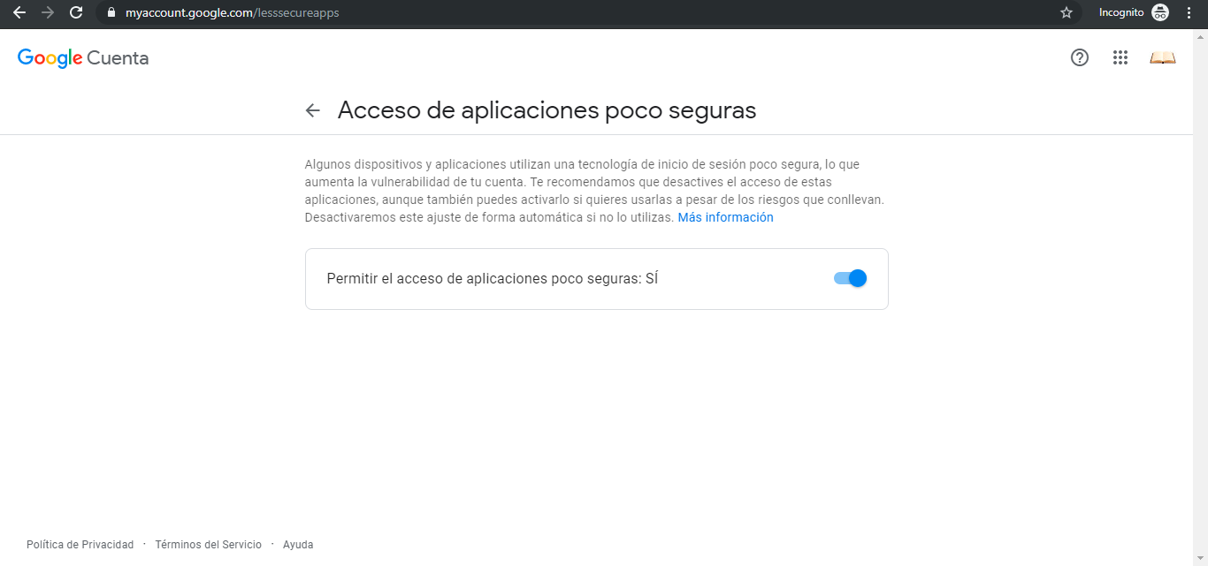
- Requeriments for send email

- Remitente (Sender)
- Destinatario (To)
- Copiar a (Cc)
- Copiar oculta a (Bcc)
- Subject
- Message
- Ruta archivo adjunto (Path attachment)

- Configuration for send email: SMTP (Simple Mail Transfer Protocol)
- Email Server: 118.180.54.55
- Port Email Server: 25
- Authentication (optional):
User name (correo) = test2020@gmail.com
Password (correo) = abc

- References
Send Email with Java and Yahoo! Mail
https://www.codeproject.com/Articles/5266074/Send-Email-with-Java-and-Yahoo-Mail

JavaMail API – Java program to send email – Gmail SMTP server example
https://howtodoinjava.com/for-fun-only/how-to-send-email-in-java-using-gmail-smtp-server/
https://gist.github.com/ipingu/7681247

email MimeMessage java
https://www.javatpoint.com/example-of-sending-email-using-java-mail-api
http://www.jtech.ua.es/j2ee/2002-2003/modulos/mensajes/apuntes/sesion1.htm
https://docs.oracle.com/javaee/6/api/javax/mail/internet/MimeMessage.html
https://www.codeproject.com/Articles/10673/Quick-Mail-using-Java-Mail-API

