Job
- Notes
- Quartz (scheduler)
Quartz is a job scheduling library that can be integrated into a wide variety of Java applications.
- Components of quartz:

- Job: a task (what?)
- Trigger: (when?)
  - Simple trigger
  - Cron trigger
- Scheduler

- Docs
http://www.quartz-scheduler.org/
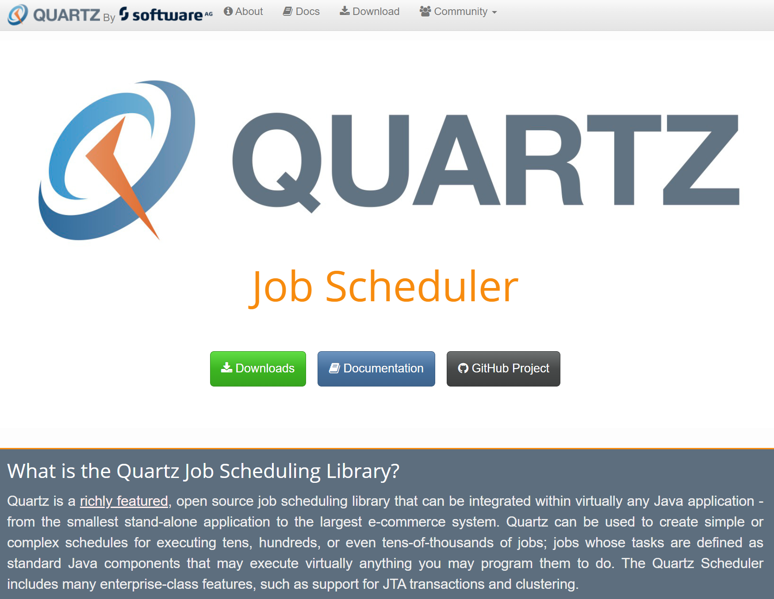
- Latest Stable Release Documentation: Quartz 2.3.0
http://www.quartz-scheduler.org/documentation/
http://www.quartz-scheduler.org/api/2.3.0/index.html
http://www.quartz-scheduler.org/documentation/quartz-2.3.0/examples/
http://www.quartz-scheduler.org/documentation/quartz-2.3.0/tutorials/
Download: Contain samples
http://www.quartz-scheduler.org/downloads/
- Samples
- Starter for using the Quartz scheduler
spring-boot-starter-quartz
D:\ROMULO\PROJECTS\AppWeb\Backend\Java8\Samples\spring-boot-master
https://www.javaguides.net/2018/09/important-spring-boot-starters-with-examples.html
https://github.com/RameshMF/spring-boot
https://github.com/RameshMF/spring-boot/tree/master/spring-boot-samples/spring-boot-sample-quartz
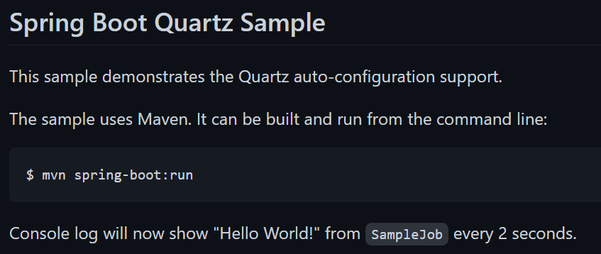
- Quartz scheduling tutorial
job-quartz_v1
https://www.youtube.com/watch?v=6ogkeEn1h7o

Getting Started: Scheduling Tasks with Quartz | Scheduling Tasks in Java - Quartz & Cron
https://www.youtube.com/watch?v=uDkleDfmvBg

- Email API Quartz Scheduler
spring-boot-quartz-scheduler-email-scheduling-master
Spring Boot Quartz Scheduler Tutorial
https://www.youtube.com/playlist?list=PLS1QulWo1RIZL1UicW3PV905pirgXjfQV

Spring Boot Quartz Scheduler Tutorial 1- Getting started with Quartz and Spring Boot
https://www.youtube.com/watch?v=bZ-aGMWAVhk
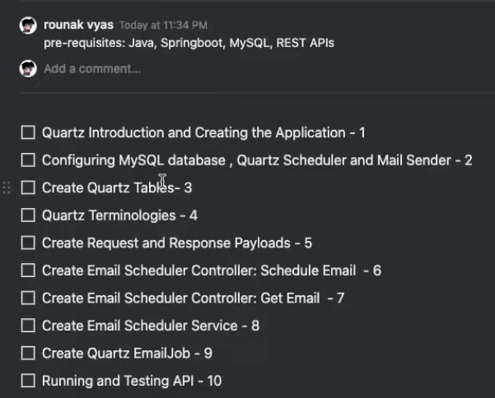
Repository:
callicoder/spring-boot-quartz-scheduler-email-scheduling
https://github.com/callicoder/spring-boot-quartz-scheduler-email-scheduling
https://github.com/callicoder/spring-boot-quartz-scheduler-email-scheduling/blob/master/src/main/resources/quartz_tables.sql
Database: MySQL

Spring Boot Quartz Scheduler Example: Building an Email Scheduling app
https://www.callicoder.com/spring-boot-quartz-scheduler-email-scheduling-example/
spring initializr
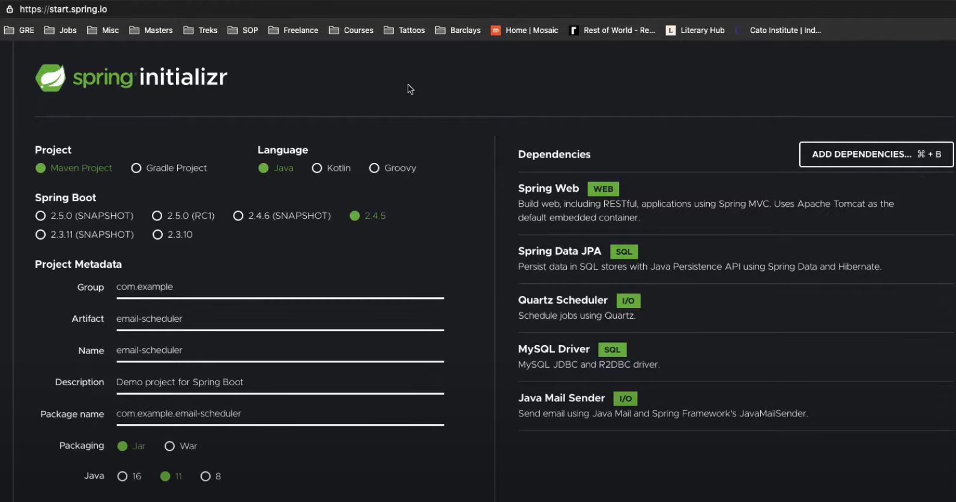
Enable security email account:
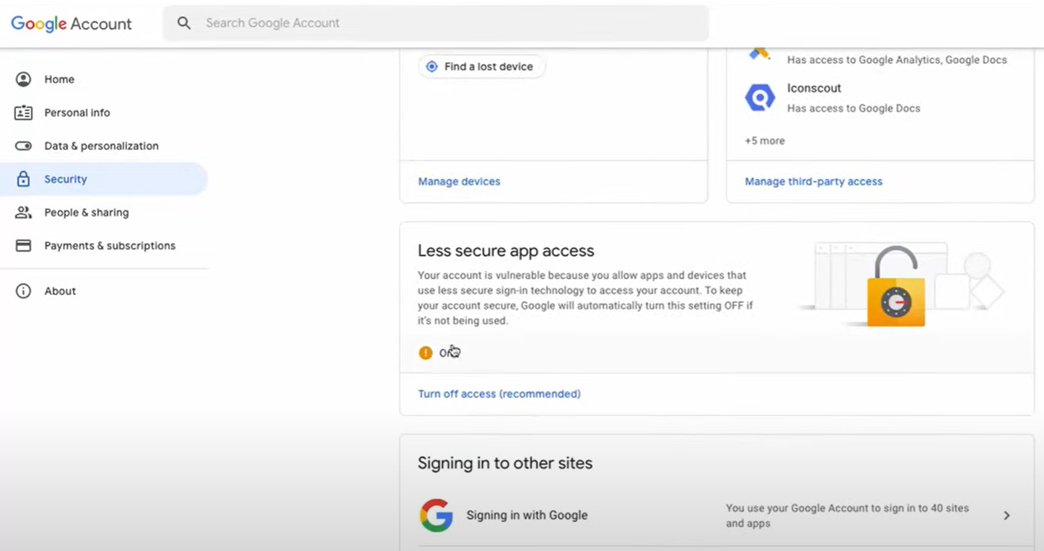
Un job puede tener varios triggers. Un trigger solo puede estar asociado a un job.
- References
- Expresiones CRON
https://www.adictosaltrabajo.com/2010/02/22/expresiones-cron/
- CronMaker: Generador de expresiones Cron
http://www.cronmaker.com/
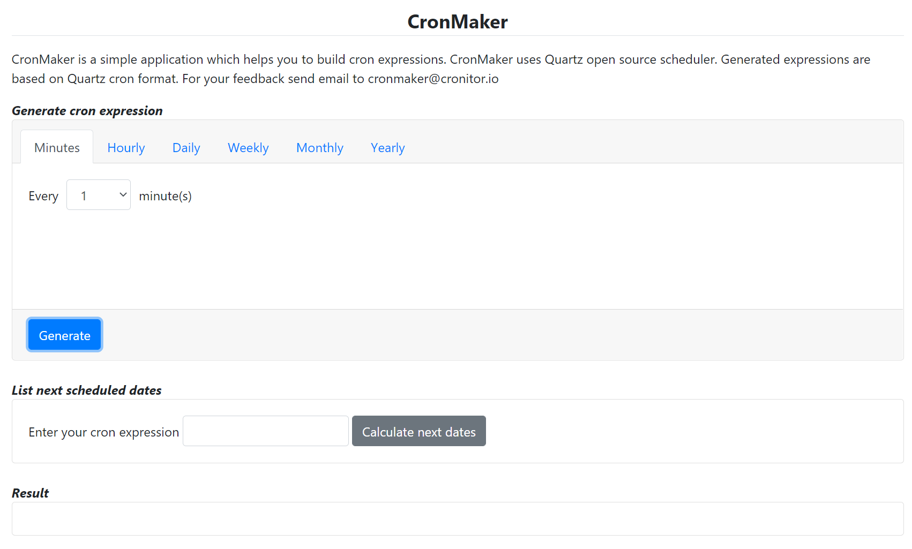
- Others
Quartz.NET
https://www.quartz-scheduler.net/features.html

