Java exercises
Contents
• References 3
• Strings 3
• reverse 3
• rotation 3
• generate all rotations of a given string 3
• sort 3
• string segmentation, work break problem 4
• print all subsequences of a string 7
• find all palindrome substrings 8
• find all distinct palindromic sub-strings of a given string 8
• palindrome in a string 9
• longest palindrome in a string 9
• anagram 10
• parenthesis checker 11
• longest common prefix in an array 12
• multiply two strings 13
• edit distance 14
• generate all binary strings from given pattern 14
• Arrays 15
• sum of two values 15
• sum of two values (leetcode 1. Two Sum) 15
• cloning arrays 16
• reverse an array or string 16
• rotation of array 16
• search+insert+delete in an unsorted array 17
• search+insert+delete in a sorted array 17
• generate all subarrays 17
• find the largest three distinct elements in an array 17
• find second largest element in an array 17
• move all zeroes to end of array 18
• kth largest element in an array 18
• kth largest element in a stream 19
• Kth largest element in a stream (leetcode 703. Kth Largest Element in a Stream) 20
• Others 21
• Linked List 21
• insert 21
• delete 21
• search 22
• search: Program for Nth node from the end of a Linked List 22
• find Length of a Linked List 22
• reverse 23
• delete Node with a given key 23
• copy linked list with arbitrary pointer 24
• Stacks 24
• stack using singly linked list 25
• stack in-built functions 25
• Queues 25
• single queue with array 25
• Tree 25
• mirror binary tree nodes 25
• check if two binary trees are identical 25
• Graphs 26
• minimum spanning tree 26
• Sorting and searching 27
• find low/high index 27
• merge overlapping intervals 27
• Dynamic programming 28
• largest sum subarray 28
• Math and stats 29
• is the number valid 29
• Backtracking 30
• all possible braces 30

- References
Java Google Coding Interview questions
https://www.codinginterview.com/google
https://www.codinginterview.com/google-interview-questions

https://leetcode.com/problemset/all/

https://www.geeksforgeeks.org/must-do-coding-questions-for-companies-like-amazon-microsoft-adobe/
https://www.geeksforgeeks.org/dsa-sheet-by-love-babbar/
https://www.geeksforgeeks.org/stuck-in-programming-get-the-solution-from-these-10-best-websites/
https://www.geeksforgeeks.org/top-15-websites-for-coding-challenges-and-competitions/

https://practice.geeksforgeeks.org/explore?page=1&sortBy=submissions
https://practice.geeksforgeeks.org/explore?page=1&company[]=Google&category[]=Strings&sortBy=submissions

https://practice.geeksforgeeks.org/problem-of-the-day

https://www.educative.io/blog/google-coding-interview

- Strings
- reverse
https://www.geeksforgeeks.org/program-reverse-string-iterative-recursive/?ref=lbp
- rotation
https://www.geeksforgeeks.org/left-rotation-right-rotation-string-2/?ref=lbp

- generate all rotations of a given string
https://www.geeksforgeeks.org/generate-rotations-given-string/
- sort
https://www.geeksforgeeks.org/sort-string-characters/?ref=lbp

- print the frequency of each character in alphabetical order
https://www.geeksforgeeks.org/print-the-frequency-of-each-character-in-alphabetical-order/?ref=lbp

- swap characters in a string
https://www.geeksforgeeks.org/swap-characters-in-a-string/?ref=lbp

- how to insert characters in a string at a certain position?
https://www.geeksforgeeks.org/how-to-insert-characters-in-a-string-at-a-certain-position/?ref=lbp

- program to check if two strings are same or not
https://www.geeksforgeeks.org/program-to-check-if-two-strings-are-same-or-not/?ref=lbp

- remove all occurrences of a character in a string
https://www.geeksforgeeks.org/remove-all-occurrences-of-a-character-in-a-string/?ref=lbp

- string segmentation, work break problem
Problem Statement
You are given a dictionary of words and a large input string. You have to find out whether the input string can be completely segmented into the words of a given dictionary. The following two examples elaborate on the problem further.

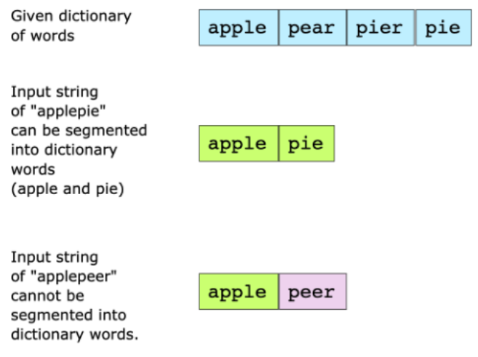
Hint:
Recursion
Memoization

Companies: Google

ref:
139. Word Break
https://leetcode.com/problems/word-break/description/

Word Break | Dynamic Programming | Leetcode #139
https://www.youtube.com/watch?v=th4OnoGasMU

Solution:
  - StringSegmentation.java: Recursion
See imagen StringSegmentation2

  - StringSegmentation2.java (better): Recursion
WB[]: each recursion
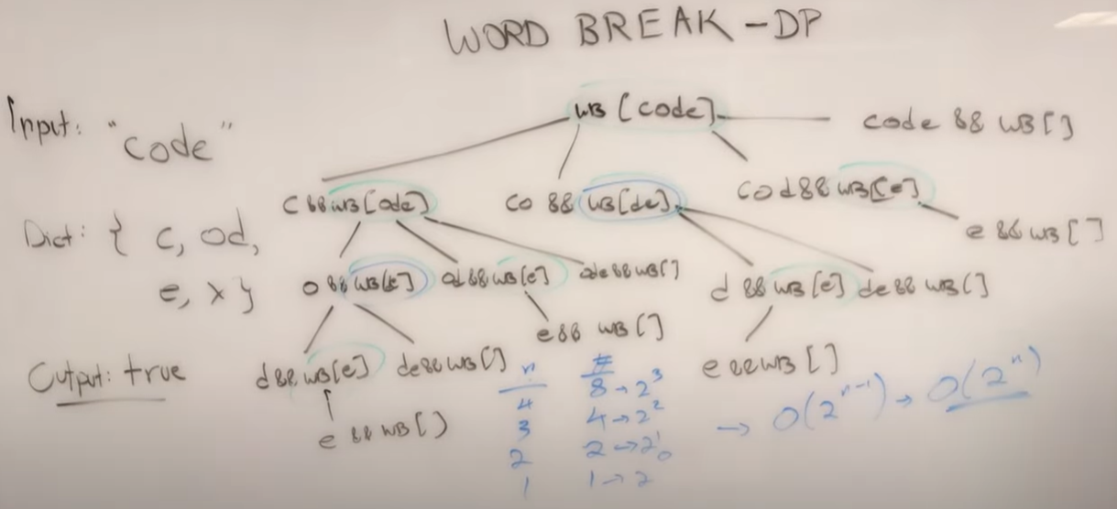

For a string of length = 4 (WB[code]), it does 8 calculation of string (WB[string]).
For a string of length = 3 (WB[ode]), it does 4 calculation of string (WB[string]).
For a string of length = 2 (WB[de]), it does 2 calculation of string (WB[string]).
For a string of length = 1 (WB[e]), it does 1 calculation of string (WB[string]).

Then Runtime Complexity is: O(2^{n})
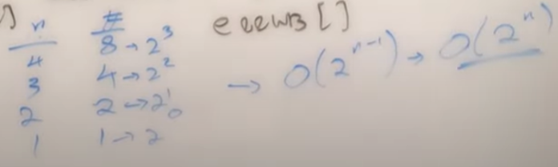

The worst case is:
When each character of the string is presented in the dictionary and ended time for all partitions points. Each partitions points can have a partitions or not, then Time Complexity is O(2^{n}).
- Use Set for fast lookup
In a recursion function first validate the best case, in this case when is empty string.
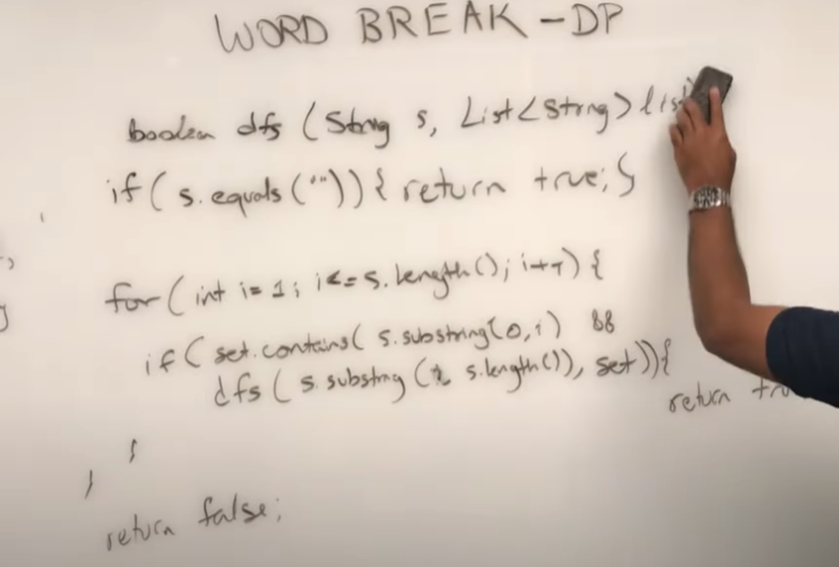
  - StringSegmentation3.java (better): Memoization
Used for large inputs and dictionary sizes.
See imagen StringSegmentation2
WB[de] = appear many times, must apply memorization
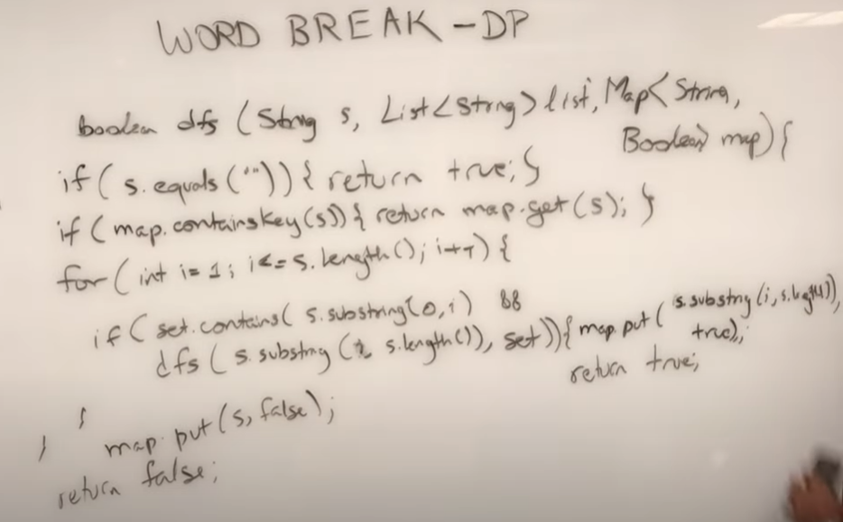
  - StringSegmentation4.java (much better): Tabulation Dynamic Programming
Used for repeating subproblems
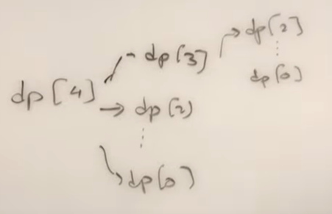

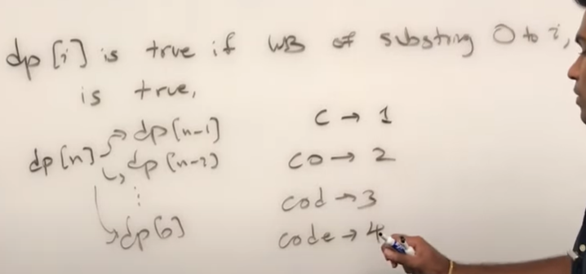

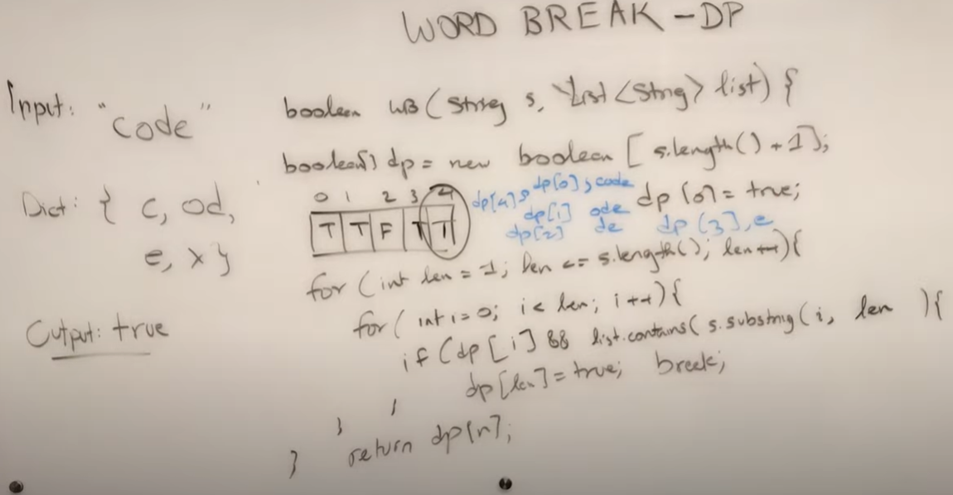
  - StringSegmentation5.java: Back Tracking
Word Break Problem using Backtracking
Given a valid sentence without any spaces between the words and a dictionary of valid English words, find all possible ways to break the sentence into individual dictionary words.

Example:
Consider the following dictionary
{ i, like, sam, sung, samsung, mobile, ice,
and, cream, icecream, man, go, mango}

Input: "ilikesamsungmobile"
Output: i like sam sung mobile
i like samsung mobilek8

Input: "ilikeicecreamandmango"
Output: i like ice cream and man go
i like ice cream and mango
i like icecream and man go
i like icecream and mango

The Dynamic Programming solution only finds whether it is possible to break a word or not. Here we need to print all possible word breaks.
- print all subsequences of a string
https://www.geeksforgeeks.org/print-subsequences-string/
- find all palindrome substrings
Problem Statement
Given a string find all non-single letter substrings that are palindromes. For instance:

Hint
Find substrings

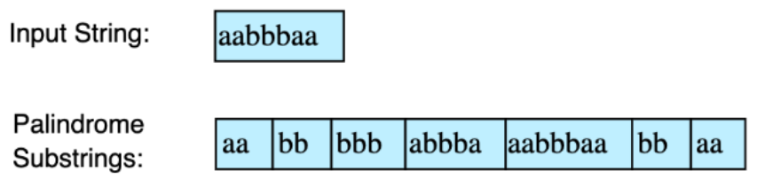

Companies: Google

ref:
Can be use Manacher’s algorithm

Solution:
  - FindAllPalindromeSubstrings.java
  - CountPalindromeSubstrings.java (better)
Given a string, the task is to count all palindrome substring in a given string. Length of palindrome substring is greater than or equal to 2.

Examples:
Input : str = "abaab"
Output: 3
Explanation :
All palindrome substring are :
"aba", "aa", "baab"

Input : str = "abbaeae"
Output: 4
Explanation :
All palindrome substring are :
"bb", "abba", "aea", "eae"
- find all distinct palindromic sub-strings of a given string
Given a string of lowercase ASCII characters, find all distinct continuous palindromic sub-strings of it.

Examples:
Input: str = "abaaa"
Output: Below are 5 palindrome sub-strings
a
aa
aaa
aba
b

Input: str = "geek"
Output: Below are 4 palindrome sub-strings
e
ee
g
k

Solution:
  - FindAllDistinctPalindromeSubstrings.java (PENDING)

- palindrome in a string
https://www.geeksforgeeks.org/find-number-distinct-palindromic-sub-strings-given-string/ (PENDING)

https://www.geeksforgeeks.org/check-given-string-rotation-palindrome/ (PENDING)

- longest palindrome in a string
Given a string S, find the longest palindromic substring in S. Substring of string S: S[ i . . . . j ] where 0 ≤ i ≤ j < len(S). Palindrome string: A string that reads the same backward. More formally, S is a palindrome if reverse(S) = S. In case of conflict, return the substring which occurs first (with the least starting index).

Example 1:
Input:
S = "aaaabbaa"
Output: aabbaa
Explanation: The longest Palindromic
substring is "aabbaa".

Example 2:
Input:
S = "abc"
Output: a
Explanation: "a", "b" and "c" are the
longest palindromes with same length.
The result is the one with the least
starting index.

Your Task:
You don't need to read input or print anything. Your task is to complete the function longestPalin() which takes the string S as input and returns the longest palindromic substring of S.

Expected Time Complexity: O(|S|²).
Expected Auxiliary Space: O(1).
Constraints:
1 ≤ |S| ≤ 10³

Companies: Google

Solution:
  - LongestPalindromeString.java
https://practice.geeksforgeeks.org/problems/longest-palindrome-in-a-string3411/1?page=1&company[]=Google&category[]=Strings&sortBy=submissions
  - better approach: use Manacher’s algorithm.
https://www.geeksforgeeks.org/manachers-algorithm-linear-time-longest-palindromic-substring-part-1/
Time Complexity: O(N), N length of the input string.
Space Complexity: O(N), N length of the modified input string.
- anagram
Given two strings a and b consisting of lowercase characters. The task is to check whether two given strings are an anagram of each other or not. An anagram of a string is another string that contains the same characters, only the order of characters can be different. For example, act and tac are an anagram of each other.

Note:
- If the strings are anagrams you have to return True or else return False
- |s| represents the length of string s.
Example 1:
Input:a = geeksforgeeks, b = forgeeksgeeks
Output: YES
Explanation: Both the string have same characters with
same frequency. So, both are anagrams.

Example 2:
Input:a = allergy, b = allergic
Output: NO
Explanation: Characters in both the strings are
not same, so they are not anagrams.

Your Task:
You don't need to read input or print anything. Your task is to complete the function isAnagram() which takes the string a and string b as input parameter and check if the two strings are an anagram of each other. The function returns true if the strings are anagram else it returns false.

Expected Time Complexity:O(|a|+|b|).
Expected Auxiliary Space: O(Number of distinct characters).
Constraints:
1 ≤ |a|,|b| ≤ 10⁵

Companies: Google

refs:
IsAnagram.java

Solution:
  - Anagram.java
Use Arrays.sort (QuickSort)
  - Anagram2.java (better)
Use a character count array.
- parenthesis checker
Given an expression string x. Examine whether the pairs and the orders of {,},(,),[,] are correct in exp.
For example, the function should return 'true' for exp = [()]{}{[()()]()} and 'false' for exp = [(]).

Note: The drive code prints "balanced" if function return true, otherwise it prints "not balanced".

Example 1:
Input:
{([])}
Output:
true
Explanation:
{ ( [ ] ) }. Same colored brackets can form
balanced pairs, with 0 number of
unbalanced bracket.

Example 2:
Input:
()
Output:
true
Explanation:
(). Same bracket can form balanced pairs,
and here only 1 type of bracket is
present and in balanced way.

Example 3:
Input:
([]
Output:
false
Explanation:
([]. Here square bracket is balanced but
the small bracket is not balanced and
Hence , the output will be unbalanced.

Your Task:
This is a function problem. You only need to complete the function ispar() that takes a string as a parameter and returns a boolean value true if brackets are balanced else returns false. The printing is done automatically by the driver code.
Expected Time Complexity: O(|x|)
Expected Auixilliary Space: O(|x|)
Constraints:
1 ≤ |x| ≤ 32000
Companies: Google

Solution:
  - ParenthesisChecker.java

- longest common prefix in an array
Given an array of N strings, find the longest common prefix among all strings present in the array.
Example 1:
Input:
N = 4
arr[] = {geeksforgeeks, geeks, geek,
geezer}
Output: gee
Explanation: "gee" is the longest common
prefix in all the given strings.

Example 2:
Input:
N = 2
arr[] = {hello, world}
Output: -1
Explanation: There's no common prefix
in the given strings.

Your Task:
You don't need to read input or print anything. Your task is to complete the function longestCommonPrefix() which takes the string array arr[] and its size N as inputs and returns the longest common prefix common in all the strings in the array. If there's no prefix common in all the strings, return "-1".
Expected Time Complexity: O(N*min(|arr_{i}|)).
Expected Auxiliary Space: O(min(|arr_{i}|)) for result.
Constraints:
1 ≤ N ≤ 10³
1 ≤ |arr_{i}| ≤ 10³

Companies: Google

Solution:
  - LongestCommonPrefix.java
  - LongestCommonPrefix2.java (better)

- multiply two strings
Given two numbers as strings s1 and s2. Calculate their Product.
Note: The numbers can be negative and You are not allowed to use any built-in function or convert the strings to integers. There can be zeros in the beginning of the numbers. You don't need to specify '+' sign in the begining of positive numbers.
Example 1:
Input:
s1 = "0033"
s2 = "2"
Output:
66
Example 2:
Input:
s1 = "11"
s2 = "23"
Output:
253
Your Task: You don't need to read input or print anything. Your task is to complete the function multiplyStrings() which takes two strings s1 and s2 as input and returns their product as a string.
Expected Time Complexity: O(n₁* n₂)
Expected Auxiliary Space: O(n₁ + n₂); where n₁ and n₂ are sizes of strings s1 and s2 respectively.
Constraints:
1 ≤ length of s1 and s2 ≤ 10³

Refs:
MultiplyTwoStrings.java
- edit distance
Given two strings s and t. Return the minimum number of operations required to convert s to t.
The possible operations are permitted:
- Insert a character at any position of the string.
- Remove any character from the string.
- Replace any character from the string with any other character.

Example 1:
Input:
s = "geek", t = "gesek"
Output: 1
Explanation: One operation is required
inserting 's' between two 'e's of s.
Example 2:
Input :
s = "gfg", t = "gfg"
Output:
0
Explanation: Both strings are same.

Your Task:
You don't need to read or print anything. Your task is to complete the function editDistance() which takes strings s and t as input parameters and returns the minimum number of operation to convert the string s to string t.
Expected Time Complexity: O(|s|*|t|)
Expected Space Complexity: O(|s|*|t|)
Constraints:
1 ≤ Length of both strings ≤ 100
Both the strings are in lowercase.

Refs:
EditDistance.java

- generate all binary strings from given pattern
Refs:
GenerateAllBinaryStringsGivenPattern.java
- Arrays

- sum of two values
Given an array of integers and a value, determine if there are any two integers in the array whose sum is equal to the given value. Return true if the sum exists and return false if it does not.

Example:
Given nums = [2, 7, 11, 15], target = 9,
Because nums[0] + nums[1] = 2 + 7 = 9,
return [0, 1].

Companies: Google

Solution:
  - SumOfTwoValues.java

- sum of two values (leetcode 1. Two Sum)
Given an array of integers nums and an integer target, return indices of the two numbers such that they add up to target.

You may assume that each input would have exactly one solution, and you may not use the same element twice.

You can return the answer in any order.

Example 1:
Input: nums = [2,7,11,15], target = 9
Output: [0,1]
Explanation: Because nums[0] + nums[1] == 9, we return [0, 1].

Example 2:
Input: nums = [3,2,4], target = 6
Output: [1,2]

Example 3:
Input: nums = [3,3], target = 6
Output: [0,1]

Constraints:
2 <= nums.length <= 10⁴
-10⁹ <= nums[i] <= 10⁹
-10⁹ <= target <= 10⁹

Only one valid answer exists.

Companies: Google

Solution:
  - SumOfTwoValuesLeetcode1.java

- cloning arrays
Solution:
  - CloningArray.java

- reverse an array or string
Given an array (or string), the task is to reverse the array/string.
Examples :
Input : arr[] = {1, 2, 3}
Output : arr[] = {3, 2, 1}

Input : arr[] = {4, 5, 1, 2}
Output : arr[] = {2, 1, 5, 4}
- iterative way:
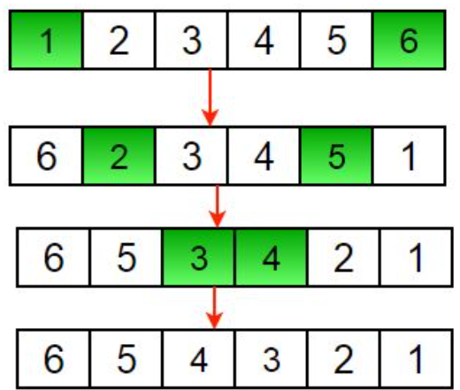
- rotation of array
https://www.geeksforgeeks.org/complete-guide-on-array-rotations/
- Approach: The Reversal Algorithm: better solution
Original array:
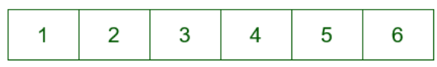
Separate it out into first ‘d’ elements and ‘n-d’ elements.
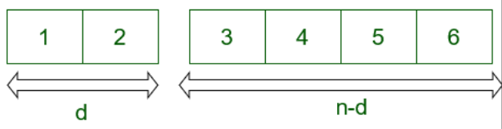
Reverse the first ‘d’ elements
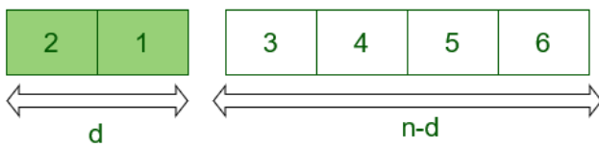
Reverse last (N-d) elements
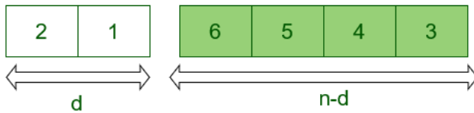
Reverse the whole array.
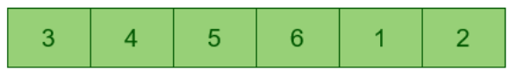
- Applications:
Searching in a sorted and rotated array: binary search
Game development: game mechanics, rotating a game board, game objects.
Audio and video processing: effects such as pitch shifting, time stretching, stereo panning.
Text editing: undo and redo functionality.
- search+insert+delete in an unsorted array
Linear Search
- search+insert+delete in a sorted array
Binary Search
- binary search in sorted array
Refs:
BinarySearchInSortedArray.java
BinarySearchInSortedArray2.java

- generate all subarrays
Given an array, generate all the possible subarrays of the given array using recursion.
Examples:
Input : [1, 2, 3]
Output : [1], [1, 2], [2], [1, 2, 3], [2, 3], [3]

Input : [1, 2]
Output : [1], [1, 2], [2]

https://www.geeksforgeeks.org/generating-subarrays-using-recursion/
- find the largest three distinct elements in an array
Given an array with all distinct elements, find the largest three elements. Expected time complexity is O(n) and extra space is O(1).

Examples :
Input: arr[] = {10, 4, 3, 50, 23, 90}
Output: 90, 50, 23
- find second largest element in an array
Given an array of integers, our task is to write a program that efficiently finds the second-largest element present in the array.

Example:

Input: arr[] = {12, 35, 1, 10, 34, 1}
Output: The second largest element is 34.
Explanation: The largest element of the array is 35 and the second largest element is 34

Input: arr[] = {10, 5, 10}
Output: The second largest element is 5.
Explanation: The largest element of the array is 10 and the second largest element is 5

Input: arr[] = {10, 10, 10}
Output: The second largest does not exist.
Explanation: Largest element of the array is 10 there is no second largest element
- move all zeroes to end of array
Given an array of random numbers, Push all the zero’s of a given array to the end of the array. For example, if the given arrays is {1, 9, 8, 4, 0, 0, 2, 7, 0, 6, 0}, it should be changed to {1, 9, 8, 4, 2, 7, 6, 0, 0, 0, 0}. The order of all other elements should be same. Expected time complexity is O(n) and extra space is O(1).

Example:

Input : arr[] = {1, 2, 0, 4, 3, 0, 5, 0};
Output : arr[] = {1, 2, 4, 3, 5, 0, 0, 0};

Input : arr[] = {1, 2, 0, 0, 0, 3, 6};
Output : arr[] = {1, 2, 3, 6, 0, 0, 0};

- kth largest element in an array
Given an integer k and an array of size n consisting of unique integers. Find the kth largest element in this array.

Examples
Input : arr : [2,1,4,6,3,9,7], k : 2
Output : 7

Input : arr : [12,65,34,90], k : 4
Output : 12

Ref:
KthLargestElement1.java
KthLargestElement2.java
KthLargestElement3.java
KthLargestElement4.java (better)

- kth largest element in a stream
Given an input stream arr[] of n integers. Find the K^{th} largest element (not K^{th} largest unique element) after insertion of each element in the stream and if the K^{th} largest element doesn't exist, the answer will be -1 for that insertion. return a list of size n after all insertions.

Example 1:

Input:
k = 4, n = 6
arr[] = {1, 2, 3, 4, 5, 6}

Output:
-1 -1 -1 1 2 3

Explanation:
k = 4
For 1, the 4th largest element doesn't
exist so answer will be -1.
For 2, the 4th largest element doesn't
exist so answer will be -1.
For 3, the 4th largest element doesn't
exist so answer will be -1.
For 4, the 4th largest element is 1.
For 5, the 4th largest element is 2.
For 6, the 4th largest element is 3.

Example 2:

Input:
k = 1, n = 2
arr[] = {3, 4}

Output:
3 4

Explanation:
For the 1st and 2nd element the 1st largest
element is itself.

Companies: Google

Solution:
  - KthLargestElementStream.java
Kth Largest Element using Priority Queue | Rahul Singla | GeeksforGeeks
https://www.youtube.com/watch?v=nJ4_1fw_7-w

Kth Largest Element in a Stream | GeeksforGeeks Java
https://www.youtube.com/watch?v=qk6jJzSPCxk
- Kth largest element in a stream (leetcode 703. Kth Largest Element in a Stream)
Find the Kth largest element in a stream of numbers. The class should have the following two things:​

- The constructor of the class should accept an integer array containing initial numbers from the stream and an integer K.

- The class should expose a function add(int num) which will store the given number and return the Kth largest number.

Examples:
Input: [4, 1, 3, 12, 7, 14], k = 3
Calling add(6) should return '7'.
Calling add(13) should return '12'.
Calling add(4) should still return '12'.

Companies: Google

ref:
https://www.educative.io/blog/google-coding-interview-questions?eid=5082902844932096

Solution:
  - KthLargestElementStreamLeetcode703.java
Design a class to find the k^{th} largest element in a stream. Note that it is the k^{th} largest element in the sorted order, not the k^{th} distinct element.

Implement KthLargest class:

KthLargest(int k, int[] nums) Initializes the object with the integer k and the stream of integers nums.
int add(int val) Appends the integer val to the stream and returns the element representing the k^{th} largest element in the stream.

Example 1:

Input: ["KthLargest", "add", "add", "add", "add", "add"]
[[3, [4, 5, 8, 2]], [3], [5], [10], [9], [4]]
Output: [null, 4, 5, 5, 8, 8]

Explanation:
KthLargest kthLargest = new KthLargest(3, [4, 5, 8, 2]);
kthLargest.add(3); // return 4
kthLargest.add(5); // return 5
kthLargest.add(10); // return 5
kthLargest.add(9); // return 8
kthLargest.add(4); // return 8

Constraints:
1 <= k <= 10⁴
0 <= nums.length <= 10⁴
-10⁴ <= nums[i] <= 10⁴
-10⁴ <= val <= 10⁴
At most 10⁴ calls will be made to add.
It is guaranteed that there will be at least k elements in the array when you search for the kth element.

ref:
703. Kth Largest Element in a Stream
https://leetcode.com/problems/kth-largest-element-in-a-stream/
- Others
Segregate even and odd numbers using Lomuto’s Partition Scheme
https://www.geeksforgeeks.org/segregate-even-odd-numbers-set-3/

Print left rotation of array in O(n) time and O(1) space
https://www.geeksforgeeks.org/print-left-rotation-array/
- Linked List
- insert
- Insert a Node at the Front/Beginning of Linked List:
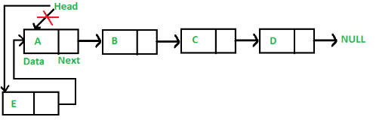
- Insert a Node after a given Node in Linked List:
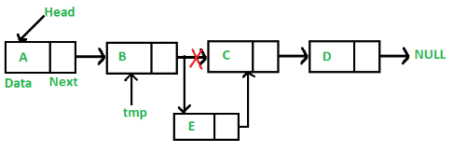
- Insert a Node at the end of Linked List:
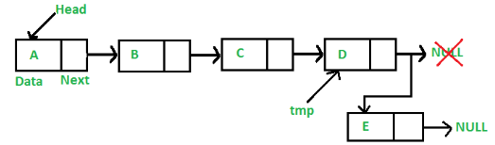
- delete
- Delete a Node recursively at the Beginning/End/Middle of Linked List:
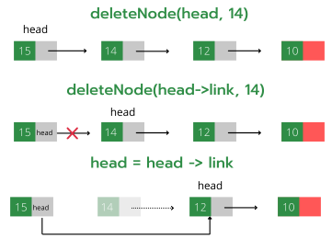
- Delete a Node at a given Node in Linked List
- Delete a Node at the end of Linked List
- Delete the entire Linked List

- search
- Search element, return true if exists, else returns false.
- Search element by index.
Example:
Input: 1->10->30->14, index = 2
Output: 30
The node at index 2 is 30
- search: Program for Nth node from the end of a Linked List
Given a Linked List and a number N, write a function that returns the value at the Nth node from the end of the Linked List.
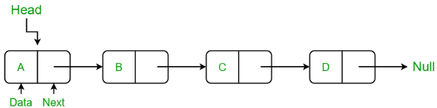
Examples:
Input: 1 -> 2 -> 3 -> 4, N = 3
Output: 2

Input: 35 -> 15 -> 4 -> 20, N = 4
Output: 35

refs:
SearchNthNodeFromEnd.java
- find Length of a Linked List
Uses tail recursion instead of regular recursion.

Refs:
SinglyLinkedList.java
- reverse
Input: Head of following linked list
1->2->3->4->NULL
Output: Linked list should be changed to,
4->3->2->1->NULL

Input: Head of following linked list
1->2->3->4->5->NULL
Output: Linked list should be changed to,
5->4->3->2->1->NULL

Input: NULL
Output: NULL

Input: 1->NULL
Output: 1->NULL
- reverse a Linked List by Iterative method:
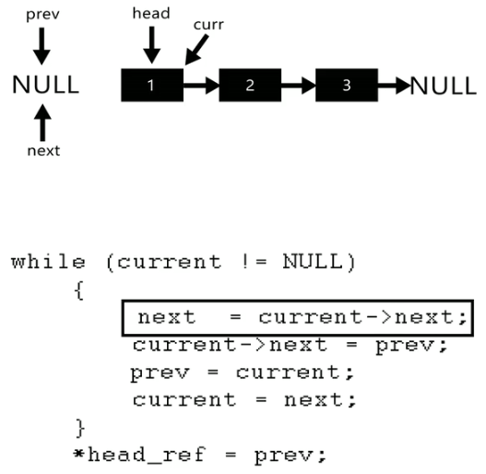
- Other methods: using Recursion, Tail Recursive, Stack.

- delete Node with a given key
Problem Statement
We are given the head of a linked list and a key. We have to delete the node that contains this given key. The following two examples elaborate on this problem further.
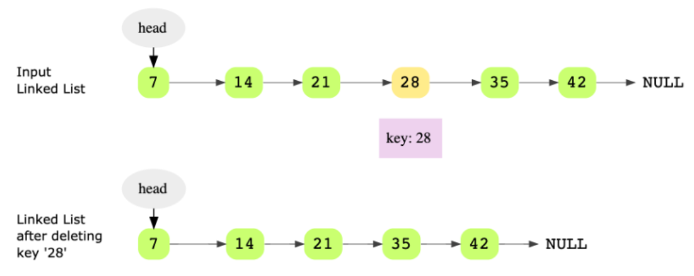
Hint: Keep track of previous pointer

Companies: Google

refs:
  - DeleteNodeWithGivenKey.java
https://leetcode.com/problems/delete-node-in-a-linked-list/description/
https://leetcode.com/problems/remove-linked-list-elements/
  - De Node by index position PENDING
https://practice.geeksforgeeks.org/problems/delete-a-node-in-single-linked-list/1
- copy linked list with arbitrary pointer
Problem Statement
You are given a linked list where the node has two pointers. The first is the regular next pointer. The second pointer is called arbitrary_pointer and it can point to any node in the linked list. Your job is to write code to make a deep copy of the given linked list. Here, deep copy means that any operations on the original list (inserting, modifying and removing) should not affect the copied list.

Here’s an example of a linked list with arbitrary pointers connected.
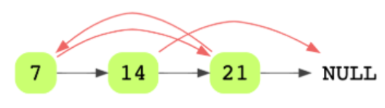
Hint: Hash table

Companies: Google

Solution:
  - CopyLinkedListWithArbitraryPointer.java
  - CopyLinkedListWithArbitraryPointer2.java (better)
Use HashMap
https://www.educative.io/copy-linked-list-with-arbitrary-pointer

Clone A Linked List (With Random Pointers) - Linear Space Solution & Tricky Constant Space Solution
https://www.youtube.com/watch?v=OvpKeraoxW0
- Stacks
- stack using singly linked list
https://www.geeksforgeeks.org/implement-a-stack-using-singly-linked-list/?ref=lbp
- stack in-built functions

- Queues
- single queue with array
SingleQueueWithArray.java
- single queue with linked list
SingleQueueWithLinkedList.java
- Tree
- mirror binary tree nodes
https://www.educative.io/mirror-binary-tree-nodes

Companies: Google

Solution:
  - MirrorBinaryTreeNodes.java (better)

  - MirrorBinaryTreeNodes2.java
Convert a Binary Tree into its Mirror Tree | GeeksforGeeks
https://www.youtube.com/watch?v=FtdyIHBaKjc
- check if two binary trees are identical
Problem Statement
Given the roots of two binary trees, determine if these trees are identical or not. Identical trees have the same layout and data at each node. Consider the following two identical binary trees that have the same layout and data.
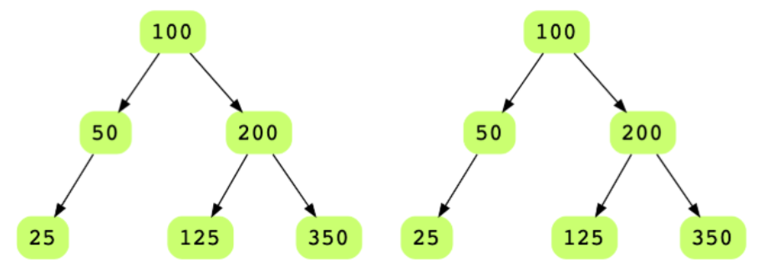

It is not necessary that trees that have the same data are identical trees. Trees that have the exact same data may not be structurally identical. For example if you look at the two trees below, although they have the same data, they are not identical.

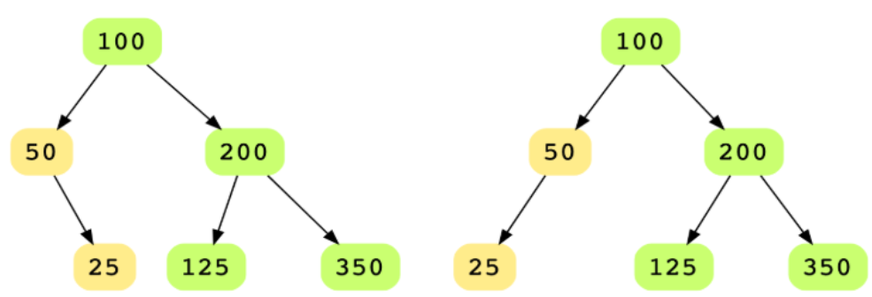
Hint
Depth first traversal
Recursion

Companies: Google

Solution:
  - CheckTwoBinaryTreesIdentical.java

- Graphs
- minimum spanning tree
Problem Statement:
Find the minimum spanning tree of a connected, undirected graph with weighted edges.

Consider the following graph.

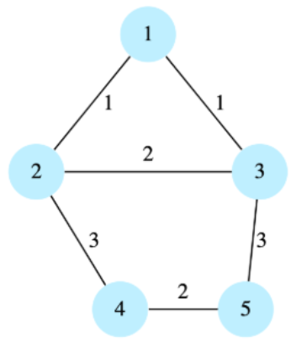

The minimum spanning tree of the above graph would be:

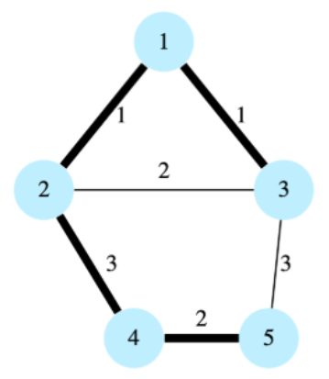

Hint:
Minimum weight edge

Companies: Google

Solution:
  - MinimumSpanningTree.java
Using Adjacency List
  - MinimumSpanningTree2.java(better)
Using Priority Queue
- Sorting and searching
- find low/high index
Problem Statement:
Given a sorted array of integers, return the low and high index of the given key. You must return -1 if the indexes are not found.

The array length can be in the millions with many duplicates.

In the following example, according to the key, the low and high indices would be:

key: 1, low = 0 and high = 0

key: 2, low = 1 and high = 1

key: 5, low = 2 and high = 9

key: 20, low = 10 and high = 10

Hint: Binary Search
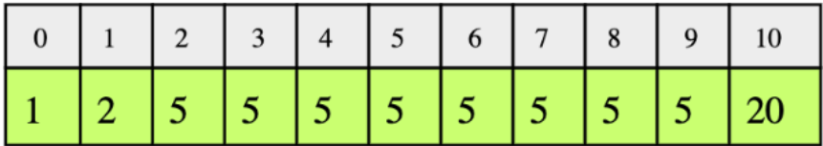

Companies: Google

Solution:
  - FindLowHighIndex.java

- merge overlapping intervals
Problem Statement:
You are given an array (list) of interval pairs as input where each interval has a start and end timestamp. The input array is sorted by starting timestamps. You are required to merge overlapping intervals and return a new output array.

Consider the input array below. Intervals (1, 5), (3, 7), (4, 6), (6, 8) are overlapping so they should be merged to one big interval (1, 8). Similarly, intervals (10, 12) and (12, 15) are also overlapping and should be merged to (10, 15).

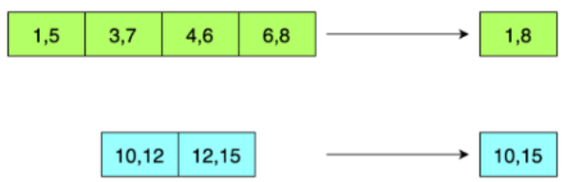

Hint:
Try the linear scan
Use the pair class defined in the code below to handle pairs of time stamps

Companies: Google

Solution:
  - MergeOverlapingIntervals.java

- sorting
https://www.geeksforgeeks.org/sorting-algorithms/
- Dynamic programming
- largest sum subarray
Problem Statement:
In the array below, the largest sum subarray starts at index 3 and ends at 6, and with the largest sum being 12.
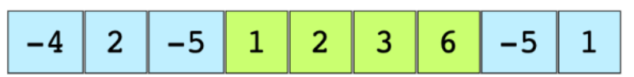
Hint:
Use Kadane’s algorithm

Solution Explanation:
Runtime complexity: The runtime complexity of this solution is linear, O(n).
Memory complexity: The memory complexity of this solution is constant, O(1).

The basic idea of Kadane’s algorithm is to scan the entire array and at each position find the maximum sum of the subarray ending there. This is achieved by keeping a current_max for the current array index and a global_max. The algorithm is as follows:

Initialize:
max_so_far = INT_MIN
max_ending_here = 0

Loop for each element of the array

(a) max_ending_here = max_ending_here + a[i]
(b) if(max_so_far < max_ending_here)
max_so_far = max_ending_here
(c) if(max_ending_here < 0)
max_ending_here = 0
return max_so_far

Companies: Google

Solution:
  - LargestSumSubarray.java
  - LargestSumSubarray2.java (better)

- Math and stats
- is the number valid
Problem Statement:
Given an input string, determine if it makes a valid number or not. For simplicity, assume that white spaces are not present in the input.

4.325 is a valid number.
1.1.1 is NOT a valid number.
222 is a valid number.
22. is NOT a valid number.
0.1 is a valid number.
22.22. is NOT a valid number.
1. is NOT a valid number.

Hint:
Use state machine

Solution Breakdown:
We’ll use the state machine below to check if a number is valid or not. The initial state is ‘Start’. We’ll process each character to identify the next state. The input string is not a valid number if we reach an UNKNOWN state at any point or if it ends in a DECIMAL.
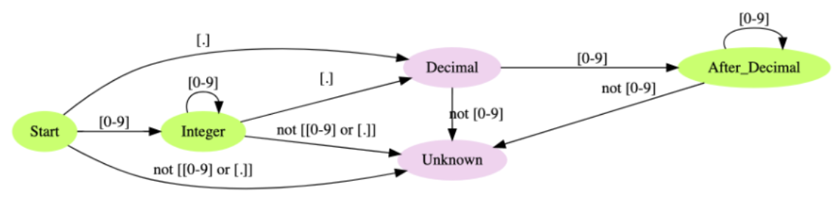

We are not looking at the sign (+ or -) at the start of a number in the state machine. If there is a sign at the start of the input string, we start processing the string for the state machine after that sign character.

Companies: Google

Solution:
  - IsNumberValid.java
https://www.geeksforgeeks.org/introduction-of-algorithmic-state-machines-asms/
https://www.geeksforgeeks.org/introduction-of-finite-automata/
- Backtracking
- all possible braces
Problem Statement: Print all braces combinations for a given value n so that they are balanced. Here are a few examples:

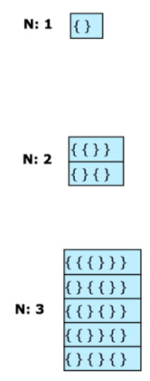

Hint: Recursion

Solution Breakdown:
The solution is to maintain counts of left_braces and right_braces. The basic algorithm is as follows:​

left_braces count: 0
right_braces count: 0

if left_braces count is less than n:
add left_braces and recurse further
if right_braces count is less than left_braces count:
add right_braces and recurse further
stop recursing when left_braces and right_braces counts are both equal to n

For n=2: {{}}
{}{}
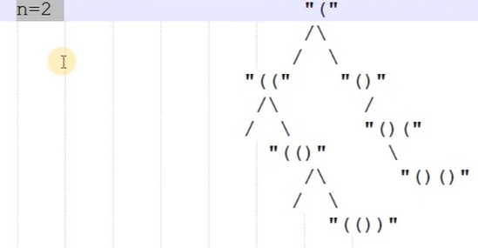

For n=3:
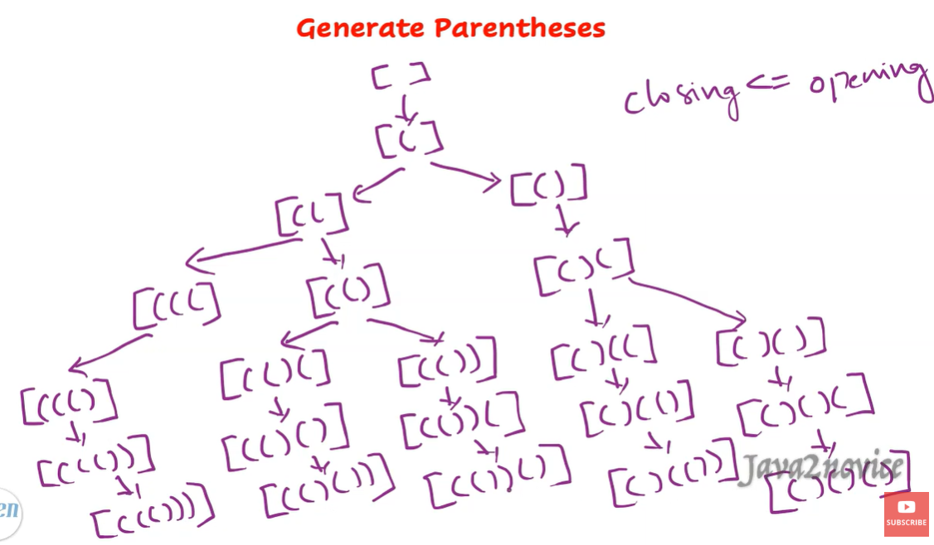

Companies: Google

Solution:
  - PrintAllBalancedBraceCombinations.java
  - PrintAllBalancedBraceCombinations2.java (better)
LeetCode 22. Generate Parentheses | Generate All Balanced Parentheses | Parentheses Permutations (explain better)
https://www.youtube.com/watch?v=FrTsckBmdyM

Learn How to Print All Combinations of Balanced Parentheses in Hindi - Java Tutorial
https://www.youtube.com/watch?v=_L3dvtG8Jxw (explain hindi)

Backtracking (Think Like a Programmer)
https://www.youtube.com/watch?v=gBC_Fd8EE8A

