Java Coding Interview

https://javarevisited.blogspot.com/2012/01/google-interview-questions-answers-top.html#google_vignette
- Google
Java interview with a Google engineer: Regex matching
https://www.youtube.com/watch?v=DduZ1-sMgOg

Google coding interview questions and answers | java coding interview questions and answers
https://www.youtube.com/watch?v=7IbxzIyRMrA
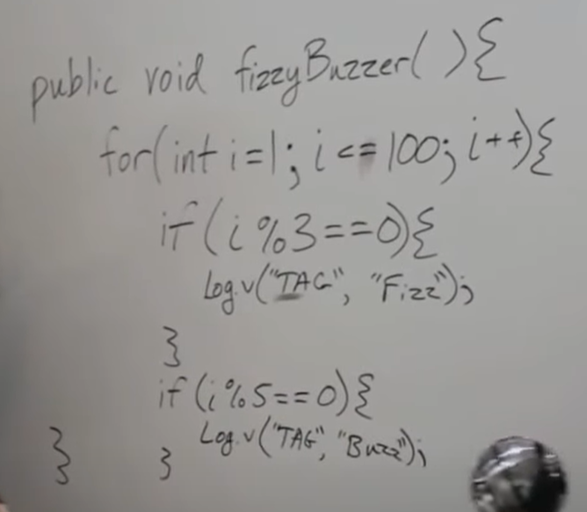
https://www.edureka.co/blog/interview-questions/google-interview-questions/

https://www.interviewcake.com/google-interview-questions

https://www.codinginterview.com/google-interview-questions

https://interviewing.io/mocks/google-java-order-statistic-of-an-unsorted-array

