**Email**

* **Habilitar acceso de aplicaciones poco seguras**

Enter to this link:

<https://myaccount.google.com/lesssecureapps>

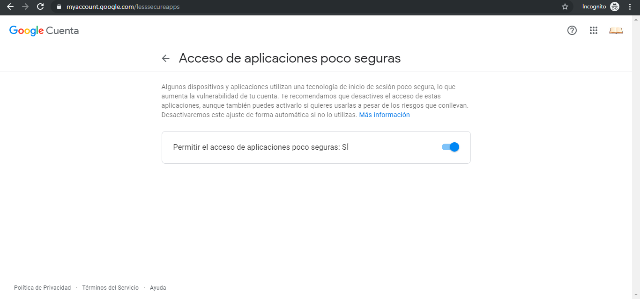

* **Requeriments for send email**
* Remitente (Sender)
* Destinatario (To)
* Copiar a (Cc)
* Copiar oculta a (Bcc)
* Subject
* Message
* Ruta archivo adjunto (Path attachment)
* **Configuration for send email: SMTP (Simple Mail Transfer Protocol)**
* Email Server: 118.180.54.55
* Port Email Server: 25
* Authentication (optional):

User name (correo) = test2020@gmail.com

Password (correo) = abc

* **References**

Send Email with Java and Yahoo! Mail

<https://www.codeproject.com/Articles/5266074/Send-Email-with-Java-and-Yahoo-Mail>

JavaMail API – Java program to send email – Gmail SMTP server example

<https://howtodoinjava.com/for-fun-only/how-to-send-email-in-java-using-gmail-smtp-server/>

<https://gist.github.com/ipingu/7681247>

email MimeMessage java

<https://www.javatpoint.com/example-of-sending-email-using-java-mail-api>

<http://www.jtech.ua.es/j2ee/2002-2003/modulos/mensajes/apuntes/sesion1.htm>

<https://docs.oracle.com/javaee/6/api/javax/mail/internet/MimeMessage.html>

<https://www.codeproject.com/Articles/10673/Quick-Mail-using-Java-Mail-API>