**dynamic-web-project-jsp**

1. Create project:

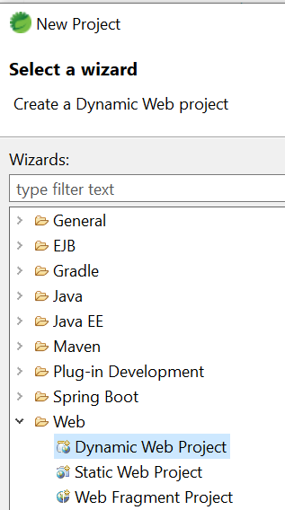

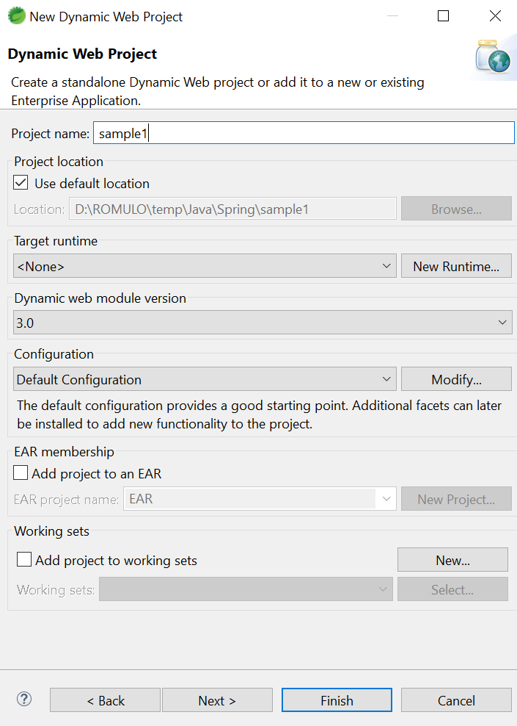

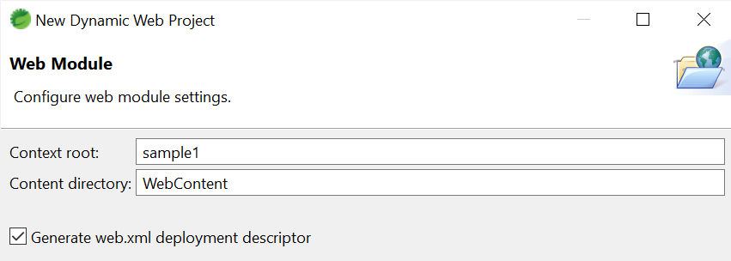

1. Create a JSP File, named index.jsp:

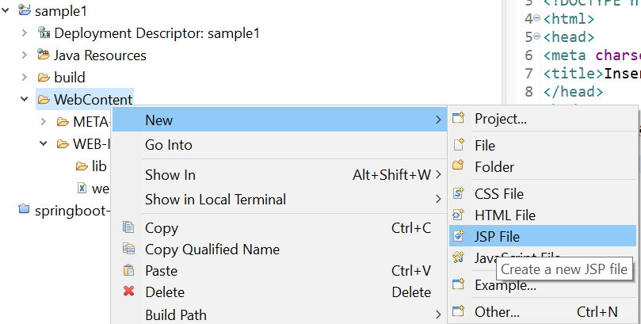

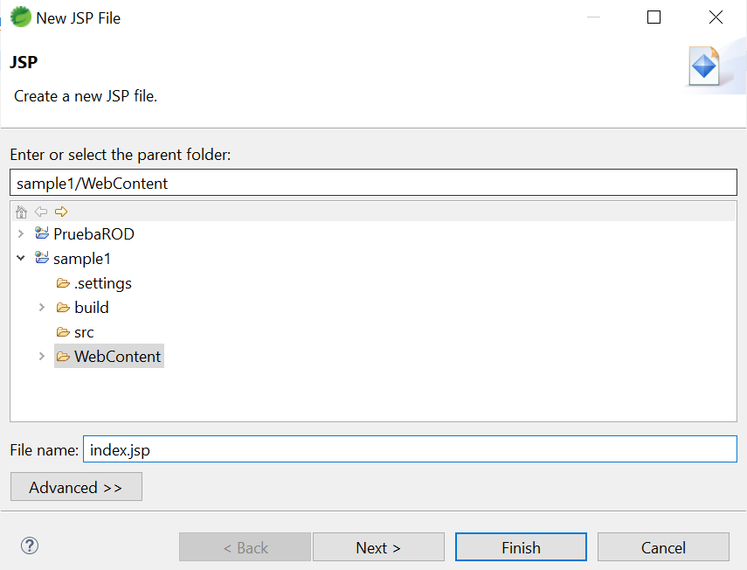

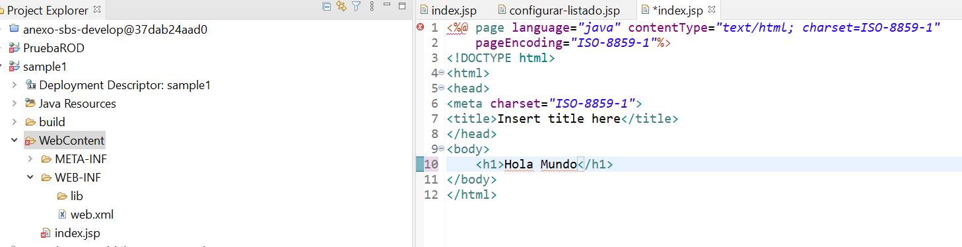

1. Export a WAR File:

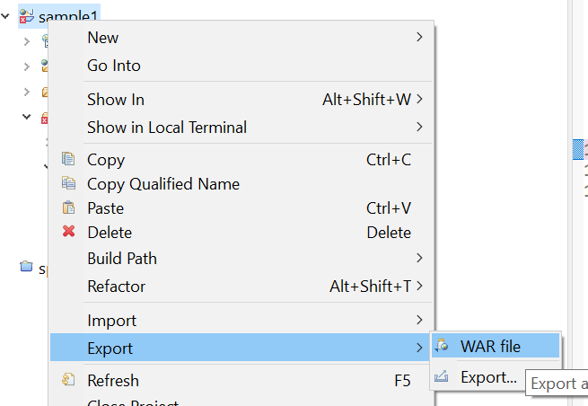

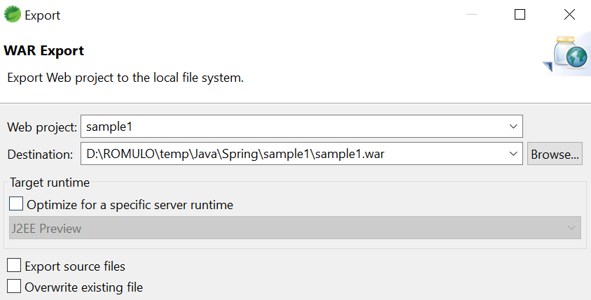

1. Deploy the .WAR in Web Server JBoss 7.0:

* Run the Web Server from C:\Servers\jboss-eap-7.0\bin\standalone.bat
* Open the Url of the Web Server from <http://127.0.0.1:9990/console/App.html#standalone-deployments>

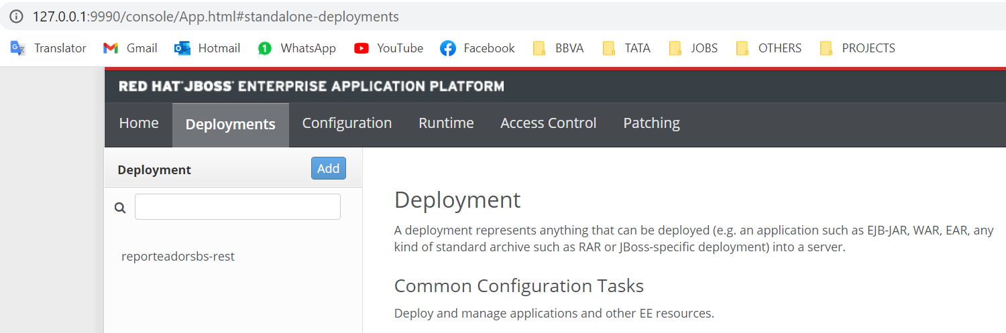

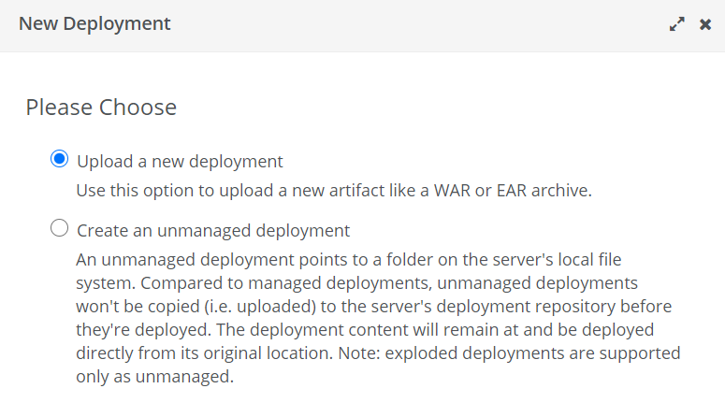

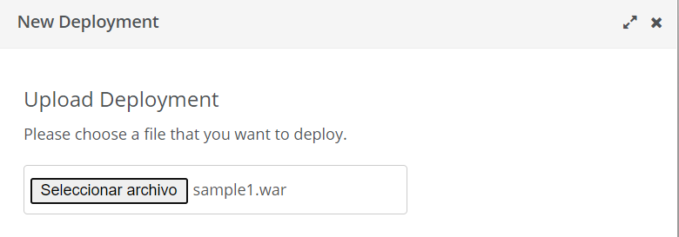

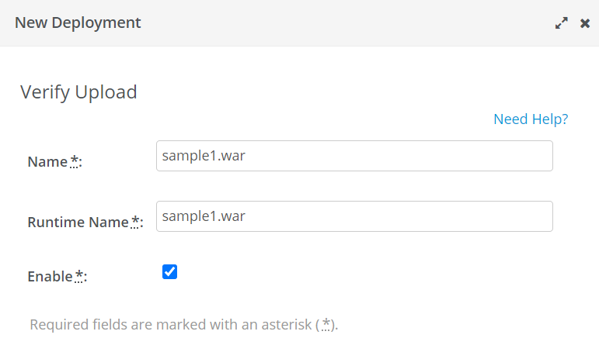

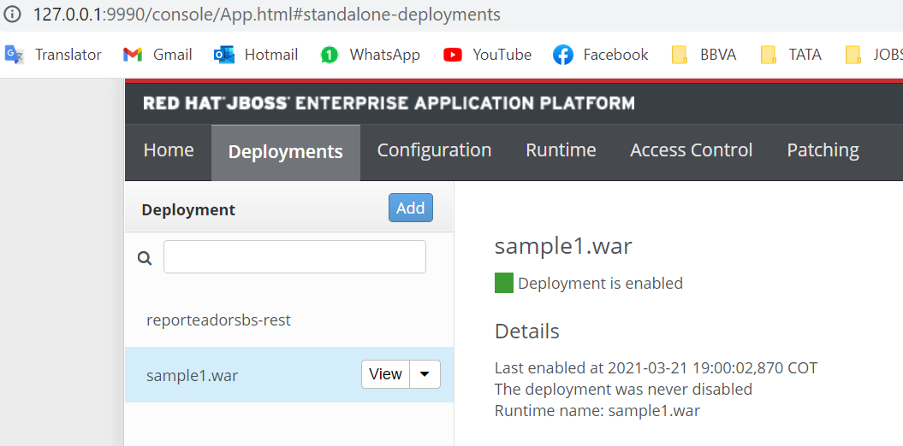

1. Finally, open the App Web: <http://127.0.0.1:8080/sample1/>

