**Job**

* **Notes**
* **Quartz (scheduler)**

Quartz is a job scheduling library that can be integrated into a wide variety of Java applications.

* Components of quartz:

1. Job: a task (what?)
2. Trigger: (when?)
   1. Simple trigger
   2. Cron trigger
3. Scheduler

* **Docs**

<http://www.quartz-scheduler.org/>

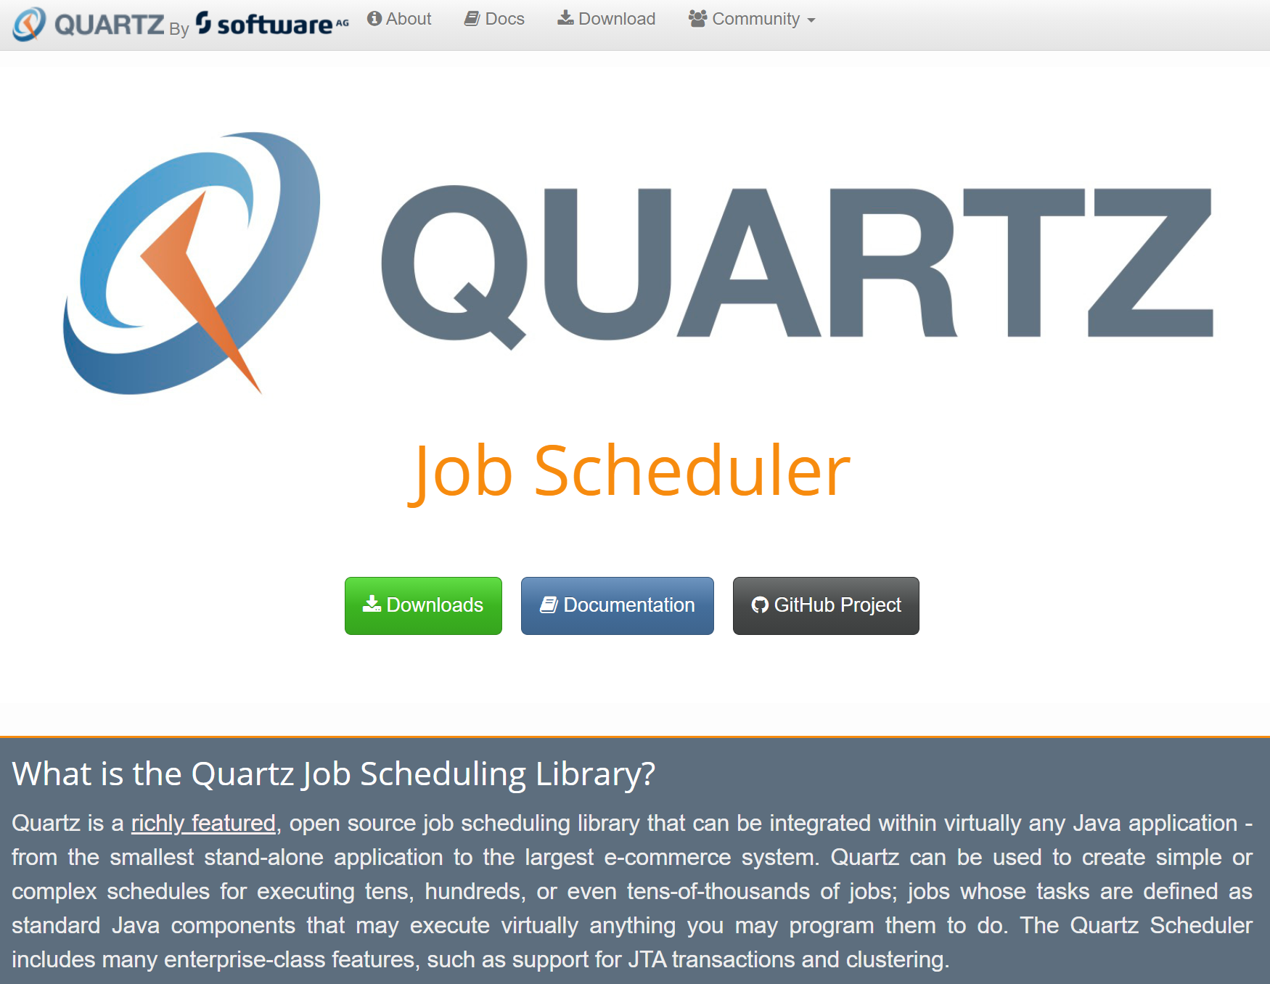

* **Latest Stable Release Documentation: Quartz 2.3.0**

<http://www.quartz-scheduler.org/documentation/>

<http://www.quartz-scheduler.org/api/2.3.0/index.html>

<http://www.quartz-scheduler.org/documentation/quartz-2.3.0/examples/>

<http://www.quartz-scheduler.org/documentation/quartz-2.3.0/tutorials/>

Download: Contain samples

<http://www.quartz-scheduler.org/downloads/>

* **Samples**
* **Starter for using the Quartz scheduler**

spring-boot-starter-quartz

D:\ROMULO\PROJECTS\AppWeb\Backend\Java8\Samples\spring-boot-master

<https://www.javaguides.net/2018/09/important-spring-boot-starters-with-examples.html>

<https://github.com/RameshMF/spring-boot>

<https://github.com/RameshMF/spring-boot/tree/master/spring-boot-samples/spring-boot-sample-quartz>

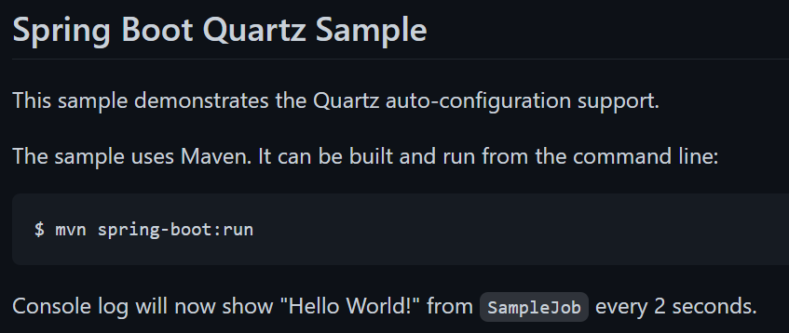

* **Quartz scheduling tutorial**

job-quartz_v1

<https://www.youtube.com/watch?v=6ogkeEn1h7o>

Getting Started: Scheduling Tasks with Quartz | Scheduling Tasks in Java - Quartz & Cron

<https://www.youtube.com/watch?v=uDkleDfmvBg>

* **Email API Quartz Scheduler**

spring-boot-quartz-scheduler-email-scheduling-master

Spring Boot Quartz Scheduler Tutorial

<https://www.youtube.com/playlist?list=PLS1QulWo1RIZL1UicW3PV905pirgXjfQV>

Spring Boot Quartz Scheduler Tutorial 1- Getting started with Quartz and Spring Boot

<https://www.youtube.com/watch?v=bZ-aGMWAVhk>

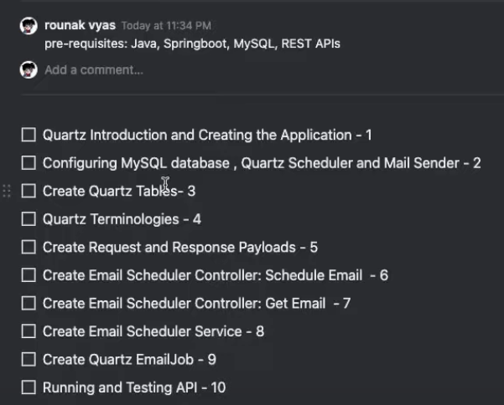

Repository:

callicoder/spring-boot-quartz-scheduler-email-scheduling

<https://github.com/callicoder/spring-boot-quartz-scheduler-email-scheduling>

<https://github.com/callicoder/spring-boot-quartz-scheduler-email-scheduling/blob/master/src/main/resources/quartz_tables.sql>

Database: MySQL

Spring Boot Quartz Scheduler Example: Building an Email Scheduling app

<https://www.callicoder.com/spring-boot-quartz-scheduler-email-scheduling-example/>

spring initializr

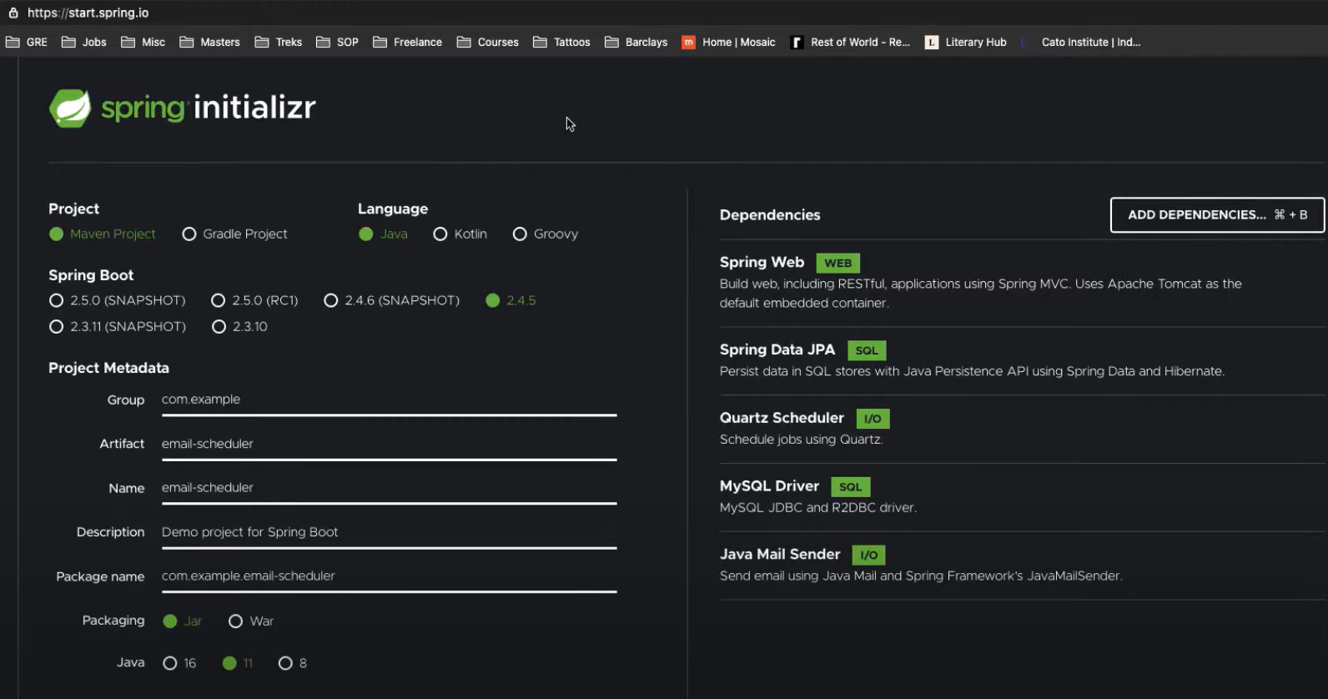

Enable security email account:

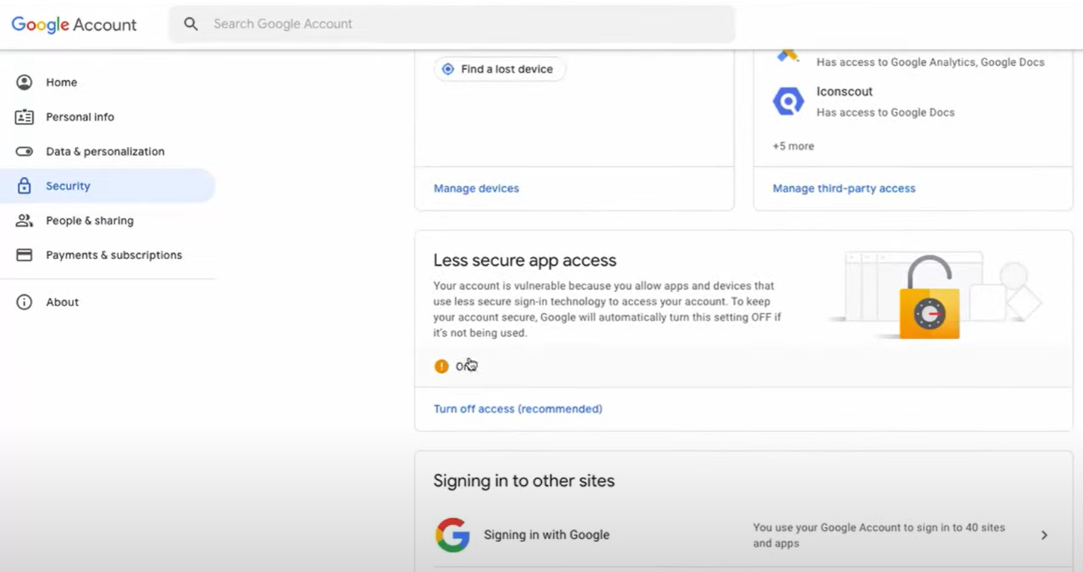

Un job puede tener varios triggers. Un trigger solo puede estar asociado a un job.

* **References**
* **Expresiones CRON**

<https://www.adictosaltrabajo.com/2010/02/22/expresiones-cron/>

* CronMaker: Generador de expresiones Cron

<http://www.cronmaker.com/>

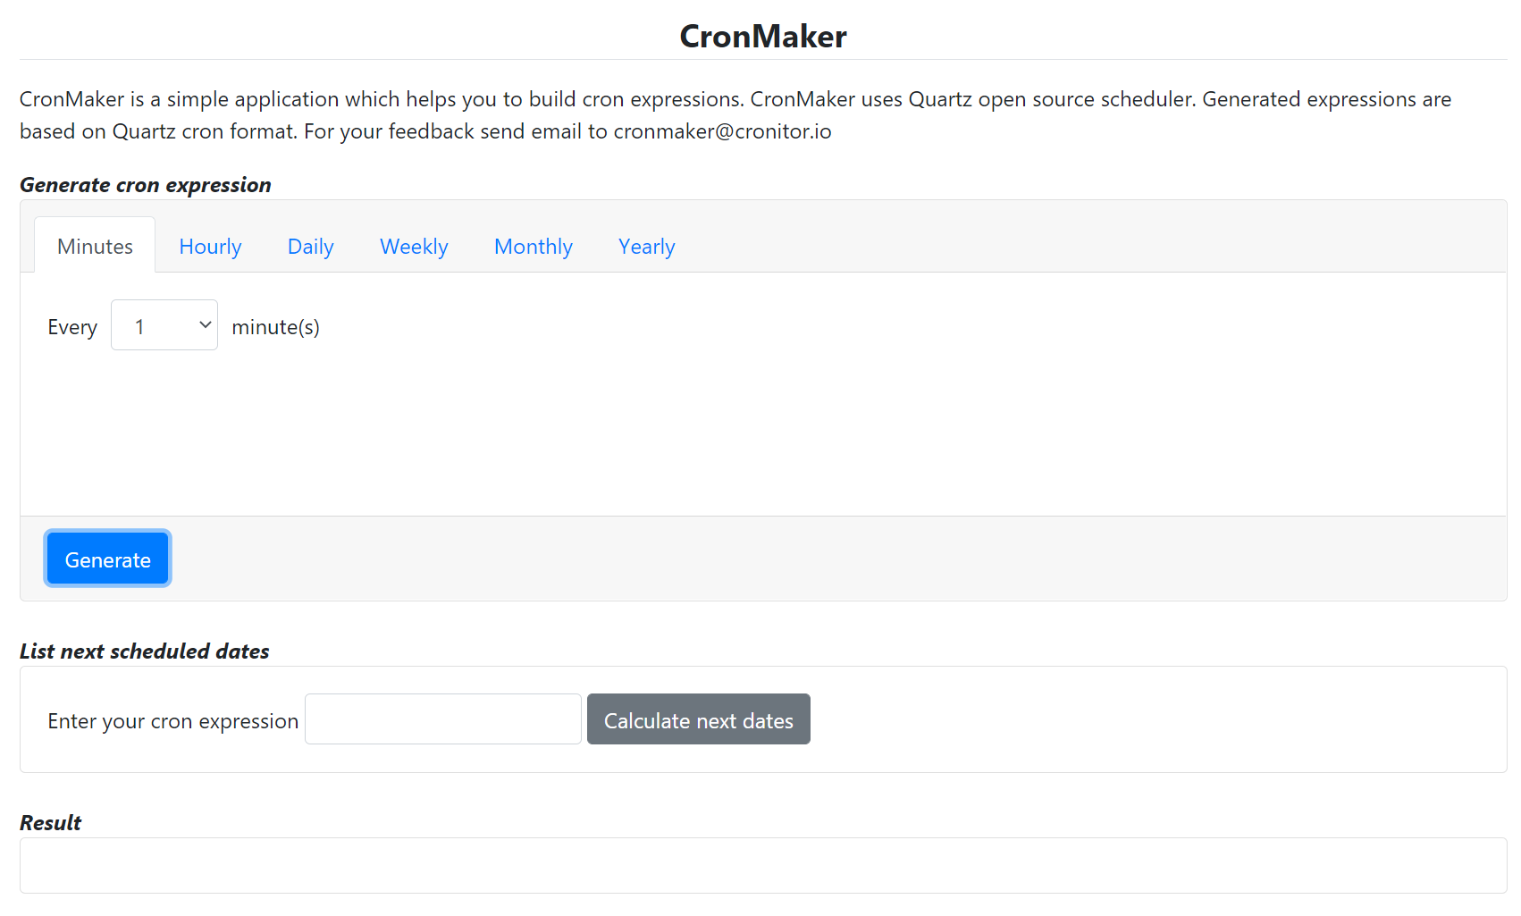

* **Others**

Quartz.NET

<https://www.quartz-scheduler.net/features.html>