Scenario #5

One of the most comprehensive and relevant piece of data visualization that is imminent in today’s managerial standards is a BI (Business Intelligence) dashboard. In a general sense, a BI dashboard is comparable that of a car’s dashboard which shows different kinds of relevant data all at once. Of course, BI dashboards differ regarding the type of information and such, an example below focuses on sales. As seen below, a dashboard contains multiple pieces of information, specifically in this case, geographical information, sales per SKU and date, and sales performance per salesperson. At one glance, all this information is already seen.

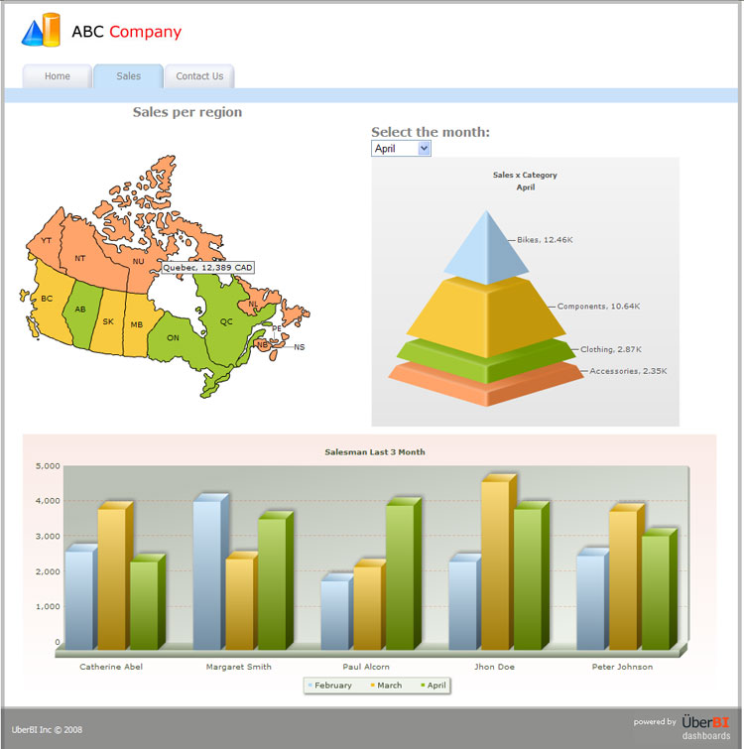s