# Question 1 (30 pts)

## Mission

To **invoke** the imagination, **provoke** the senses, and **evoke** the emotions of people around the world

## Vision

In the pursuit of its dreams and in its business practices, *Cirque du Soleil* strives to position itself in the community as a responsible proponent of change. Their long-term goal is to be the most inspiring creative company in the world.

## Savoie’s Major Objectives

1. Develop a strategic IT Vision that would be accepted by Cirque’s top management
2. Deploy a highly professional IT group that would have the required resources
3. Improve the credibility of the IT group among the leaders of the firm

## IT Environment during 2000

* Servers: mostly clones; majority running on Windows NT 4.0 while some run with Novell Netware
* Network: uses various standards; shared or wireless in certain sites
* Desktops: comes from at least 10 different suppliers
* Operating Systems: inconsistent; various versions of Windows
* MS Office Suite: different versions
* Applications: more than 800, many supporting the same function (usage based on personal preference)
  + Critical Application: performer’s medical record tracker
  + Performers as critical resource
* Data Sharing: no actual sharing; applications were standalone; working as independent business rather than parts

### Difficulties

* The demands made on maintenance support were very high.
* Users had to change their work methods and adapt to each workstation or workplace where they happened to be, impacting their effectiveness significantly.
* It was extremely difficult to deploy applications that worked on all workstations and in all regional contexts.
* The infrastructure was unstable.
* It took a considerable amount of time to solve any technical problems that arose.

### Current Situation of IT Group

* Small size -> essentially a support group
* No development team
* No structured governance (no standards or procedures)
* Decentralized IT management -> no coordination between each unit
* Deficit in IT credibility
  + Poor ability to deliver the desired IT solutions with the required degree of depth, reliability and operational uptime availability
  + Insufficient leverage of user investment in terms of efforts and funds caused by lack of project management, weak integration of IT solutions and incoherent technology
  + A lack of vision with respect to IT direction in the organization, the delivery of business solutions, infrastructure acquisition and investments and technology transfer
* Nutshell: **Cirque’s IT could not support its growth.**

## IT Governance

Prior to Savoie’s arrival at Cirque du Soleil, a *decentralized feudal* IT governance was in place, where business unit leaders or their delegates have the decision rights and authority is localized. This style is found in enterprises with relatively autonomous business units and can be useful in delivering local responsiveness. The company’s travelling shows are often considered as the formerly-mentioned autonomous business units.

Once Savoie was hired by the company as CIO, the IT governance shifted to being a *centralized* *business monarchy***.** In a business monarchy, the executive leadership has decision rights. These are often exercised through an executive committee or IT Council comprising a combination of business and IT executives. The said business executives are included in the Executive Committee, and the IT executive being Savoie herself.

## Stages of Growth

1. Initiation
   * Acquisition of SAP to support the ff processes: human resources, logistics, and finance (p.5)
2. Expansion/Contagion
   * Current stage of Cirque du Soleil’s IT
   * Savoie was hired as CIO because of IT need
   * Decentralized IT
     + Each touring show had its own unique IT infrastructure
     + Over 800 software applications and packages installed. They were most varied and unconventional
     + Collaboration across different business units was difficult (p.6)
3. Control
   * Savoie’s IT strategic plan entails this stage

## Business Model Canvas

1. Customer Segments
   1. The redefined circus performance is intended for the whole audience of Cirque Du Soleil. The industry is aimed at the general audience ranging from children to adults. **(p2)**
2. Value Proposition
   1. **Distinct and unusual style of circus (p. 3)**: Cirque du Soleil reinvented the traditional circus by integrating the interesting and exciting side of the traditional circus with the sophisticated more dramatic elements of theatre. No animals were used which made the circus set apart as a special class of circus.
   2. **Theatrical and coherent performance (p. 3)**: A Cirque du Soleil show is not a series of unrelated acts but a theatrical performance featuring talents as actors. With the reduction of rings from three rings to one ring, the circus would captivate the audience’s attention.
3. Channels
   1. **Touring Shows (p. 3)**: Cirque du Soleil is known as a little village that travels from city to city. As said, they deliver their value to their customers by having tours in different cities around the world. They also have permanent shows in selected areas.
   2. **Permanent Shows (p. 2)**: They have three (3) permanent shows in Las Vegas and Walt Disney World Resort.
   3. **Regional offices (p. 2)** These are responsible for managing and supporting the events/performances that happen within their respective areas
4. Customer Relationship - outline the relationship you want to establish and maintain with your customers or each customer segment
   1. Create a lasting effect on their customers/audience through invoke, provoke, and evoke - their creative mission. **(p. 3)**
   2. Achieving their creative mission through combining the sophistication of theatre and the awe-striking effect of the circus.
5. Revenue Streams
   1. Their source of revenue comes from the ticket sales of their permanent shows that they have in selected places, from the tours they do in cities around the world, and other merchandise that they sell before, during and after their shows. Some of the merchandise are unique garments and accessories inspired by Cirque du Soleil. Each piece of merchandise is unique given that it was created under the company’s theme of human expression, costumes and troupe with each having a part of garment coming from the costume of the performers of cirque themselves. Although it was not stated during the time of the case, presently merchandise by the company is now available which can be seen in their website (<http://www.cirquedusoleil.com/en/home/other-activities/desigual.aspx>) **(p.3)**
6. Key Resources
   1. **Performers (p. 4-5)**: Quality of shows relies heavily on the availability of excellent artists, acrobats, jugglers, athletes, singers, etc.
   2. **Key Players in Show Production (p. 5)**: The key players are Creation, Cirque Image, Finance, Merchandising, Resources, Marketing, Legal, Production, SAP and Planning and Public Affairs. (p. 5)
   3. **Casting Directors and Talent Scouts (p. 4)**: Casting’s talent scouts are always on the move, travelling to the ends of the earth, recruiting artists for new shows in the future. Together with the Casting Director, they handle recruitment and maintaining pool of artists.
7. Key Activities
   1. **Casting (p. 4)**: The recruitment, training, and managing the talents of the shows in order to maintain the quality of shows. Scouts go around the world to find and recruit key talent in different places for their shows.
   2. **Pre-Production Staffing (article)**: Every aspect of the creative process is considered from selecting key staff to pre-production, the creation of the ‘acrobatic skeleton’, facilitated group discussions among the members of the creation team, casting, rehearsals and finally until premiere.
   3. **Precise and methodical arrangement of materials (p. 3-4)**: During the assembly of the infrastructure for the shows, the logistics, while complicated supremely efficient that is supported by technical documentation.
8. Key Partnerships
   1. In order to identify new talent, develop acts and identify new areas of technology and knowledge, external sources are needed.
   2. Cirque du Soleil established strategic alliances with educational institutions, including polytechnics and circus schools to feed its inspiration and stock its cupboard of ideas.
   3. Partnerships with hotels and other establishments like Treasure Island, Bellagio and Walt Disney World Resort. **(p2)**
   4. They can also partner with ticketing offices.
9. Cost Structure
   1. **Using only one ring (p.3)** instead of three that is used in typical circus productions.
   2. The decision to **not use animals (p.3)** for performances.

They have **three regional offices (p.2)** around the world. These regional offices supervise shows that happen within their area of responsibility. They have offices in Las Vegas, Orlando, Amsterdam and Singapore.

## Value Chain

Support Activities

* Firm Infrastructure
  + Events and planning management - each regional office provided an overview of each show namely operations, finance, human resources, marketing and IT. This provided efficient movement of resources from production until presentation to the audience. Each office had responsibility over the area that they were assigned in. (p.2)
* Human resource management
  + The need for high quality human resource is because their business relies heavily on it. The quality of the performances/ presentations would be determined by the skills of the performers they hire.
  + Management control, marker, measurements and making of casts.
* Technology development
  + Diverse technology Involved all about IT here
  + Each touring show had its own unique IT Infrastructure
* Procedure
  + Standardizing its practices in terms
  + Documented
  + Excel

Primary Activities

* Inbound Logistics
  + The company invests heavily in recruitment since they acquire/recruit performers from different parts of the world specializing in their own fields. According to the case, they search for sopranos who radiated childlike energy, artists with gesture that guaranteed laughs.
  + Performers, casting
  + Creating the concepts of each show happen during the discussion of the members of the creation team wherein after thinking of concepts, music, design etc they work individually to create the different parts of the show (From website link given)
* Operations
  + Training of performers which are sent to Montreal
  + The transfer of logistics and other equipment
* Outbound Logistics
  + Trained performers
  + Having regional offices and having tours all around the world
  + “A little village travelling from city to city” (p.3)
* Marketing and Sales
  + Localized global marketing teams
  + Strategic regional offices to manage shows on certain regions
    - Las Vegas -> Las Vegas and Orlando
    - Montreal -> America
    - Amsterdam -> Europe
    - Singapore -> Asia-Pacific
* Services
  + Merchandise

## Critical Success Factors

|  |  |  |  |
| --- | --- | --- | --- |
| **Objectives** | **Critical Success Factors** | **Decisions and Actions** | **Variables** |
| Reinventing the circus and differentiating themselves from traditional circuses. | Offering theatrical performances instead of traditional circus acts. | Finding and nurturing key talents. | Characteristics of the talents that are being searched |
| Maintaining low cost structure | Low support costs | Animals are no longer used. |  |

## SWOT

|  |  |
| --- | --- |
| **Strengths**   * Lower cost structure * Ability to find and nurture talent in different fields of production * Large information base of different talents from around the globe. * Gifted producers in relation to their creative department * Reinvent circus to differentiate themselves * Recruitment of world class acts | **Opportunities**   * Expansion of their creative base through different partnerships with educational institutions. * Innovation by showing different show formats compared to traditional circus shows * Integrating new and old technology with their procedures and other processes * Collaboration with renowned creators for various projects |
| **Weaknesses**   * Maintenance support required for IT is very high * Little coordination between different shows in the organization * Unstable infrastructure * Manual documentation (folders, Excel) | **Threats**   * IT may not scale well as the company expands leading to information mismanagement * Indirect competition in the form of traditional circus performances and other theatrical productions |

## TOWS

|  |  |  |
| --- | --- | --- |
|  | **Threats** | **Opportunities** |
| **Weaknesses** | * Maintenance support required for IT will increase as the company expands * With manual documentation already having the risk of loss, the threat of information mismanagement will lead to a greater loss of information | * Through integration, it is possible to lower costs from IT maintenance. |
| **Strengths** | * Continually, recruiting unique talents from around the globe in order to create more innovative productions. | * Through partnerships with educational institutions, it is possible to further expand and produce more creative shows. |

# Question 2 (15 pts)

## Critical Business Process

1. Production Creation & Conceptualization
   1. Each new production is assigned a Director, a Product Manager and a Director of Creation. They will conceptualize an idea based from guidelines from Guy Laliberte. Once the basic idea is formed, other creators such as a set designer, a costume designer, a composer, a choreographer and other specialists. (p3)
   2. The acrobatic skeleton is developed and acts that will make up the show is formulated. The concept is formed based on existing knowledge and discussion among the members of the creation team. The concept is discussed from pre-production until the premiere and beyond. (<http://www.cirquedusoleil.com/en/press/news/2011/creation-process.aspx>)
2. Casting and Training
   1. Scouting
      1. Talent Scouts
   2. Training
      1. Make-up lessons
      2. Costume Workshop
      3. creation of Casts
3. Logistics
   1. A tour is a little village travelling from city to city
   2. Electricity, phones, water, offices, Internet, and a computer network; practically self-sufficient, with its own kitchen, workshop, box office, and heating and air conditioning system
   3. Moves every six to seven weeks, which means that it has to be constantly torn down and set up again
   4. Big top that seats 2,500; 55 trailer-loads of equipment; everything has to be in working order within 30 hours; technical documentation
   5. Everything has to be precise and methodical. Everything needs to be documented.
4. Business Support Units
   1. Human Resources
   2. Finance
   3. IT

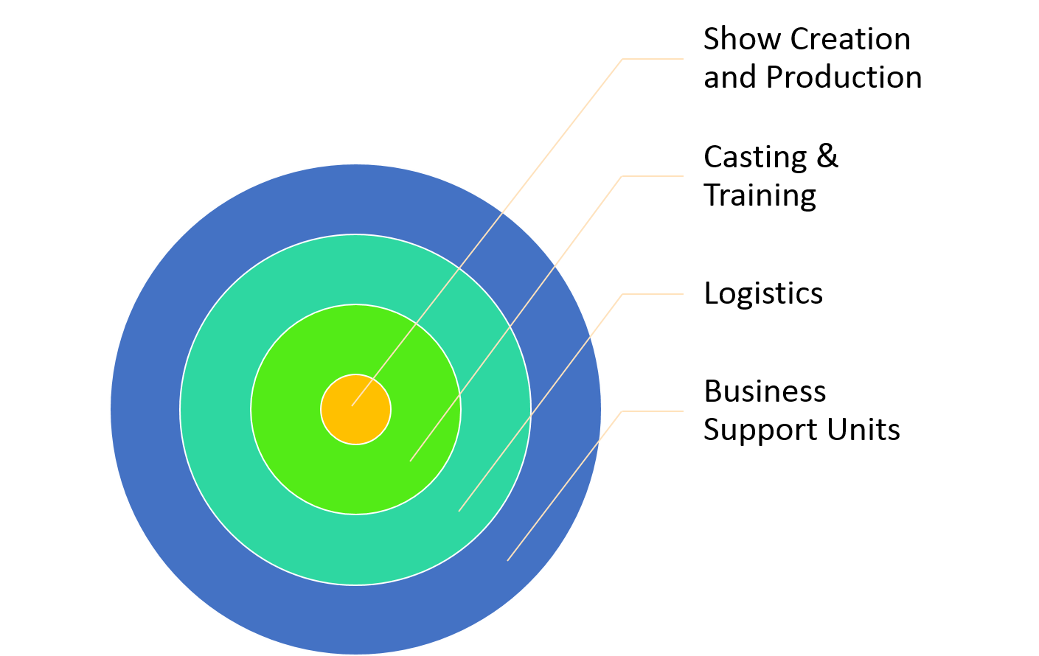

# Question 3 (15 pts)

Cirque du Soleil‘s business model differs from that of the traditional circus model in the aspects of value proposition and cost structure. The two aspects are closely related. The company has a distinct and unusual style of circus, which is its main difference from the other traditional circuses. By combining the spectacle of the traditional circus with the sophistication and drama of the theatre, Cirque du Soleil has reinvented the modern circus. This is the main selling point in the model’s value proposition. Also, in the reinvention of the circus, only one ring is used in which the actors perform, as compared to the traditional three. This helped lower the cost structure than that of the traditional circus’s. Animals were also not used, further reducing the cost structure by eliminating transport, food, shelter, and health costs of the animals.

# Question 4 (20 pts)

The current IT infrastructure of Cirque du Soleil works well enough that its operations are continuous, though quite difficult and challenging. The IT infrastructure is also an important support process in the relocation of the travelling shows, which in turn is a key step in the critical business process. The show’s technician has to be onsite several days before the tour arrives to ensure that the IT infrastructure is in place (p. 5). The installation could take quite a long time and was quite cumbersome. Each touring show also had an application that tracked the performers’ medical records. Since performers are a critical resource, this application was deemed extremely important (p. 5). Casting, also a part of the critical business process, could use some help from IT. Casting directors have to carry around piles of files, video recordings, pictures, and so on (p. 4). A paperless Internet-based solution from IT should alleviate the difficulties experienced by the casting directors.

# Question 5 (15 pts)

Savoie is a good choice for Cirque du Soleil’s CIO. From the onset of her new job as CIO, she immediately worked towards analyzing and familiarizing herself with the company’s current IT situation and business (p. 5), quite similar to what Jack Carlisle had done during the beginning of his tenure at IZL. Like Carlisle, she also introduced herself to the general managers and key players in the company (p. 5). Savoie was excellent in terms of not only IT, but also management, as demonstrated in her sailboat presentation to Guy Laliberte (p. 7). This is an important trait that IT managers, let alone an executive, should possess. Effective IT managers and executives must communicate clearly with both technical and non-technical personnel.

# Question 6 (10 pts)

Savoie’s first course of action would be to standardize IT across the company, including the touring shows. This will not only solve the issues the IT infrastructure in the touring shows, especially those brought about by the diverse nature of their current hardware and software, but also make it easier to implement changes across the entire company. Should Laliberte “direct a course” in which IT should take, the standardized IT infrastructure should prove less difficult for Savoie to “steer” towards.