**# Minnesota Interstate Traffic Volume  
  
## Dashboard.**

[**Minnesota Traffic Volume Dashboard**](https://public.tableau.com/authoring/MinnesotaTrafficVolumeDashboard_17004833764790/MinnesotaTrafficVolumeDashboard#3)The dashboard for this project has four charts and a legend. These charts include **Traffic volumes by month per year, Traffic volumes by hour of the day, Traffic volumes organized by weather patterns, and a circle chart for Holidays with the highest traffic.** Together, these charts address the stakeholders’ main interests: comparing the traffic volume at different points in time and at different timescales and examining holiday and weather patterns throughout the year.

The legend specifies a separate color for each of the three years represented in the data. This visualization uses only three years of data to prioritize simplicity. If these charts featured data from all the years, there would be too many lines and bars. This would make it much harder to read, and therefore much less effective as a visualization. Because the charts use data from the same years, the color schema can be consistent across all the charts. This way, the orange line in one chart corresponds to the same year as the orange bars in another.

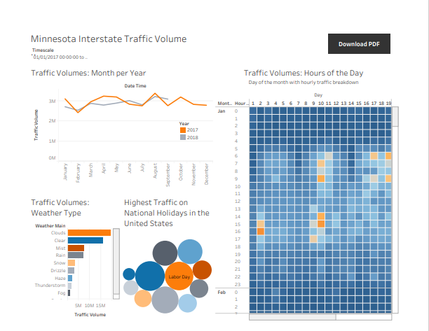

In this dashboard, the line chart is placed at the top, alongside the legend. Since the legend applies to each of the charts, it’s important to place it at the top of the visualization. There is a bar chart representing weather patterns and a circle chart representing national holidays in the United States.

The Heat map represents the traffic volumes by hours of the day. Because a large amount of data is being visualized at once, this chart is larger than the others so it can be viewed more easily.

The line chart and heat map represent two of the timescales in which the stakeholder is most interested: the monthly timescale and the weekly timescale. In these charts, it can be viewed which months and days of the week have the highest traffic volume. You can also find other trends: based on the line chart, it seems like the traffic volume for 2017 was generally higher than in 2016.

**## Chart Analysis**

**### Traffic Volumes by month per year**

This line chart illustrates a comparison of traffic volumes between consecutive years for each month. The chart addresses the inquiry: Which month typically experiences the highest traffic volume? The Date Time dimension is employed with a filter set to display the Month timescale. Additionally, the chart aggregates the sum of traffic volume across each period, resulting in a consolidated total for each monthly interval. Each data point on the chart reflects the overall number of cars on the road throughout an entire month.

The chart features three lines representing the years 2016, 2017, and 2018.  
You can interact live with the chart in Tableau [Here](https://public.tableau.com/app/profile/clement.zare/viz/Traffic_17004975313620/Trafficvolumesbymonthperyear)

**### Traffic volumes by hour**

This heat map breaks down traffic concentration for each day and hour of each month. As you scroll through the visualization, the chart automatically updates to display each month’s data. This chart lets you compare each day and hour of traffic to the next, detailing traffic volume down to the hour. Columns in this heat map represent the day of the month and rows represent the time of day. Higher concentrations of traffic are represented by the color of each square in the heat map, with orange demonstrating a higher volume while the darker blue squares indicate less traffic.

You can interact live with the Heat Map in Tableau [Here](https://public.tableau.com/authoring/MinnesotaTrafficVolumeDashboard_17004833764790/Trafficvolumesbyhour#3)

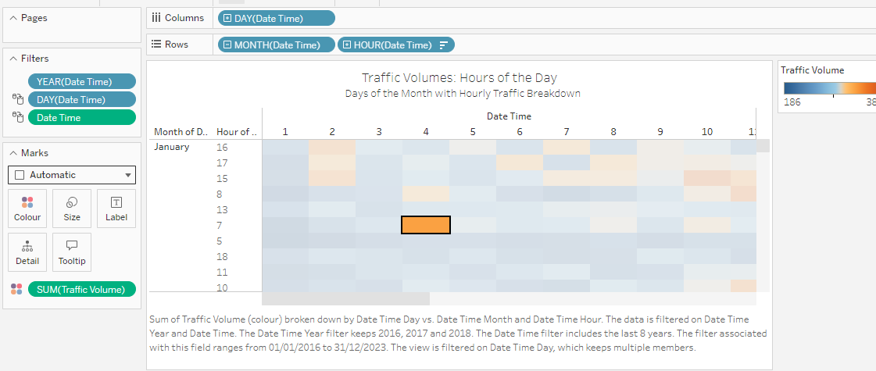

**### Traffic volumes by weather pattern**

This bar chart displays yearly traffic volume grouped by weather type. I included a date time filter that spans the years 2016 through 2018, I represented total traffic volume for those years and grouped it by weather type. For example, in those years, there were 24 million cars on the road during days with clear weather, while traffic volume decreased to 10 million during rainy weather. This also answers the question about the effect that weather has on traffic.

You can interact live with the Bar Chart in Tableau [Here](https://public.tableau.com/authoring/MinnesotaTrafficVolumeDashboard_17004833764790/Trafficvolumesbyweatherpattern#3)

**### Holidays with highest traffic**

I created a Custom column that specifies which entries are on holidays. I used the calculation: “if [Holiday] = "None" then null else "X" end”. This will create a column that is used to make a chart that compares only holiday traffic, using the circle chart.

This chart uses color and size to compare the holidays with the highest traffic. The color represents the holiday, while the size of each circle represents the traffic volume on that holiday. The use of size and color in this way demonstrates relationships between numeric data and presents it in a compact format.

